Tropical Cyclone Report
Tropical Storm Patricia
(EP192009)
11-14 October 2009

Christopher W. Landsea and Richard J. Pasch
National Hurricane Center
10 November 2009

Patricia was a tropical storm that threatened - but had little impact on - the southern Baja California peninsula of Mexico.

- Synoptic History

Patricia formed from a tropical wave that emerged from the coast of western Africa on 23 September. Atlantic basin Tropical Depression Eight originated from this wave a few hundred miles west of the Cape Verde Islands on 25 September. The wave continued westward and crossed Central America on 6 October. Widespread but sporadic deep convection was observed in association with the wave as it slowly moved across the eastern North Pacific during the next few days and a broad low pressure area formed a couple of hundred miles south of Manzanillo, Mexico on 9 October. On 11 October, convection persisted and a well-defined center of circulation formed. It is estimated that a tropical depression developed at 1800 UTC that day, about 350 n mi south-southeast of the southern tip of Baja California, Mexico. The “best track” chart of the tropical cyclone’s path is given in Fig. 1, with the wind and pressure histories shown in Figs. 2 and 3, respectively. The best track positions and intensities are listed in Table 1.

The system’s cloud pattern continued to become better organized and the depression reached tropical storm intensity about six hours after genesis, while centered about 310 n mi south-southeast of the southern tip of Baja California. Patricia continued to gradually strengthen over the next day while moving over very warm waters (though only with marginally conducive atmospheric stability) and experiencing light easterly tropospheric vertical wind shear. While intensifying, the tropical cyclone was moving generally north-northwestward at less than 10 kt under the influence of a deep-layer ridge to its east and a mid- to upper-level trough to its northwest. Patricia reached its peak intensity, with maximum sustained winds of 50 kt and a minimum central pressure of 996 mb, around 0000 UTC 13 October, while centered about 190 n mi south of the southern tip of Baja California.

A combination of moderate southeasterly vertical shear and a more stable air mass late on 13 October and early 14 October appears to have caused Patricia’s relatively quick demise. Deep convection ceased late on 13 October, and it is estimated that the cyclone became a remnant low (bypassing the dissipating tropical depression stage) around 0600 UTC 14 October, while centered just 25 n mi east-southeast of the southern tip of Baja California. Patricia’s remnant low then moved toward the west embedded in the trade winds for the next day and a half, before dissipating over the open eastern North Pacific Ocean.

- Meteorological Statistics

Observations in Patricia (Figs. 2 and 3) include satellite-based Dvorak technique intensity estimates from the Tropical Analysis and Forecast Branch (TAFB) and the Satellite Analysis Branch (SAB). Data and imagery from NOAA polar-orbiting satellites including the Advanced Microwave Radiometer (AMSU), the NASA Tropical Rainfall Measuring Mission (TRMM), the NASA QuikSCAT, and Defense Meteorological Satellite Program (DMSP) satellites, among others, were also useful in constructing the best track of Patricia.

Patricia’s estimated peak intensity of 50 kt from 1200 UTC on 12 October to 0600 UTC on 13 October was based upon a combination of the TAFB/SAB Dvorak classifications and two QuikSCAT passes.

There were no ship or land-based station reports of tropical-storm-force winds in association with Patricia. Though tropical storm warnings were issued for the southern portion of Baja California, Patricia weakened before reaching the peninsula and it is likely that tropical-storm-force winds did not occur along the Mexican coast.

- Casualty and Damage Statistics

There were no reports of damage or casualties associated with Patricia.

- Forecast and Warning Critique

The genesis of Patricia was well predicted. Patricia’s generating disturbance was first included in the Tropical Weather Outlook with a low (<30%) probability for formation 72 h before genesis occurred. This was raised to medium (30-50%) 54 h before genesis and high (>50%) 30 h before Patricia’s formation.

A verification of NHC official track forecasts for Patricia is given in Table 2a. Official forecast track errors were larger than the mean official errors for the previous five-year period at 12 and 24 h and smaller at 36 and 48 h. A homogeneous comparison of the official track errors with selected guidance models is given in Table 2b. The small number of cases precludes any meaningful intercomparison.

A verification of NHC official intensity forecasts for Patricia is given in Table 3a. Official forecast intensity errors were comparable to the mean official errors for the previous five-year period. A homogeneous comparison of the official intensity errors with selected guidance models is given in Table 3b.

Watches and warnings associated with Patricia are given in Table 4.
Table 1. Best track for Tropical Storm Patricia, 11-14 October 2009.

Date/Time  (UTC) | Latitude  (°N) | Longitude  (°W) | Pressure  (mb) | Wind Speed  (kt) | Stage
11 / 1800 | 17.1 | 108.2 | 1005 | 30 | tropical depression
12 / 0000 | 17.7 | 108.7 | 1003 | 35 | tropical storm
12 / 0600 | 18.3 | 109.2 | 1001 | 40 | "
12 / 1200 | 18.8 | 109.5 | 997 | 50 | "
12 / 1800 | 19.3 | 109.5 | 997 | 50 | "
13 / 0000 | 19.8 | 109.4 | 996 | 50 | "
13 / 0600 | 20.4 | 109.2 | 997 | 50 | "
13 / 1200 | 21.1 | 109.0 | 1000 | 45 | "
13 / 1800 | 21.9 | 108.9 | 1002 | 40 | "
14 / 0000 | 22.4 | 109.1 | 1004 | 35 | "
14 / 0600 | 22.6 | 109.5 | 1006 | 30 | low
14 / 1200 | 22.7 | 110.2 | 1008 | 25 | "
14 / 1800 | 22.8 | 111.2 | 1008 | 25 | "
15 / 0000 | 22.7 | 111.9 | 1009 | 20 | "
15 / 0600 | 22.5 | 112.5 | 1009 | 20 | "
15 / 1200 | 22.3 | 112.9 | 1009 | 20 | "
15 / 1800 |  |  |  |  | dissipated
13 / 0000 | 19.8 | 109.4 | 996 | 50 | minimum pressure and maximum wind speed

Table 2a. NHC official (OFCL) and climatology-persistence skill baseline (CLIPER - OCD5) track forecast errors (n mi) for Tropical Storm Patricia, 11-14 October 2009. Mean errors for the five-year period 2004-8 are shown for comparison. Official errors that are smaller than the five-year means are shown in boldface type.

 | Forecast Period (h)
 | 12 | 24 | 36 | 48 | 72 | 96 | 120
OFCL | 43.5 | 55.0 | 26.0 | 55.7
OCD5 | 46.0 | 73.4 | 67.6 | 66.0
Forecasts | 8 | 6 | 4 | 2
OFCL (2004-8) | 31.0 | 51.7 | 71.7 | 90.2 | 123.6 | 161.3 | 201.8
OCD5 (2004-8) | 38.4 | 73.6 | 111.9 | 149.1 | 214.2 | 261.1 | 311.5

Table 2b. Homogeneous comparison of selected track forecast guidance models (in n mi) for Tropical Storm Patricia, 11-14 October 2009. Errors smaller than the NHC official forecast are shown in boldface type. The number of official forecasts shown here will generally be smaller than that shown in Table 2a due to the homogeneity requirement.

Model ID | Forecast Period (h)
Model ID | 12 | 24 | 36 | 48 | 72 | 96 | 120
OFCL | 44.3 | 68.1 | 40.1
OCD5 | 46.8 | 90.8 | 104.0
GFSI | 61.6 | 104.4 | 148.7
GHMI | 51.1 | 73.7 | 35.2
HWFI | 45.0 | 56.3 | 48.9
GFNI | 57.4 | 86.2 | 66.0
NGPI | 57.9 | 87.7 | 54.1
EGRI | 58.0 | 89.8 | 73.6
EMXI | 32.3 | 57.4 | 86.8
TCON | 52.2 | 75.9 | 57.6
TVCN | 47.7 | 69.6 | 34.9
TVCC | 53.0 | 76.4 | 54.9
GUNA | 54.0 | 81.8 | 59.9
FSSE | 50.4 | 72.6 | 55.6
AEMI | 56.6 | 80.3 | 60.7
BAMS | 63.5 | 121.8 | 132.8
BAMM | 56.6 | 96.1 | 97.7
BAMD | 56.1 | 88.7 | 81.3
LBAR | 44.0 | 101.7 | 141.5
Forecasts | 6 | 4 | 2
Table 3a. NHC official (OFCL) and climatology-persistence skill baseline (Decay SHIFOR - OCD5) intensity forecast errors (kt) for Tropical Storm Patricia, 11-14 October 2009. Mean errors for the five-year period 2004-8 are shown for comparison. Official errors that are smaller than the five-year means are shown in boldface type.

 | Forecast Period (h)
 | 12 | 24 | 36 | 48 | 72 | 96 | 120
OFCL | 8.8 | 10.8 | 12.5 | 12.5
OCD5 | 6.8 | 9.5 | 6.5 | 5.5
Forecasts | 8 | 6 | 4 | 2
OFCL (2004-8) | 6.2 | 10.2 | 13.3 | 15.1 | 17.7 | 19.0 | 18.8
OCD5 (2004-8) | 7.1 | 11.5 | 14.7 | 16.8 | 18.9 | 20.3 | 20.2

Table 3b. Homogeneous comparison of selected intensity forecast guidance models (in kt) for Tropical Storm Patricia, 11-14 October 2009. Errors smaller than the NHC official forecast are shown in boldface type. The number of official forecasts shown here will generally be smaller than that shown in Table 3a due to the homogeneity requirement.

Model ID | Forecast Period (h)
Model ID | 12 | 24 | 36 | 48 | 72 | 96 | 120
OFCL | 9.3 | 10.0 | 11.7 | 15.0
OCD5 | 6.9 | 8.6 | 4.0 | 5.0
HWFI | 13.1 | 16.2 | 26.0 | 49.0
GHMI | 8.3 | 5.4 | 10.3 | 27.0
GFNI | 7.4 | 9.6 | 6.7 | 2.0
DSHP | 8.6 | 10.2 | 7.7 | 11.0
LGEM | 8.0 | 10.2 | 10.0 | 14.0
ICON | 9.6 | 10.2 | 14.0 | 25.0
FSSE | 8.1 | 10.2 | 18.0 | 33.0
Forecasts | 7 | 5 | 3 | 1

Table 4. Watch and warning summary for Tropical Storm Patricia, 11-14 October 2009.

Date/Time (UTC) | Action | Location
12/1500 | Tropical Storm Watch issued | La Paz to Santa Fe, Mexico
13/0900 | Tropical Storm Watch changed to Tropical Storm Warning | Buenavista to Agua Blanca, Mexico
13/0900 | Tropical Storm Watch modified to | Buenavista to La Paz and Agua Blanca to Santa Fe, Mexico
14/0600 | Tropical Storm Warning and Tropical Storm Watch discontinued | All

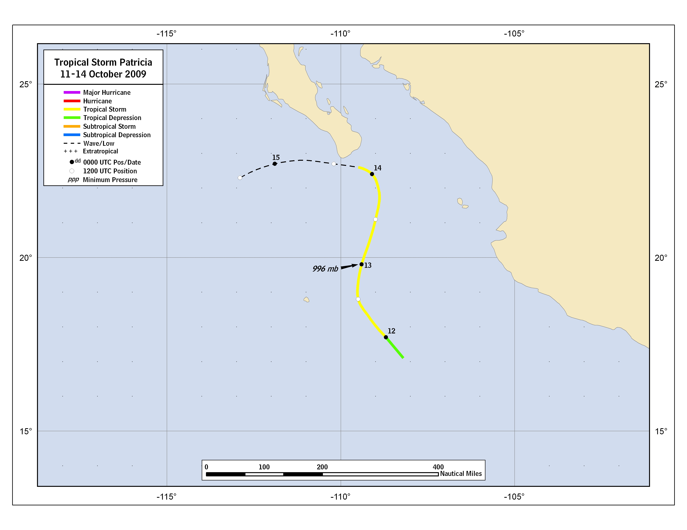
Figure 1. Best track positions for Tropical Storm Patricia, 11-14 October 2009.

Figure 2. Selected wind observations and best track maximum sustained surface wind speed curve for Tropical Storm Patricia, 11-14 October 2009. AMSU intensity estimates are from the Cooperative Institute for Meteorological Satellite Studies technique. Dashed vertical lines correspond to 0000 UTC.

Figure 3. Selected pressure observations and best track minimum central pressure curve for Tropical Storm Patricia, 11-14 October 2009. AMSU intensity estimates are from the Cooperative Institute for Meteorological Satellite Studies technique. Dashed vertical lines correspond to 0000 UTC.

A digital record of the complete best track, including wind radii, can be found on line at ftp://ftp.nhc.noaa.gov/atcf. Data for the current year’s storms are located in the btk directory, while previous years’ data are located in the archive directory.

