Tropical Cyclone Report
Tropical Storm Nora
(EP172009)
23-25 September 2009

John P. Cangialosi and Daniel P. Brown
National Hurricane Center
07 November 2009

Tropical Storm Nora formed over the central portion of the eastern North Pacific basin and did not impact land.

- Synoptic History

Nora originated from a tropical wave that entered the eastern North Pacific on 15 September. The wave moved westward with minimal thunderstorm activity until 18 September, when deep convection associated with the wave increased near the Gulf of Tehuantepec and then gradually improved in organization during the next several days. A low developed along the wave axis on 22 September, and late that day shower activity began to increase near the center. By 0000 UTC 23 September, the low had developed sufficient convective organization to be considered a tropical depression, while centered about 560 n mi southwest of the southern tip of Baja California. The “best track” chart of Nora’s path is given in Fig. 1, with the wind and pressure histories shown in Figs. 2 and 3, respectively. The best track positions and intensities are listed in Table 1.

The depression strengthened to a tropical storm six hours after genesis while it moved west-northwestward to northwestward around the southwestern periphery of a subtropical mid-level ridge. In a low wind shear environment and over warm waters, Nora steadily strengthened over the next 18 hours and reached a peak intensity of 50 kt around 0000 UTC 24 September, while centered about 600 n mi southwest of the southern tip of Baja California. Shortly thereafter, an upper-level trough to the northwest of Nora contributed strong southwesterly upper-level winds over the cyclone, which caused the low- and mid-level centers to decouple. The shear, combined with cooler waters, caused the system to weaken as it turned toward the west under the influence of a low-level ridge to the north. Nora became a tropical depression around 0000 UTC 25 September about 710 n mi west-southwest of the southern tip of Baja California and then degenerated into a remnant low six hours later.

The remnant low initially moved west-southwestward, then turned west-northwestward for a couple of days before resuming a southwestward motion. The remnant low persisted for about four days before it was absorbed within the Inter-Tropical Convergence Zone in the vicinity of 15°N and 133°W.

- Meteorological Statistics

Observations in Nora (Figs. 2 and 3) include satellite-based Dvorak technique intensity estimates from the Tropical Analysis and Forecast Branch (TAFB) and the Satellite Analysis Branch (SAB). Data and imagery from NOAA polar-orbiting satellites including the Advanced Microwave Sounding Unit (AMSU) instrument, the NASA Tropical Rainfall Measuring Mission (TRMM), the NASA QuikSCAT, and Defense Meteorological Satellite Program (DMSP) satellites, among others, were also useful in constructing the best track of Nora.

The estimated peak intensity of 50 kt at 0000 UTC 24 September is based on a blend of subjective satellite estimates of 45 kt from TAFB and 55 kt from SAB and an AMSU intensity estimate of 52 kt.

No ship reports of winds of tropical storm force associated with Nora have been received.

- Casualty and Damage Statistics

There were no reports of damage or casualties associated with Nora.

- Forecast and Warning Critique

The genesis of Nora was well forecast. The tropical wave that played a role in Nora’s development was introduced by the National Hurricane Center into its Tropical Weather Outlook (TWO) product 48 hours prior to genesis. The formation probability reached the medium (30-50%) category 30 hours prior to formation, and the high (greater than 50%) category 18 hours prior to formation.

A verification of NHC official track forecasts for Nora is given in Table 2a. Official forecast track errors were lower than the mean official errors for the previous five-year period at 12 h and 24 h, but greater than the long-term mean at 36 h and 48 h. A homogeneous comparison of the official track errors with selected guidance models is given in Table 2b. The official forecasts were better on average than most of the dynamical model guidance, albeit for a small sample size. The track forecast errors for the BAMS, a shallow single layer trajectory model, were lower than all of the dynamical models, likely due to the overestimation of Nora’s vertical depth by the dynamical models.

A verification of NHC official intensity forecasts for Nora is given in Table 3a. Official forecast intensity errors were lower than the mean official errors for the previous five-year period at 12 h, 24 h, and 48 h, but greater than the mean at 36 h. A homogeneous comparison of the official intensity errors with selected guidance models is given in Table 3b.

Table 1. Best track for Tropical Storm Nora, 23-25 September 2009.

Date/Time  (UTC) | Latitude  (°N) | Longitude  (°W) | Pressure  (mb) | Wind Speed  (kt) | Stage
22 / 0000 | 13.5 | 113.0 | 1008 | 20 | low
22 / 0600 | 13.9 | 113.8 | 1008 | 25 | "
22 / 1200 | 14.4 | 114.6 | 1008 | 25 | "
22 / 1800 | 14.9 | 115.3 | 1007 | 25 | "
23 / 0000 | 15.4 | 115.9 | 1006 | 30 | tropical depression
23 / 0600 | 15.9 | 116.6 | 1005 | 35 | tropical storm
23 / 1200 | 16.4 | 117.4 | 1003 | 40 | "
23 / 1800 | 16.8 | 118.2 | 1000 | 45 | "
24 / 0000 | 17.1 | 118.9 | 997 | 50 | "
24 / 0600 | 17.3 | 119.5 | 1000 | 45 | "
24 / 1200 | 17.4 | 120.1 | 1000 | 45 | "
24 / 1800 | 17.4 | 120.7 | 1002 | 40 | "
25 / 0000 | 17.4 | 121.2 | 1005 | 30 | tropical depression
25 / 0600 | 17.3 | 121.8 | 1006 | 30 | low
25 / 1200 | 17.1 | 122.5 | 1007 | 30 | "
25 / 1800 | 16.7 | 123.2 | 1007 | 30 | "
26 / 0000 | 16.5 | 124.0 | 1008 | 25 | "
26 / 0600 | 16.5 | 124.7 | 1008 | 25 | "
26 / 1200 | 16.6 | 125.3 | 1008 | 25 | "
26 / 1800 | 16.8 | 125.9 | 1008 | 25 | "
27 / 0000 | 17.1 | 126.6 | 1008 | 25 | "
27 / 0600 | 17.4 | 127.4 | 1008 | 25 | "
27 / 1200 | 17.7 | 128.2 | 1009 | 25 | "
27 / 1800 | 18.0 | 128.9 | 1009 | 25 | "
28 / 0000 | 18.0 | 129.6 | 1009 | 25 | "
28 / 0600 | 17.7 | 130.2 | 1010 | 20 | "
28 / 1200 | 17.4 | 130.7 | 1010 | 20 | "
28 / 1800 | 17.0 | 131.1 | 1010 | 20 | "
29 / 0000 | 16.5 | 131.5 | 1010 | 20 | "
29 / 0600 | 16.0 | 131.8 | 1010 | 20 | "
29 / 1200 | 15.5 | 132.2 | 1010 | 20 | "
29 / 1800 |  |  |  |  | dissipated
24 / 0000 | 17.1 | 118.9 | 997 | 50 | minimum pressure and maximum winds

Table 2a. NHC official (OFCL) and climatology-persistence skill baseline (CLIPER - OCD5) track forecast errors (n mi) for Tropical Storm Nora, 23-25 September 2009. Mean errors for the five-year period 2004-8 are shown for comparison. Official errors that are smaller than the five-year means are shown in boldface type.

 | Forecast Period (h)
 | 12 | 24 | 36 | 48 | 72 | 96 | 120
OFCL | 28.4 | 41.9 | 77.4 | 127.1
OCD5 | 35.3 | 57.4 | 95.8 | 148.9
Forecasts | 7 | 5 | 3 | 1
OFCL (2004-8) | 31.0 | 51.7 | 71.7 | 90.2
OCD5 (2004-8) | 38.4 | 73.6 | 111.9 | 149.1

Table 2b. Homogeneous comparison of selected track forecast guidance models (in n mi) for Tropical Storm Nora, 23-25 September 2009. Errors smaller than the NHC official forecast are shown in boldface type. The number of official forecasts shown here will generally be smaller than that shown in Table 2a due to the homogeneity requirement.

Model ID | Forecast Period (h)
Model ID | 12 | 24 | 36 | 48 | 72 | 96 | 120
OFCL | 30.1 | 49.1 | 77.4 | 127.1
OCD5 | 34.1 | 57.3 | 95.8 | 148.9
GFSI | 69.8 | 121.2 | 150.0 | 159.5
GHMI | 49.7 | 74.4 | 103.7 | 133.0
HWFI | 42.0 | 73.1 | 106.9 | 167.7
NGPI | 37.7 | 51.0 | 79.0 | 122.7
EMXI | 29.8 | 51.0 | 80.6 | 183.3
AEMI | 54.7 | 82.6 | 105.0 | 91.8
TVCN | 30.6 | 59.2 | 85.8 | 138.7
TVCC | 31.3 | 62.3 | 78.9 | 144.4
LBAR | 39.9 | 71.7 | 123.6 | 196.7
BAMD | 43.7 | 78.7 | 122.8 | 210.7
BAMM | 28.2 | 51.3 | 59.6 | 114.2
BAMS | 29.6 | 46.2 | 39.9 | 85.2
Forecasts | 5 | 4 | 3 | 1

Table 3a. NHC official (OFCL) and climatology-persistence skill baseline (Decay SHIFOR - OCD5) intensity forecast errors (kt) for Tropical Storm Nora, 23-25 September 2009. Mean errors for the five-year period 2004-8 are shown for comparison. Official errors that are smaller than the five-year means are shown in boldface type.

 | Forecast Period (h)
 | 12 | 24 | 36 | 48 | 72 | 96 | 120
OFCL | 5.7 | 13.0 | 11.7 | 0.0
OCD5 | 6.3 | 10.8 | 10.7 | 10.0
Forecasts | 7 | 5 | 3 | 1
OFCL (2004-8) | 6.2 | 10.2 | 13.3 | 15.1
OCD5 (2004-8) | 7.1 | 11.5 | 14.7 | 16.8

Table 3b. Homogeneous comparison of selected intensity forecast guidance models (in kt) for Tropical Storm Nora, 23-25 September 2009 . Errors smaller than the NHC official forecast are shown in boldface type. The number of official forecasts shown here will generally be smaller than that shown in Table 2a due to the homogeneity requirement.

Model ID | Forecast Period (h)
Model ID | 12 | 24 | 36 | 48 | 72 | 96 | 120
OFCL | 5.7 | 13.0 | 11.7 | 0.0
OCD5 | 6.3 | 10.8 | 10.7 | 10.0
HWFI | 7.6 | 20.8 | 38.3 | 49.0
GHMI | 4.9 | 7.2 | 12.3 | 33.0
DSHP | 4.9 | 10.2 | 10.0 | 14.0
LGEM | 5.6 | 10.8 | 10.7 | 4.0
ICON | 4.6 | 11.4 | 16.3 | 25.0
Forecasts | 7 | 5 | 3 | 1

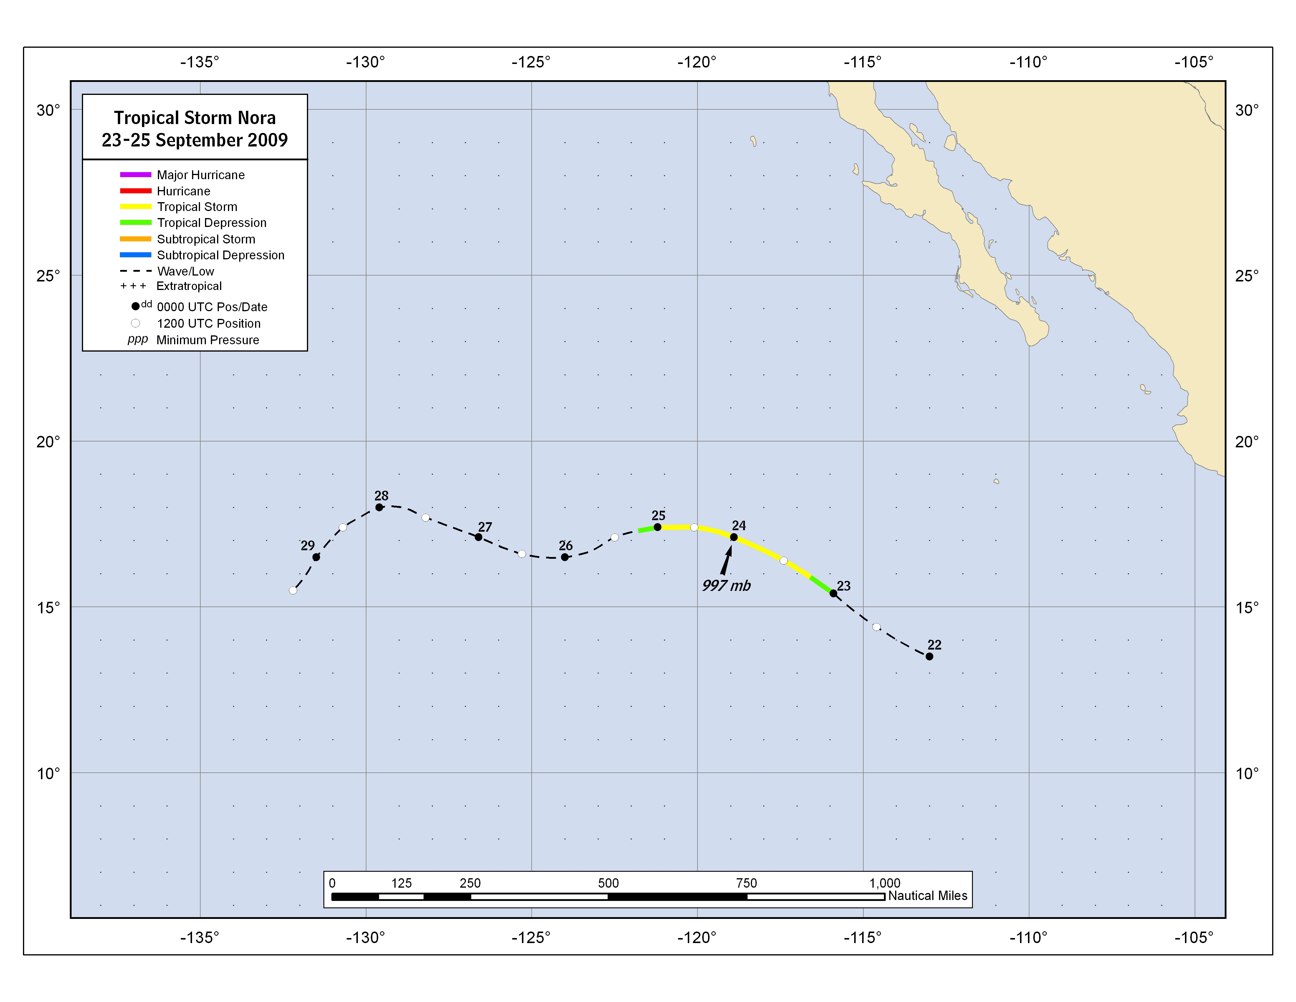

Figure 1. Best track positions for Tropical Storm Nora, 23-25 September 2009.

Figure 2. Selected wind observations and best track maximum sustained surface wind speed curve for Tropical Storm Nora, 23-25 September 2009. AMSU intensity estimates are from the Cooperative Institute for Meteorological Satellite Studies (CIMSS) technique. Dashed vertical lines correspond to 0000 UTC.

Figure 3. Selected pressure observations and best track minimum central pressure curve for Tropical Storm Nora, 23-25 September 2009. Dashed vertical lines correspond to 0000 UTC.

A digital record of the complete best track, including wind radii, can be found on line at ftp://ftp.nhc.noaa.gov/atcf. Data for the current year’s storms are located in the btk directory, while previous years’ data are located in the archive directory.

