Tropical Cyclone Report
Tropical Depression Sixteen-E
15-20 October 2005

Stacy R. Stewart
National Hurricane Center
10 November 2005

Tropical Depression Sixteen-E was a relatively long-lived tropical cyclone, given its weak intensity, and remained over the open Pacific Ocean during its entire lifetime.

- Synoptic History

A tropical wave moved off the west coast of Africa on 28 September and continued its uneventful trek across the tropical Atlantic and northern South America for the next two weeks. On 13 October, the wave emerged over the eastern North Pacific Ocean, but still embedded within the Intertropical Convergence Zone (ITCZ). Satellite classifications were initiated at 0000 UTC 14 October and, at 1200 UTC 14 October, a QuikSCAT overpass indicated a broad low-level cyclonic circulation had formed along the wave axis within the ITCZ. As deep convection continued to develop and become organized into tight curved bands around the center, the disturbance gradually moved northwestward and began to break away from the ITCZ. It is estimated that a tropical depression formed at 0000 UTC 15 October, about 360 n mi south of Acapulco, Mexico. The “best track” chart of the tropical cyclone’s path is given in Fig. 1, with the wind and pressure histories shown in Figs. 2 and 3, respectively. The best track positions and intensities are listed in Table 1.

The depression moved generally westward to west-northwestward at 5-10 kt for the next 5 days as it came under the influence of deep easterly steering flow on the south side of the Mexican subtropical ridge. Deep convective bursts with cloud tops colder than -80º C frequently occurred near the low-level center through 16 October, and may have resulted in the brief development of a small but well-defined mid-level eye-like feature (Fig 4). It is not uncommon for tropical storm-force winds to occur when such a feature is present in satellite imagery, and it is possible that the depression may have briefly reached tropical storm strength. However, increasing northeasterly to easterly upper-level shear gradually displaced the convection to the west of the low-level center later that day, and by 1800 UTC 18 October, the cyclone had degenerated into a non-convective low pressure system. The remnant low moved westward under the influence of the low-level easterly Trade Wind flow for the next 24 h. Early on 19 October, deep convection began to redevelop near the well-defined low-level center, and by 1200 UTC, thunderstorm activity again became organized enough for the cyclone to be classified as a tropical depression about 675 n mi south-southwest of the southern tip of Baja California. A combination of southeasterly upper-level shear and dry mid-tropospheric air limited the development of deep convection to mainly a few curved bands in the northwestern semicircle. A QuikSCAT overpass at 1332 UTC 20 October indicated the low-level circulation had broadened and that surface winds had decreased to 25 kt. Weakening continued and the system degenerated into a non-convective low pressure system a second time by 1800 UTC that day. The remnant low continued to weaken and turned southwestward and was absorbed back into the ITCZ about 800 n mi southwest of southern Baja California.

- Meteorological Statistics

Observations in Tropical Depression Sixteen-E (Figs. 2 and 3) include satellite-based Dvorak technique intensity estimates from the Tropical Analysis and Forecast Branch, the Satellite Analysis Branch and the U. S. Air Force Weather Agency (AFWA). Microwave satellite imagery from NOAA polar-orbiting satellites, the NASA Tropical Rainfall Measuring Mission (TRMM), the NASA QuikSCAT, and Defense Meteorological Satellite Program (DMSP) satellites were also useful in tracking Tropical Depression Sixteen-E.

There were no ship reports of winds of tropical storm force associated with Tropical Depression Sixteen-E.

- Casualty and Damage Statistics

There were no reports of damages or casualties associated with tropical Depression Sixteen-E.

- Forecast and Warning Critique

Average official track errors (with the number of cases in parentheses) for Tropical Depression Sixteen-E were 27 (17), 49 (15), 77 (13), 109 (12), 195 (11), 337 (6), and 497 (3) n mi for the 12, 24, 36, 48, 72, 96, and 120 h forecasts, respectively. These errors are lower than, the average official track errors for the 10-yr period 1995-2004 [37, 68, 97, 123, 175, 208, and 259 n mi, respectively), (Table 2)] through 48 h, and then much higher the 72-, 96-, and 120-h forecast times. The first few official forecast tracks indicated a west-southwestward motion in anticipation of a strong ridge developing to the northeast of the cyclone and extending southwestward. Instead, the subtropical ridge axis remained oriented east-to-west, which kept the cyclone moving on west-northwestward to westward track.

Average official intensity errors were 3, 5, 5, 7, 10, 13 and 15 kt for the 12, 24, 36, 48, 72, 96, and 120 h forecasts, respectively. These errors were lower than the average official intensity errors over the 10-yr period 1995-2004 of 6, 11, 14, 17, 19, 18, and 19 kt, respectively. The moderate east to southeasterly vertical wind shear conditions were correctly forecast, which resulted in only modest official intensity forecast errors.

Table 1. Best track for Tropical Depression Sixteen-E, 15-20 October 2005.
Date/Time  (UTC) | Latitude  (□N) |  | Longitude  (□W) | Pressure  (mb) | Wind Speed  (kt) | Stage
15 / 0000 |  | 11.0 | 101.2 | 1008 | 30 | tropical depression
15 / 0600 |  | 11.0 | 101.4 | 1008 | 30 | "
15 / 1200 |  | 11.0 | 101.6 | 1007 | 30 | "
15 / 1800 |  | 11.0 | 101.8 | 1007 | 30 | "
16 / 0000 |  | 11.0 | 102.1 | 1006 | 30 | "
16 / 0600 |  | 11.1 | 102.5 | 1005 | 30 | "
16 / 1200 |  | 11.4 | 103.2 | 1006 | 30 | "
16 / 1800 |  | 11.7 | 103.8 | 1006 | 30 | "
17 / 0000 |  | 12.0 | 104.4 | 1006 | 30 | "
17 / 0600 |  | 12.1 | 105.1 | 1007 | 30 | "
17 / 1200 |  | 12.2 | 105.8 | 1007 | 30 | "
17 / 1800 |  | 12.2 | 106.6 | 1007 | 30 | "
18 / 0000 |  | 12.1 | 107.5 | 1008 | 25 | remnant low
18 / 0600 |  | 12.0 | 108.4 | 1008 | 25 | "
18 / 1200 |  | 12.0 | 109.3 | 1008 | 25 | "
18 / 1800 |  | 11.9 | 110.3 | 1008 | 25 | "
19 / 0000 |  | 11.8 | 111.3 | 1008 | 25 | "
19 / 0600 |  | 12.3 | 112.3 | 1008 | 25 | "
19 / 1200 |  | 12.1 | 113.5 | 1007 | 30 | tropical depression
19 / 1800 |  | 12.3 | 114.7 | 1007 | 30 | "
20 / 0000 |  | 12.4 | 115.6 | 1007 | 30 | "
20 / 0600 |  | 12.4 | 116.7 | 1007 | 30 | "
20 / 1200 |  | 12.5 | 117.8 | 1007 | 30 | "
20 / 1800 |  | 12.7 | 118.9 | 1008 | 25 | "
21 / 0000 |  | 12.7 | 119.6 | 1009 | 25 | remnant low
21 / 0600 |  | 12.6 | 120.2 | 1010 | 20 | "
21 / 1200 |  |  |  |  |  | absorbed into ITCZ
16 / 0600 |  | 11.1 | 102.5 | 1005 | 30 | minimum pressure
Table 4. Preliminary forecast evaluation (heterogeneous sample) for Tropical Depression
Sixteen-E, 15-20 October 2005. Forecast errors (n mi) are followed by the number of forecasts
in parentheses. Errors smaller than the NHC official forecast are shown in bold-face type.
Verification includes the depression stage, but does not include the extratropical stage, if any.
Forecast Technique | Forecast Period (h)
Forecast Technique | 12 | 24 | 36 | 48 | 72 | 96 | 120
CLP5 | 31 (21) | 66 (19) | 110 (17) | 161 (15) | 292 (12) | 442 ( 8) | 541 ( 4)
GFNI | 35 (12) | 74 ( 9) | 121 ( 9) | 157 ( 8) | 204 ( 6) | 285 ( 5) | 586 ( 2)
GFDI | 31 (19) | 53 (17) | 71 (15) | 92 (14) | 142 (12) | 193 ( 8) | 193 ( 4)
GFDL* | 29 (19) | 52 (17) | 75 (15) | 95 (13) | 151 (11) | 196 ( 8) | 225 ( 4)
GFDN* | 30 (11) | 66 ( 9) | 109 ( 7) | 156 ( 7) | 189 ( 6) | 356 ( 3) | 435 ( 1)
GFSI | 35 (17) | 69 (15) | 111 (13) | 149 (12) | 249 ( 9) | 336 ( 5)
GFSO* | 35 (20) | 65 (18) | 100 (16) | 141 (13) | 245 (10) | 316 ( 6) | 332 ( 1)
AEMI | 31 (17) | 58 (15) | 88 (13) | 118 (12) | 185 ( 7) | 208 ( 2) | 300 ( 1)
NGPI | 30 (17) | 69 (15) | 121 (14) | 164 (14) | 254 (12) | 383 ( 8) | 462 ( 4)
NGPS* | 35 (17) | 63 (15) | 107 (13) | 145 (13) | 210 (11) | 343 ( 7) | 397 ( 3)
UKMI | 61 (18) | 113 (16) | 160 (14) | 205 (13) | 299 ( 9) | 517 ( 5) | 908 ( 3)
UKM* | 43 (10) | 115 ( 9) | 153 ( 8) | 195 ( 7) | 297 ( 5) | 463 ( 3) | 728 ( 2)
BAMD | 40 (21) | 79 (19) | 124 (17) | 169 (15) | 270 (12) | 412 ( 8) | 750 ( 4)
BAMM | 24 (21) | 41 (19) | 61 (17) | 74 (15) | 98 (12) | 168 ( 8) | 124 ( 4)
BAMS | 30 (21) | 49 (19) | 69 (17) | 90 (15) | 139 (12) | 268 ( 8) | 344 ( 4)
CONU | 31 (19) | 60 (17) | 93 (15) | 123 (14) | 190 (12) | 289 ( 8) | 480 ( 4)
GUNA | 28 (14) | 55 (12) | 86 (11) | 116 (11) | 150 ( 7) | 263 ( 3)
OFCL | 27 (17) | 49 (15) | 77 (13) | 109 (12) | 195 (11) | 337 ( 6) | 497 ( 3)
NHC Official  (1995-2004 mean) | 37  (2654) | 68  (2378) | 97  (2096) | 123  (1829) | 175  (1386) | 208  (355) | 259  (224)
* model not available at forecast time

Figure 1. Best track positions for Tropical Depression Sixteen-E, 15-20 October 2005.

Figure 2. Selected wind observations and best track maximum sustained surface wind speed
curve for Tropical Depression Sixteen-E, 15-20 October 2005. Objective Dvorak estimates
represent linear averages over a three-hour period centered on the nominal observation time.

Figure 3. Selected pressure observations and best track minimum central pressure curve for Tropical Depression Sixteen-E, 15-20 October 2005. Objective Dvorak estimates represent linear averages over a three-hour period centered on the nominal observation time.

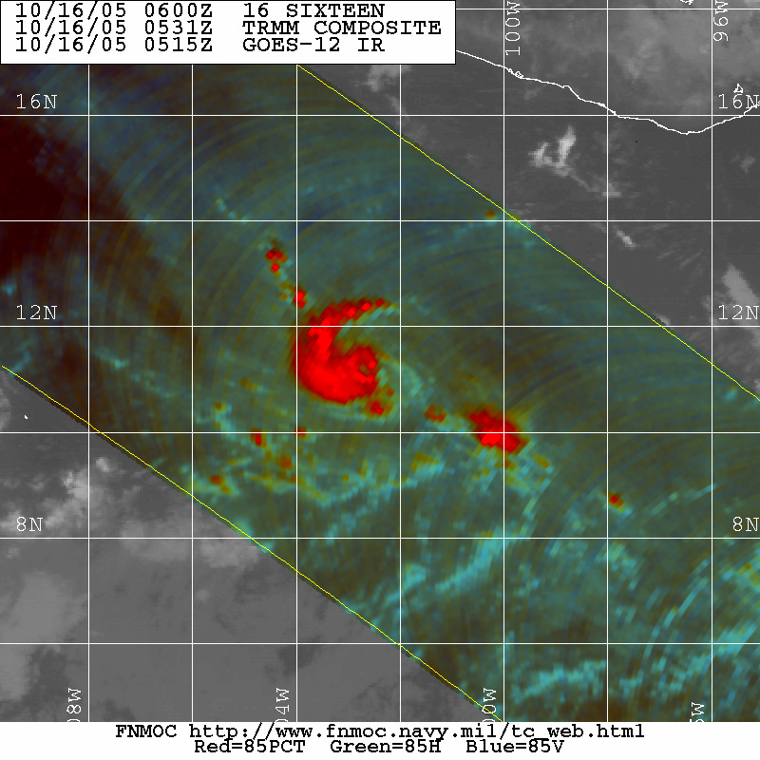

Figure 4. A 0531 UTC 16 October 2005 NASA TRMM 85GHZ microwave satellite image showing a small eye feature at about the time the depression was at its peak intensity (image courtesy of the U.S. Navy FNMOC, Monterey, CA).

Errors given for the 96 and 120 h periods are averages over the four-year period 2001-4.

