Tropical Cyclone Report
Tropical Storm Kevin
(EP142009)
29 August-1 September 2009

Michael J. Brennan
National Hurricane Center
24 September 2009

Kevin was a weak tropical storm that formed over the central portion of the eastern North Pacific basin, moved slowly northward, and dissipated without impacting land.

- Synoptic History

Kevin originated from a tropical wave that entered the eastern Pacific on 23 August. The wave moved westward uneventfully for a few days, and an area of low pressure formed along the wave on 27 August. Deep convection remained intermittent until early on 29 August, and it is estimated that a tropical depression formed from the disturbance around 1200 UTC that day, centered about 890 n mi southwest of the southern tip of Baja California. As the cyclone moved west-northwestward convective banding increased, and the depression became a tropical storm at 1800 UTC on 29 August while centered about 910 n mi southwest of the southern tip of Baja California. The “best track” chart of Kevin’s track is given in Fig. 1, with the wind and pressure histories shown in Figs. 2 and 3, respectively. The best track positions and intensities are listed in Table 1.

The synoptic steering flow around Kevin was complex. The cyclone was located on the southeastern periphery of a mid- to upper-level subtropical ridge. A mid- to upper-level trough extended southwestward from the Baja peninsula and continued to dig southwestward to the north of Kevin during the cyclone’s life. Also, a mid- to upper-level anticyclone was located several hundred nautical miles east-southeast of Kevin, to the west of Hurricane Jimena. Kevin was moving slowly west-northwestward around the time of genesis, however the combination of the digging mid- to upper-level trough and the anticyclone to the southeast induced a sharp turn toward the north late on 29 August. This general northward motion continued for the remainder of Kevin’s life as a tropical cyclone. While sea-surface temperatures were moderate, Kevin was located in an environment characterized by weak to moderate southeasterly to southerly vertical wind shear, upper-level subsidence, and relatively dry air in the lower to middle troposphere. Consequently, deep convection near the center of Kevin remained intermittent. The coverage and intensity of deep convection (as inferred by cloud top temperatures) reached a maximum over the cyclone early on 30 August, and Kevin reached an estimated peak intensity of 45 kt during the period from 0600 to 1200 UTC that day based on satellite imagery. After that time, the convection decreased in coverage and intensity, and Kevin began to weaken slowly. Kevin became a tropical depression around 0600 UTC 31 August, as it turned toward the north-northwest and northwest. After a final burst of deep convection near the center between 0600 and 1200 UTC that day, Kevin became a remnant low around 1800 UTC, when centered about 730 n mi west-southwest of the southern tip of Baja California.

As a remnant low, Kevin turned toward the northeast on 2 September and moved very slowly. The low turned toward the west and southwest early 4 September and continued in that general direction with increasing forward speed until dissipation after 0600 UTC 6 September, while located about 1200 n mi west-southwest of the southern tip of Baja California.

- Meteorological Statistics

Observations in Kevin (Figs. 2 and 3) include satellite-based Dvorak technique intensity estimates from the Tropical Analysis and Forecast Branch (TAFB) and the Satellite Analysis Branch (SAB). Data and imagery from NOAA polar-orbiting satellites, the NASA Tropical Rainfall Measuring Mission (TRMM), the NASA QuikSCAT, ASCAT, and Defense Meteorological Satellite Program (DMSP) satellites, among others, were also useful in constructing the best track of Kevin.

The estimated peak intensity of Kevin is based on Dvorak classifications of 45 kt from TAFB and SAB at 0600 and 1200 UTC 30 August.

- Casualty and Damage Statistics

There were no reports of damage or casualties associated with Kevin.

- Forecast and Warning Critique

The genesis of Kevin was well anticipated. The precursor wave associated with the genesis of Kevin was first mentioned in the Tropical Weather Outlook issued at 0000 UTC 26 August, 84 hours prior to genesis. The genesis forecast remained in the “low” category (less than 30% chance of formation within the next 48 hours) for a day and was raised to “medium” (30-50% chance) at 0000 UTC 27 August. The probability was raised to “high” (greater than 50%) at 1800 UTC 28 August, 18 hours prior to genesis.

A verification of NHC official track forecasts for Kevin is given in Table 2a. Official forecast track errors were similar to the mean official errors for the previous five-year period (2004-2008) from 12 to 48 h. However, the track errors of CLIPER5 (OCD5) were larger than the 2004-2008 mean OCD5 errors, especially from 36-72 h. This suggests that Kevin was a more difficult storm to forecast at those time ranges. A homogeneous comparison of the official track errors with selected guidance models is given in Table 2b. The ECMWF model had smaller average track errors than the official NHC forecast at all lead times from 12 to 48 h. The TVCC corrected consensus and HWRF also performed better than the official NHC forecast on average at lead times of 12-24 h and 36-48 h, respectively.

A verification of NHC official intensity forecasts for Kevin is given in Table 3a. Official forecast intensity errors were lower than the mean official errors for the 2004-2008 period at all forecast times. Decay-SHIFOR5 (OCD5) errors for intensity were slightly less than the five-year mean at 12 h, near the five-year mean at 24 h, and much larger than the five-year mean from 36-72 h, implying that the intensity forecasts were more difficult than average at the longer lead times. A homogeneous comparison of the official track errors with selected guidance models is given in Table 3b. The HWRF and GFDL models, along with the ICON intensity consensus, had lower average errors than the NHC official forecast from 12 to 48 h. Official NHC intensity forecasts had an average high bias of around 10 kt from 36-72 h. This was due to several official forecasts over-forecasting the intensity of Kevin and holding the intensity near this peak for ;too long.
Table 1. Best track for Kevin, 29 August–1 September 2009.

Date/Time  (UTC) | Latitude  (°N) | Longitude  (°W) | Pressure  (mb) | Wind Speed  (kt) | Stage
27 / 1800 | 10.9 | 113.8 | 1010 | 25 | low
28 / 0000 | 11.0 | 115.1 | 1009 | 25 | "
28 / 0600 | 11.1 | 116.2 | 1009 | 25 | "
28 / 1200 | 11.2 | 117.3 | 1009 | 25 | "
28 / 1800 | 11.5 | 118.4 | 1009 | 25 | "
29 / 0000 | 11.9 | 119.4 | 1009 | 25 | "
29 / 0600 | 12.2 | 120.3 | 1009 | 25 | "
29 / 1200 | 12.5 | 121.1 | 1007 | 30 | tropical depression
29 / 1800 | 12.7 | 121.8 | 1005 | 35 | tropical storm
30 / 0000 | 13.3 | 121.9 | 1002 | 40 | "
30 / 0600 | 13.9 | 122.0 | 1000 | 45 | "
30 / 1200 | 14.5 | 122.0 | 1000 | 45 | "
30 / 1800 | 15.1 | 122.0 | 1003 | 40 | "
31 / 0000 | 15.6 | 121.9 | 1005 | 35 | "
31 / 0600 | 16.1 | 121.8 | 1007 | 30 | tropical depression
31 / 1200 | 16.5 | 121.7 | 1007 | 30 | "
31 / 1800 | 16.9 | 121.6 | 1008 | 30 | "
01 / 0000 | 17.3 | 121.6 | 1008 | 30 | "
01 / 0600 | 17.6 | 121.8 | 1008 | 30 | "
01 / 1200 | 17.9 | 121.9 | 1008 | 30 | "
01 / 1800 | 18.2 | 121.9 | 1008 | 25 | low
02 / 0000 | 18.4 | 121.7 | 1008 | 25 | "
02 / 0600 | 18.5 | 121.5 | 1008 | 25 | "
02 / 1200 | 18.7 | 121.3 | 1008 | 25 | "
02 / 1800 | 19.0 | 121.0 | 1008 | 25 | "
03 / 0000 | 19.4 | 120.8 | 1008 | 25 | "
03 / 0600 | 19.7 | 120.6 | 1008 | 25 | "
03 / 1200 | 19.8 | 121.0 | 1009 | 20 | "
03 / 1800 | 19.9 | 121.5 | 1009 | 20 | "
04 / 0000 | 19.8 | 122.1 | 1009 | 20 | "
04 / 0600 | 19.5 | 122.7 | 1009 | 20 | "
04 / 1200 | 19.1 | 123.3 | 1009 | 20 | "
04 / 1800 | 18.7 | 124.0 | 1009 | 20 | "
05 / 0000 | 18.2 | 124.8 | 1009 | 20 | "
05 / 0600 | 17.8 | 125.7 | 1009 | 20 | "
05 / 1200 | 17.3 | 126.6 | 1009 | 20 | "
05 / 1800 | 16.8 | 127.6 | 1009 | 20 | "
06 / 0000 | 16.3 | 128.6 | 1009 | 20 | "
06 / 0600 | 15.8 | 129.7 | 1009 | 20 | "
06 / 1200 |  |  |  |  | dissipated
30 / 0600 | 13.9 | 122.0 | 1000 | 45 | Maximum wind and minimum pressure
Table 2a. NHC official (OFCL) and climatology-persistence skill baseline (OCD5) track forecast errors (n mi) for Kevin. Mean errors for the five-year period 2004-8 are shown for comparison. Official errors that are smaller than the five-year means are shown in boldface type.

 | Forecast Period (h)
 | 12 | 24 | 36 | 48 | 72 | 96 | 120
OFCL (Kevin) | 30.6 | 52.5 | 78.5 | 84.8 | 72.3
OCD5 (Kevin) | 39.8 | 85.6 | 159.7 | 261.9 | 458.4
Forecasts | 11 | 9 | 7 | 5 | 1
OFCL (2004-8) | 31.0 | 51.7 | 71.7 | 90.2 | 123.6
OCD5 (2004-8) | 38.4 | 73.6 | 111.9 | 149.1 | 214.2

Table 2b. Homogeneous comparison of selected track forecast guidance models (in n mi) for Kevin. Errors smaller than the NHC official forecast are shown in boldface type. The number of official forecasts shown here will generally be smaller than that shown in Table 2a due to the homogeneity requirement.

Model ID | Forecast Period (h)
Model ID | 12 | 24 | 36 | 48 | 72 | 96 | 120
OFCL | 26.2 | 50.7 | 67.1 | 100.9
OCD5 | 40.1 | 74.7 | 141.5 | 229.9
GFSI | 56.4 | 91.3 | 153.7 | 188.4
GHMI | 42.0 | 82.2 | 127.5 | 163.5
HWFI | 34.1 | 54.3 | 63.0 | 88.6
GFNI | 39.2 | 103.9 | 184.3 | 321.1
NGPI | 36.1 | 86.8 | 141.1 | 197.2
UKMI | 48.5 | 79.6 | 144.7 | 124.1
EMXI | 24.7 | 34.2 | 49.8 | 68.8
AEMI | 41.8 | 72.7 | 107.4 | 125.6
FSSE | 30.2 | 59.8 | 84.1 | 114.3
TVCN | 28.1 | 52.4 | 85.0 | 136.8
TVCC | 23.9 | 48.6 | 71.1 | 106.6
LBAR | 30.0 | 51.9 | 74.6 | 117.9
BAMD | 28.3 | 46.4 | 71.2 | 111.3
BAMM | 27.0 | 45.5 | 87.4 | 116.1
BAMS | 44.9 | 78.8 | 145.3 | 171.2
Forecasts | 5 | 5 | 3 | 2
Table 3a. NHC official (OFCL) and climatology-persistence skill baseline (OCD5) intensity forecast errors (kt) for Kevin. Mean errors for the five-year period 2004-8 are shown for comparison. Official errors that are smaller than the five-year means are shown in boldface type.

 | Forecast Period (h)
 | 12 | 24 | 36 | 48 | 72 | 96 | 120
OFCL (Kevin) | 5.5 | 8.3 | 11.4 | 12.0 | 10.0
OCD5 (Kevin) | 5.5 | 12.4 | 20.4 | 29.8 | 30.0
Forecasts | 11 | 9 | 7 | 5 | 1
OFCL (2004-8) | 6.2 | 10.2 | 13.3 | 15.1 | 17.7
OCD5 (2004-8) | 7.1 | 11.5 | 14.7 | 16.8 | 18.9

Table 3b. Homogeneous comparison of selected intensity forecast guidance models (in kt) for Kevin. Errors smaller than the NHC official forecast are shown in boldface type. The number of official forecasts shown here will generally be smaller than that shown in Table 3a due to the homogeneity requirement.

Model ID | Forecast Period (h)
Model ID | 12 | 24 | 36 | 48 | 72 | 96 | 120
OFCL | 7.0 | 10.0 | 16.7 | 11.7
OCD5 | 9.2 | 17.2 | 30.0 | 31.7
GHMI | 1.2 | 5.2 | 4.7 | 4.3
HWFI | 5.6 | 6.0 | 6.3 | 6.7
GFNI | 4.0 | 6.6 | 10.3 | 14.7
FSSE | 5.6 | 11.2 | 18.3 | 18.0
DSHP | 4.4 | 11.0 | 15.3 | 13.3
LGEM | 6.4 | 13.0 | 21.3 | 19.0
ICON | 4.4 | 8.8 | 12.0 | 11.3
Forecasts | 5 | 5 | 3 | 3

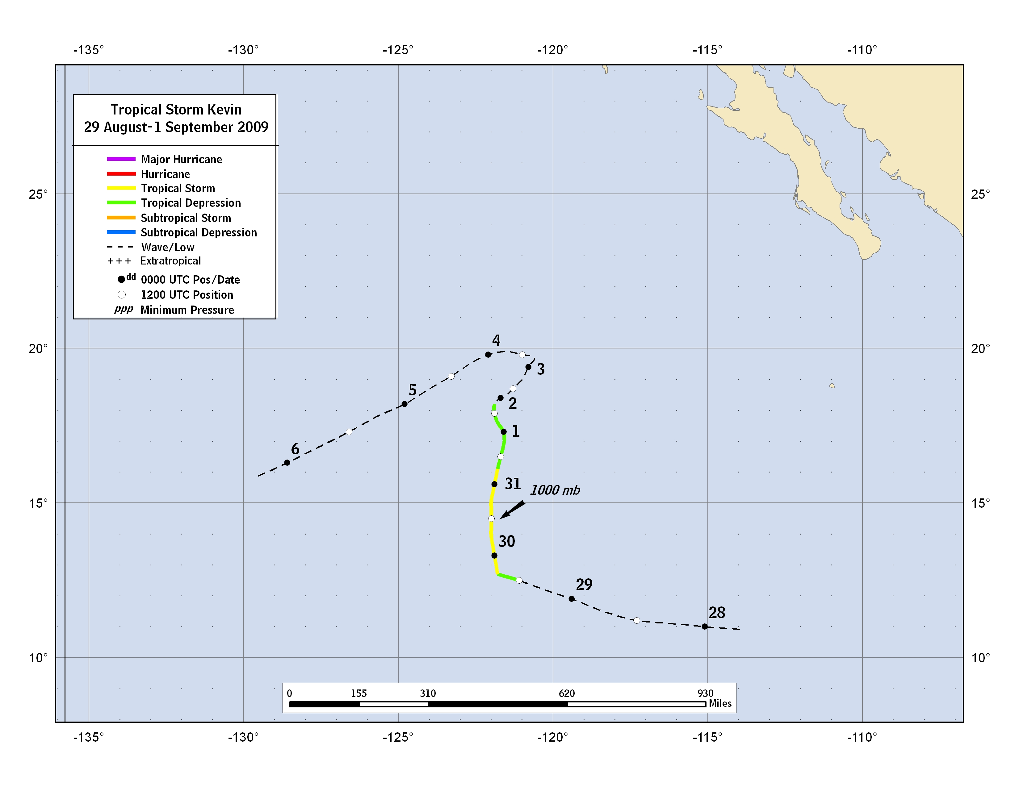

Figure 1. Best track positions for Kevin, 29 August–1 September 2009.

Figure 2. Selected wind observations and best track maximum sustained surface wind speed curve for Kevin,
29 August–1 September 2009. Dashed vertical lines correspond to 0000 UTC.

Figure 3. Selected pressure observations and best track minimum central pressure curve for Kevin,
29 August–1 September 2009. Dashed vertical lines correspond to 0000 UTC.

A digital record of the complete best track, including wind radii, can be found on line at ftp://ftp.nhc.noaa.gov/atcf. Data for the current year’s storms are located in the btk directory, while previous years’ data are located in the archive directory.

