Tropical Cyclone Report
Tropical Storm Ignacio (EP122009)
24-27 August 2009

Lixion A. Avila
National Hurricane Center
28 October 2009

Ignacio was a short-lived tropical cyclone that formed south of Mexico and dissipated over the cool waters west of Baja California.

- Synoptic History

Ignacio formed from the same tropical wave that spawned Tropical Storm Ana in the Atlantic basin. The southern portion of the wave continued westward across the Caribbean Sea and Central America from 16 to 19 August with little representation in the wind and cloud fields. On 20 August, when the axis of the wave was over the eastern North Pacific south of Mexico, the associated shower activity began to increase gradually but was disorganized. A broad area of low pressure formed on 22 August south of Cabo Corrientes, Mexico, and the convection began to show signs of organization as the system moved toward the west-northwest. A cyclonically-curved convective band formed on the western side of the low pressure area, and the low-level circulation became better defined. Although the convective organization fluctuated, it had enough structure to classify the system as a tropical depression at 1800 UTC 24 August about 600 n m southwest of the southern tip of Baja California. Once the circulation was established and the convection increased, the depression intensified and became a tropical storm at 0000 UTC 25 August. There was only slight additional strengthening, and based on satellite presentation and QuikSCAT data, it is estimated that Ignacio reached its maximum intensity of 45 knots and a minimum pressure of 999 mb at 1200 UTC that day. The cyclone maintained the same strength for a day or so but it then weakened as it moved toward the northwest over cooler waters. Ignacio degenerated into a remnant low at 1200 UTC 27 August and dissipated on 29 August.

The “best track” chart of the tropical cyclone’s path is given in Fig. 1, with the wind and pressure histories shown in Figs. 2 and 3, respectively. The best track positions and intensities are listed in Table 1.

- Meteorological Statistics

Observations in Ignacio (Figs. 2 and 3) include satellite-based Dvorak technique intensity estimates from the Tropical Analysis and Forecast Branch (TAFB) and the Satellite Analysis Branch (SAB). Data and imagery from NOAA polar-orbiting satellites, including the Advanced Microwave Sounding (AMSU, CIMMS) instrument, the NASA Tropical Rainfall Measuring Mission (TRMM), the NASA QuikSCAT, and Defense Meteorological Satellite Program (DMSP) satellites, among others, were also useful in tracking Ignacio. Although Ignacio remained a 45-kt storm for a day or so, the peak intensity was assigned to 1200 UTC 25 August when the cyclone had the best satellite presentation.

- Casualty and Damage Statistics

There were no reports of damage or casualties associated with Ignacio.

- Forecast and Warning Critique

The area of disturbed weather from which Ignacio formed was first mentioned in the Tropical Weather Outlook at 0000 UTC 22 August, about 66 h prior to genesis. At that time the disturbance was given a “low” (less than 30%) chance of formation, and it was considered to have a “high” (greater than 50%) chance of development at 1800 UTC 23 August, about 24 h before genesis occurred.

A verification of NHC official track forecasts for Ignacio is given in Table 2. Ignacio was a short-lived tropical cyclone. The few official forecast track errors available were mostly greater than the mean official errors for the previous five-year period

A verification of NHC official intensity forecasts for Ignacio is given in Table 3. In contrast to the track forecasts, the intensity errors were smaller than the mean official errors for the previous five-year period.

There were no watches and warnings associated with Ignacio.
Table 1. Best track for Tropical Storm Ignacio, 24-27 August 2009.

Date/Time  (UTC) | Latitude  (°N) | Longitude  (°W) | Pressure  (mb) | Wind Speed  (kt) | Stage
24 / 1800 | 16.6 | 116.3 | 1005 | 30 | tropical depression
25 / 0000 | 17.2 | 117.0 | 1004 | 35 | tropical storm
25 / 0600 | 17.7 | 117.9 | 1002 | 40 | "
25 / 1200 | 18.3 | 118.9 | 999 | 45 | "
25 / 1800 | 19.1 | 120.0 | 1000 | 45 | "
26 / 0000 | 19.8 | 121.2 | 1000 | 45 | "
26 / 0600 | 20.4 | 122.5 | 1000 | 45 | "
26 / 1200 | 21.2 | 123.5 | 1000 | 45 | "
26 / 1800 | 22.2 | 124.4 | 1002 | 40 | "
27 / 0000 | 23.2 | 125.4 | 1005 | 35 | "
27 / 0600 | 24.1 | 126.2 | 1005 | 30 | tropical depression
27 / 1200 | 25.1 | 127.2 | 1007 | 30 | remnant low
27 / 1800 | 26.4 | 128.0 | 1007 | 30 | "
28 / 0000 | 27.8 | 128.4 | 1007 | 25 | "
28 / 0600 | 28.5 | 128.5 | 1008 | 20 | "
28 / 1200 | 29.3 | 128.5 | 1008 | 20 | "
28 / 1800 | 30.0 | 128.5 | 1008 | 20 | "
29 / 0000 |  |  |  |  | dissipated
25 / 1200 | 18.3 | 118.9 | 999 | 45 | minimum pressure

Table 2. NHC official (OFCL) and climatology-persistence skill baseline (OCD5) track forecast errors (n mi) for Ignacio. Mean errors for the five-year period 2004-8 are shown for comparison. Official errors that are smaller than the five-year means are shown in boldface type.

 | Forecast Period (h)
 | 12 | 24 | 36 | 48 | 72 | 96 | 120
OFCL | 39.4 | 47.9 | 80.2 | 123.6
OCD5 | 54.0 | 92.9 | 174.4 | 247.0
Forecasts | 9 | 7 | 5 | 3
OFCL (2004-8) | 31.0 | 51.7 | 71.7 | 90.2
OCD5 (2004-8) | 38.4 | 73.6 | 111.9 | 149.1

Table 3. NHC official (OFCL) and climatology-persistence skill baseline (OCD5) intensity forecast errors (kt) for Ignacio. Mean errors for the five-year period 2004-8 are shown for comparison. Official errors that are smaller than the five-year means are shown in boldface type.

 | Forecast Period (h)
 | 12 | 24 | 36 | 48 | 72 | 96 | 120
OFCL | 2.8 | 5.0 | 11.0 | 11.7
OCD5 | 3.9 | 6.0 | 7.0 | 11.0
Forecasts | 9 | 7 | 5 | 3
OFCL (2004-8) | 6.2 | 10.2 | 13.3 | 15.1
OCD5 (2004-8) | 7.1 | 11.5 | 14.7 | 16.8

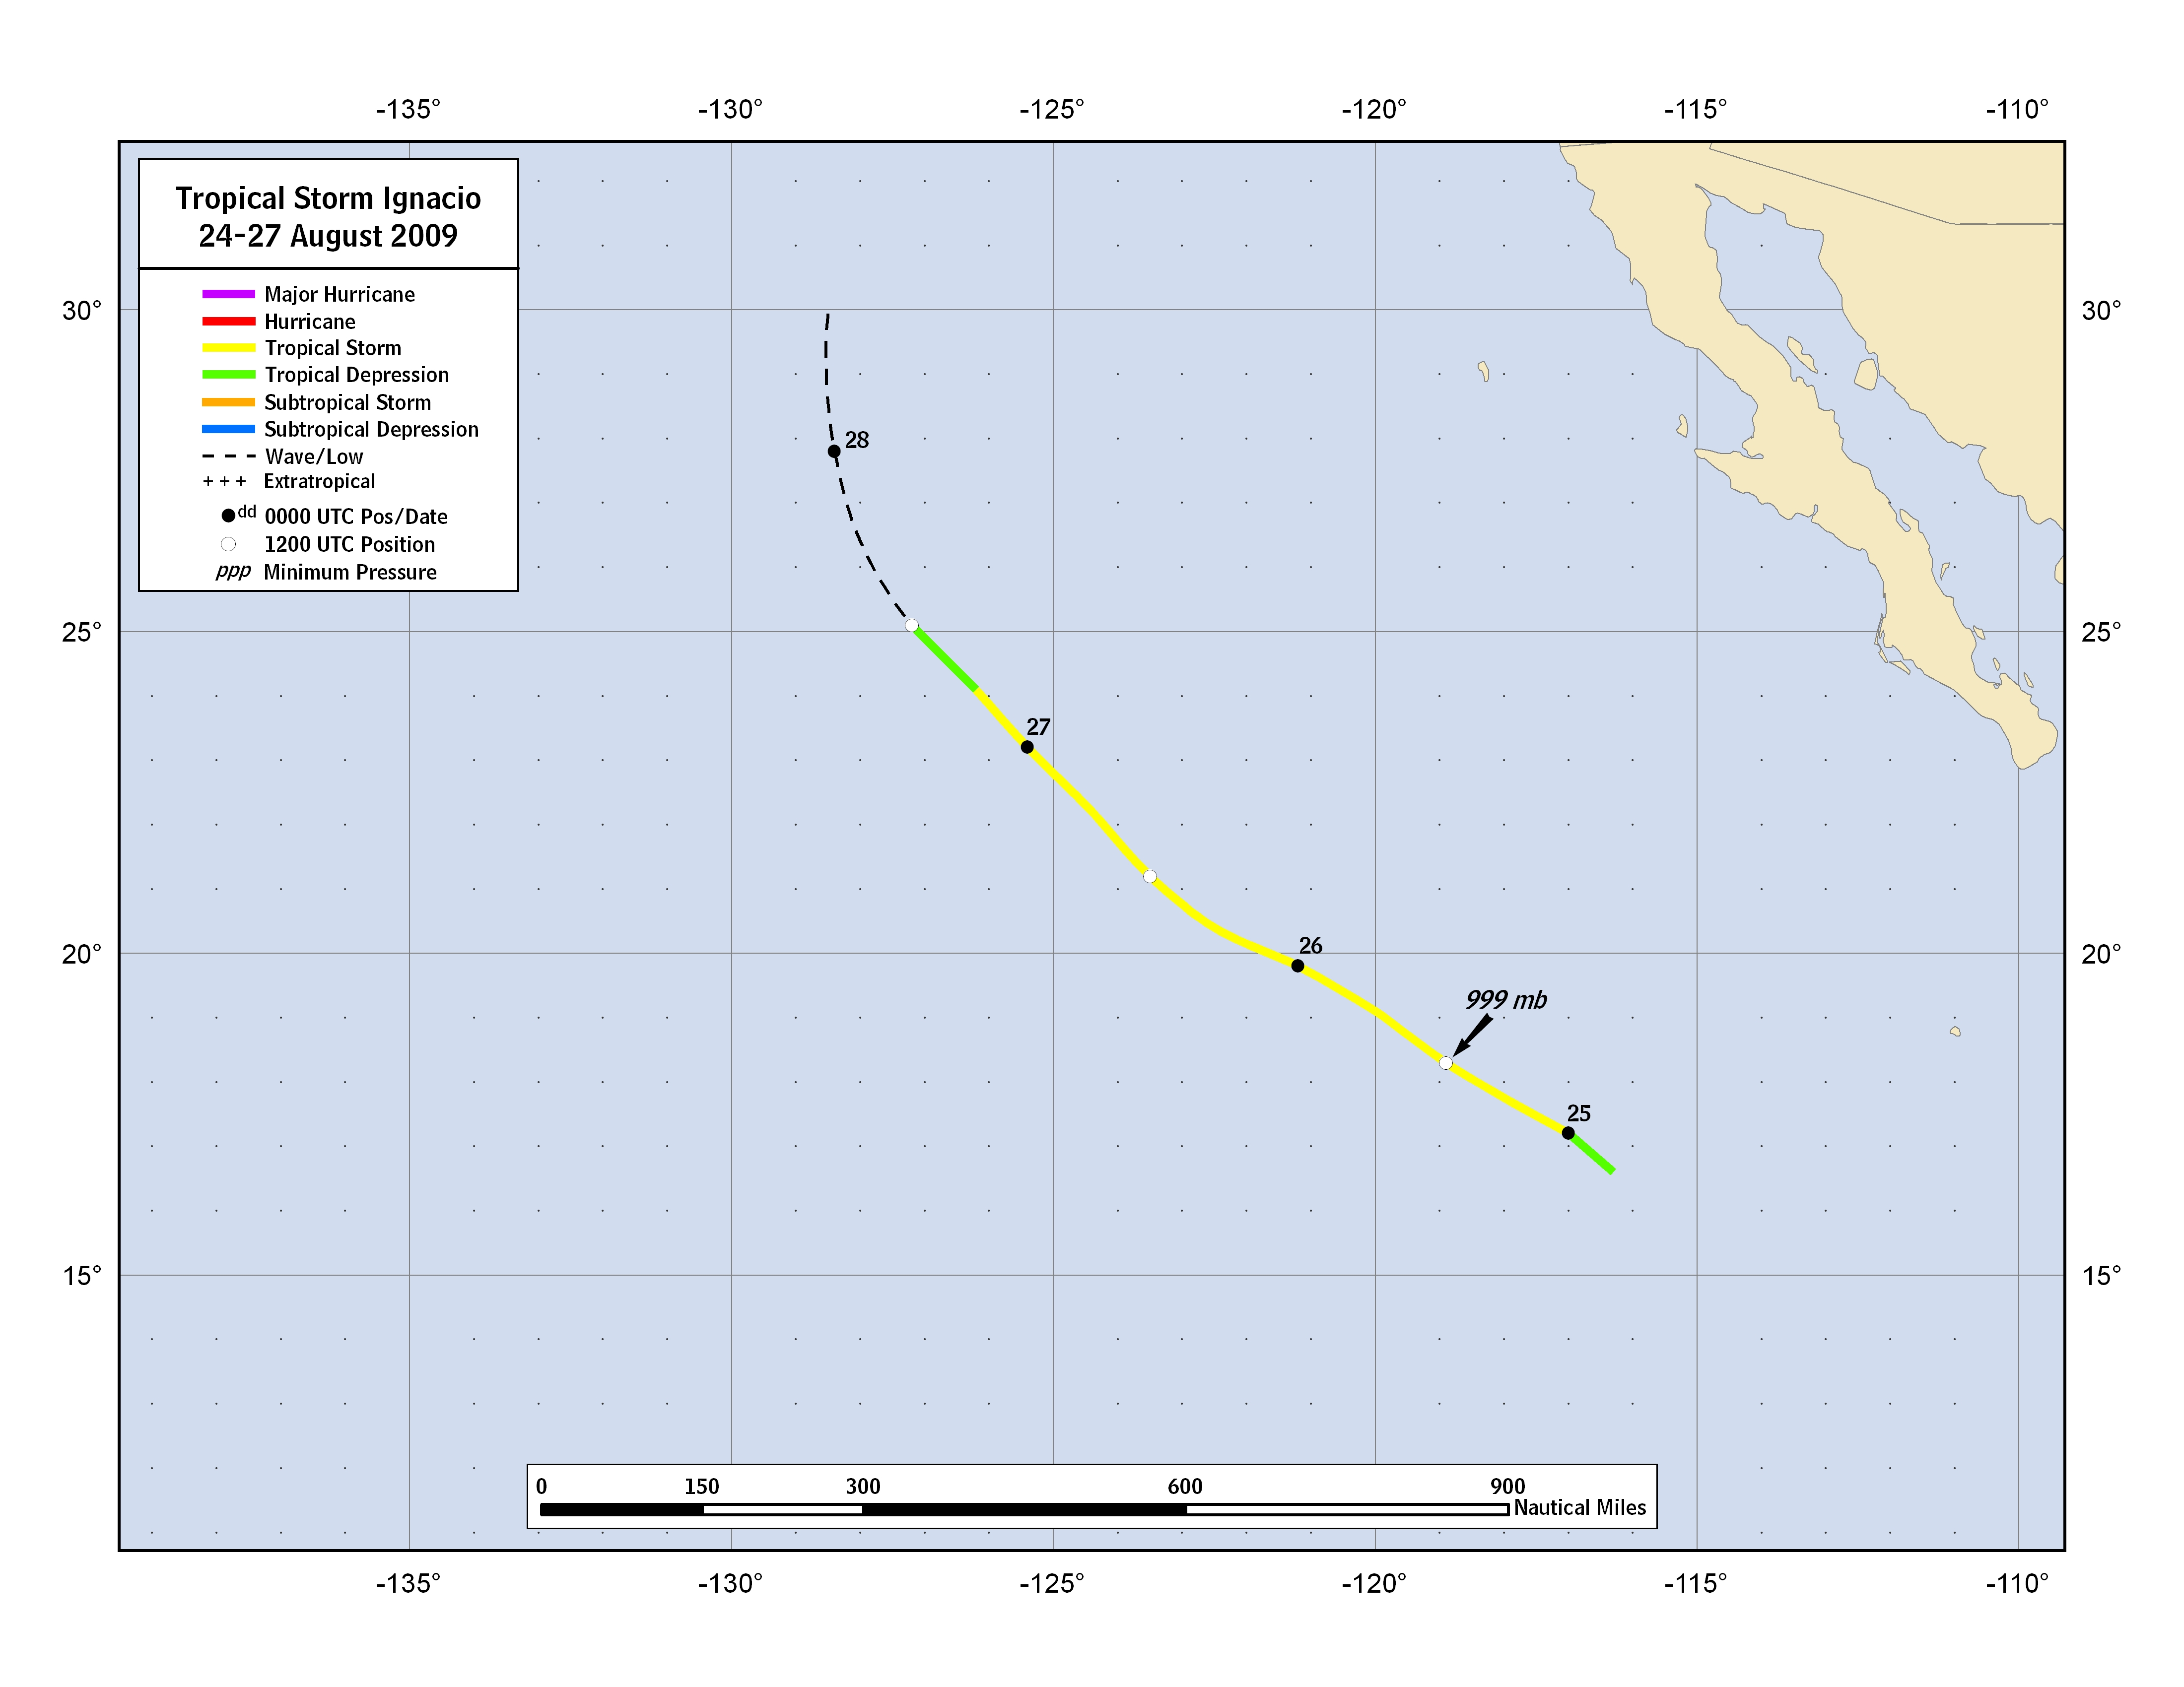
Figure 1. Best track positions for Tropical Storm Ignacio, 24-27 August 2009.

Figure 2. Selected wind observations and best track maximum sustained surface wind speed curve for Tropical Storm Ignacio, 24-27 August 2009. Dashed vertical lines correspond to 0000 UTC.

Figure 3. Selected pressure observations and best track minimum central pressure curve for Tropical Storm Ignacio, 24-27 August 2009. Dashed vertical lines correspond to 0000 UTC.

A digital record of the complete best track, including wind radii, can be found on line at ftp://ftp.nhc.noaa.gov/atcf. Data for the current year’s storms are located in the btk directory, while previous years’ data are located in the archive directory.

