Tropical Cyclone Report
Hurricane Ivo
(EP122007)
18-23 September 2007

James L. Franklin
National Hurricane Center
3 December 2007

Ivo was a category 1 hurricane (on the Saffir-Simpson Hurricane Scale) that dissipated as it approached southern Baja California.

- Synoptic History

Ivo developed from a tropical wave that moved across the west coast of Africa on 1 September. The wave was associated with little convection during its passage across the Atlantic basin until it reached the western Caribbean Sea. The wave crossed Central America and entered the eastern North Pacific basin on 15 September, when the wave began to show signs of increased organization. A broad area of low pressure formed within the wave the next day and Dvorak classifications were initiated. The organization of the system gradually increased as the low moved westward, and a tropical depression formed around 0600 UTC 18 September, about 400 n mi south-southwest of Manzanillo, Mexico.

The “best track” chart of the tropical cyclone’s path is given in Fig. 1, with the wind and pressure histories shown in Figs. 2 and 3, respectively. The best track positions and intensities are listed in Table 1. The depression initially moved west-northwestward to the south of a mid-level ridge that extended westward from northern Mexico. Under light northwesterly shear, the cyclone strengthened, becoming a tropical storm by 0000 UTC 19 September, about 525 n mi south of the southern tip of Baja California. Ivo continued to strengthen and became a hurricane at 0000 UTC 20 September, about 450 n mi south-southwest of the southern tip of Baja California. As a large deep-layer low moved southward into California, the western periphery of the subtropical ridge eroded, and Ivo turned northwestward on 20 September. During the day microwave imagery showed a well-defined eye, although the eye was only intermittently visible in conventional satellite imagery; Ivo reached its estimated peak intensity of 70 kt around 1800 UTC that day.

Early on 21 September, westerly flow associated with the large upper low began to undercut the outflow of Ivo, and the cyclone began to weaken. As Ivo turned northward around the periphery of the subtropical ridge, the cloud pattern began to deteriorate, and Ivo weakened to a tropical storm around 1800 UTC that day about 275 n mi southwest of the southern tip of Baja California. Ivo turned to the north-northeast on 22 September, and even though it remained over warm waters, continued to weaken in increasing westerly shear as it approached Baja California. The cyclone weakened to a depression near 0000 UTC 23 September about 130 n mi west-southwest of the southern tip of Baja California. Deep convection associated with the cyclone diminished, and Ivo degenerated into a remnant low later that day about 80 n mi southwest of the southern tip of Baja California. The remnant low moved slowly eastward and dissipated early on 25 September.

- Meteorological Statistics

Observations in Ivo (Figs. 2 and 3) include satellite-based Dvorak technique intensity estimates from the Tropical Analysis and Forecast Branch (TAFB) and the Satellite Analysis Branch (SAB). Data and imagery from NOAA polar-orbiting satellites, the NASA Tropical Rainfall Measuring Mission (TRMM), the NASA QuikSCAT, and Defense Meteorological Satellite Program (DMSP) satellites, among others, were also useful in tracking Ivo.

There were no ship or land-based observations of tropical storm force winds reported in association with Ivo. The estimated maximum intensity of 70 kt was based on a blend of subjective Dvorak estimates of 77 kt and objective (ADT) estimates of around 65 kt from the University of Wisconsin/Cooperative Institute for Meteorological Satellite Studies.

- Casualty and Damage Statistics

There were no reports of damage or casualties associated with Ivo.

- Forecast and Warning Critique

The genesis of Ivo was well anticipated in Tropical Weather Outlook (TWO) products. The possibility of cyclogenesis was first mentioned in the TWO issued at 2300 UTC 16 September, about 31 hours prior to genesis.

A verification of official and guidance model track forecasts is given in Table 2. Average official track errors for Ivo were 18, 26, 38, 48, 52, 97, and 103 n mi for the 12, 24, 36, 48, 72, 96, and 120 h forecasts, respectively. The number of forecasts ranged from 19 at 12 h to 1 at 120 h. These errors are less than half as large as the average long-term official track errors (Table 2). The official forecasts beat nearly all of the available objective track guidance.

A verification of official and guidance model intensity forecasts is given in Table 3. Average official intensity errors were 7, 13, 16, 20, 22, 20, and 5 kt for the 12, 24, 36, 48, 72, 96, and 120 h forecasts, respectively. For comparison, the average long-term official intensity errors are 6, 11, 15, 17, 19, 19, and 19 kt, respectively. The official forecasts had a substantial positive bias, were a little worse than the long-term means, and in general were not quite as good as the guidance. The statistical SHIPS model outperformed the dynamical GFDL and HWRF models.

A tropical storm watch was briefly in effect as Ivo approached the Baja California peninsula (Table 4).
Table 1. Best track for Hurricane Ivo, 18-23 September 2007.

Date/Time  (UTC) | Latitude  (°N) | Longitude  (°W) | Pressure  (mb) | Wind Speed  (kt) | Stage
18 / 0600 | 12.7 | 106.3 | 1007 | 25 | tropical depression
18 / 1200 | 13.2 | 107.1 | 1006 | 25 | "
18 / 1800 | 13.7 | 107.9 | 1005 | 30 | "
19 / 0000 | 14.2 | 108.8 | 1002 | 40 | tropical storm
19 / 0600 | 14.6 | 109.7 | 997 | 50 | "
19 / 1200 | 15.0 | 110.7 | 994 | 55 | "
19 / 1800 | 15.3 | 111.6 | 991 | 60 | "
20 / 0000 | 15.7 | 112.1 | 987 | 65 | hurricane
20 / 0600 | 16.2 | 112.5 | 987 | 65 | "
20 / 1200 | 16.8 | 112.8 | 986 | 65 | "
20 / 1800 | 17.5 | 113.1 | 985 | 70 | "
21 / 0000 | 18.2 | 113.4 | 984 | 70 | "
21 / 0600 | 18.8 | 113.6 | 984 | 70 | "
21 / 1200 | 19.3 | 113.6 | 987 | 65 | "
21 / 1800 | 19.8 | 113.5 | 990 | 60 | tropical storm
22 / 0000 | 20.3 | 113.3 | 994 | 55 | "
22 / 0600 | 20.7 | 113.1 | 997 | 50 | "
22 / 1200 | 21.2 | 112.8 | 999 | 45 | "
22 / 1800 | 21.6 | 112.5 | 1002 | 35 | "
23 / 0000 | 21.9 | 112.1 | 1004 | 30 | tropical depression
23 / 0600 | 22.0 | 111.8 | 1006 | 25 | "
23 / 1200 | 22.0 | 111.5 | 1007 | 25 | "
23 / 1800 | 22.0 | 111.1 | 1007 | 25 | low
24 / 0000 | 22.0 | 110.7 | 1007 | 25 | "
24 / 0600 | 22.0 | 110.4 | 1008 | 20 | "
24 / 1200 | 22.0 | 110.1 | 1009 | 15 | "
24 / 1800 | 21.9 | 109.9 | 1009 | 15 | "
25 / 0000 | 21.8 | 109.6 | 1010 | 15 | "
25 / 0600 |  |  |  |  | dissipated
21 / 0000 | 18.2 | 113.4 | 984 | 70 | minimum pressure

Table 2. Preliminary track forecast evaluation (heterogeneous sample) for Hurricane Ivo, 18-23 September 2007. Forecast errors (n mi) are followed by the number of forecasts in parentheses. Errors smaller than the NHC official forecast are shown in bold-face type.

Forecast Technique | Forecast Period (h)
Forecast Technique | 12 | 24 | 36 | 48 | 72 | 96 | 120
CLP5 | 28 (19) | 59 (17) | 105 (15) | 165 (13) | 309 ( 9) | 430 ( 5) | 457 ( 1)
GFNI | 35 (17) | 68 (15) | 93 (13) | 111 (11) | 167 ( 7) | 255 ( 3)
GFDI | 22 (19) | 29 (17) | 44 (15) | 68 (13) | 95 ( 9) | 186 ( 5) | 176 ( 1)
HWFI | 24 (19) | 38 (17) | 52 (15) | 69 (13) | 91 ( 9) | 102 ( 5) | 122 ( 1)
GFSI | 32 (19) | 65 (17) | 103 (15) | 153 (13) | 248 ( 7)
AEMI | 31 (19) | 59 (17) | 90 (15) | 136 (13) | 175 ( 3)
NGPI | 26 (19) | 46 (17) | 69 (15) | 93 (13) | 130 ( 9) | 233 ( 5) | 474 ( 1)
UKMI | 29 (16) | 49 (14) | 75 (12) | 118 (10) | 144 ( 6) | 130 ( 2)
BAMD | 34 (19) | 62 (17) | 90 (15) | 118 (13) | 120 ( 9) | 113 ( 5) | 104 ( 1)
BAMM | 35 (19) | 63 (17) | 99 (15) | 129 (13) | 169 ( 9) | 210 ( 5) | 385 ( 1)
BAMS | 39 (19) | 80 (17) | 125 (15) | 173 (13) | 234 ( 9) | 289 ( 5) | 388 ( 1)
CONU | 18 (19) | 26 (17) | 34 (15) | 49 (13) | 75 ( 9) | 205 ( 5) | 324 ( 1)
GUNA | 19 (16) | 28 (14) | 34 (12) | 42 (10) | 30 ( 5)
FSSE | 18 (17) | 29 (15) | 39 (13) | 38 (11) | 61 ( 7) | 99 ( 3)
OFCL | 18 (19) | 26 (17) | 38 (15) | 48 (13) | 52 ( 9) | 97 ( 5) | 103 ( 1)
NHC Official  (2002-2006 mean) | 33 (1349) | 57 (1192) | 79 (1039) | 99 (897) | 140 (655) | 188 (465) | 233 (311)

Table 3. Preliminary intensity forecast evaluation (heterogeneous sample) for Hurricane Ivo, 18-23 September 2007. Forecast errors (kt) are followed by the number of forecasts in parentheses. Errors smaller than the NHC official forecast are shown in bold-face type.

Forecast Technique | Forecast Period (h)
Forecast Technique | 12 | 24 | 36 | 48 | 72 | 96 | 120
SHF5 | 7.3 (19) | 10.2 (17) | 12.7 (15) | 16.2 (13) | 21.9 ( 9) | 24.6 ( 5) | 30.0 ( 1)
GHMI | 9.5 (19) | 11.9 (17) | 16.1 (15) | 20.8 (13) | 25.1 ( 9) | 24.8 ( 5) | 11.0 ( 1)
HWFI | 11.7 (19) | 18.0 (17) | 22.8 (15) | 24.2 (13) | 14.7 ( 9) | 20.8 ( 5) | 9.0 ( 1)
SHIP | 6.9 (19) | 9.7 (17) | 12.9 (15) | 17.0 (13) | 19.6 ( 9) | 21.0 ( 5) | 11.0 ( 1)
DSHP | 6.9 (19) | 9.7 (17) | 12.9 (15) | 17.0 (13) | 19.6 ( 9) | 21.0 ( 5) | 5.0 ( 1)
FSSE | 7.6 (17) | 10.1 (15) | 12.8 (13) | 16.0 (11) | 20.6 ( 7) | 27.7 ( 3)
ICON | 9.2 (19) | 12.6 (17) | 15.7 (15) | 19.2 (13) | 19.9 ( 9) | 21.2 ( 5) | 3.0 ( 1)
OFCL | 7.4 (19) | 12.6 (17) | 16.3 (15) | 20.0 (13) | 22.2 ( 9) | 20.0 ( 5) | 5.0 ( 1)
NHC Official  (2002-2006 mean) | 6.3 (1349) | 11.0 (1192) | 14.6 (1039) | 16.9 (896) | 18.9 (655) | 18.5 (465) | 19.3 (311)

Table 4. Watch and warning summary for Hurricane Ivo, 18-23 September 2007.

Date/Time (UTC) | Action | Location
22 / 2100 | Tropical Storm Watch issued | Santa Fe to Cabo San Lucas
23 / 0900 | Tropical Storm Watch discontinued | All

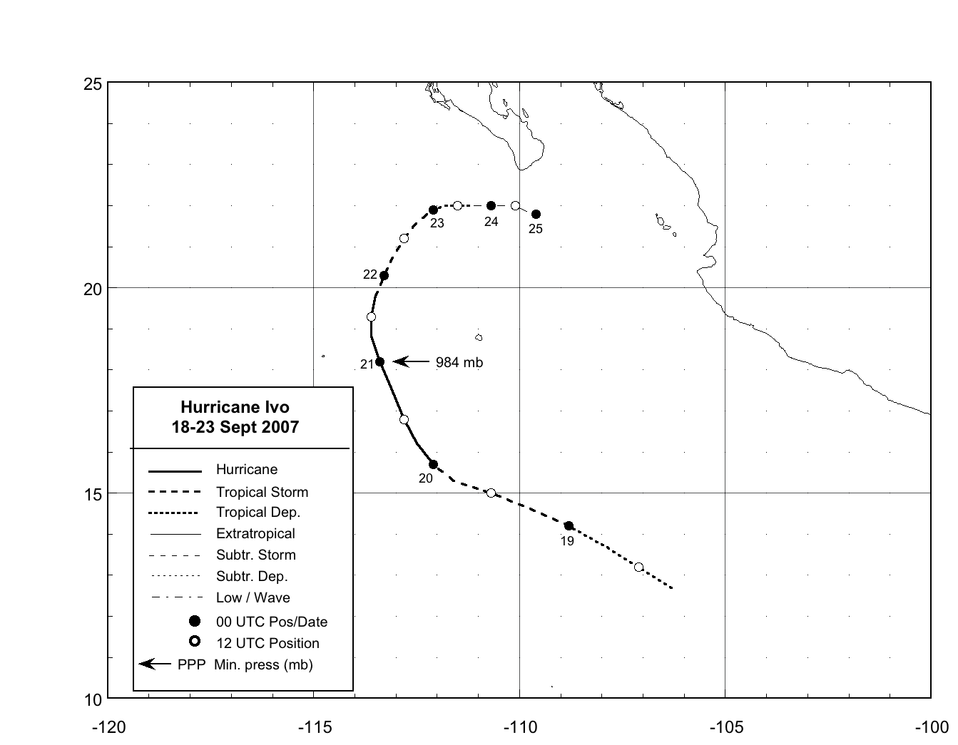
Figure 1. Best track positions for Hurricane Ivo, 18-23 September 2007.
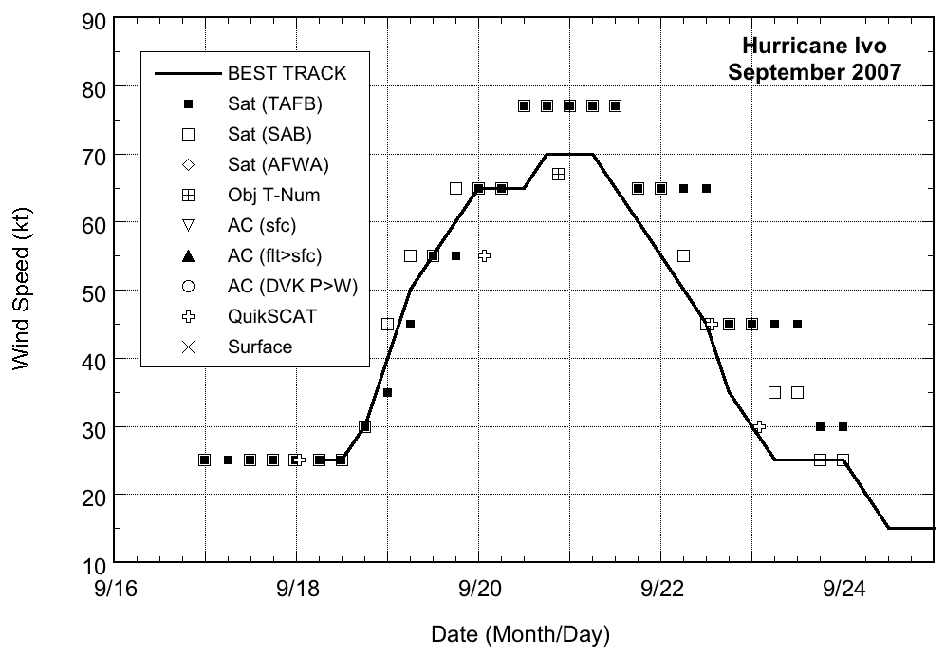
Figure 2. Selected wind observations and best track maximum sustained surface wind speed curve for Hurricane Ivo, 18-23 September 2007. Objective Dvorak (ADT) estimate represents a linear average over a three-hour period centered on the nominal observation time.

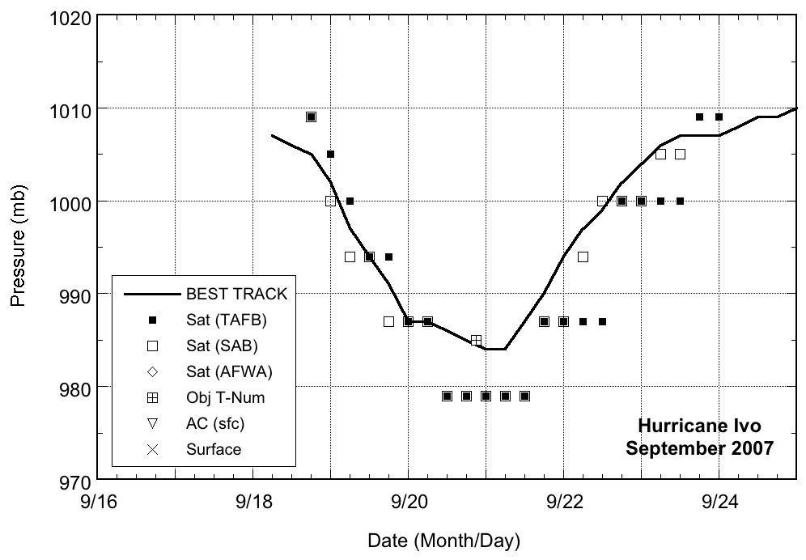
Figure 3. Selected pressure observations and best track minimum central pressure curve for Hurricane Ivo, 18-23 September 2007. Objective Dvorak (ADT) estimate represents a linear average over a three-hour period centered on the nominal observation time.

