Tropical Cyclone Report
Hurricane Guillermo
(EP102009)
12-19 August 2009

Eric S. Blake
National Hurricane Center

Sam Houston and Richard D. Knabb
Central Pacific Hurricane Center

10 February 2010

Guillermo became a Category 3 hurricane over the open waters of the eastern Pacific Ocean and did not affect land. It persisted as a tropical storm, however, at a relatively high latitude over the central Pacific basin for an unusual amount of time.

- Synoptic History

Guillermo was spawned by a large, high-amplitude tropical wave that left the west coast of Africa on 26 July. The wave moved westward without significant organization, entering the eastern Pacific on 5 August. Convection increased along the wave axis on 8 August, and an elongated low formed the next day with disorganized banding features noted. Thunderstorms increased markedly near the circulation center late on 11 August, leading to a better-defined circulation by early on 12 August. It is estimated that a tropical depression formed by 1200 UTC 12 August, located about 570 n mi south-southwest of the southern tip of Baja California, and the depression became a tropical storm 12 h later. The “best track” chart of the tropical cyclone’s path is given in Figure 1, and the best track positions and intensities are listed in Table 1.

Soon after genesis, Guillermo began to intensify, strengthening from a weak tropical storm into a major hurricane in about 48 hours while moving to the west and west-northwest. A banded eye was noted in visible satellite images late on 13 August, and Guillermo became a hurricane early the next day. However, further strengthening was briefly arrested as the banding eye structure transitioned into a central dense overcast pattern, a change which occasionally precedes rapid intensification. Warm water, light shear, and an expanding outflow pattern aloft also probably contributed to a rapid intensification of Guillermo late on 14 August. It became a major hurricane on 15 August, reaching a peak intensity of 110 kt at 1200 UTC while located about 1300 n mi west-southwest of the southern tip of Baja California.

A weakening trend began later that day as sea surface temperatures decreased, and by the time Guillermo crossed into the central Pacific basin very late on 16 August, the cyclone had weakened to an intensity of 65 kt. A gradual decline in intensity continued during the next three days over relatively cool sea-surface temperatures and within an environment of moderate westerly wind shear associated with the flow around a mid- to upper-level trough located to the west of the tropical cyclone. Guillermo headed generally northwestward, well to the north of Hawaii during this period, around a subtropical ridge located to its northeast. By 0600 UTC 17 August, Guillermo weakened to a tropical storm while centered about 740 n mi east of Hilo, Hawaii. Deep convection disappeared near the circulation center later that day, although a QuikSCAT pass over the cyclone at 1648 UTC 17 August revealed winds up to 45 kt within convection far north of the exposed center. By 1800 UTC 19 August, the convection well removed from the center had also vanished, and Guillermo degenerated to a remnant low centered about 550 n mi north of Hawaii.

As the low continued northwestward at about 12 kt, it encountered a frontal zone and developed extratropical characteristics. Deep convection reformed in the northeastern semicircle and, based upon QuikSCAT data, it is estimated that maximum winds increased to 40 kt at 1200 UTC 20 August while the extratropical cyclone was centered about 700 n mi north of Hawaii. The cyclone turned northward as it was steered around the western periphery of the subtropical ridge to its east. Thunderstorms continued in association with the low until around 0600 UTC 21 August, but the system weakened and turned northeastward. Once again reduced to a swirl of low clouds, the low became elongated and was eventually absorbed by an approaching cold front around 1200 UTC 23 August.

- Meteorological Statistics

Observations in Guillermo (Figs. 2 and 3) include satellite-based Dvorak technique intensity estimates from the Tropical Analysis and Forecast Branch (TAFB), the Satellite Analysis Branch (SAB), the Central Pacific Hurricane Center, UW-CIMSS intensity estimates using the Advanced Dvorak Technique (ADT) and the Advanced Microwave Sounding Unit (AMSU). Data and imagery from NOAA polar-orbiting satellites, Defense Meteorological Satellite Program (DMSP) satellites, National Aeronautics and Space Administration (NASA) satellites, including TRMM, QuikSCAT, and Aqua, the U.S. Navy WindSat, and the EUMETSAT ASCAT, among other satellites, were also useful in constructing the best track of Guillermo.

The 110-kt peak intensity of Guillermo is based on a blend of satellite estimates from TAFB, SAB, and the ADT technique from UW-CIMSS. Several QuikSCAT passes were helpful for estimating the intensity of Guillermo as it persisted as a tropical storm well north of Hawaii.

There were two ships reporting winds of tropical storm force associated with Guillermo. A ship with the call letters WDC378 measured 38 kt sustained winds on 18 August at 0000 UTC, and 17 h later the ship “Maui” reported 37 kt winds.

- Forecast and Warning Critique

The genesis of Guillermo was well anticipated. The wave that eventually became Guillermo was introduced in the Tropical Weather Outlook (TWO) about three days before genesis. The genesis forecasts reached the medium (between 30-50%) category about 42 h before formation, although the chance of formation only reached the high (>50% percent) category six hours before genesis.

A verification of NHC official track forecasts for Guillermo is given in Table 2a. Official forecast track errors were considerably lower than the mean official errors for the previous five-year period at all forecast periods except for 120 h. The higher errors at 120 h were due to the storm turning more to the northwest over the central Pacific when a more westward track was anticipated. A homogeneous comparison of the official track errors with selected guidance models is given in Table 2b. The official forecast was better than or competitive with all guidance through 48 h, with the GFS-based guidance (GFS, HWRF, GFDL) superior in the longer time periods.

A verification of NHC official intensity forecasts for Guillermo is given in Table 3a. Official forecast intensity errors were much higher than the mean official errors for the previous five-year period through 72 h and then below the long-term mean afterwards. The rapid strengthening of Guillermo was not well forecast by NHC and caused the large errors. A homogeneous comparison of the official track errors with selected guidance models is given in Table 3b. Although the model errors were also large, the statistical and consensus-based guidance were the best performers with Guillermo.

There were no coastal watches or warnings required for Guillermo and no reports of damage or injuries.

Table 1. Best track for Hurricane Guillermo, 12-19 August 2009.

Date/Time  (UTC) | Latitude  (°N) | Longitude  (°W) | Pressure  (mb) | Wind Speed  (kt) | Stage
12 / 0000 | 13.8 | 112.3 | 1009 | 25 | low
12 / 0600 | 14.4 | 113.9 | 1008 | 25 | "
12 / 1200 | 15.0 | 115.6 | 1006 | 30 | tropical depression
12 / 1800 | 15.6 | 117.1 | 1005 | 30 | "
13 / 0000 | 16.1 | 118.5 | 1004 | 35 | tropical storm
13 / 0600 | 16.5 | 119.9 | 999 | 45 | "
13 / 1200 | 16.8 | 121.2 | 994 | 55 | "
13 / 1800 | 17.0 | 122.5 | 992 | 60 | "
14 / 0000 | 17.2 | 123.8 | 992 | 60 | "
14 / 0600 | 17.4 | 125.2 | 987 | 65 | hurricane
14 / 1200 | 17.6 | 126.7 | 984 | 70 | "
14 / 1800 | 17.9 | 128.2 | 972 | 85 | "
15 / 0000 | 18.2 | 129.7 | 965 | 95 | "
15 / 0600 | 18.5 | 131.2 | 960 | 100 | "
15 / 1200 | 18.7 | 132.6 | 954 | 110 | "
15 / 1800 | 19.0 | 133.9 | 958 | 100 | "
16 / 0000 | 19.3 | 135.3 | 960 | 95 | "
16 / 0600 | 19.6 | 136.7 | 964 | 90 | "
16 / 1200 | 19.9 | 138.0 | 973 | 85 | "
16 / 1800 | 20.2 | 139.2 | 980 | 75 | "
17 / 0000 | 20.4 | 140.5 | 986 | 65 | "
17 / 0600 | 20.7 | 142.0 | 993 | 55 | tropical storm
17 / 1200 | 21.1 | 143.7 | 997 | 50 | "
17 / 1800 | 21.7 | 145.4 | 1000 | 45 | "
18 / 0000 | 22.6 | 146.9 | 1000 | 45 | "
18 / 0600 | 23.7 | 148.1 | 1000 | 45 | "
18 / 1200 | 25.1 | 149.1 | 1000 | 45 | "
18 / 1800 | 26.4 | 150.3 | 1001 | 45 | "
19 / 0000 | 27.7 | 151.5 | 1003 | 40 | "
19 / 0600 | 28.7 | 152.8 | 1006 | 35 | "
19 / 1200 | 29.5 | 154.1 | 1009 | 35 | "
19 / 1800 | 30.4 | 155.3 | 1012 | 30 | low
20 / 0000 | 31.3 | 156.3 | 1014 | 30 | "
20 / 0600 | 32.1 | 157.1 | 1016 | 30 | "
20 / 1200 | 33.2 | 157.5 | 1015 | 40 | extratropical
20 / 1800 | 34.3 | 157.6 | 1015 | 40 | "
21 / 0000 | 35.1 | 157.5 | 1015 | 40 | "
21 / 0600 | 35.6 | 157.4 | 1017 | 35 | "
21 / 1200 | 36.0 | 157.2 | 1019 | 30 | "
21 / 1800 | 36.4 | 157.0 | 1020 | 30 | "
22 / 0000 | 36.8 | 156.8 | 1021 | 30 | "
22 / 0600 | 37.2 | 156.6 | 1021 | 30 | "
22 / 1200 | 37.6 | 156.3 | 1021 | 30 | "
22 / 1800 | 38.2 | 155.8 | 1021 | 30 | "
23 / 0000 | 38.9 | 154.9 | 1021 | 30 | "
23 / 0600 | 39.7 | 153.7 | 1021 | 30 | "
23 / 1200 |  |  |  |  | absorbed by a cold front
15 / 1200 | 18.7 | 132.6 | 954 | 110 | minimum pressure/ maximum wind

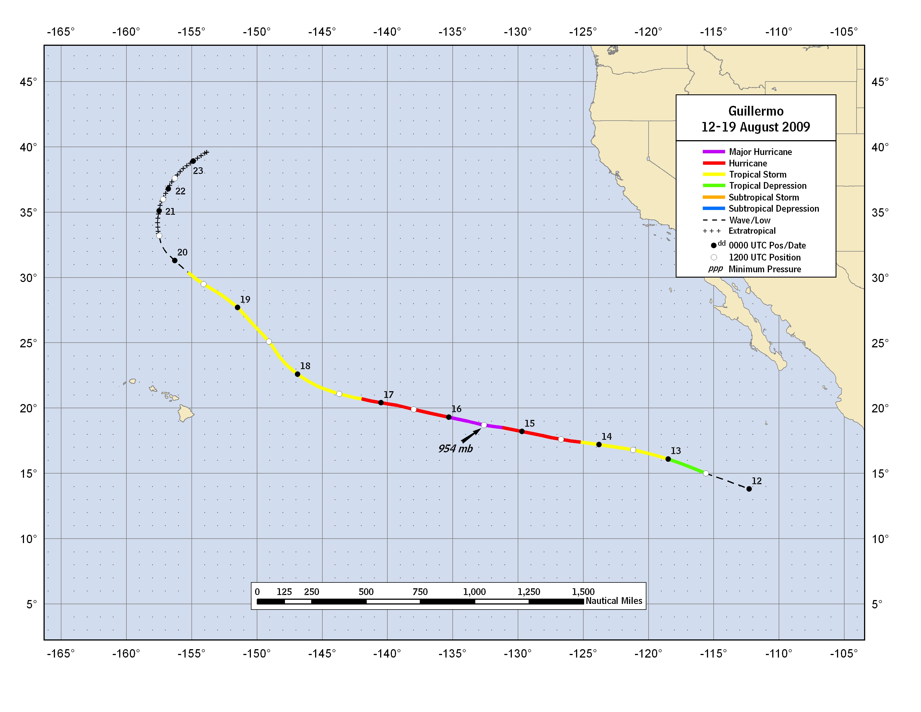
Figure 1. Best track positions for Hurricane Guillermo, 12-19 August 2009.

Figure 2. Selected wind observations and best track maximum sustained surface wind speed curve for Guillermo, 12-19 August 2009. Dashed vertical lines correspond to 0000 UTC.

Figure 3. Selected pressure observations and best track minimum central pressure curve for Guillermo, 12-19 August 2009. Dashed vertical lines correspond to 0000 UTC.
Table 2a. NHC official (OFCL) and climatology-persistence skill baseline (OCD5) track forecast errors (n mi) for Guillermo. Mean errors for the five-year period 2004-8 are shown for comparison. Official errors that are smaller than the five-year means are shown in boldface type.

 | Forecast Period (h)
 | 12 | 24 | 36 | 48 | 72 | 96 | 120
OFCL (Guillermo) | 15.8 | 24.6 | 31.7 | 45.7 | 83.5 | 144.2 | 276.2
OCD5 (Guillermo) | 17.8 | 39.4 | 73.4 | 124.2 | 248.3 | 358.5 | 495.7
Forecasts | 18 | 18 | 18 | 18 | 17 | 13 | 9
OFCL (2004-8) | 31.0 | 51.7 | 71.7 | 90.2 | 123.6 | 161.3 | 201.8
OCD5 (2004-8) | 38.4 | 73.6 | 111.9 | 149.1 | 214.2 | 261.1 | 311.5

Table 2b. Homogeneous comparison of selected track forecast guidance models (in n mi) for Guillermo. Errors smaller than the NHC official forecast are shown in boldface type. The number of official forecasts shown here will generally be smaller than that shown in Table 2a due to the homogeneity requirement.

Model ID | Forecast Period (h)
Model ID | 12 | 24 | 36 | 48 | 72 | 96 | 120
OFCL | 16.6 | 25.6 | 34.0 | 49.3 | 87.1 | 154.5 | 312.6
OCD5 | 17.8 | 40.2 | 75.3 | 126.2 | 250.2 | 364.6 | 507.3
GFSI | 21.1 | 33.6 | 46.4 | 57.2 | 80.4 | 105.8 | 214.0
GHMI | 20.9 | 35.4 | 46.1 | 66.1 | 77.2 | 61.1 | 226.1
HWFI | 20.8 | 47.2 | 72.2 | 92.6 | 93.9 | 83.1 | 144.7
NGPI | 18.7 | 39.6 | 74.8 | 126.5 | 240.0 | 313.4 | 385.5
FSSE | 14.4 | 28.9 | 43.4 | 59.2 | 83.8 | 118.3 | 246.5
TVCN | 15.0 | 25.4 | 40.0 | 58.7 | 91.1 | 138.6 | 254.3
TVCC | 11.5 | 22.7 | 30.1 | 57.0 | 92.2 | 187.3 | 383.6
LBAR | 30.8 | 76.0 | 126.5 | 185.1 | 354.1 | 656.8 | 1034.5
BAMD | 27.2 | 64.8 | 106.6 | 152.6 | 299.6 | 577.6 | 832.3
BAMM | 29.7 | 60.0 | 89.4 | 116.7 | 175.4 | 266.5 | 386.6
BAMS | 30.1 | 50.1 | 57.2 | 69.5 | 99.5 | 121.1 | 169.9
Forecasts | 16 | 16 | 16 | 16 | 15 | 11 | 7
Table 3a. NHC official (OFCL) and climatology-persistence skill baseline (OCD5) intensity forecast errors (kt) for Guillermo. Mean errors for the five-year period 2004-8 are shown for comparison. Official errors that are smaller than the five-year means are shown in boldface type.

 | Forecast Period (h)
 | 12 | 24 | 36 | 48 | 72 | 96 | 120
OFCL (Guillermo) | 8.6 | 14.4 | 18.6 | 22.5 | 19.1 | 12.7 | 8.3
OCD5 (Guillermo) | 8.4 | 15.2 | 20.9 | 25.1 | 18.3 | 11.2 | 4.4
Forecasts | 18 | 18 | 18 | 18 | 17 | 13 | 9
OFCL (2004-8) | 6.2 | 10.2 | 13.3 | 15.1 | 17.7 | 19.0 | 18.8
OCD5 (2004-8) | 7.1 | 11.5 | 14.7 | 16.8 | 18.9 | 20.3 | 20.2

Table 3b. Homogeneous comparison of selected intensity forecast guidance models (in kt) for Guillermo. Errors smaller than the NHC official forecast are shown in boldface type. The number of official forecasts shown here will generally be smaller than that shown in Table 3a due to the homogeneity requirement.

Model ID | Forecast Period (h)
Model ID | 12 | 24 | 36 | 48 | 72 | 96 | 120
OFCL | 9.4 | 14.7 | 19.4 | 22.2 | 14.3 | 8.6 | 7.9
OCD5 | 8.8 | 14.9 | 21.0 | 24.0 | 13.3 | 6.9 | 5.0
DSHP | 7.8 | 10.4 | 14.9 | 17.3 | 13.5 | 9.5 | 7.7
LGEM | 8.8 | 13.1 | 18.1 | 19.7 | 12.1 | 7.2 | 8.0
GHMI | 9.6 | 17.6 | 24.5 | 24.7 | 19.3 | 10.7 | 9.0
HWFI | 10.8 | 15.2 | 19.9 | 22.1 | 18.1 | 12.6 | 7.9
FSSE | 9.9 | 15.6 | 20.1 | 21.1 | 14.8 | 7.7 | 7.7
ICON | 8.8 | 13.5 | 17.9 | 19.7 | 13.9 | 6.8 | 5.0
IVCN | 8.7 | 13.9 | 17.9 | 19.5 | 13.1 | 5.9 | 5.6
Forecasts | 16 | 16 | 16 | 16 | 15 | 11 | 7

A digital record of the complete best track, including wind radii, can be found on line at ftp://ftp.nhc.noaa.gov/atcf. Data for the current year’s storms are located in the btk directory, while previous years’ data are located in the archive directory.

