Tropical Cyclone Report
Tropical Depression Nine-E
(EP092009)
9-11 August 2009

Daniel P. Brown
National Hurricane Center
22 September 2009

Tropical Depression Nine-E formed from a tropical wave that appears to have entered the eastern North Pacific Ocean on 1 August. The wave was poorly defined and difficult to track until 6 August when it was located about 600 n mi south of Manzanillo, Mexico. The next day the wave spawned a broad area of low pressure about 700 n mi south-southwest of the southern tip of Baja California. The circulation gradually became better defined over the next 24 to 36 h, although the associated shower and thunderstorm activity remained limited. Shortly before 1200 UTC 9 August, thunderstorm activity began to increase in association with the low. The convective activity continued to become organized during the next several hours, and it is estimated that a tropical depression formed by 1800 UTC 9 August, about 770 n mi southwest of the southern tip of Baja California. The “best track” chart of the tropical cyclone’s path is given in Fig. 1. The best track positions and intensities are listed in Table 1.

Within an environment of moderate westerly shear, the depression did not strengthen as it moved generally westward during the next day or so. Although Dvorak classifications from both TAFB and SAB suggested the system was near tropical storm strength around 0600 UTC 11 August, microwave imagery during that time (not shown) indicated that the low-level center was exposed to the west of a fragmented band of thunderstorms. Visible satellite images later that day showed that the center was exposed to the west of the convective activity, confirming that the cyclone was not well organized. The deep convection dissipated later that day, and it is estimated that the depression degenerated into a remnant low around 0000 UTC 12 August, while centered about 1200 n mi west-southwest of the southern tip of Baja California. The low turned west-southwestward and produced intermittent and disorganized showers and thunderstorms during the next couple of days. On 14 August, the low became less defined as it moved near the inter-tropical convergence zone (ITCZ). The low dissipated about 1825 n mi west-southwest of the southern tip of Baja California as it was absorbed into the ITCZ shortly after 0000 UTC 15 August.

The genesis of Tropical Depression Nine-E was not well forecast, although perhaps with good reason. The incipient disturbance was introduced into the NHC Tropical Weather Outlook about 30 h before genesis. The chance of formation, however, remained low (less than 30%) in the Outlook until the time that genesis occurred, since the overall environmental conditions were judged to be not especially favorable for development. Although the disturbance did become a tropical cyclone, the marginal environment did not allow for any additional development.

Table 1. Best track for Tropical Depression Nine-E, 9-11 August 2009.

Date/Time  (UTC) | Latitude  (°N) | Longitude  (°W) | Pressure  (mb) | Wind Speed  (kt) | Stage
09 / 0000 | 14.1 | 118.1 | 1010 | 25 | low
09 / 0600 | 14.1 | 118.7 | 1010 | 25 | "
09 / 1200 | 14.2 | 119.4 | 1008 | 25 | "
09 / 1800 | 14.4 | 120.2 | 1007 | 30 | tropical depression
10 / 0000 | 14.7 | 121.1 | 1007 | 30 | "
10 / 0600 | 14.8 | 121.9 | 1006 | 30 | "
10 / 1200 | 14.9 | 122.7 | 1006 | 30 | "
10 / 1800 | 15.0 | 123.7 | 1006 | 30 | "
11 / 0000 | 15.1 | 124.9 | 1006 | 30 | "
11 / 0600 | 15.1 | 126.0 | 1006 | 30 | "
11 / 1200 | 15.1 | 127.1 | 1006 | 30 | "
11 / 1800 | 15.1 | 128.3 | 1006 | 30 | "
12 / 0000 | 15.0 | 129.4 | 1007 | 30 | low
12 / 0600 | 14.8 | 130.5 | 1007 | 30 | "
12 / 1200 | 14.5 | 131.6 | 1007 | 30 | "
12 / 1800 | 14.2 | 132.7 | 1007 | 30 | "
13 / 0000 | 13.9 | 133.7 | 1007 | 25 | "
13 / 0600 | 13.4 | 134.5 | 1007 | 25 | "
13 / 1200 | 12.9 | 135.2 | 1007 | 25 | "
13 / 1800 | 12.3 | 135.8 | 1008 | 25 | "
14 / 0000 | 11.8 | 136.6 | 1009 | 25 | "
14 / 0600 | 11.5 | 137.4 | 1009 | 25 | "
14 / 1200 | 11.2 | 138.1 | 1009 | 25 | "
14 / 1800 | 11.0 | 138.7 | 1009 | 25 | "
15 / 0000 | 10.7 | 139.3 | 1009 | 25 | "
15 / 0600 |  |  |  |  | dissipated
10 / 0600 | 14.8 | 121.9 | 1006 | 30 | minimum pressure

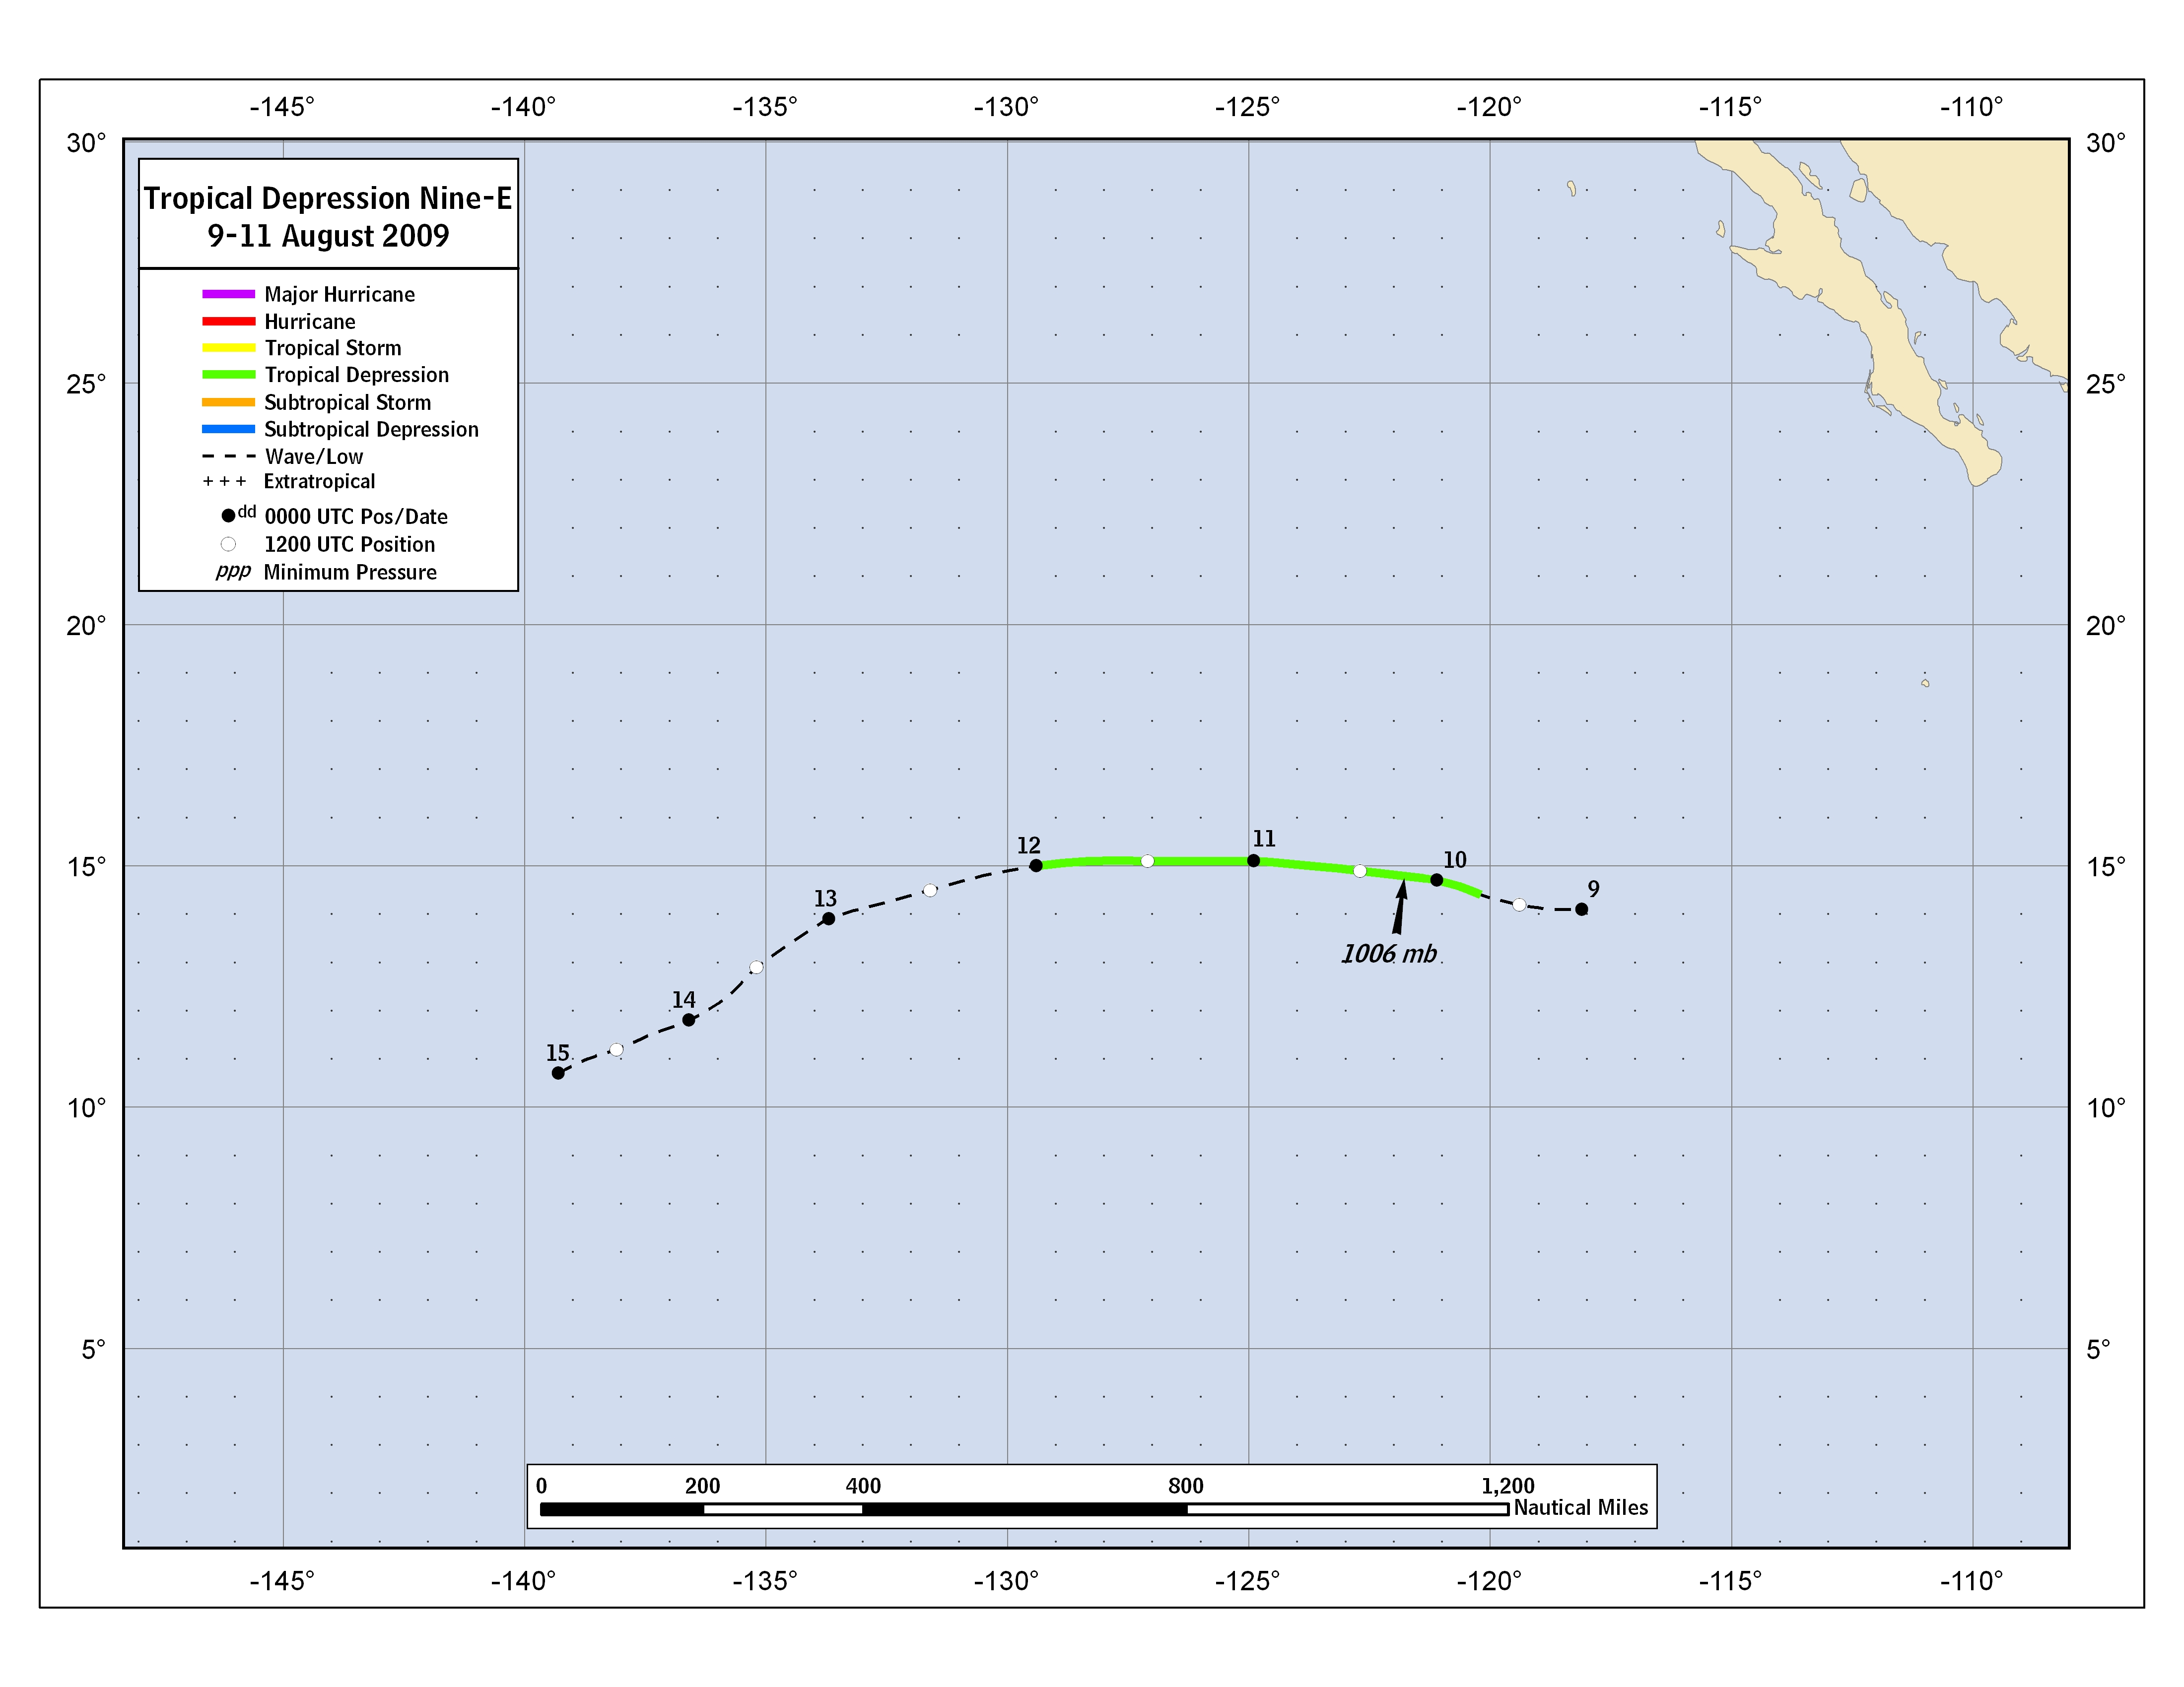
Figure 1. Best track positions for Tropical Depression Nine-E, 9-11 August 2009.

A digital record of the complete best track can be found on line at ftp://ftp.nhc.noaa.gov/atcf. Data for the current year’s storms are located in the btk directory, while previous years’ data are located in the archive directory.

