Tropical Cyclone Report
Tropical Storm Enrique
(EP072009)
3 - 7 August 2009

Robbie Berg
National Hurricane Center
21 September 2009

Enrique was a tropical storm that remained over the open waters of the northeastern Pacific Ocean.

- Synoptic History

Enrique developed from a tropical wave that moved off the west coast of Africa on 21 July and crossed the Atlantic over the next nine days with very little associated shower and thunderstorm activity. Deep convection developed near the wave as it began to move across Central America on 30 July, but this activity remained disorganized while the wave moved westward to the south of the Mexican coast over the next few days. Deep convection increased early on 3 August, and it is estimated that a tropical depression formed around 1800 UTC 3 August, centered about 580 n mi southwest of Manzanillo, Mexico. The convection continued to become better organized over the next few hours, and the depression became a tropical storm around 0000 UTC 4 August. The “best track” chart of Enrique’s path is given in Fig. 1, with the wind and pressure histories shown in Figs. 2 and 3, respectively. The best track positions and intensities are listed in Table 1.

Enrique strengthened fairly quickly after becoming a tropical storm. The 85 GHz channel from a NASA Tropical Rainfall Measuring Mission (TRMM) microwave pass at 1329 UTC 4 August indicated that Enrique had developed a well-defined mid-level eye-like feature, with a band of deep convection that circled halfway around the storm’s circulation (Fig. 4a). However, the strengthening trend was short-lived, and a 2121 UTC AMSR-E pass later that day (Fig. 4b) showed that the low-level center had become exposed to the northwest of the deep convection. Enrique moved west-northwestward then northwestward over the next few days, steered between the subtropical mid-level ridge to its north and the circulation associated with Hurricane Felicia to its west. Some binary interaction may have occurred between Enrique and Felicia, and their centers moved to within 425 n mi of each other by 1200 UTC 6 August (Fig. 5). Enrique began to move over sea surface temperatures colder than 26.5ºC on 5 August, and this combined with northerly shear to cause the cyclone to slowly weaken. Enrique became a tropical depression around 0000 UTC 7 August about 790 n mi west-southwest of Punta Eugenia, Mexico, and then degenerated into a remnant low by 0000 UTC 8 August. The low then began moving slowly south-southwestward under the influence of the low-level flow, dissipating about 18 h later.
- Meteorological Statistics

Observations in Enrique (Figs. 2 and 3) include satellite-based Dvorak technique intensity estimates from the Tropical Analysis and Forecast Branch (TAFB) and the Satellite Analysis Branch (SAB) and intensity estimates from the Advanced Microwave Sounding Unit (AMSU). Data and imagery from NOAA polar-orbiting satellites; Defense Meteorological Satellite Program (DMSP) satellites; National Aeronautics and Space Administration (NASA) satellites, including TRMM, QuikSCAT, and Aqua; the U.S. Navy WindSat; and the EUMETSAT ASCAT were also useful in constructing the best track of Enrique.

The estimated peak intensity of 55 kt from 1200 UTC to 1800 UTC 4 August is based on a blend of subjective satellite intensity estimates of 55 kt from TAFB, a peak 3-hr averaged objective satellite intensity estimate of 59 kt from the Automated Dvorak Technique (ADT), an estimate of 50 kt from a 1324 UTC 4 August QuikSCAT pass, and Advanced Microwave Sounding Unit (AMSU) estimates of 57 kt and 54 kt.

- Casualty and Damage Statistics

There were no reports of damage or casualties associated with Enrique.

- Forecast and Warning Critique

The genesis of Enrique was not well forecast. The precursor area of low pressure was first mentioned in the Tropical Weather Outlook (TWO) and given a low chance of development (less than 30% during the ensuing 48 h) 18 h before the system is estimated to have become a tropical depression. The system was given a medium chance (30 – 50%) at 1200 UTC 3 August, 6 h before becoming a depression.

A verification of NHC official track forecasts for Enrique is given in Table 2a. Official forecast track errors were greater than the mean official errors for the previous five-year period (2004 – 2008) at all forecast times. However, the CLIPER5 (OCD5) errors were also larger than their respective five-year mean errors at all forecast times, indicating that the track forecasts for Enrique were more difficult than average. For example, the 24- and 48-h forecasts were about 32% and 57% more difficult than average, respectively. A homogeneous comparison of the official track errors with selected guidance models is given in Table 2b. The LBAR, BAMM, BAMS, as well as the consensus TVCN and TVCC performed better than the official forecast at all times through 48 h, and overall the LBAR had the lowest errors. Figure 6 shows that the official forecast, the model consensus, and the individual models (specifically the LBAR and HWFI) had a significant westward bias. Hurricane Felicia’s circulation might have had an effect on the track of Enrique, and the westward bias in the models was likely the result of poor model representation of the binary interaction between the cyclones.

A verification of NHC official intensity forecasts for Enrique is given in Table 3a. Official forecast intensity errors were lower than the mean official errors for the previous five-year period through 48 h but were slightly greater at 72 h. The Decay-SHIFOR5 (OCD5) errors were less than their respective five-year mean errors through 48 h, indicating that the intensity forecasts were easier than average at those periods. A homogeneous comparison of the official track errors with selected guidance models is given in Table 3b. No single model performed better than the rest at all forecast periods, but the intensity consensus (ICON) consistently had some of the lowest errors through 48 h.

Table 1. Best track for Tropical Storm Enrique, 3 – 7 August 2009.

Date/Time  (UTC) | Latitude  (°N) | Longitude  (°W) | Pressure  (mb) | Wind Speed  (kt) | Stage
03 / 1800 | 12.9 | 112.2 | 1006 | 30 | tropical depression
04 / 0000 | 13.2 | 113.6 | 1004 | 35 | tropical storm
04 / 0600 | 13.7 | 114.9 | 1000 | 45 | "
04 / 1200 | 14.3 | 116.3 | 994 | 55 | "
04 / 1800 | 14.9 | 117.7 | 994 | 55 | "
05 / 0000 | 15.6 | 119.1 | 998 | 50 | "
05 / 0600 | 16.4 | 120.3 | 1000 | 45 | "
05 / 1200 | 17.2 | 121.5 | 1000 | 45 | "
05 / 1800 | 18.1 | 122.7 | 1000 | 45 | "
06 / 0000 | 19.1 | 124.0 | 1000 | 45 | "
06 / 0600 | 20.1 | 125.3 | 1000 | 45 | "
06 / 1200 | 21.0 | 126.6 | 1002 | 40 | "
06 / 1800 | 22.0 | 127.7 | 1005 | 35 | "
07 / 0000 | 22.8 | 128.5 | 1007 | 30 | tropical depression
07 / 0600 | 23.6 | 129.1 | 1007 | 30 | "
07 / 1200 | 24.2 | 129.4 | 1007 | 30 | "
07 / 1800 | 24.8 | 129.6 | 1008 | 25 | "
08 / 0000 | 25.0 | 129.7 | 1009 | 25 | remnant low
08 / 0600 | 24.7 | 129.8 | 1009 | 20 | "
08 / 1200 | 24.3 | 129.9 | 1009 | 20 | "
08 / 1800 |  |  |  |  | dissipated
04 / 1200 | 14.3 | 116.3 | 994 | 55 | maximum wind and minimum pressure

Table 2a. NHC official (OFCL) and climatology-persistence skill baseline (OCD5) track forecast errors (n mi) for Tropical Storm Enrique, 3 – 7 August 2009. Mean errors for the five-year period 2004-8 are shown for comparison. Official errors that are smaller than the five-year means are shown in boldface type.

 | Forecast Period (h)
 | 12 | 24 | 36 | 48 | 72 | 96 | 120
OFCL | 41.4 | 99.2 | 171.7 | 245.4 | 375.3 | 476.5
OCD5 | 41.0 | 97.1 | 148.4 | 233.6 | 374.3 | 463.7
Forecasts | 15 | 13 | 11 | 8 | 5 | 1
OFCL (2004-8) | 31.0 | 51.7 | 71.7 | 90.2 | 123.6 | 161.3 | 201.8
OCD5 (2004-8) | 38.4 | 73.6 | 111.9 | 149.1 | 214.2 | 261.1 | 311.5

Table 2b. Homogeneous comparison of selected track forecast guidance models (in n mi) for Tropical Storm Enrique, 3 – 7 August 2009. Errors smaller than the NHC official forecast are shown in boldface type. The number of official forecasts shown here will generally be smaller than that shown in Table 2a due to the homogeneity requirement.

Model ID | Forecast Period (h)
Model ID | 12 | 24 | 36 | 48 | 72 | 96 | 120
OFCL | 24.5 | 79.0 | 155.5 | 243.3
OCD5 | 29.7 | 93.1 | 166.3 | 234.3
GHMI | 20.7 | 57.2 | 168.7 | 373.6
HWFI | 25.0 | 74.8 | 154.3 | 267.4
GFNI | 45.2 | 95.7 | 152.3 | 191.7
NGPI | 56.0 | 130.8 | 213.3 | 285.3
UKMI | 35.7 | 82.8 | 165.6 | 298.8
EGRI | 38.9 | 82.8 | 158.2 | 238.9
TVCN | 23.3 | 61.3 | 120.9 | 206.0
TVCC | 18.3 | 74.1 | 110.8 | 194.0
LBAR | 21.3 | 38.7 | 69.4 | 93.9
BAMD | 25.9 | 63.7 | 97.0 | 138.6
BAMM | 18.4 | 43.9 | 74.4 | 120.9
BAMS | 21.6 | 45.7 | 79.5 | 139.5
Forecasts | 8 | 6 | 6 | 6
Table 3a. NHC official (OFCL) and climatology-persistence skill baseline (OCD5) intensity forecast errors (kt) for Tropical Storm Enrique, 3 – 7 August 2009. Mean errors for the five-year period 2004-8 are shown for comparison. Official errors that are smaller than the five-year means are shown in boldface type.

 | Forecast Period (h)
 | 12 | 24 | 36 | 48 | 72 | 96 | 120
OFCL | 5.7 | 6.9 | 6.8 | 10.0 | 19.0 | 25.0
OCD5 | 5.1 | 6.3 | 7.5 | 13.6 | 31.6 | 35.0
Forecasts | 15 | 13 | 11 | 8 | 5 | 1
OFCL (2004-8) | 6.2 | 10.2 | 13.3 | 15.1 | 17.7 | 19.0 | 18.8
OCD5 (2004-8) | 7.1 | 11.5 | 14.7 | 16.8 | 18.9 | 20.3 | 20.2

Table 3b. Homogeneous comparison of selected intensity forecast guidance models (in kt) for Tropical Storm Enrique, 3 – 7 August 2009. Errors smaller than the NHC official forecast are shown in boldface type. The number of official forecasts shown here will generally be smaller than that shown in Table 3a due to the homogeneity requirement.

Model ID | Forecast Period (h)
Model ID | 12 | 24 | 36 | 48 | 72 | 96 | 120
OFCL | 5.6 | 10.0 | 9.2 | 10.8
OCD5 | 5.8 | 6.0 | 8.5 | 13.5
GHMI | 5.5 | 5.7 | 4.3 | 8.5
HWFI | 5.5 | 6.5 | 5.0 | 8.0
GFNI | 4.6 | 6.3 | 6.0 | 6.5
NGPI | 5.3 | 3.7 | 6.5 | 8.7
UKMI | 5.5 | 4.7 | 7.0 | 11.7
DSHP | 6.0 | 7.5 | 7.7 | 10.0
LGEM | 6.5 | 8.0 | 6.0 | 7.2
ICON | 5.1 | 6.5 | 5.0 | 6.5
Forecasts | 8 | 6 | 6 | 6

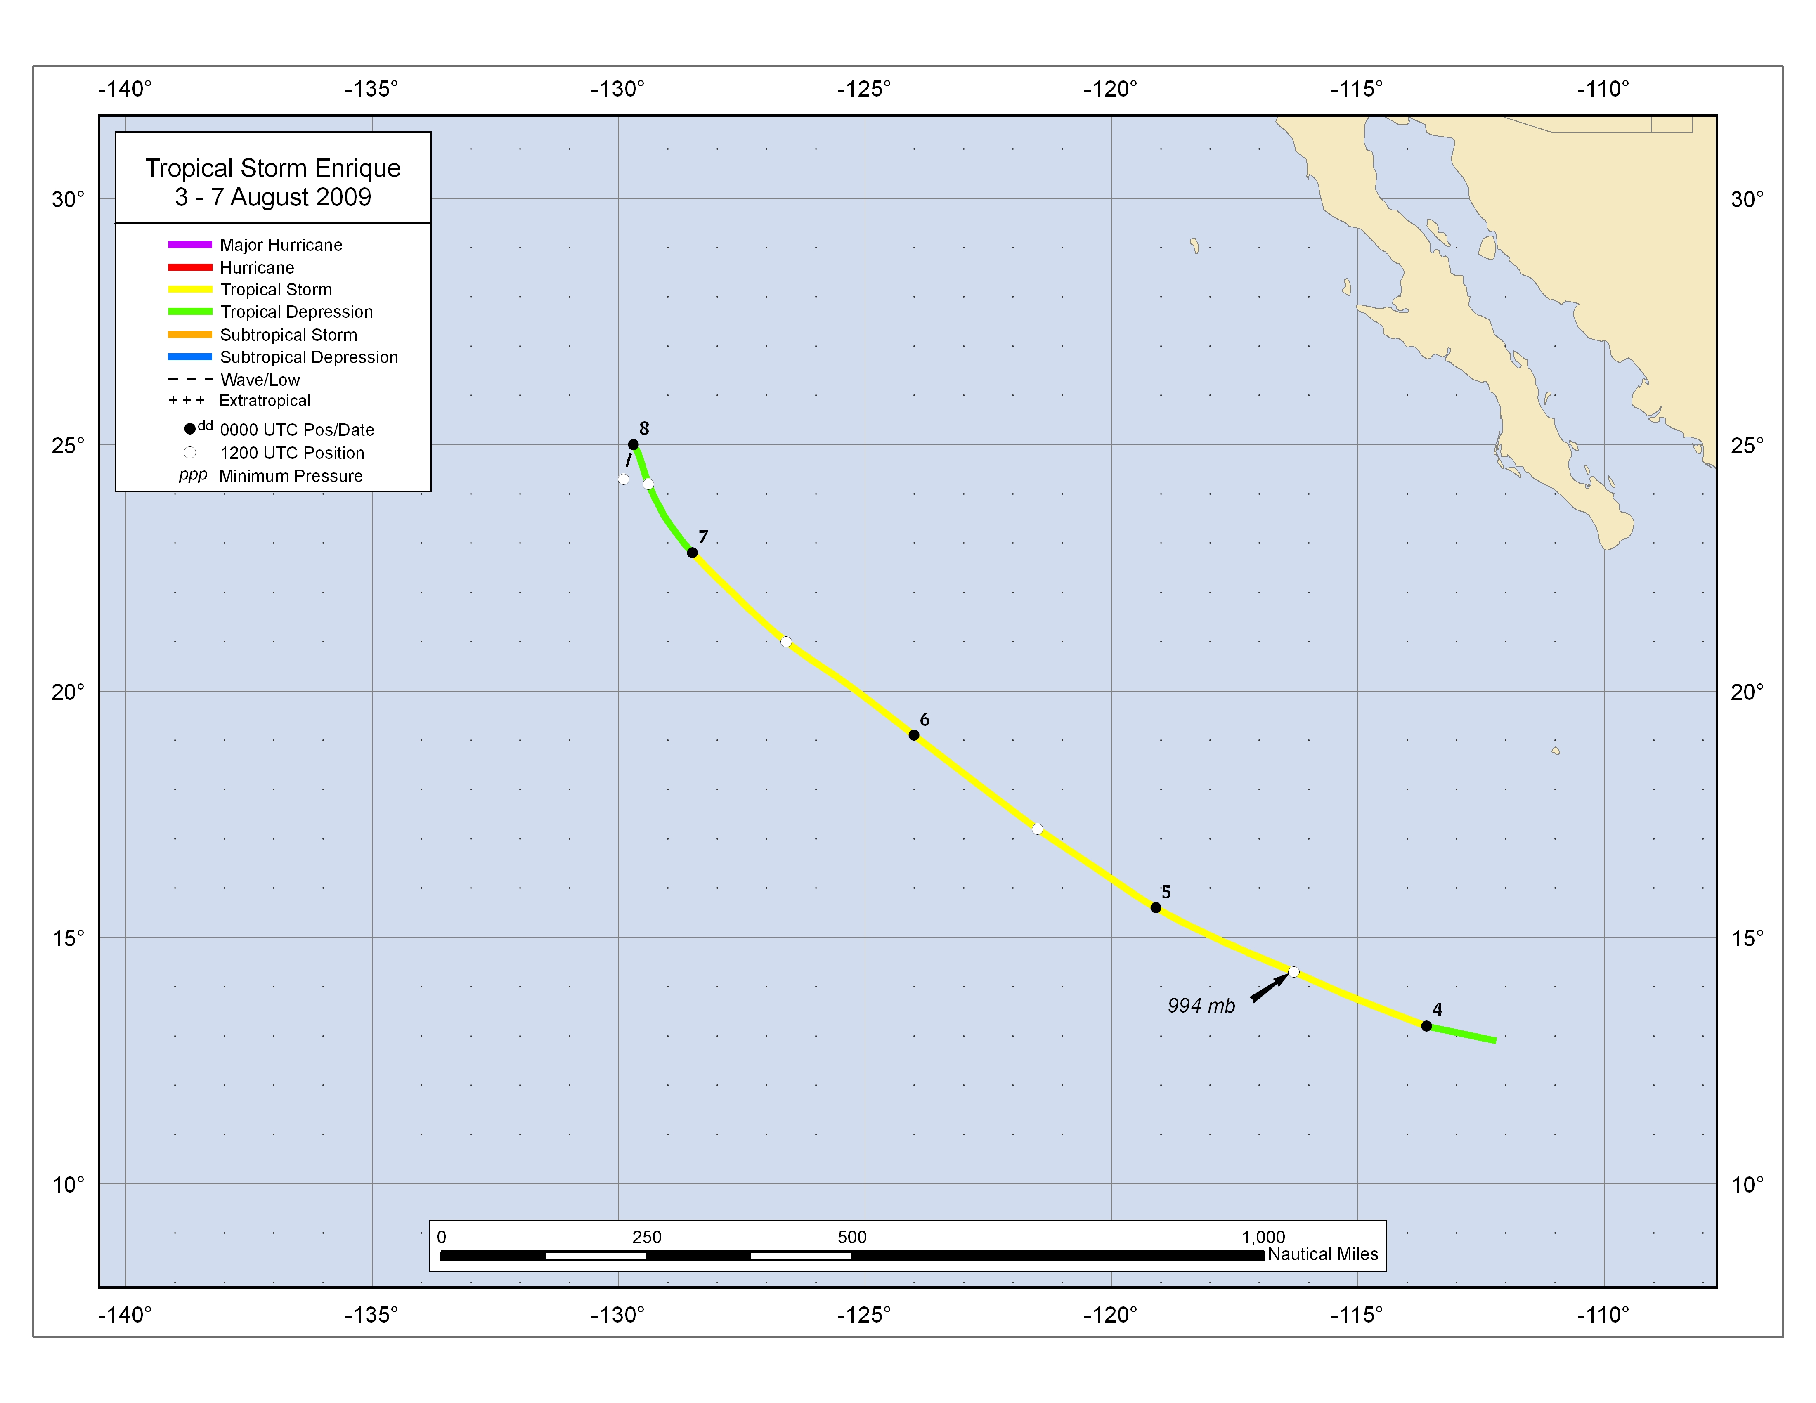
Figure 1. Best track positions for Tropical Storm Enrique, 3 – 7 August 2009.

Figure 2. Selected wind observations and best track maximum sustained surface wind speed curve for Tropical Storm Enrique,
3 – 7 August 2009. Advanced Dvorak Technique estimates represent linear averages over a three-hour period centered on the nominal observation time. Dashed vertical lines correspond to 0000 UTC.

Figure 3. Selected pressure observations and best track minimum central pressure curve for Tropical Storm Enrique, 3 – 7 August 2009. Advanced Dvorak Technique estimates represent linear averages over a three-hour period centered on the nominal observation time. Dashed vertical lines correspond to 0000 UTC.
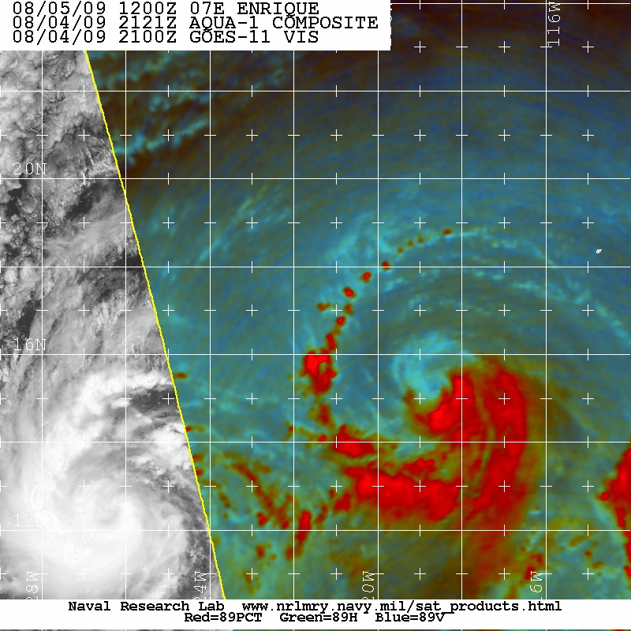
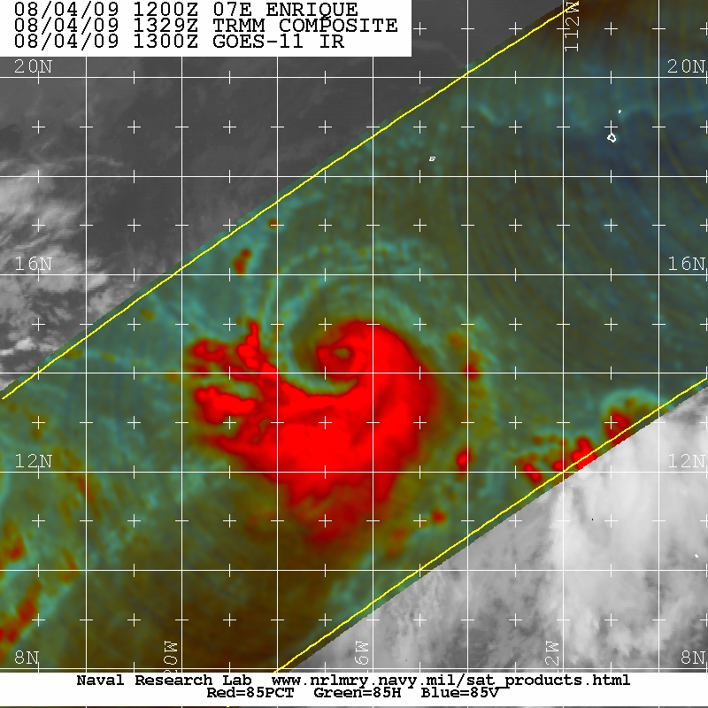

Figure 4. 85 GHz color composite TRMM image of Tropical Storm Enrique at 1329 UTC 4 August (a) and a 89 GHz color composite AMSR-E image at 2121 UTC 4 August (b). The images show that Enrique developed a well-defined mid-level eye-like feature (a) that dissipated with the low-level center becoming displaced from the deep convection eight hours later (b). Images courtesy of the Naval Research Laboratory in Monterey, CA.

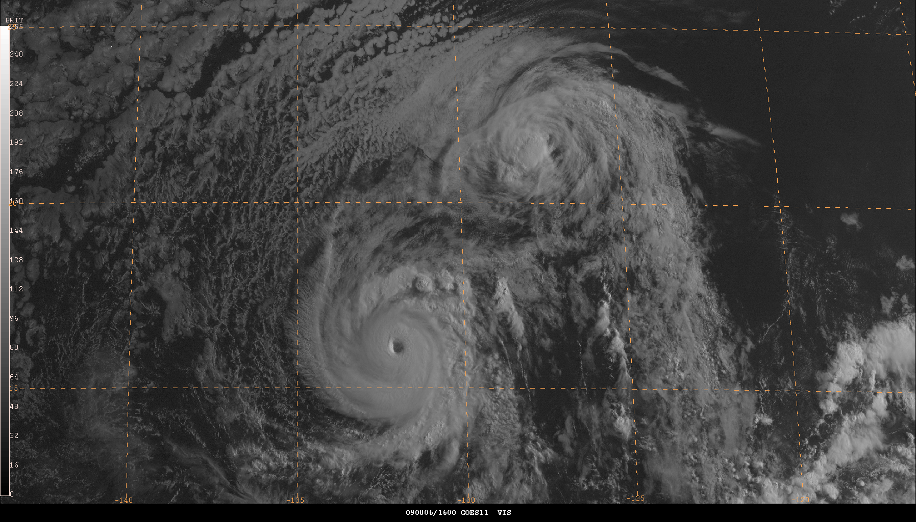

Figure 5. GOES-11 visible image of Tropical Storm Enrique (upper right) and Hurricane Felicia (lower left with distinct eye) at 1600 UTC 6 August 2009, around the time when the two cyclones were centered within 425 n mi of each other.

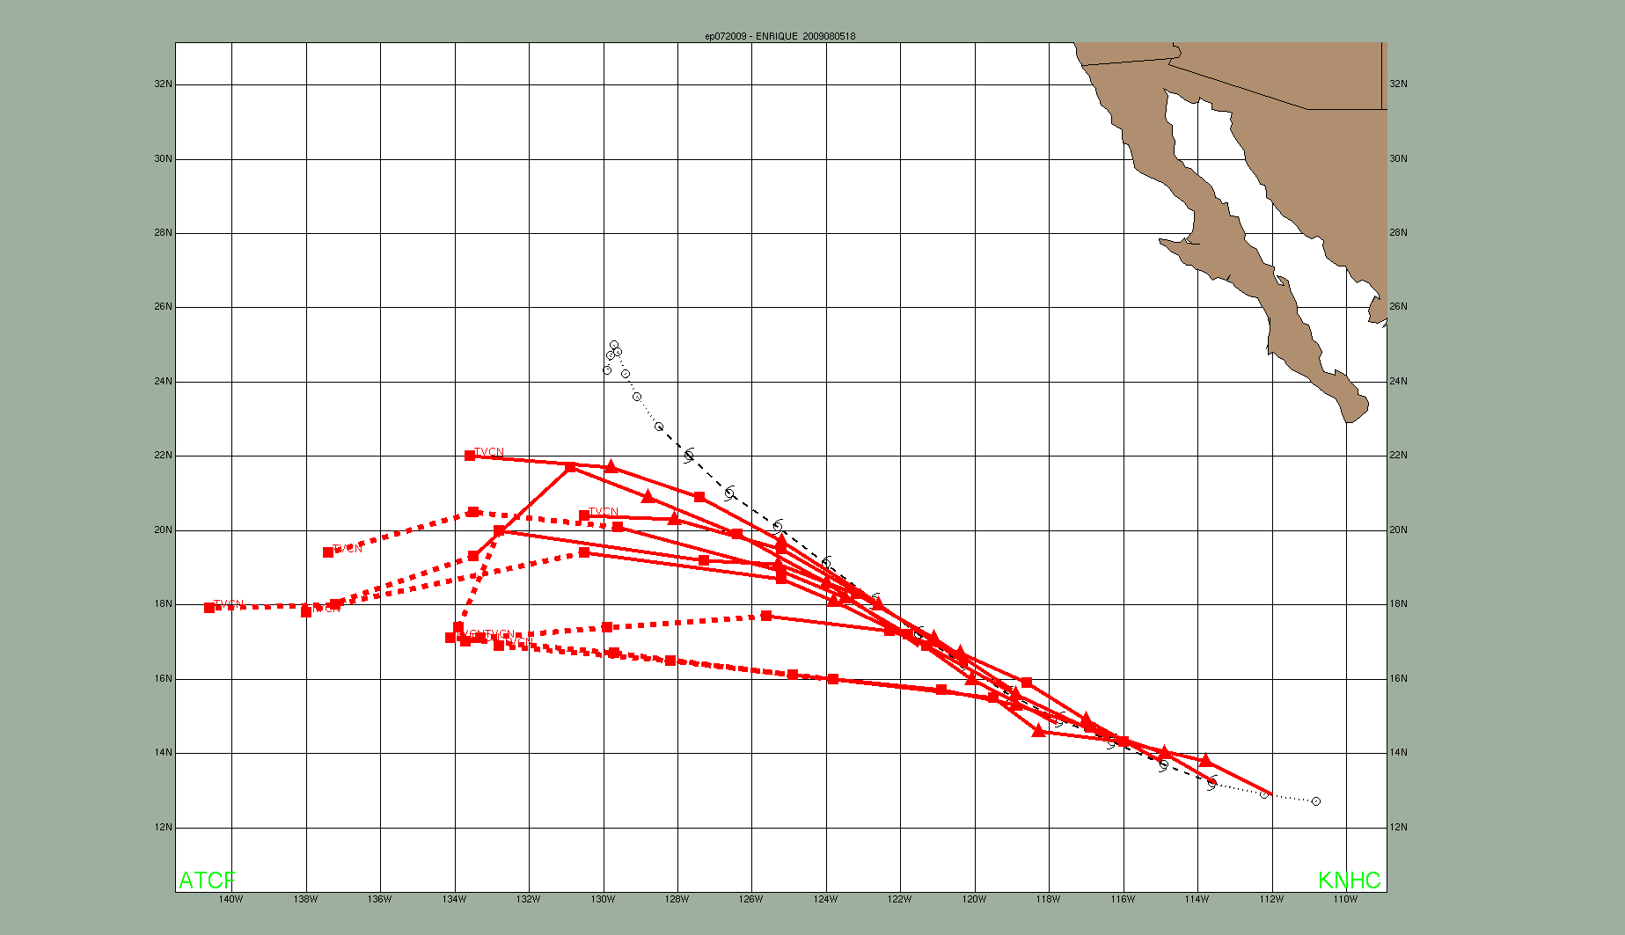
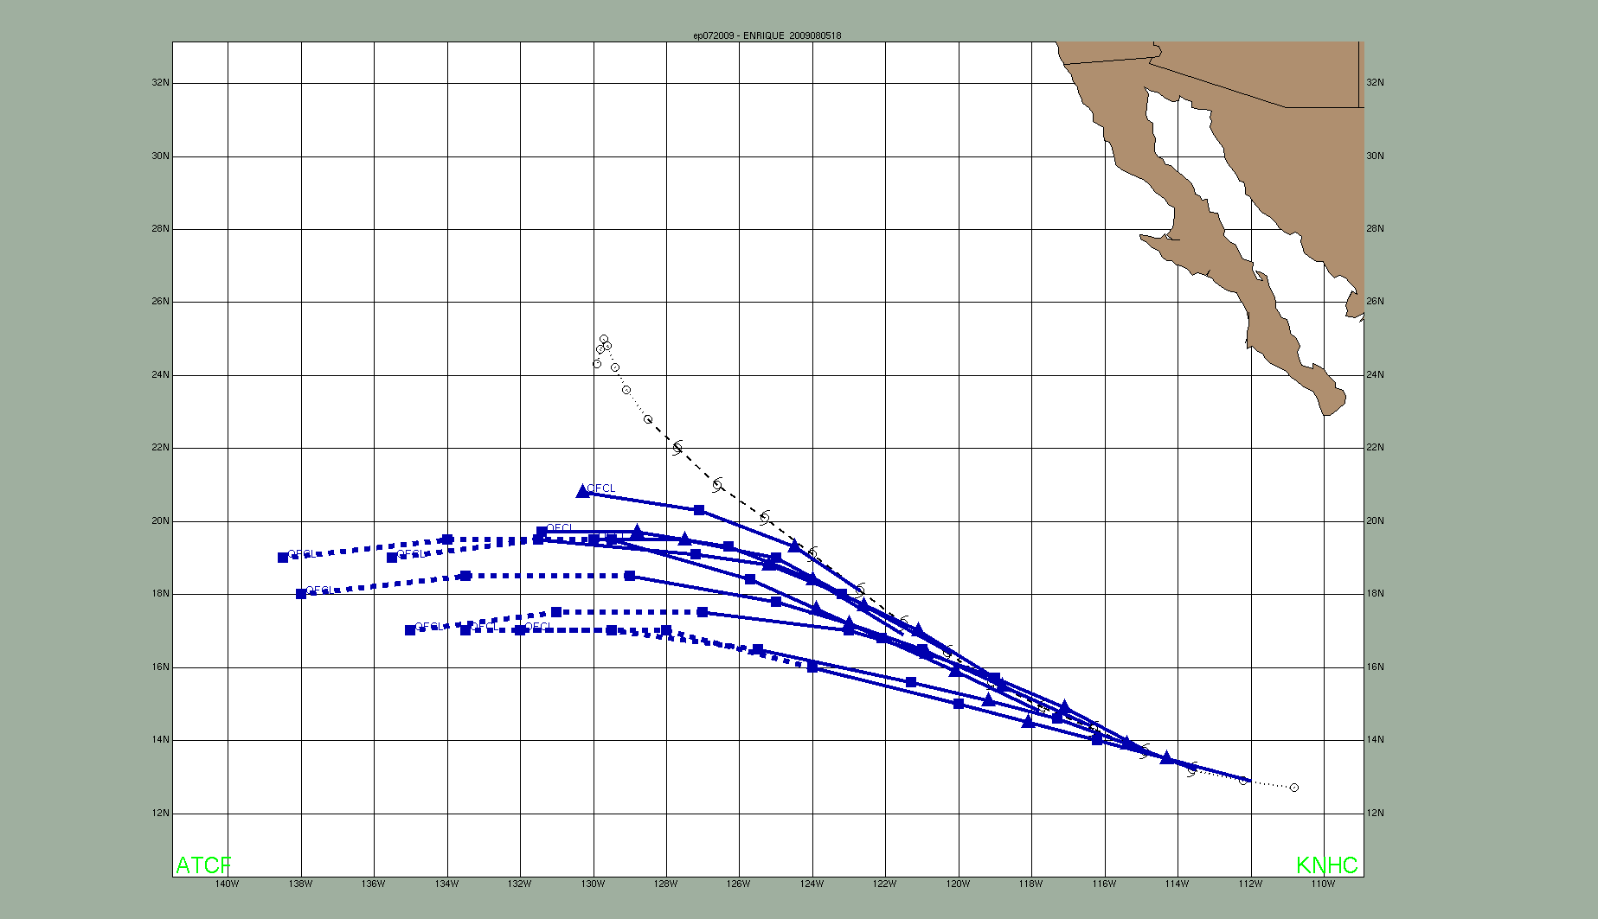
(a)
(b)

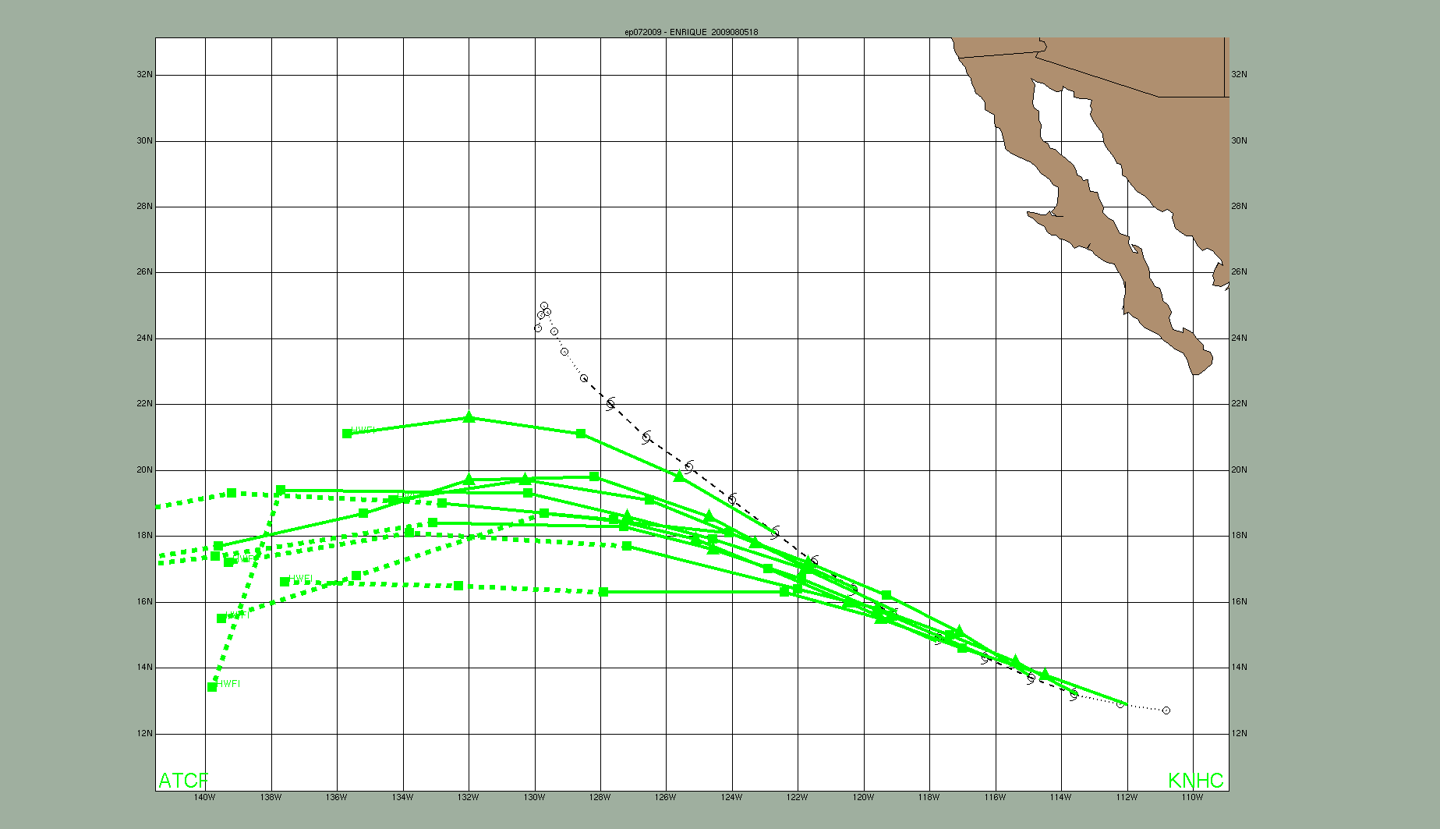
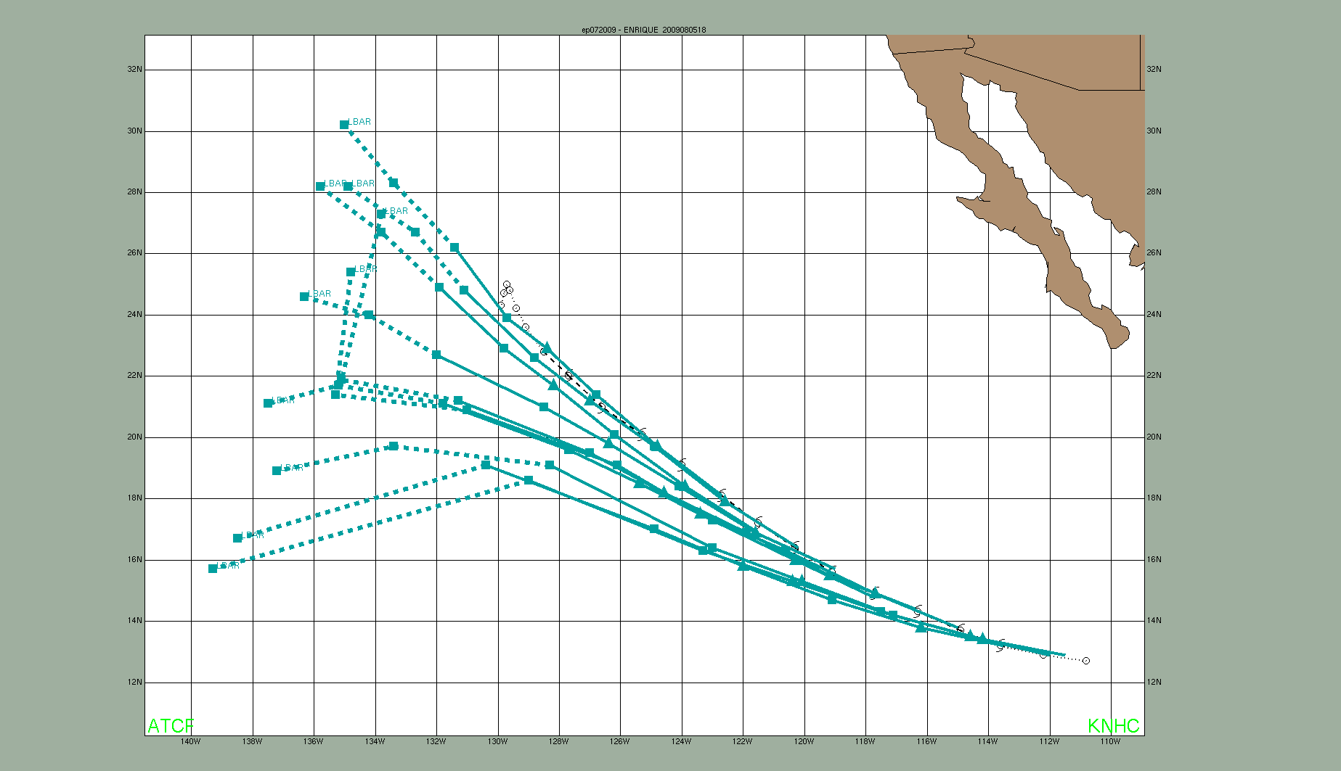
(c)
(d)

Figure 6. (a) NHC official, (b) TVCN, (c) LBAR, and (d) HWFI track forecasts from 1800 UTC 3 August through 1800 UTC 5 August for Tropical Storm Enrique. The best track is given by the black line with positions shown at 6 h intervals.

A digital record of the complete best track, including wind radii, can be found on line at ftp://ftp.nhc.noaa.gov/atcf. Data for the current year’s storms are located in the btk directory, while previous years’ data are located in the archive directory.

