Tropical Cyclone Report
Tropical Storm Lana
(EP062009)
30 July–2 August 2009

Thomas Birchard and Richard D. Knabb
Central Pacific Hurricane Center

Michael J. Brennan
National Hurricane Center

17 February 2010

Lana originated as a tropical depression in the extreme western portion of the east Pacific basin, and became a short-lived tropical storm in the central Pacific basin before moving well south of the Hawaiian Islands and dissipating.

- Synoptic History

Lana had its origins in a tropical wave that entered the eastern Atlantic on 11 July and reached the eastern Pacific on 21 July. The area of disturbed weather associated with the wave merged with another area of disturbed weather on 26 July, and by 0000 UTC 27 July the system was located near 115-120°W. As the system moved westward, vertical wind shear remained unfavorable for development for a couple of days, but shear began to decrease on 29 July as a mid- to upper-level trough located north of the wave moved away. Deep convection began to increase late on 29 July and the system continued to become better organized early on 30 July. It is estimated that a tropical depression formed around 1200 UTC 30 July while centered about 1030 n mi east-southeast of Hilo, Hawaii. The “best track” chart of the tropical cyclone’s path is given in Fig. 1, with the wind and pressure histories shown in Figs. 2 and 3, respectively. The best track positions and intensities are listed in Table 1.

The depression moved quickly westward at 16-17 kt to the south of the subtropical ridge, and the convective structure of the cyclone continued to become better organized. It crossed 140°W longitude and entered the central Pacific basin just prior to reaching tropical storm intensity around 1800 UTC 30 July, when it was centered about 935 n mi east-southeast of Hilo. Steady strengthening beneath upper-level anticyclonic flow continued for the next 24 h, and by 1800 UTC the next day Lana reached its peak intensity of 55 kt while located about 585 n mi southeast of Hilo. Increasing southwesterly vertical wind shear began to impinge upon the cyclone as it approached an upper-level trough over Hawaii, and Lana gradually weakened during the following two days as it continued westward in the low- to mid-level flow south of a ridge. By 1800 UTC 2 August, Lana had weakened to a tropical depression about 400 n mi south of Honolulu, Hawaii. Thereafter, only small, intermittent bursts of convection appeared in the northeastern quadrant, and the system degenerated to a remnant low six hours later. The low dissipated in the low-level trade wind flow shortly after 0600 UTC 3 August about 475 n mi southwest of Honolulu.

- Meteorological Statistics

Observations in Lana (Figs. 2 and 3) include satellite-based Dvorak technique intensity estimates from the Tropical Analysis and Forecast Branch (TAFB), the Central Pacific Hurricane Center (PHFO), and the Satellite Analysis Branch (SAB). Data and imagery from NOAA polar-orbiting satellites, the NASA Tropical Rainfall Measuring Mission (TRMM), the NASA QuikSCAT, the European ASCAT onboard METOP-A, and Defense Meteorological Satellite Program (DMSP) satellites, among others, were also useful in constructing the best track of Lana.

Lana’s estimated peak intensity of 55 kt on 31 July is based upon subjective Dvorak intensity estimates of 55 kt from both SAB and PHFO at 1800 UTC that day (Fig. 2).

No ship reports of winds of tropical storm force were reported in association with Lana.

- Casualty and Damage Statistics

There were no reports of damage or casualties associated with Lana.

- Forecast and Warning Critique

The genesis of Lana was not well anticipated. The precursor disturbance that developed into Lana was first mentioned in NHC’s Tropical Weather Outlook issued at 1800 UTC 27 July, and was given a “low” probability of genesis (less than 30%) in the next 48 h. The genesis forecast remained in the low category through 1800 UTC 28 July. Due to increasing vertical wind shear, the disturbance was removed from the outlook at 0000 UTC 29 July. After the shear diminished later that day, the disturbance was again given a low probability of genesis. The probability of formation remained in the low category until genesis occurred.

NHC made only one forecast for Lana, which prevents any meaningful forecast critique. Official track forecast errors were 38, 75, 93, 86, and 85 n mi for the 12, 24, 36, 48, and 72 h forecasts, respectively. Official intensity forecast errors were 10 kt at 12 and 24 h, and 0 kt at 36, 48, and 72 h.

No coastal tropical cyclone watches or warnings were issued in association with Lana.
Table 1. Best track for Tropical Storm Lana, 30 July–2 August 2009.

Date/Time  (UTC) | Latitude  (°N) | Longitude  (°W) | Pressure  (mb) | Wind Speed  (kt) | Stage
30 / 1200 | 12.0 | 139.1 | 1008 | 30 | tropical depression
30 / 1800 | 12.1 | 140.6 | 1005 | 35 | tropical storm
31 / 0000 | 12.6 | 142.3 | 1000 | 45 | "
31 / 0600 | 13.0 | 143.9 | 997 | 50 | "
31 / 1200 | 13.4 | 145.5 | 997 | 50 | "
31 / 1800 | 13.8 | 146.9 | 995 | 55 | "
01 / 0000 | 14.0 | 148.4 | 997 | 50 | "
01 / 0600 | 14.2 | 149.8 | 999 | 45 | "
01 / 1200 | 14.4 | 151.2 | 1000 | 45 | "
01 / 1800 | 14.4 | 152.6 | 1000 | 45 | "
02 / 0000 | 14.5 | 154.2 | 1002 | 40 | "
02 / 0600 | 14.5 | 155.9 | 1003 | 40 | "
02 / 1200 | 14.4 | 157.4 | 1004 | 35 | "
02 / 1800 | 14.4 | 158.9 | 1006 | 30 | tropical depression
03 / 0000 | 14.4 | 160.3 | 1008 | 25 | low
03 / 0600 | 14.4 | 161.7 | 1010 | 20 | "
03 / 1200 |  |  |  |  | dissipated
31 / 1800 | 13.8 | 146.9 | 995 | 55 | maximum wind speed and minimum pressure

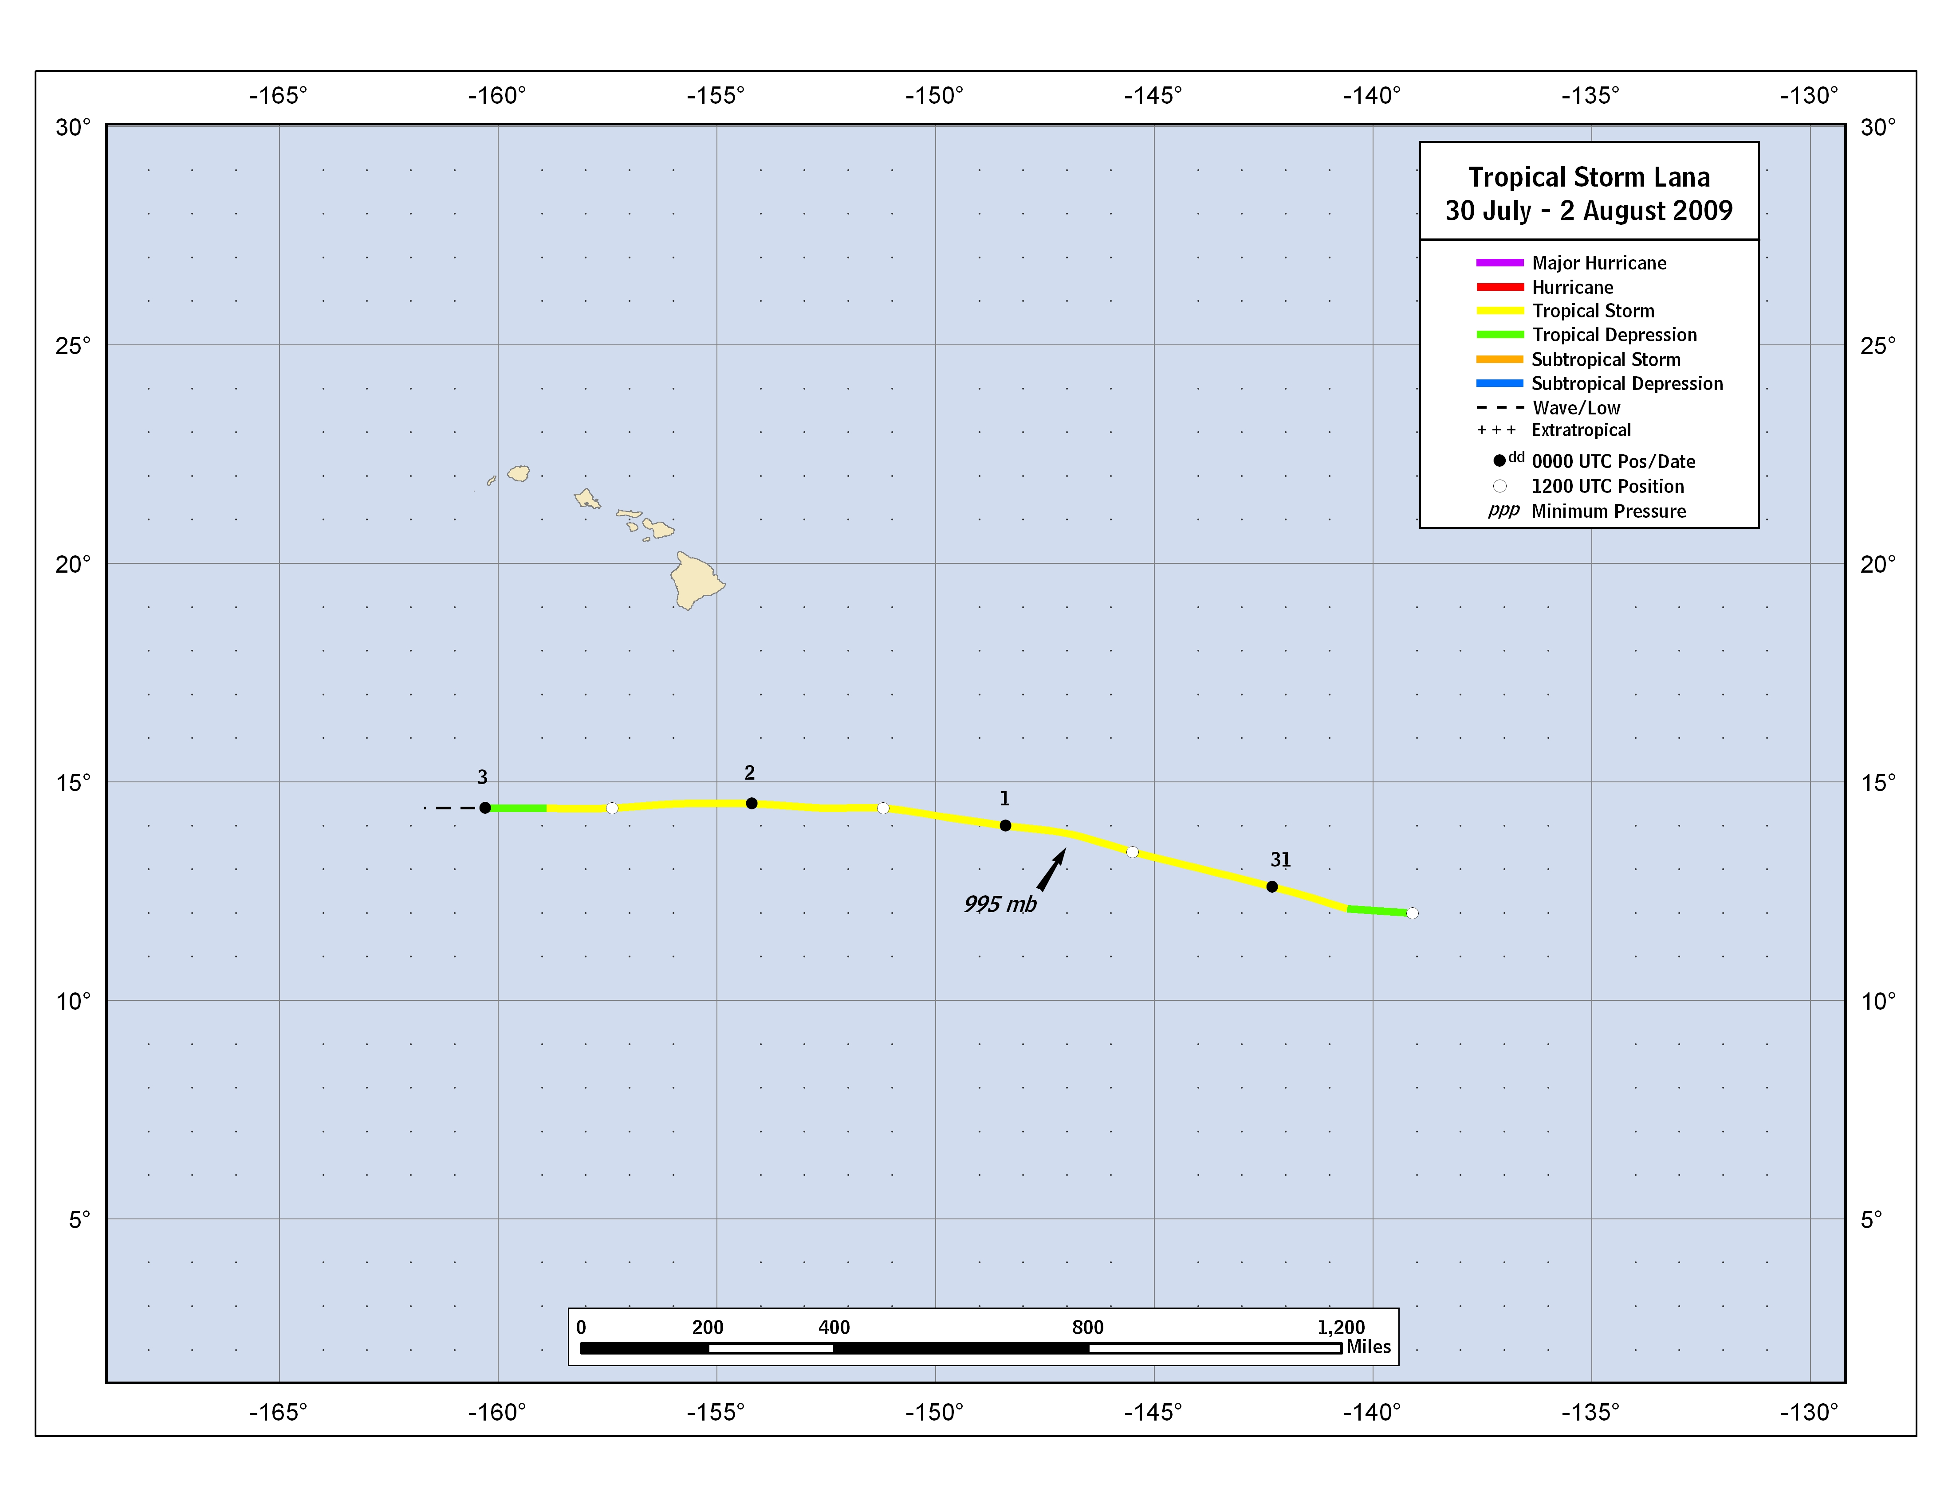
Figure 1. Best track positions for Tropical Storm Lana, 30 July–2 August 2009.

Figure 2. Selected wind observations and best track maximum sustained surface wind speed curve for Tropical Storm Lana,
30 July–2 August 2009. Dashed vertical lines correspond to 0000 UTC.

Figure 3. Selected pressure observations and best track minimum central pressure curve for Tropical Storm Lana,
30 July–2 August 2009. Dashed vertical lines correspond to 0000 UTC.

A digital record of the complete best track, including wind radii, can be found on line at ftp://ftp.nhc.noaa.gov/atcf. Data for the current year’s storms are located in the btk directory, while previous years’ data are located in the archive directory.

