Tropical Cyclone Report
Tropical Depression One-E
(EP012009)
18-19 June 2009

Eric S. Blake
National Hurricane Center
31 July 2009

The genesis of this tropical cyclone can be traced to a tropical wave that left the west coast of Africa on 29 May. Any thunderstorm activity produced by the wave was confined to the ITCZ as the system moved slowly westward across the Atlantic Ocean. The system entered the eastern North Pacific on 10 June with vigorous convection, but little organization, and moved westward during the next five days with generally disorganized convection. Late on 15 June, a broad low formed from the wave several hundred miles south-southwest of Acapulco, Mexico. The low moved toward the west-northwest on 16 June, then to the northwest on 17 June while the low-level circulation became better-defined. Convection increased near the low early on 18 June and a tropical depression formed around 1200 UTC that day, located about 350 n mi south-southwest of Mazatlan, Mexico. The “best track” chart of the tropical cyclone’s path is given in Figure 1, and the best track positions and intensities are listed in Table 1.

The depression turned toward the north on 18 June and north-northeast the next day as it moved around the western periphery of a mid-level ridge over Mexico and ahead of an unusually deep trough approaching California. By the evening of 18 June, the system was on the verge of becoming a tropical storm, but convection associated with the system weakened early the next day. Visible satellite images indicated that the low-level circulation became elongated and ill-defined on 19 June as the low approached southwestern Mexico. It is estimated the depression degenerated into an open trough of low pressure by 1800 UTC 19 June, near Las Tres Marias, Mexico.

The genesis of this depression was well-anticipated. The system was introduced into the Tropical Weather Outlook about 3 days before genesis, and during the 48 hours prior to genesis, 7 out of 8 forecasts issued were for a high chance (greater than 50%) of tropical cyclone formation.

Although a tropical storm watch was issued for southwestern Mexico and a tropical storm warning was issued for Las Tres Marias, the system remained below tropical storm strength.

Table 1. Best track for Tropical Depression One-E, 18-19 June 2009.

Date/Time  (UTC) | Latitude  (°N) | Longitude  (°W) | Pressure  (mb) | Wind Speed  (kt) | Stage
17 / 1800 | 15.9 | 107.8 | 1006 | 25 | low
18 / 0000 | 16.3 | 108.1 | 1005 | 25 | "
18 / 0600 | 16.8 | 108.2 | 1005 | 25 | "
18 / 1200 | 17.3 | 108.2 | 1005 | 25 | tropical depression
18 / 1800 | 17.9 | 108.1 | 1004 | 30 | "
19 / 0000 | 18.6 | 107.8 | 1003 | 30 | "
19 / 0600 | 19.6 | 107.4 | 1003 | 30 | "
19 / 1200 | 20.8 | 107.0 | 1003 | 30 | "
19 / 1800 | - | - | - | - | dissipated
19 / 0000 | 18.6 | 107.8 | 1003 | 30 | minimum pressure

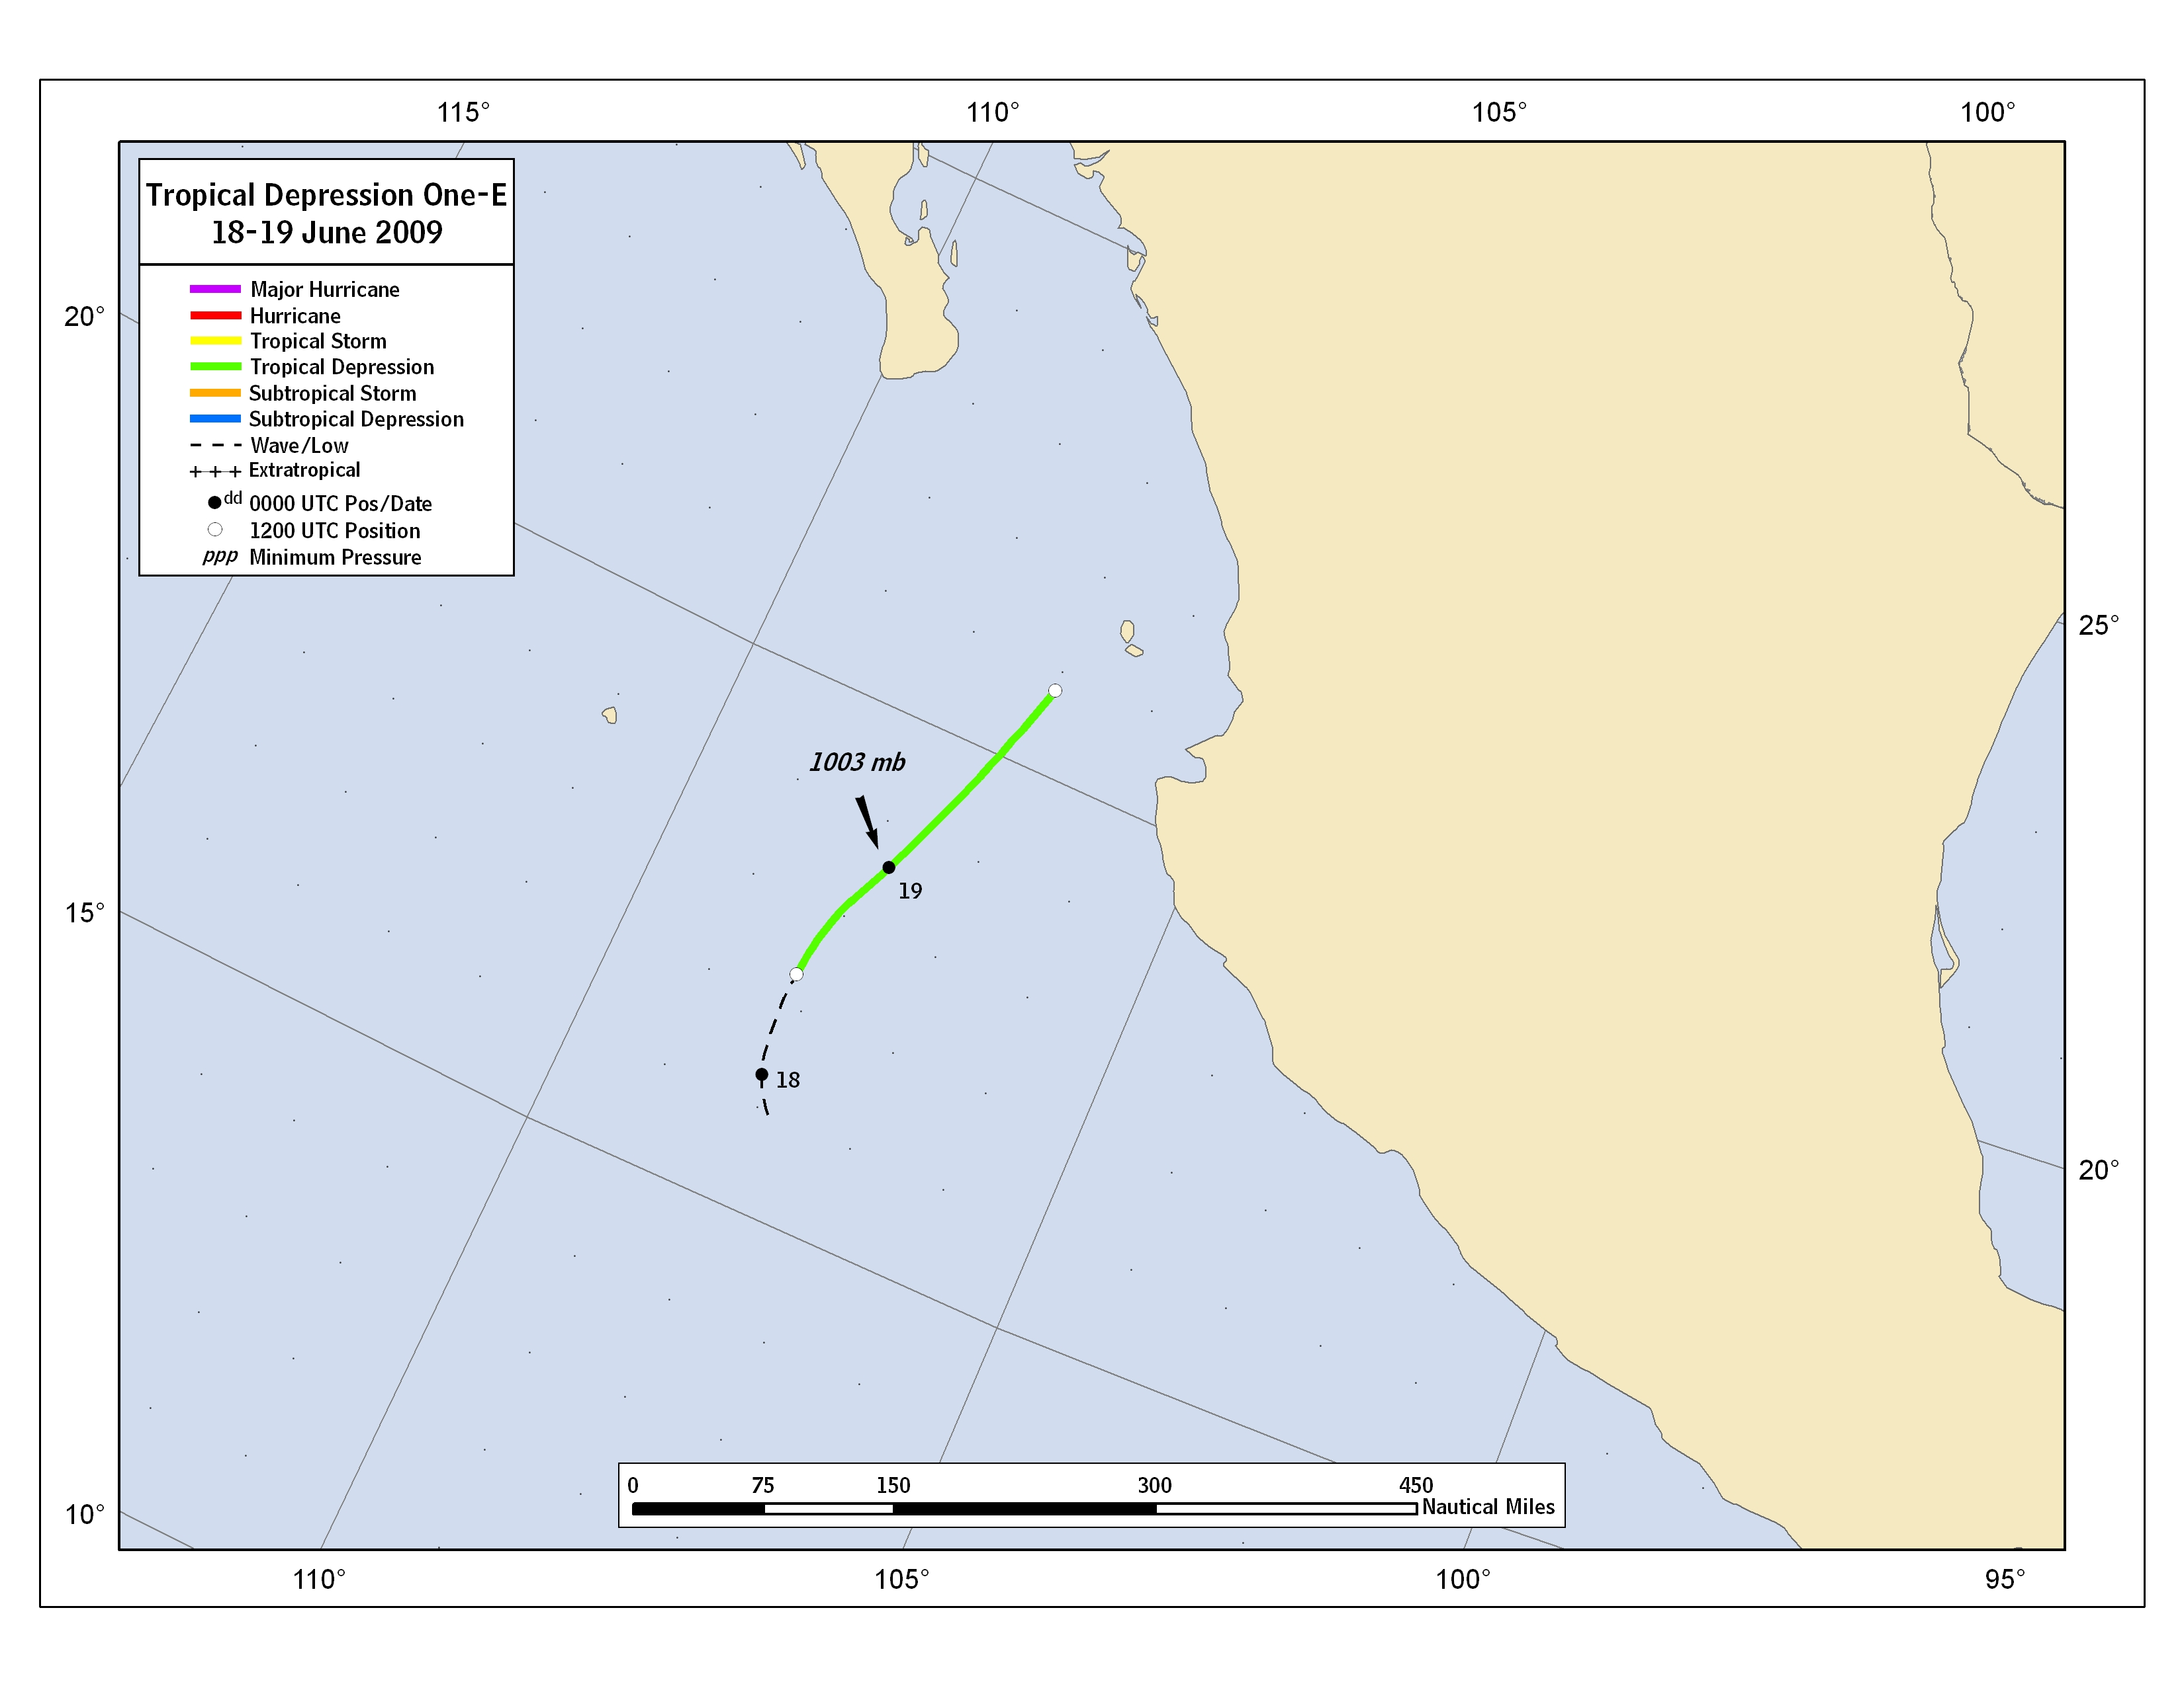

Figure 1. Best track positions for Tropical Depression One-E, 18-19 June 2009.

A digital record of the complete best track, can be found on line at ftp://ftp.nhc.noaa.gov/atcf. Data for the current year’s storms are located in the btk directory, while previous years’ data are located in the archive directory.

