Tropical Cyclone Report
Hurricane Adrian
17-21 May 2005

Richard D. Knabb
National Hurricane Center
24 November 2005

Hurricane Adrian was a very early season tropical cyclone that moved northeastward. Adrian was briefly a category 1 hurricane (on the Saffir-Simpson Hurricane Scale) as it approached Central America but then weakened just offshore of El Salvador. It later made landfall as a tropical depression on the Pacific coast of Honduras via the Gulf of Fonseca. Adrian caused heavy rains, flooding, and mud slides in portions of Central America. One fatality directly attributable to Adrian was reported in Nicaragua. No eastern Pacific hurricane has come closer to El Salvador in at least 57 years than Adrian.

- Synoptic History

As is often the case with early season tropical cyclones in the eastern North Pacific basin, the incipient weather systems leading to the formation of Adrian were relatively weak and difficult to track until just before reaching the area of genesis. Disorganized areas of disturbed weather moved westward from Central America during 10-14 May, perhaps aiding in the development of a broad and nearly stationary area of low pressure centered about 450 n mi south-southeast of Acapulco, Mexico. While convection within this broad low gradually consolidated on 15-16 May, another disturbance crossed Central America on 15 May. Analysis of satellite Hovmoeller diagrams indicates the latter disturbance can be tracked back to a poorly-defined tropical wave that crossed northern South America during 11-13 May. As this wave moved westward over the eastern Pacific into the area of the nearly stationary low on 16 May, convective organization within the low increased further. Dvorak classifications began late on 16 May as the low began drifting east-northeastward. A tropical depression is estimated to have formed from these systems at 1800 UTC 17 May, just south of 10°N latitude about 400 n mi west-southwest of El Salvador. While most eastern Pacific tropical cyclones have remained from 10°N northward throughout their existence, 40 of them in the available records back to 1949, including Adrian, have spent at least some time south of 10°N. The farthest south was a tropical depression that formed near 7.1°N and later became Hurricane Adolph (1983).

The “best track” chart of Adrian’s path is given in Fig. 1, with the wind and pressure histories shown in Figs. 2 and 3, respectively. The best track positions and intensities are listed in Table 1. Adrian did not follow the typical westward to northwestward track of most eastern Pacific tropical cyclones. Rather, it moved generally toward the east-northeast throughout its lifetime in advance of an unusually strong mid- to upper-level trough that extended over Mexico and the extreme eastern Pacific Ocean. Following genesis, the depression initially moved very slowly, about 4 kt, while strengthening to a tropical storm by 0000 UTC 18 May. Adrian gradually gained additional strength on 18-19 May while moving at 7-8 kt in an environment of moderate southwesterly wind shear. During this period, convection in bands well removed from the center dissipated, while convection became more concentrated in a small area near the center. Adrian was briefly a hurricane with an estimated intensity of 70 kt near 1800 UTC 19 May about 75 n mi southwest of the coast of El Salvador.

Operationally, Adrian was assessed to have made landfall on the coast of El Salvador near 0600 UTC 20 May as a borderline category 1 hurricane. Post-storm analysis reveals, however, that shortly after Adrian reached hurricane status offshore, the persistent southwesterly wind shear led to its abrupt weakening, and that the low-level center turned toward the east and never made landfall in El Salvador. The nearly perpendicular approach of Adrian toward the mountain ranges of Central America might have enhanced the effects of the wind shear by limiting the northeastward motion of the low-level portion of the tropical cyclone. While it appears that a mid-level circulation center accompanied the strong convection that continued northeastward and passed over El Salvador early on 20 May, during that same period the low level center moved eastward and roughly parallel to the El Salvador coast. Adrian weakened to a 35-kt tropical storm by 1200 UTC 20 May when it was centered about 30 n mi offshore from eastern El Salvador. Further weakening ensued and the center of the tropical depression entered the Gulf of Fonseca at about 1800 UTC 20 May and moved inland over Honduras around 2100 UTC. The circulation dissipated within a few hours after moving inland.

Adrian made the closest approach to El Salvador (approximately 75 n mi) of any eastern Pacific hurricane in the available records since 1949. The next closest were an unnamed hurricane in 1954 and Hurricane Olivia (1971), both of which became hurricanes about 100 n mi west-southwest of El Salvador and were moving westward. However, Adrian was not the closest approach to El Salvador of a strong tropical storm. While Adrian was still about 60 n mi from El Salvador before its intensity decreased to less than 60 kt, Tropical Storm Miriam (1988), moving toward the west-northwest, passed only about 20 n mi off the coast of El Salvador at that intensity. Since the center of Adrian did not make landfall on the coast of El Salvador, Andres (1997) remains the only landfall in that country since 1949, and it did so as a tropical depression. Adrian was only the third eastern Pacific tropical cyclone since 1949 to make landfall in Central America; all were depressions at landfall including Paul (1982) in Guatemala.

- Meteorological Statistics

Observations in Adrian (Figs. 2 and 3) include satellite-based Dvorak technique intensity estimates from the Tropical Analysis and Forecast Branch (TAFB), the Satellite Analysis Branch (SAB) and the U. S. Air Force Weather Agency (AFWA), as well as flight-level and dropwindsonde observations from one mission of the 53rd Weather Reconnaissance Squadron of the United States Air Force Reserve Command. Microwave satellite imagery from National Oceanic and Atmospheric Administration (NOAA) polar-orbiting satellites, the National Aeronautics and Space Administration (NASA) Tropical Rainfall Measuring Mission (TRMM), the NASA QuikSCAT, and Defense Meteorological Satellite Program (DMSP) satellites were also useful in tracking Adrian and assessing its structure.

The significant changes in Adrian on 19 and 20 May were challenging to diagnose both operationally and in post-analysis even given more data than usual, including aircraft reconnaissance, for an eastern Pacific hurricane. Passive microwave imagery at 1238 UTC 19 May from the Special Sensor Microwave Imager (SSMI) depicted inner-core convective banding around a developing eye-like feature, suggesting, along with Dvorak classifications, that Adrian was nearing hurricane intensity. The one United States Air Force reconnaissance flight into Adrian during the early afternoon of 19 May indicated that it had subsequently become a hurricane. The mission included two separate penetrations of the eye. The first fix at 1655 UTC estimated a minimum central pressure of 982 mb and maximum flight-level winds of 83 kt. The standard 80% reduction of this observation yields surface winds of approximately 66 kt. The second aircraft fix at 1830 UTC estimated a slightly greater minimum central pressure of 984 mb, and maximum 850 mb flight-level winds of 92 kt. The 80% reduction of this observation would yield about 74 kt at the surface. However, this was a somewhat isolated peak measurement, and it is reasonable to assume that the vertical extent of the strongest winds was also relatively small and that 75 kt winds might not have reached the surface. The slightly broader area of flight-level winds exceeding 85 kt supports assigning a peak best track intensity of 70 kt at 1800 UTC 20 May. The slight rise in central pressure between the two fixes might have been an early sign of the subsequent weakening of Adrian. Also, the second aircraft fix was due east of the first by about 7 n mi. While consecutive fixes do not always depict real motion, it is possible that this was an initial indication of the turn of the low-level center toward the east that has been analyzed based on several other sources of data from the following 24 h.

The satellite cloud pattern became elongated after the aircraft departed, indicating the effects of wind shear. GOES imagery, SSMI imagery, and analysis of QuikSCAT directional ambiguities near 0000 UTC 20 May all suggested the low-level center was located on the south edge of the deep convection and to the east of the earlier aircraft fixes. AMSU imagery near 0400 UTC and TRMM imagery at 0730Z suggested the low-level center continued toward the east. Hints of an offshore low-level swirl then appeared on GOES 3.9 µm imagery beginning at about 0900 UTC. GOES visible imagery later on 20 May more clearly revealed the low-level circulation, with a weak attendant convective band. Continuity of the fix positions from the aircraft, microwave imagery, and GOES imagery (Fig. 4) strongly suggests that this feature was the low-level circulation of the weakening tropical cyclone that eventually made landfall east of El Salvador on 20 May.

Surface observations, some of which were received after the event, also support the conclusion that the low-level circulation center passed south of the El Salvador coast, and no direct evidence could be found for a landfalling circulation center in El Salvador. The only reports of tropical storm force winds from land-based locations were in gusts very early on 20 May, when the center of Adrian was about 40 n mi south of the coast. The meteorological service of El Salvador, Servicio Nacional de Estudios Territoriales (SNET), indicated a gust to 38 kt was reported at 0500 UTC 20 May at the El Salvador International Airport (just inland from the central coast), and that a gust to 42 kt was reported at 0600 UTC at San Miguel (well inland in eastern El Salvador at an elevation of 80 m). Poor exposure at many land-based sites may have resulted in underestimates of the wind speeds, and many wind direction observations do not appear to have responded to the circulation of Adrian. Sustained tropical storm force winds, as strong as 43 kt, were observed near 0400 UTC 20 May by the cruising yacht SV-Carina that was anchored along the central coast of El Salvador near Bahia del Sol. Additionally, the wind directions from SV-Carina were useful in the post-storm analysis since they were also consistent with the conclusion that the center of Adrian remained offshore from El Salvador. Data from SV-Carina were obtained after the event by HAM radio operators at the National Hurricane Center who employed the assistance of dozens of other HAM operators and the Hurricane Watch Net to contact the crew of the vessel. Their efforts are greatly appreciated.

Ship PCEX reported sustained winds of 34 kt at 1200 UTC 20 May about 40 n mi south of the center of Adrian. Even though this observation occurred within a band of convection, it might have been a slight overestimate. However, 34-kt winds could easily have occurred closer to the center. This ship also reported a surface pressure of 1008 mb. These observations support the best track intensity of 35 kt and central pressure of 1003 mb at that time.

The hydrological service of SNET in El Salvador reported that Adrian produced storm total rainfall of at least 4 inches throughout most of the eastern two-thirds of that country, with isolated maxima to 16 inches in the mountainous terrain.

- Casualty and Damage Statistics

Media reports indicate as many as 23,000 people in El Salvador were evacuated from the coast and from inland flood-prone areas. Smaller-scale evacuations were reported in Guatemala and Nicaragua. Widespread flooding, many washed out roads, and some mud slides were reported in El Salvador and Honduras. Flooding was also reported in portions of Nicaragua and Guatemala. One fatality directly attributable to Adrian, due to flooding, was reported in Nicaragua. Reports from SNET indicate that wind damage in El Salvador was not substantial and was limited to some downed trees and power outages. Media reports reveal that widely scattered and mostly minor damage to homes was caused by Adrian in El Salvador and Honduras.

- Forecast and Warning Critique

The potential for genesis of the tropical cyclone that became Adrian was conveyed by the National Hurricane Center in the eastern Pacific Tropical Weather Outlook beginning the morning of 16 May, more than 24 hours in advance of the first tropical cyclone advisory. Global models initialized well the broad and nearly stationary low pressure area involved in the genesis and, up to about three days in advance, were strongly suggesting that this system would develop into a tropical cyclone.

Average official (OFCL) track forecast errors (with the number of cases in parentheses) for Adrian were 59 (12), 65 (10), 75 (8), 110 (6), and 215 (2) n mi for the 12, 24, 36, 48, and 72 h forecasts, respectively (no 96 and 120 h forecasts could be verified due to the short life span of Adrian). The errors at 24, 36, and 48 h are somewhat less than the average official track errors for the 10-yr period 1995-2004 (Table 2), while the errors at 12 and 72 h are somewhat greater (although there were only two 72 h forecasts to verify). On average, the interpolated Global Forecast System model (GFSI) outperformed OFCL at all forecast times through 72 h, and the interpolated Geophysical Fluid Dynamics Laboratory hurricane model (GFDI) did so through 36 h. However, average OFCL errors were less than those of the other individual dynamical models (i.e., GFNI, NGPI, UKMI) at most forecast times. All of the track guidance agreed on the northeastward motion, even in the early stages when the tropical depression initially formed, thereby increasing the confidence in the official track forecasts.

Official forecasts of the track of Adrian that were issued up to about the time it became a hurricane on 19 May were very accurate, with most errors much less than the 10-yr averages. Many of the subsequent forecasts, however, were characterized by a substantial bias toward the north, due mostly to the unexpected weakening and eastward motion just before landfall that were assessed after the event. All of the official forecasts issued 17-19 May indicated a tropical depression was expected to cross the western Caribbean Sea and Cuba, but the uncertainty in whether or not Adrian would even emerge beyond Central America was conveyed in many of the tropical cyclone discussions. Most of the dynamical models also forecast Adrian to move through the western Caribbean Sea, except for several GFDI and GFNI forecasts, especially those initialized at 1800 UTC 18 May and thereafter, which dissipated the low-level center near or over Central America.

Average official intensity errors were 5, 6, 6, 8, and 8 kt for the 12, 24, 36, 48, and 72 h forecasts, respectively. For comparison, the average official intensity errors for these forecast times over the 10-yr period 1995-2004 are 6, 11, 14, 17, and 19 kt, respectively. The official intensity errors were on average relatively small and unbiased, and they were less than those from all available intensity guidance models out to 72 h. However, the intensification to a 70-kt hurricane on 19 May was under-forecast at most lead times, generally by about 10 kt. The SHIPS model also under-forecast the peak intensity, while the GFDI and GFNI models only captured the peak intensity 24 h in advance and overall had a high bias during the event.

Table 3 lists the coastal watches and warnings issued by countries in Central America in association with Adrian. Even though it has been determined in post-analysis that Adrian did not make landfall as a hurricane in El Salvador as assessed operationally, the hurricane and tropical storm watches and warnings issued on 18 and 19 May were warranted, given all data and forecast guidance available at the time. These watches and warnings invoked prudent preparations to protect lives and property in many areas including El Salvador, which was affected by heavy rains, flooding, and mud slides and by tropical storm force winds (at least in gusts). The potential for heavy rains and flooding in Central America was consistently conveyed in all National Hurricane Center advisories on Adrian.
Table 1. Best track for Hurricane Adrian, 17-21 May 2005.

Date/Time  (UTC) | Latitude  (°N) | Longitude  (°W) | Pressure  (mb) | Wind Speed  (kt) | Stage
17 / 1800 | 9.8 | 95.2 | 1005 | 30 | tropical depression
18 / 0000 | 10.1 | 94.9 | 1004 | 35 | tropical storm
18 / 0600 | 10.5 | 94.4 | 1003 | 40 | "
18 / 1200 | 10.7 | 93.6 | 1000 | 45 | "
18 / 1800 | 10.8 | 92.9 | 997 | 50 | "
19 / 0000 | 11.0 | 92.3 | 997 | 50 | "
19 / 0600 | 11.5 | 91.8 | 997 | 50 | "
19 / 1200 | 12.1 | 91.2 | 990 | 60 | "
19 / 1800 | 12.5 | 90.6 | 983 | 70 | hurricane
20 / 0000 | 12.6 | 89.9 | 990 | 60 | tropical storm
20 / 0600 | 12.7 | 89.2 | 997 | 50 | "
20 / 1200 | 12.7 | 88.5 | 1003 | 35 | "
20 / 1800 | 13.0 | 87.9 | 1006 | 25 | tropical depression
21 / 0000 | 13.4 | 87.4 | 1008 | 20 | "
21 / 0600 |  |  |  |  | dissipated
19 / 1700 | 12.5 | 90.7 | 982 | 70 | minimum pressure
20/2100 | 13.3 | 87.6 | 1007 | 20 | landfall on the Pacific coast of Honduras in the Gulf of Fonseca

Table 2. Preliminary track forecast evaluation (heterogeneous sample) for Hurricane Adrian, 17-21 May 2005. Forecast errors (n mi) are followed by the number of forecasts in parentheses. Errors smaller than the NHC official forecast are shown in bold-face type. Verification includes the depression stage, but does not include the extratropical stage, if any. Models not available at the time the official forecasts were made are indicated by (*).

Forecast Technique | Forecast Period (h)
Forecast Technique | 12 | 24 | 36 | 48 | 72 | 96 | 120
CLP5 | 64 (12) | 114 (10) | 185 ( 8) | 263 ( 6) | 524 ( 2)
GFNI | 49 (12) | 71 ( 9) | 101 ( 8) | 111 ( 6) | 187 ( 1)
GFDI | 36 (11) | 47 ( 9) | 52 ( 7) | 131 ( 5) | 237 ( 1)
GFDL* | 40 (11) | 64 ( 9) | 37 ( 7) | 84 ( 5) | 226 ( 2)
GFDN* | 57 (11) | 46 ( 8) | 81 ( 7) | 121 ( 5) | 229 ( 1)
GFSI | 51 ( 8) | 61 ( 8) | 47 ( 7) | 93 ( 5) | 192 ( 1)
GFSO* | 81 ( 7) | 100 ( 7) | 89 ( 7) | 81 ( 5) | 254 ( 2)
NGPI | 70 (12) | 91 (10) | 116 ( 8) | 161 ( 6) | 182 ( 2)
NGPS* | 76 (11) | 107 ( 9) | 122 ( 7) | 176 ( 5) | 174 ( 1)
UKMI | 66 (10) | 80 ( 8) | 86 ( 6) | 118 ( 4)
UKM* | 59 ( 6) | 89 ( 5) | 109 ( 4) | 112 ( 3) | 228 ( 1)
BAMD | 97 (12) | 157 (10) | 199 ( 8) | 256 ( 6) | 318 ( 2)
BAMM | 79 (12) | 107 (10) | 123 ( 8) | 129 ( 6) | 186 ( 2)
BAMS | 93 (12) | 156 (10) | 186 ( 8) | 146 ( 6) | 53 ( 2)
CONU | 49 (12) | 50 (10) | 50 ( 8) | 72 ( 6) | 121 ( 2)
GUNA | 37 ( 7) | 45 ( 7) | 53 ( 6) | 91 ( 4)
FSSE | 37 ( 8) | 68 ( 8) | 79 ( 6) | 147 ( 4)
OFCL | 59 (12) | 65 (10) | 75 ( 8) | 110 ( 6) | 215 ( 2)
NHC Official  (1995-2004 mean) | 37  (2654) | 68  (2378) | 97  (2096) | 123 (1829) | 175 (1386)

Table 3. Watch and warning summary for Hurricane Adrian, 17-21 May 2005.

Date/Time (UTC) | Action | Location
18 / 0900 | Tropical Storm Watch issued | Mexico/Guatemala Border to El Salvador/Honduras Border
18 / 2100 | Tropical Storm Watch changed to Tropical Storm Warning/Hurricane Watch | Guatemala/El Salvador Border to El Salvador/Honduras Border
18 / 2100 | Tropical Storm Watch issued | El Salvador/Honduras Border to Honduras/Nicaragua Border
19 / 1500 | Tropical Storm Watch changed to Tropical Storm Warning/Hurricane Watch | Sipicate Guatemala to Guatemala/El Salvador Border
19 / 1800 | Tropical Storm Warning/Hurricane Watch changed to Hurricane Warning | Sipicate Guatemala to El Salvador/Honduras Border
20 / 0300 | Tropical Storm Watch discontinued | Mexico/Guatemala Border to Sipicate Guatemala
20 / 0300 | Hurricane Warning changed to Tropical Storm Warning | Sipicate Guatemala to Guatemala/El Salvador Border
20 / 0900 | Hurricane Warning changed to Tropical Storm Warning | Guatemala/El Salvador Border to El Salvador/Honduras Border
20 / 0900 | Tropical Storm Watch discontinued | El Salvador/Honduras Border to Honduras/Nicaragua Border
20 / 0900 | Tropical Storm Warning discontinued | Sipicate Guatemala to Guatemala/El Salvador Border
20 / 1200 | Tropical Storm Warning discontinued | Guatemala/El Salvador Border to El Salvador/Honduras Border

Figure 1. Best track positions for Hurricane Adrian, 17-21 May 2005.

Figure 2. Selected wind observations and best track maximum sustained surface wind speed curve for Hurricane Adrian, 17-21 May 2005. Aircraft observations have been adjusted for elevation using an 80% reduction factor for observations from 850 mb.

Figure 3. Selected pressure observations and best track minimum central pressure curve for Hurricane Adrian, 17-21 May 2005.
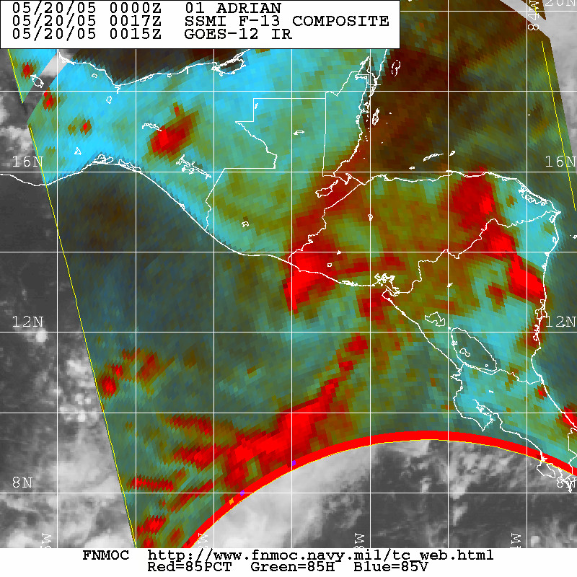
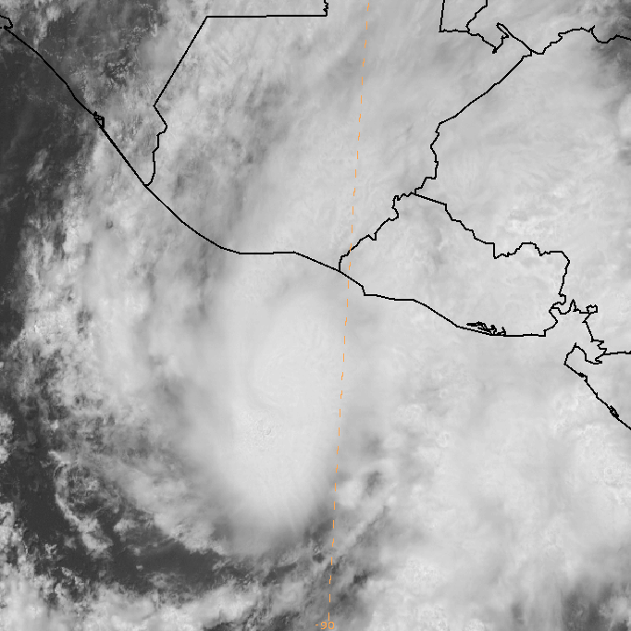
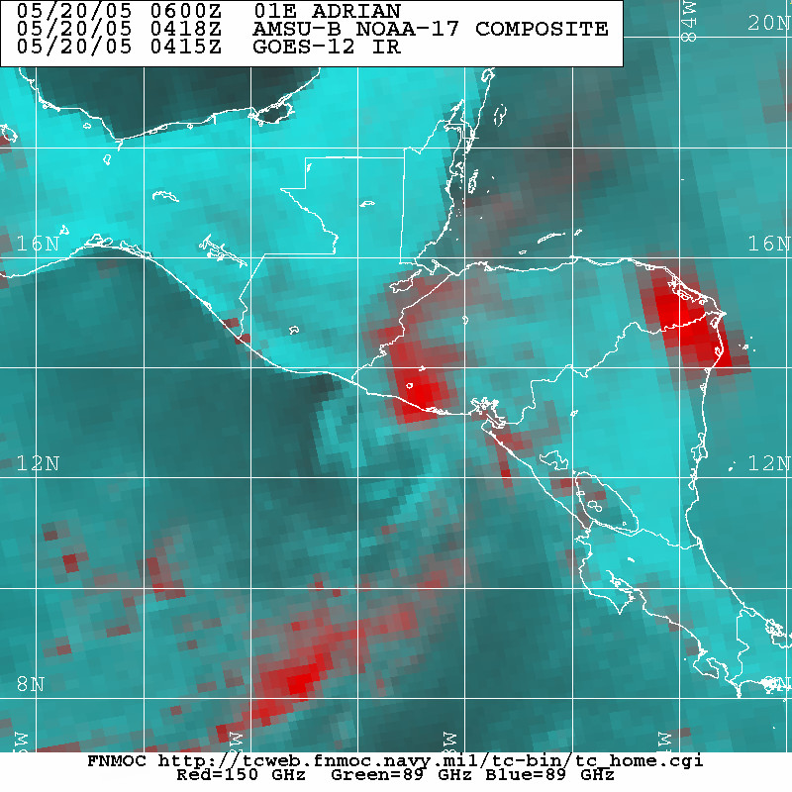
A) 1815 UTC 19 May B) 0017 UTC 20 May C) 0418 UTC 20 May
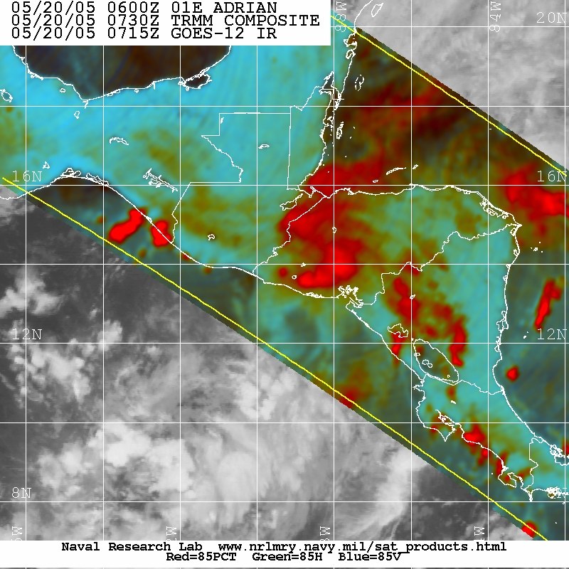
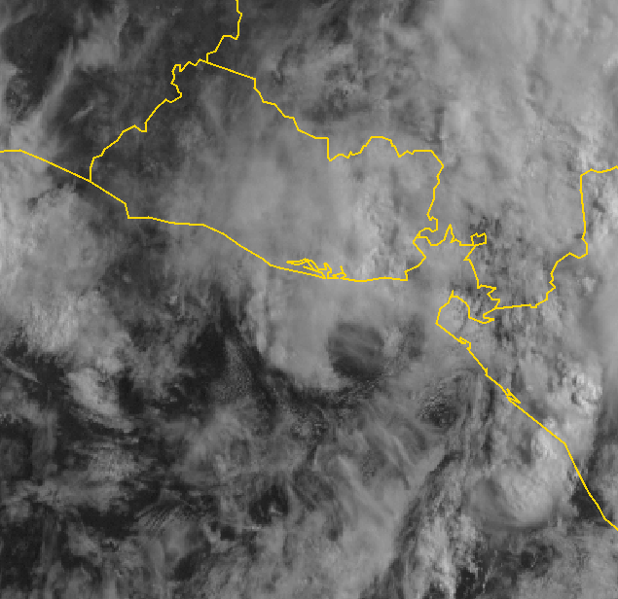
D) 0730 UTC 20 May E) 1415 UTC 20 May

Figure 4. Sequence of infrared and microwave images of Hurricane Adrian on 19 and 20 May 2005 depicting its weakening and turn to the east just off the coast of El Salvador. A) GOES-12 visible, 1815 UTC 19 May; B) SSMI 85 GHz color composite, 0017 UTC 20 May; C) AMSU color composite, 0418 UTC 20 May; D) TRMM 85 GHz color composite, 0730 UTC 20 May; E) GOES-12 visible, 1415 UTC 20 May.

