Tropical Cyclone Report
Hurricane Paloma
(AL172008)
5-9 November 2008

Michael J. Brennan
National Hurricane Center
26 January 2009

Updated 4 February 2009 for modification to best track over Cuba and landfall location

Updated 17 February 2009 to correct station elevation for wind observation on Cayman Brac

Updated 14 April 2009 for damage details, damage amounts, and rainfall totals from Cuba

Hurricane Paloma was a powerful hurricane that formed in the western Caribbean Sea and impacted the Cayman Islands before making landfall in Cuba and rapidly weakening. Paloma reached category 4 intensity (on the Saffir-Simpson Hurricane Scale) and became the second-strongest November Atlantic hurricane on record.

- Synoptic History

Paloma originated from a broad area of disturbed weather that developed in the southwestern Caribbean Sea on 1 November. Convection in this region was intermittent for a couple of days but became more persistent on 4 November, and Dvorak classifications were initiated on the disturbance at 0000 UTC that day. The system continued to become better organized and is estimated to have developed into a tropical depression around 1800 UTC 5 November, about 115 n mi southeast of the Nicaragua/Honduras border. The “best track” chart of Paloma’s path is given in Fig. 1, with the wind and pressure histories shown in Figs. 2 and 3, respectively. The best track positions and intensities are listed in Table 1.

At the time of genesis, the depression was located on the southwestern edge of a mid- to upper-level ridge centered over the eastern Caribbean, resulting in an initial motion toward the northwest. The tropical cyclone was situated in a small region of relatively low wind shear south of a belt of strong upper-level winds associated with a long wave mid- to upper-level trough centered in the Gulf of Mexico. The combination of low shear and favorable oceanic conditions allowed the depression to steadily intensify, and the depression became a tropical storm around 0600 UTC 6 November about 60 n mi east of the Nicaragua/Honduras border. Paloma then turned toward the north as it continued to move around the periphery of the ridge and reached hurricane status around 0000 UTC 7 November, about 155 n mi south-southwest of Grand Cayman.

Paloma began to rapidly intensify late on 7 November and became a major hurricane around 0000 UTC 8 November. This intensification may have occurred partly in response to an increase in upper-level divergence over the cyclone, as indicated in the SHIPS model analysis, while the cyclone was located in a region of very favorable oceanic conditions for intensification. This increase in divergence aloft occurred ahead of an approaching upper-level trough digging into the Gulf of Mexico, which also appears responsible for enhancing the outflow on the northwestern periphery of the cyclone early on 8 November. Paloma reached its peak intensity of 125 kt (category 4) around 1200 UTC that day as it turned toward the northeast (Fig. 4). During the 24-h period ending at 1200 UTC 8 November, Paloma’s intensity increased by 50 kt. At its peak intensity, Paloma became the second strongest November Atlantic hurricane on record; only Hurricane Lenny (1999) was stronger (135 kt). Paloma was a category 4 hurricane when the cyclone’s eye passed just to the southeast of Little Cayman and Cayman Brac, with the northwestern eyewall passing over the eastern end of Cayman Brac.

Late on 8 November and early on 9 November, Paloma began to weaken as vertical wind shear increased markedly as the aforementioned mid- to upper-level trough continued to move eastward. According to the SHIPS model analysis, the magnitude of the shear increased from 27 kt at 1800 UTC 8 November to 40 kt at 0000 UTC 9 November. As the hurricane approached Cuba, the strong upper-level southwesterly winds advected the mid- and upper-level portions of Paloma’s circulation rapidly to the northeast (Fig. 5). While weakening, Paloma crossed the Jardines de la Reina archipelago and its center made landfall around 0100 UTC 9 November near Santa Cruz del Sur, Camagüey, Cuba. At the time of landfall, Paloma is estimated to have been a category 2 hurricane, with maximum sustained winds of around 85 kt.

After landfall, the low-level center of Paloma continued northeastward for a short time, then slowed and turned toward the northwest while it continued to decouple from the deep layer flow. The cyclone weakened rapidly due to continued strong vertical wind shear, a decrease in deep convection, and interaction with the landmass of Cuba. Paloma became a tropical storm around 0600 UTC 9 November and further weakened to a tropical depression by 1800 UTC that day. During the 24-h period ending at 1200 UTC 9 November, Paloma weakened by 90 kt, from a 125-kt category 4 hurricane (Fig. 6) to a 35-kt tropical storm (Fig. 7). By 0000 UTC 10 November, no deep convection was present near the circulation of Paloma, marking the degeneration of the cyclone into a remnant low.

On 10 November, the remnant low of Paloma moved slowly northward into the Atlantic waters just north of east-central Cuba before becoming nearly stationary early on 11 November. Later that day, as a low-level ridge built to the north over the western Atlantic, Paloma’s remnants completed a small anticyclonic loop, and began moving southwestward across Cuba before re-entering the northwestern Caribbean early on 12 November. The remnant low turned toward the west and west-northwest later that day, around the western periphery of the low-level ridge, and passed just north of the Isle of Youth around 0000 UTC 13 November before crossing the western tip of Cuba and entering the Gulf of Mexico. As Paloma’s remnants accelerated northward, the surface low center became ill-defined early on 14 November, about 60 n mi south-southwest of Apalachicola, Florida. Although the low-level center dissipated, remnant moisture contributed to the development of heavy rainfall in the Florida panhandle later that day.

- Meteorological Statistics

Observations in Paloma (Figs. 2 and 3) include satellite-based Dvorak technique intensity estimates from the Tropical Analysis and Forecast Branch (TAFB) and the Satellite Analysis Branch (SAB), as well as flight-level, stepped frequency microwave radiometer (SFMR), and dropwindsonde observations from seven flights of the 53rd Weather Reconnaissance Squadron of the U. S. Air Force Reserve Command and three flights of the NOAA Aircraft Operations Center (AOC) WP-3D aircraft. In addition, the NOAA G-IV aircraft flew two synoptic surveillance missions around Paloma. Data and imagery from NOAA polar-orbiting satellites, the NASA Tropical Rainfall Measuring Mission (TRMM), the NASA QuikSCAT, and Defense Meteorological Satellite Program (DMSP) satellites, among others, were also useful in tracking Paloma. Radar data from Cuba were helpful in tracking Paloma as it approached and made landfall on the island.

The 125-kt (category 4) estimated peak intensity of Paloma at 1200 UTC 8 November is based on blend of a 127-kt wind measurement from the SFMR around 1110 UTC and a maximum flight-level wind of 134 kt measured at 0935 UTC, which corresponds to a surface wind estimate of 121 kt using the standard 90 percent adjustment factor. This intensity was maintained at 1800 UTC based on a flight level wind-maximum of 142 kt at 1931 UTC, which equates to 128-kt at the surface using the standard adjustment, and a wind measurement of 124 kt from the SFMR at 1935 UTC. Paloma began to weaken rapidly late on 8 November as indicated by decreasing SFMR and flight-level wind measurements and rising central pressure. The intensity at landfall is estimated to be 85 kt (category 2). This estimate is based on a flight-level wind maximum of 94 kt measured around 2315 UTC 8 November, which equates to 85 kt at the surface using the standard flight level to surface adjustment, and an observed 78-kt sustained wind at 0130 UTC 9 November at Santa Cruz del Sur, Camagüey, Cuba.

Selected surface observations from land stations and data buoys are given in Table 2. No ship reports of winds of tropical storm force or greater were associated with Paloma. On Cayman Brac an unofficial anemometer at an elevation of 73 meters above sea level measured a sustained wind of 131 kt around 1200 UTC 8 November, near the time of Paloma’s maximum intensity. On Grand Cayman, the highest reported sustained wind was 52 kt at the Owen Roberts International Airport on the western side of the island at 2206 UTC 7 November. On the eastern side of Grand Cayman, an automated station reported a maximum sustained wind of 50 kt.

In Cuba, the highest reported sustained wind was that mentioned above at Santa Cruz del Sur, where a gust of 105 kt was also measured. Elsewhere in Camagüey, the highest reported sustained winds were between 34 and 39 kt, with gusts around 50 kt.

The minimum pressure in Paloma is estimated to be 944 mb around 1200 UTC 8 November based on a dropsonde measurement in the eye of 945 mb around 0930 UTC and another dropsonde that measured a pressure of 946 mb with 24 kt of wind at the surface at 1112 UTC. The minimum pressure measured on Cayman Brac was 959 mb at 0900 UTC 8 November. The landfall pressure is estimated to be around 970 mb based on continued weakening of the cyclone after the final dropsonde pressure measurement of 968 mb at 2305 UTC 8 November. The lowest pressure measured in Cuba was 985 mb at Santa Cruz del Sur at 0010 UTC 9 November.

Paloma produced 17.77 inches of rain on Cayman Brac, with 6.05 inches reported on Grand Cayman. In Cuba, Paloma produced rainfall totals of 5 to 15 inches across portions of Camagüey, with maximum amounts of 15.78 inches at Presa Najasa and 15.08 inches at Cuatro Caminos. In Las Tunas, rainfall of around 2 to 3 inches was reported.

A storm surge of 4 to 8 feet is estimated to have occurred on Cayman Brac, with 2 to 4 feet estimated on Little Cayman. No storm surge height estimates were received from Cuba, however the Cuban Meteorological Service reported that storm surge penetrated inland 0.8 n mi in Santa Cruz del Sur and 0.4 n mi in Guayabal.

- Casualty and Damage Statistics

No direct casualties or fatalities were reported in association with Paloma.

The greatest impacts from Paloma occurred on Cayman Brac and Little Cayman. On Cayman Brac nearly every building on the island was damaged or destroyed, according to media reports from the Cayman Net News. Damage on Little Cayman appears to have been less severe, but trees and power lines along with some buildings were significantly damaged. An official monetary estimate of damages from the Cayman Islands is not available as of this writing, but media reports from Cayman Net News suggest damages were between $15 and $20 million (USD). According to the Cuban government, 12,159 homes were impacted by Paloma, with 1,453 homes destroyed. Paloma caused around $300 million (USD) in damage on that island.

- Forecast and Warning Critique

The genesis of Paloma was fairly well anticipated. The area of disturbed weather that became Paloma was first mentioned in the Tropical Weather Outlook (TWO) at 1800 UTC
2 November, 72 h prior to genesis. The initial genesis forecast was in the “low” category (less than 20% probability of genesis in 48 h), and the probability was increased to “medium”
(20–50% probability of genesis) at 0000 UTC 3 November and remained in this category for
36 h. Six hours prior to genesis, at 1200 UTC 5 November, the genesis forecast was increased to “high” (greater than 50% probability of genesis). While the genesis of Paloma was well anticipated overall, the probability of genesis was not raised into the “high” category until just prior to genesis.

A verification of official and guidance model track forecasts is given in Table 3. Average official track errors for Paloma were 31, 58, 80, 105, 171, and 173 n mi for the 12, 24, 36, 48, 72, and 96 h forecasts, respectively. The number of forecasts ranged from 15 at 12 h to one at 96 h. These errors are lower than the average 5-yr official track errors at all forecast times except at 24 h, when the official error was similar to the average 5-yr error, and at 72 h, when the official error was above the average 5-yr error (Table 3). The GFSI was the best single model for track and had a smaller mean error than the official track forecast at all forecast lead times through 72 h. The GUNA and FSSE consensus track models also had smaller mean errors than the official forecast from 24 through 72 h for the heterogeneous sample. However, for a homogeneous sample, the official forecast had a smaller mean error than GUNA at all times through 72 h. The official forecast was also more competitive with the FSSE in the homogeneous sample, having a smaller mean error at 12 and 72 h. Much of the track error in the official forecast at longer lead times was due to difficulty in determining how quickly Paloma’s low-level circulation would decouple from the fast mid- to upper-level flow. This uncertainty was also seen in much of the available track model guidance. From late on 5 November through early 8 November, the official forecasts carried Paloma too far to the northeast across Cuba, when in reality the cyclone weakened rapidly and slowed down dramatically after landfall (Fig. 8).

A verification of official and guidance model intensity forecasts is given in Table 4. Average official intensity errors were 14, 20, 23, 28, 36, and 50 kt for the 12, 24, 36, 48, 72, and 96 h forecasts, respectively. These errors were much larger than the average 5-yr official intensity errors, which are 7, 10, 12, 14, 18, and 20 kt, respectively. The large errors in the official forecast were due to a failure to accurately predict the timing and magnitude of both Paloma’s rapid intensification and subsequent rapid weakening (Fig. 9). However, a number of the official forecasts did correctly anticipate significant strengthening followed by considerable weakening.

Watches and warnings associated with Paloma are given in Table 5. The government of the Cayman Islands issued a hurricane watch for those islands at 1500 UTC 6 November, approximately 30 hours prior to the onset of tropical storm conditions on Grand Cayman. A hurricane warning was issued at 2100 UTC that day, approximately 24 hours prior to the onset of tropical storm conditions on Grand Cayman. While it is uncertain exactly when tropical storm or hurricane conditions began on Little Cayman and Cayman Brac, the hurricane warning was issued approximately 36 h prior to the closest approach of Paloma’s center to those islands. A hurricane watch was issued by the Cuban government for portions of that island, including the province of Camagüey where Paloma made landfall, at 1200 UTC 7 November, approximately 36 hours prior to landfall. A hurricane warning was issued for Camagüey at 2100 UTC that day, approximately 27 hours in advance of landfall.

- Acknowledgements
The Cayman Islands Airports Authority and the Meteorological Service of Cuba provided storm summaries for observation sites in their respective countries. The National Data Buoy Center supplied a storm summary for NOAA Buoy 42057.
Table 1. Best track for Hurricane Paloma, 5–9 November 2008.

Date/Time  (UTC) | Latitude  (°N) | Longitude  (°W) | Pressure  (mb) | Wind Speed  (kt) | Stage
05 / 1800 | 13.7 | 81.7 | 1004 | 25 | tropical depression
06 / 0000 | 14.2 | 82.0 | 1004 | 30 | "
06 / 0600 | 14.8 | 82.1 | 1003 | 35 | tropical storm
06 / 1200 | 15.4 | 82.0 | 1000 | 40 | "
06 / 1800 | 16.1 | 81.9 | 994 | 55 | "
07 / 0000 | 16.8 | 81.8 | 987 | 65 | hurricane
07 / 0600 | 17.4 | 81.7 | 985 | 65 | "
07 / 1200 | 18.0 | 81.6 | 979 | 75 | "
07 / 1800 | 18.6 | 81.4 | 975 | 80 | "
08 / 0000 | 19.0 | 81.0 | 964 | 100 | "
08 / 0600 | 19.4 | 80.4 | 951 | 110 | "
08 / 1200 | 19.8 | 79.6 | 944 | 125 | "
08 / 1800 | 20.2 | 78.8 | 951 | 125 | "
09 / 0000 | 20.7 | 78.0 | 968 | 90 | "
09 / 0600 | 21.0 | 77.7 | 990 | 55 | tropical storm
09 / 1200 | 21.3 | 77.8 | 1002 | 35 | "
09 / 1800 | 21.6 | 77.9 | 1004 | 25 | tropical depression
10 / 0000 | 21.8 | 77.9 | 1005 | 25 | low
10 / 0600 | 22.1 | 77.8 | 1006 | 25 | "
10 / 1200 | 22.4 | 77.7 | 1007 | 20 | "
10 / 1800 | 22.5 | 77.6 | 1008 | 20 | "
11 / 0000 | 22.4 | 77.5 | 1009 | 20 | "
11 / 0600 | 22.1 | 77.6 | 1009 | 20 | "
11 / 1200 | 21.8 | 77.9 | 1009 | 20 | "
11 / 1800 | 21.3 | 78.3 | 1009 | 20 | "
12 / 0000 | 20.9 | 78.8 | 1009 | 20 | "
12 / 0600 | 20.8 | 79.7 | 1009 | 20 | "
12 / 1200 | 21.0 | 80.7 | 1009 | 20 | "
12 / 1800 | 21.4 | 81.7 | 1009 | 20 | "
13 / 0000 | 22.1 | 82.8 | 1010 | 20 | "
13 / 0600 | 22.8 | 83.8 | 1010 | 20 | "
13 / 1200 | 23.8 | 84.7 | 1010 | 20 | "
13 / 1800 | 25.0 | 85.5 | 1010 | 20 | "
14 / 0000 | 26.8 | 85.9 | 1010 | 20 | "
14 / 0600 | 28.9 | 85.6 | 1010 | 20 | "
14 / 1200 |  |  |  |  | dissipated
08 / 1200 | 19.8 | 79.6 | 944 | 125 | Maximum wind and minimum pressure
08 / 2300 |  |  |  | 95 | Landfall of northern eyewall in Cuba
09 / 0100 | 20.7 | 78.0 | 970 | 85 | Landfall near Santa Cruz del Sur, Camagüey, Cuba
Table 2. Selected surface observations for Hurricane Paloma, 5–9 November 2008.

Location | Minimum Sea Level Pressure |  | Maximum Surface  Wind Speed |  |  | Storm surge  (ft)^{c} | Storm  tide  (ft)^{d} | Total  rain  (in)
Location | Date/  time  (UTC) | Press.  (mb) | Date/  time  (UTC)ª | Sustained  (kt)^{b} | Gust  (kt) | Storm surge  (ft)^{c} | Storm  tide  (ft)^{d} | Total  rain  (in)
Cayman Islands
Cayman Brac | 08/0900 | 959.0 | 08/1200 | 131e |  |  | 4-8 | 17.77
Grand Cayman – Owen Roberts International Airport (MWCR) | 07/0100 | 998.0 | 07/2206 | 52 |  |  |  | 6.05
Little Cayman |  |  |  |  |  |  | 2-4
Cuba
Las Tunas
Puerto Padre (78358) | 09/0710 | 1006.7 | 09/0523 | 30 | 40 |  |  | 2.83
Las Tunas (78357) | 09/0500 | 1006.0 | 09/0525 | 21 | 30 |  |  | 1.79
Camagüey
Santa Cruz del Sur (78351) | 09/0010 | 984.9 | 09/0130 | 78 | 105 |  |  | 5.43
Nuevitas (78353) | 09/0700 | 1006.4 | 09/0415 | 39 | 52 |  |  | 6.80
Camagüey (78355) |  |  | 09/0155 | 38 | 54 |  |  | 3.72
Palo Seco (78354) | 09/0330 | 1004.2 | 09/0350 | 34 | 49 |  |  | 10.62
Florida (78350) | 08/2230 | 1004.3 | 08/2230 | 34 | 48 |  |  | 1.12
Presa Najasa |  |  |  |  |  |  |  | 15.78
Cuatro Caminos |  |  |  |  |  |  |  | 15.08
Marti |  |  |  |  |  |  |  | 12.36
Esmeralda (78352) | 08/2000 | 1006.1
Buoys
NOAA Buoy 42057 – Western Caribbean | 06/2259 | 992.9 | 06/2239 | 61^{f} | 74

ª Date/time is for sustained wind when both sustained and gust are listed.
^{b} Except as noted, sustained wind averaging periods for C-MAN and land-based ASOS reports are 2 min; buoy averaging periods are 8 min.
^{c} Storm surge is water height above normal astronomical tide level.
^{d} Storm tide is water height above National Geodetic Vertical Datum (1929 mean sea level).
^{e} Anemometer elevation 73-m above sea level
^{f} Wind averaging period is 1 min.

Table 3. Track forecast evaluation (heterogeneous sample) for Hurricane Paloma, 5–9 November 2008. Forecast errors (n mi) are followed by the number of forecasts in parentheses. Errors smaller than the NHC official forecast are shown in boldface type.

Forecast Technique | Forecast Period (h)
Forecast Technique | 12 | 24 | 36 | 48 | 72 | 96 | 120
CLP5 | 45 (15) | 90 (13) | 136 (11) | 195 ( 9) | 282 ( 5) | 362 ( 1)
GFNI | 38 (13) | 79 (11) | 114 ( 9) | 150 ( 7) | 206 ( 3)
GFDI | 39 (15) | 64 (13) | 79 (11) | 108 ( 9) | 148 ( 5) | 57 ( 1)
HWFI | 35 (15) | 57 (13) | 85 (11) | 106 ( 9) | 118 ( 5) | 123 ( 1)
GFSI | 29 (15) | 43 (13) | 60 (11) | 82 ( 9) | 109 ( 5) | 244 ( 1)
AEMI | 42 (15) | 75 (13) | 102 (11) | 125 ( 9) | 165 ( 5)
NGPI | 37 (15) | 74 (13) | 123 (11) | 186 ( 9) | 397 ( 5) | 753 ( 1)
UKMI | 36 (13) | 76 (11) | 112 ( 9) | 145 ( 7) | 219 ( 3)
EGRI | 36 (13) | 76 (11) | 112 ( 9) | 146 ( 7) | 227 ( 3)
EMXI | 41 (12) | 86 (11) | 123 (10) | 149 ( 8) | 195 ( 4) | 111 ( 1)
BAMD | 70 (15) | 123 (13) | 173 (11) | 222 ( 9) | 229 ( 5) | 161 ( 1)
BAMM | 42 (14) | 70 (12) | 100 (11) | 132 ( 9) | 194 ( 5) | 408 ( 1)
BAMS | 54 (14) | 100 (12) | 137 (11) | 158 ( 9) | 222 ( 5) | 541 ( 1)
LBAR | 45 (15) | 85 (13) | 127 (11) | 161 ( 9) | 275 ( 5) | 361 ( 1)
TVCN | 34 (15) | 60 (13) | 84 (11) | 113 ( 9) | 176 ( 5) | 209 ( 1)
GUNA | 32 (13) | 55 (11) | 76 ( 9) | 98 ( 7) | 136 ( 3)
FSSE | 30 (12) | 46 (10) | 54 ( 8) | 70 ( 6) | 98 ( 2)
OFCL | 31 (15) | 58 (13) | 80 (11) | 105 ( 9) | 171 ( 5) | 173 ( 1)
NHC Official  (2003-2007 mean) | 34.0 (1742) | 58.2 (1574) | 82.2 (1407) | 106.2 (1254) | 154.2 (996) | 207.5 (787) | 272.5 (627)

Table 4. Intensity forecast evaluation (heterogeneous sample) for Hurricane Paloma, 5–9 November 2008. Forecast errors (kt) are followed by the number of forecasts in parentheses. Errors smaller than the NHC official forecast are shown in boldface type.

Forecast Technique | Forecast Period (h)
Forecast Technique | 12 | 24 | 36 | 48 | 72 | 96 | 120
OCD5 | 20.1 (15) | 30.6 (13) | 38.1 (11) | 39.4 ( 9) | 37.6 ( 5) | 16.0 ( 1)
GHMI | 19.0 (15) | 22.2 (13) | 21.8 (11) | 29.9 ( 9) | 33.4 ( 5) | 61.0 ( 1)
HWFI | 16.6 (15) | 21.9 (13) | 27.4 (11) | 25.3 ( 9) | 32.0 ( 5) | 43.0 ( 1)
LGEM | 20.0 (15) | 28.7 (13) | 33.2 (11) | 37.0 ( 9) | 34.6 ( 5) | 33.0 ( 1)
DSHP | 17.5 (15) | 23.8 (13) | 28.1 (11) | 32.4 ( 9) | 32.4 ( 5) | 35.0 ( 1)
FSSE | 23.1 (12) | 29.5 (10) | 31.4 ( 8) | 30.5 ( 6) | 39.5 ( 2)
ICON | 17.9 (15) | 24.0 (13) | 27.4 (11) | 29.4 ( 9) | 31.6 ( 5) | 43.0 ( 1)
OFCL | 14.0 (15) | 19.6 (13) | 22.7 (11) | 28.3 ( 9) | 36.0 ( 5) | 50.0 ( 1)
NHC Official  (2003-2007 mean) | 6.7 (1742) | 10.0 (1574) | 12.3 (1407) | 14.3 (1254) | 18.2 (996) | 19.7 (787) | 21.8 (627)

Table 5. Watch and warning summary for Hurricane Paloma, 5–9 November 2008.

Date/Time (UTC) | Action | Location
5 / 2100 | Tropical Storm Watch issued | Puerto Cabezas, Nicaragua, to  Limon, Honduras
6 / 1500 | Hurricane Watch issued | Cayman Islands
6 / 2100 | Hurricane Watch upgraded to Hurricane Warning | Cayman Islands
6 / 2100 | Tropical Storm Watch discontinued | Puerto Cabezas, Nicaragua, to  Limon, Honduras
7 / 1200 | Hurricane Watch issued | Sancti Spiritus, Ciego de Avila, Camagüey, Las Tunas, and  Granma, Cuba
7 / 2100 | Hurricane Watch upgraded to Hurricane Warning | Sancti Spiritus Ciego de Avila, Camagüey, and Las Tunas, Cuba
7 / 2100 | Tropical Storm Warning issued | Granma, Cuba
8 / 0900 | Tropical Storm Warning issued | Holguin and Santiago de Cuba, Cuba
08 / 0900 | Tropical Storm Watch issued | Central Bahamas
08 / 1500 | Tropical Storm Warning and Hurricane Watch upgraded to Hurricane Warning | Granma, Cuba
08 / 1500 | Tropical Storm Warning upgraded to Hurricane Warning | Holguin, Cuba
08 / 1500 | Hurricane Warning discontinued | Sancti Spiritus, Cuba
08 / 2100 | Hurricane Warning discontinued | Grand Cayman
08 / 2100 | Tropical Storm Watch upgraded to Tropical Storm Warning | Central Bahamas
09 / 0000 | Hurricane Warning discontinued | Little Cayman and Cayman Brac
09 / 1200 | Hurricane Warning discontinued | Ciego de Avila, Camagüey, Las Tunas, Granma, and Holguin, Cuba
09 / 1200 | Tropical Storm Warning discontinued | Santiago de Cuba, Cuba
09 /1500 | Tropical Storm Warning discontinued | Central Bahamas

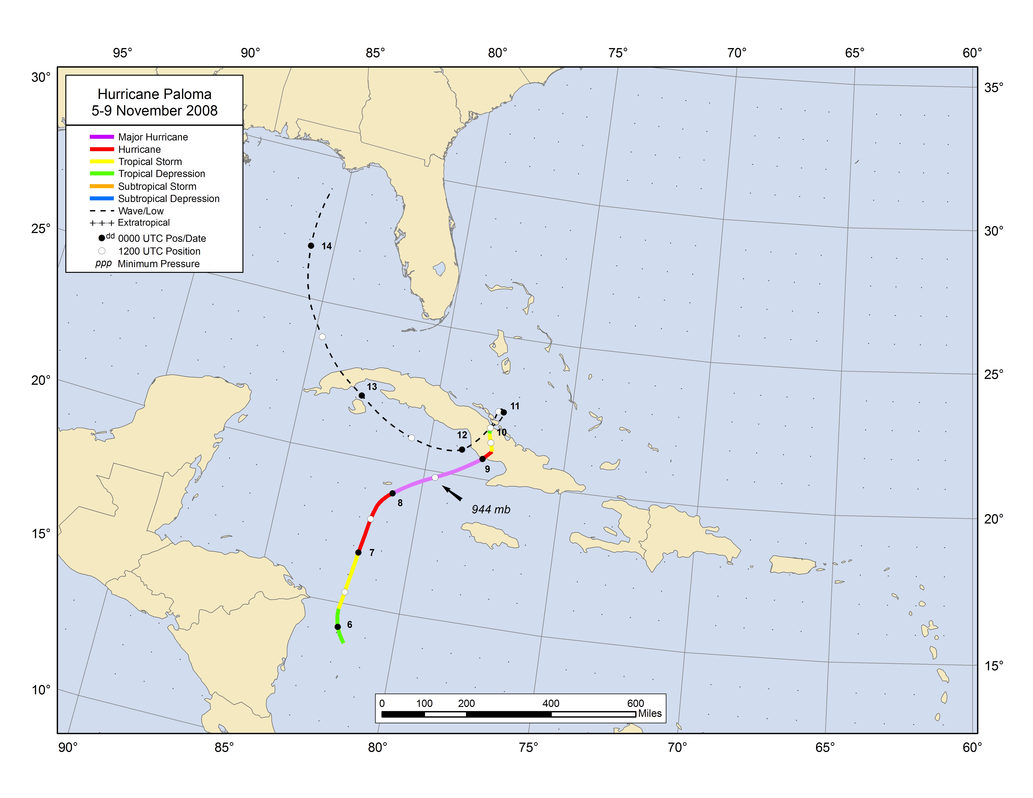

Figure 1. Best track positions for Hurricane Paloma, 5–9 November 2008.

Figure 2. Selected wind observations and best track maximum sustained surface wind speed curve for Hurricane Paloma, 5–9 November 2008. Aircraft observations have been adjusted for elevation using 90%, 80%, and 80% adjustment factors for observations from 700 mb, 850 mb, and 1500 ft, respectively. Dropwindsonde observations include actual 10 m winds (sfc), as well as surface estimates derived from the mean wind over the lowest 150 m of the wind sounding (LLM), and from the sounding boundary layer mean (MBL). Objective Dvorak estimates represent linear averages over a three-hour period centered on the nominal observation time. Dashed vertical lines correspond to 0000 UTC. The time of landfall is indicated by the vertical black line.

Figure 3. Selected pressure observations and best track minimum central pressure curve for Hurricane Paloma, 5–9 November 2008. Objective Dvorak estimates represent linear averages over a three-hour period centered on the nominal observation time. Dashed vertical lines correspond to 0000 UTC. The time of landfall is indicated by the vertical black line.
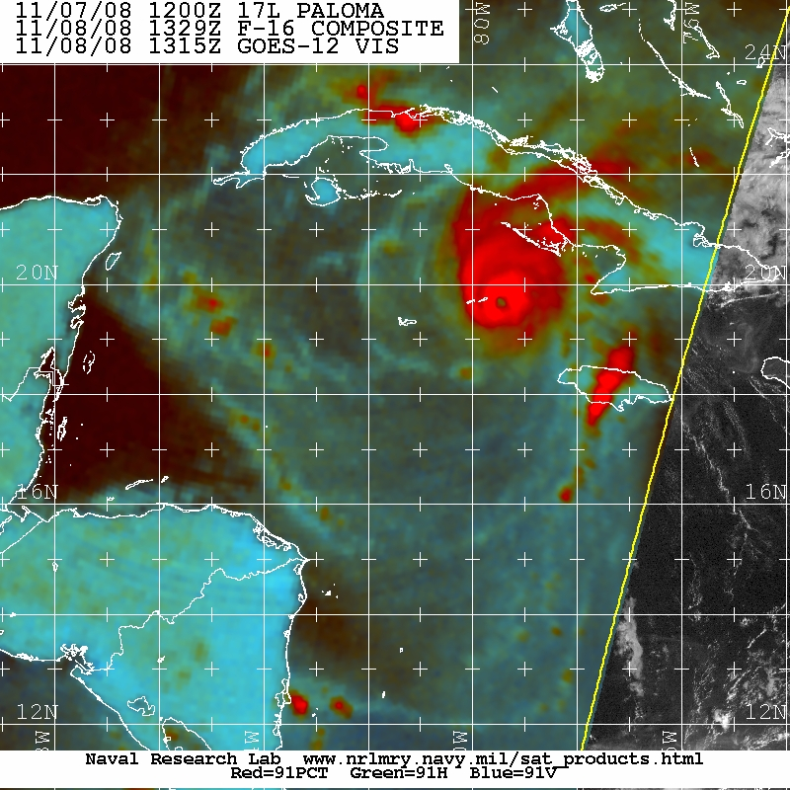

Figure 4. SSMIS 91-GHz color composite image of Hurricane Paloma at 1329 UTC 8 November 2008. Image courtesy of the U.S. Naval Research Laboratory.
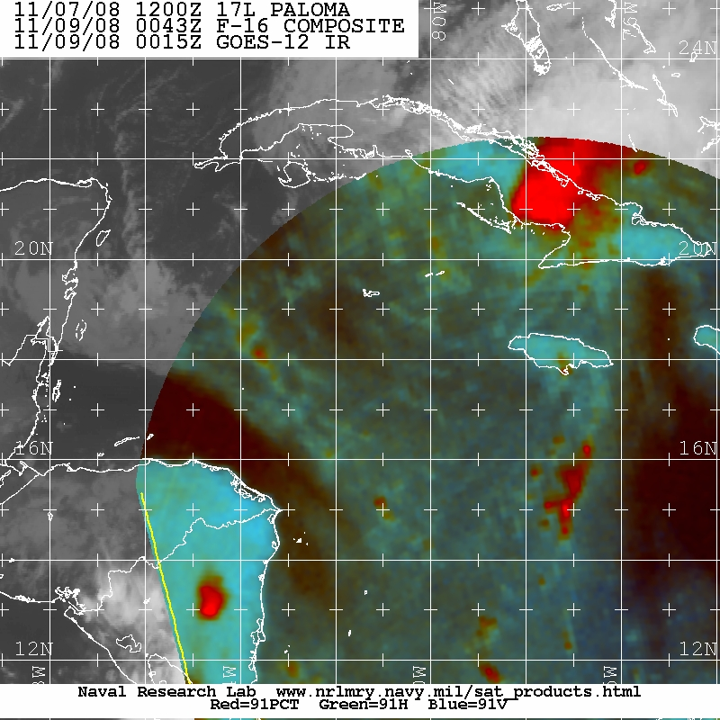

Figure 5. As in Fig. 4, except at 0043 UTC 9 November 2008. Image courtesy of the U.S. Naval Research Laboratory.
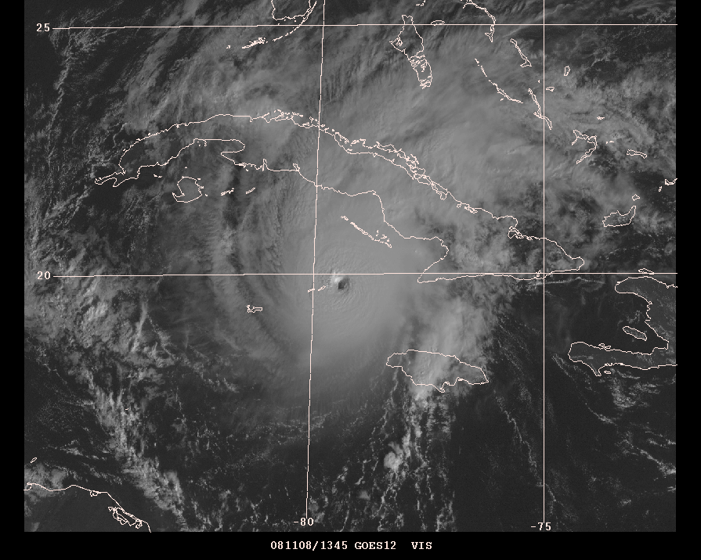

Figure 6. GOES-12 visible satellite image of Paloma at 1345 UTC 8 November 2008, near the time of the cyclone’s peak intensity.
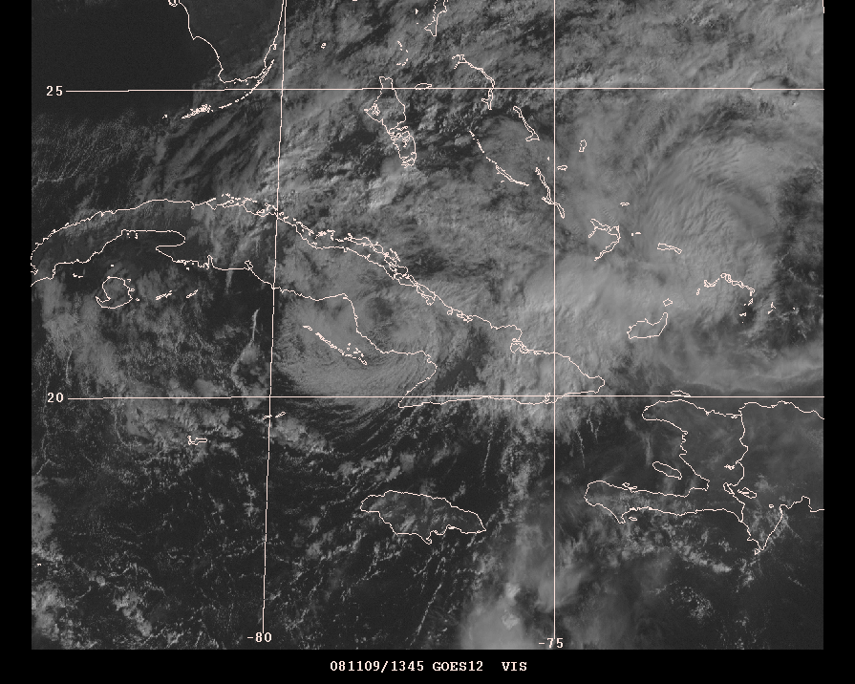

Figure 7. GOES-12 visible satellite image of Paloma at 1345 UTC 9 November 2008 as the cyclone is weakening rapidly after landfall.
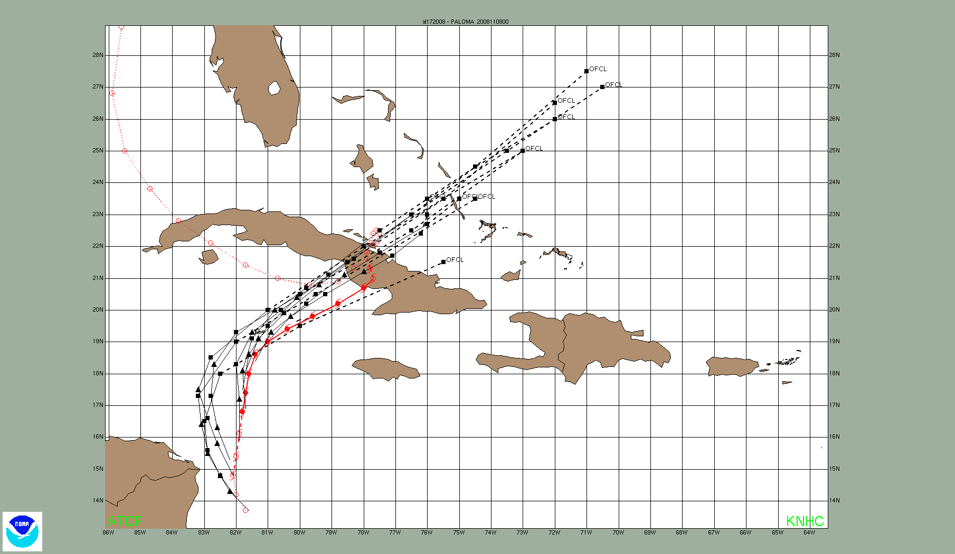

Figure 8. Official track forecasts (black lines) for Hurricane Paloma from 1800 UTC 5 November through 0000 UTC 8 November 2008. The best track of Paloma is indicated by the red line with positions given at 6 h intervals.

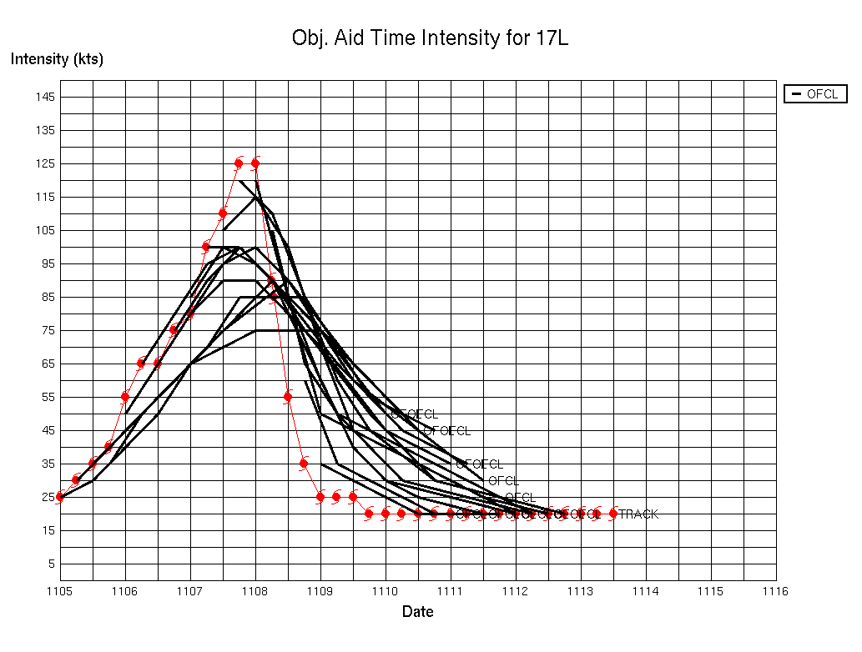

Figure 9. Time series of official intensity forecasts (black lines) for Hurricane Paloma from 1800 UTC 5 November through 1800 UTC 9 November 2008. The best track intensity of Paloma is indicated by the red line.

A digital record of the complete best track, including wind radii, can be found on line at ftp://ftp.nhc.noaa.gov/atcf. Data for the current year’s storms are located in the btk directory, while previous years’ data are located in the archive directory.
This ranking is subject to revision based on potential adjustments to the best-track intensity of the November 1932 hurricane.

