Tropical Cyclone Report
Tropical Storm Nana
(AL142008)
12-14 October 2008

Stacy R. Stewart
National Hurricane Center
28 November 2008

Nana was a short-lived, weak tropical storm that remained over the open tropical Atlantic Ocean throughout its lifetime and threatened no land areas.

- Synoptic History

Nana originated from a tropical wave that moved off the west coast of Africa coast on 6 October. QuikSCAT satellite-derived surface wind data (not shown) indicated the wave was accompanied by a broad low pressure system. Convection associated with the wave was initially minimal, but by 8 October convection became organized into bands around the low center as the system moved westward at about 10 kt. By 0000 UTC 11 October, thunderstorm activity had increased enough for Dvorak satellite classifications to be initiated. Convective banding continued to increase and become better organized over the next 36 h, and it is estimated that a tropical depression formed around 0600 UTC 12 October, when the system was centered about 690 n mi west of the Cape Verde Islands. The “best track” chart of the tropical cyclone’s path is given in Fig. 1. The best track positions and intensities are listed in Table 1, with the wind and pressure histories shown in Figs. 2 and 3, respectively.

The depression moved west-northwestward toward a weakness in the subtropical ridge and quickly strengthened into a tropical storm just 6 h later. Nana continued its west-northwestward motion into a region of moderate to strong upper-level westerly winds. Nana is estimated to have reached its peak intensity of 35 kt and lowest estimated minimum pressure at 0000 UTC 13 October (Fig. 4) before it weakened back to depression status 12 h later about 870 n mi west of the Cape Verde Islands. The strong westerly vertical wind shear continued to displace the convection well to the east of the center, and Nana degenerated into a non-convective remnant low pressure system on 14 October. The remnant low turned northwestward ahead of a strong frontal system and dissipated around 1200 UTC 15 October about 820 n mi east-northeast of the Leeward Islands.

- Meteorological Statistics

Observations in Nana (Figs. 2 and 3) include satellite-based Dvorak technique intensity estimates from the Tropical Analysis and Forecast Branch (TAFB) and the Satellite Analysis Branch (SAB). Data and imagery from NOAA polar-orbiting satellites, the NASA Tropical Rainfall Measuring Mission (TRMM), the NASA QuikSCAT, and Defense Meteorological Satellite Program (DMSP) satellites, among others, were also useful in tracking Nana.

The estimated peak intensity of 35 kt is based on QuikSCAT wind data obtained from a 2036 UTC 12 October overpass.

There were no ship reports of winds of tropical storm force associated with Nana.

- Casualty and Damage Statistics

There were no reports of damage or casualties associated with Nana.

- Forecast and Warning Critique

The genesis of Nana was well forecast. The incipient disturbance was first noted in the Tropical Weather Outlook (TWO) issued at 0000 UTC 10 October. The possibility of tropical depression or tropical cyclone formation was first mentioned in the 0000 UTC 11 October TWO – 30 h before actual genesis occurred. The experimental genesis forecasts were in the “high” (> 50% probability) category 24 h prior to issuance of the first advisory.

A verification of official and guidance model track forecasts is given in Table 2. Average official track errors for Nana were 33, 42, and 68 n mi for the 12, 24, and 36 h forecasts, respectively. The number of forecasts ranged from 5 at 12 h to only 1 at 36 h. These errors are lower than the average long-term official track errors at 24 and 36 h (Table 2), albeit for a very small sample.

Average official intensity errors were 2, 5, and 5 kt for the 12, 24, and 36 h forecasts, respectively (Table 3). For comparison, the average long-term official intensity errors are 7, 10, and 12 kt, respectively.

No watches and warnings were associated with Nana.
Table 1. Best track for Tropical Storm Nana, 12-14 October 2008.

Date/Time  (UTC) | Latitude  (°N) | Longitude  (°W) | Pressure  (mb) | Wind Speed  (kt) | Stage
12 / 0600 | 15.5 | 36.6 | 1007 | 30 | tropical depression
12 / 1200 | 16.0 | 37.1 | 1006 | 35 | tropical storm
12 / 1800 | 16.4 | 37.7 | 1005 | 35 | "
13 / 0000 | 16.5 | 38.4 | 1004 | 35 | "
13 / 0600 | 16.6 | 39.0 | 1005 | 35 | "
13 / 1200 | 16.8 | 39.6 | 1006 | 30 | tropical depression
13 / 1800 | 17.2 | 40.3 | 1007 | 30 | "
14 / 0000 | 17.6 | 41.5 | 1007 | 30 | "
14 / 0600 | 18.0 | 42.7 | 1007 | 30 | "
14 / 1200 | 18.3 | 44.0 | 1008 | 25 | remnant low
14 / 1800 | 18.6 | 45.0 | 1008 | 25 | "
15 / 0000 | 19.4 | 46.1 | 1009 | 25 | "
15 / 0600 | 20.5 | 47.1 | 1010 | 25 | "
15 / 1200 | 22.0 | 48.0 | 1011 | 20 | "
15 / 1800 |  |  |  |  | dissipated
13 / 0000 | 16.5 | 38.4 | 1004 | 35 | minimum pressure

Table 2. Track forecast evaluation (heterogeneous sample) for Tropical Storm Nana, 12-14 October 2008. Forecast errors (n mi) are followed by the number of forecasts in parentheses.

Forecast Technique | Forecast Period (h)
Forecast Technique | 12 | 24 | 36 | 48 | 72 | 96 | 120
CLP5 | 54 ( 7) | 99 ( 5) | 205 ( 3) | 412 ( 1)
GFNI | 79 ( 3) | 166 ( 1)
GFDI | 45 ( 7) | 75 ( 5) | 46 ( 3) | 166 ( 1)
HWFI | 66 ( 7) | 90 ( 5) | 26 ( 3) | 131 ( 1)
GFSI | 49 ( 7) | 105 ( 2) | 117 ( 2)
AEMI | 27 ( 6) | 27 ( 3) | 61 ( 2) | 165 ( 1)
NGPI | 69 ( 6) | 142 ( 4) | 185 ( 2) | 257 ( 1)
UKMI | 41 ( 3) | 75 ( 1)
EGRI | 41 ( 3) | 75 ( 1)
EMXI | 55 ( 3) | 104 ( 2) | 158 ( 2) | 234 ( 1)
BAMD | 108 ( 7) | 201 ( 5) | 303 ( 3) | 529 ( 1)
BAMM | 45 ( 7) | 74 ( 5) | 129 ( 3) | 253 ( 1)
BAMS | 36 ( 7) | 66 ( 5) | 92 ( 3) | 97 ( 1)
LBAR | 82 ( 7) | 152 ( 5) | 239 ( 3) | 435 ( 1)
TVCN | 43 ( 7) | 78 ( 5) | 78 ( 3) | 200 ( 1)
GUNA | 36 ( 3)
FSSE | 17 ( 2) | 90 ( 2)
OFCL | 33 ( 5) | 42 ( 3) | 68 ( 1)
NHC Official  (2003-2007 mean) | 34.0 (1742) | 58.2 (1574) | 82.2 (1407) | 106.2 (1254) | 154.2 (996) | 207.5 (787) | 272.5 (627)

Table 3. Intensity forecast evaluation (heterogeneous sample) for Tropical Storm Nana, 12-14 October 2008. Forecast errors (kt) are followed by the number of forecasts in parentheses.

Forecast Technique | Forecast Period (h)
Forecast Technique | 12 | 24 | 36 | 48 | 72 | 96 | 120
OCD5 | 3.6 ( 7) | 5.8 ( 5) | 6.7 ( 3) | 8.0 ( 1)
GHMI | 3.3 ( 7) | 3.2 ( 5) | 5.3 ( 3) | 6.0 ( 1)
HWFI | 6.4 ( 7) | 9.6 ( 5) | 14.0 ( 3) | 19.0 ( 1)
LGEM | 4.7 ( 7) | 3.2 ( 5) | 5.3 ( 3) | 8.0 ( 1)
DSHP | 4.3 ( 7) | 2.8 ( 5) | 4.7 ( 3) | 6.0 ( 1)
FSSE | 3.0 ( 2) | 1.5 ( 2)
ICON | 4.1 ( 7) | 3.8 ( 5) | 4.7 ( 3) | 7.0 ( 1)
OFCL | 2.0 ( 5) | 5.0 ( 3) | 5.0 ( 1)
NHC Official  (2003-2007 mean) | 6.7  (1742) | 10.0 (1574) | 12.3 (1407) | 14.3 (1254) | 18.2 (996) | 19.7 (787) | 21.8 (627)

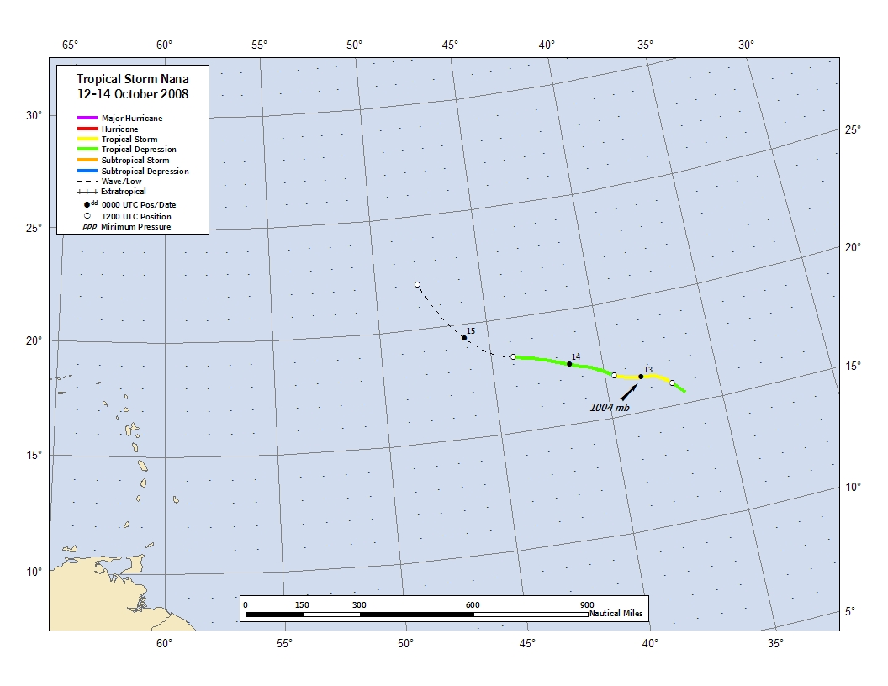
Figure 1. Best track positions for Tropical Storm Nana, 12-14 October 2008. Track positions during the remnant low stage are based on analyses from the NOAA Tropical Prediction Center’s Tropical Analysis and Forecast Branch (TAFB).

Figure 2. Selected wind observations and best track maximum sustained surface wind speed curve for Tropical Storm Nana,
12-14 October 2008. Estimates during the remnant low stage are based on analyses from the NOAA Tropical Prediction Center’s Tropical Analysis and Forecast Branch (TAFB). Dashed vertical lines correspond to 0000 UTC.
Figure 3. Selected pressure observations and best track minimum central pressure curve for Tropical Storm Nana, 12-14 October 2008. Estimates during the extratropical stage are based on analyses from the NOAA Tropical Prediction Center’s Tropical Analysis and Forecast Branch (TAFB). Dashed vertical lines correspond to 0000 UTC.
Figure 4. Microwave satellite images of Tropical Storm Nana near its peak intensity and lowest estimated minimum pressure --
a. SSM/I S 2157 UTC 12 OCT 2008; b. AMSU-B 2331 UTC 12 OCT 2008 (images courtesy of U.S. Naval Research Laboratory).

A digital record of the complete best track, including wind radii, can be found on line at ftp://ftp.nhc.noaa.gov/atcf. Data for the current year’s storms are located in the btk directory, while previous years’ data are located in the archive directory.

