Tropical Cyclone Report
Hurricane Humberto
(AL092007)
12-14 September 2007

Eric S. Blake
National Hurricane Center
28 November 2007 (updated to fix typo)

Humberto was a short-lived tropical cyclone that made landfall in extreme southeastern Texas as a strong category 1 hurricane (on the Saffir-Simpson Hurricane Scale). The hurricane is notable for its exceptionally rapid intensification near the coast of Texas from a tropical depression into a hurricane within 19 hours.

- Synoptic History

The genesis of Humberto can be traced to the remnants of a frontal trough (the same front that spawned Gabrielle) that moved offshore of south Florida in the southeastern Gulf of Mexico on 5 September. This trough remained nearly stationary for a couple of days, then moved slowly west-northwestward for almost a week as high pressure built over the southeastern United States. The trough was located over the northwestern Gulf of Mexico on 11 September, and convection increased markedly near the trough axis on that day a couple hundred miles south of Galveston, Texas. Although thunderstorms diminished that night, a weak surface low had formed along the trough. Convection re-fired near the low early on 12 September, and was organized enough by 0900 UTC to estimate that a tropical depression had formed about 120 miles south of Galveston, Texas. The “best track” chart of the tropical cyclone’s path is given in Fig. 1, with the wind and pressure histories shown in Figs. 2 and 3, respectively. The best track positions and intensities are listed in Table 1.

A ship report and radar data suggest that the depression quickly became a tropical storm near 1200 UTC 12 September, and moved slowly to the north. Intense thunderstorm activity in well-defined spiral bands continued near Humberto, and the small tropical cyclone continued to rapidly strengthen just offshore of the upper Texas coast. Later that day, the system turned to the north-northeast due to steering around a large middle-level high over the southeastern United States. Radar data indicate that the tropical storm became a hurricane about 20 miles south of High Island, Texas near 0400 UTC 13 September, and the cyclone reached an estimated peak intensity of 80 kt as it made landfall just east of High Island in McFaddin National Wildlife Refuge around 0700 UTC on 13 September. The hurricane moved over extreme southeastern Texas across the Beaumont/Port Arthur area, and entered southwestern Louisiana, weakening into a tropical storm about 75 miles west-northwest of Lafayette, Louisiana. The storm became a depression near Alexandria, Louisiana late on 13 September, and dissipated the next day over central Mississippi.

- Meteorological Statistics

Observations in Humberto (Figs. 2 and 3) include satellite-based Dvorak technique intensity estimates from the Tropical Analysis and Forecast Branch (TAFB) and the Satellite Analysis Branch (SAB), as well as flight-level, dropsonde, and stepped-frequency microwave radiometer (SFMR) observations from three flights of the 53rd Weather Reconnaissance Squadron of the U. S. Air Force Reserve Command aircraft. Microwave satellite imagery from NOAA polar-orbiting satellites, the NASA Tropical Rainfall Measuring Mission (TRMM), the NASA QuikSCAT, and Defense Meteorological Satellite Program (DMSP) satellites were also useful in tracking Humberto.

The initial development of Humberto was rather quick. Around 0300 UTC, almost all thunderstorm activity had dissipated with the low that eventually spawned Humberto, but convection increased dramatically between 0600-0900 UTC on 12 September. By 0900 UTC, enough convection had persisted near the low center for it to be considered a tropical depression. Only three hours later, ship data from the Tyco Decisive of 38 kt winds, concurrent with increasing radar winds of 35-40 kt between 7,000 to 9,000 ft from the Houston National Weather Service radar, suggested that the depression became a tropical storm near 1200 UTC.

Estimating the landfall intensity of Humberto is problematic because the hurricane was rapidly strengthening near landfall. Peak flight-level winds of 98 kt were measured at an altitude of 850 mb near landfall, corresponding to about 78 kt at the surface. SFMR data from the WC-130 aircraft measured surface winds of up to 85 kt just before landfall. However, the SFMR reading was taken in the shallow gulf waters and shoaling in this location introduces some uncertainty to the measurement. A dropsonde about an hour earlier in the eastern eyewall provided a surface wind estimate of 70 kt, derived from the lowest 150 m of the sounding. It is probable, however, that this single dropsonde did not capture the maximum winds. Peak winds noted from radar data from the National Weather Service office in Houston were about 100 kt at around 3000 ft, and an approximate reduction factor of 75-80% from the altitude suggests that 75-80 kt winds were observed near the surface. Vertical scans from the Houston and Lake Charles radars showed a deeper layer of 85-90 kt winds from 3000-9000 ft. Up to a 90% reduction of these deeper winds given the strong convection seems justified, resulting in an estimate of about 75-80 kt. A peak intensity of 80 kt is assigned for this hurricane after considering all data sources.

The highest official wind reported was from the C-MAN station at Sea Rim State Park in Texas. The station recorded 10-minute averaged sustained winds of 60 kt with gusts to 74 kt. However, this station likely did not receive the maximum winds in Humberto as radar data suggested the radius of maximum winds was several miles west of the station. An unofficial measurement of a wind gust to 101 kt was received from a barge located in the Golden Pass ship channel near the Texas/Louisiana border. Based on surface and reconnaissance wind reports and radar estimates, sustained hurricane-force winds were likely observed in only a small area up to about 15 miles wide in extreme southwestern Louisiana and southeastern Texas.

The rapid intensification of Humberto was aided by a couple of factors. The hurricane was a very small tropical cyclone, with 34 kt wind radii never exceeding 50 n mi. Small cyclones are more susceptible than large storms to rapid changes in intensity, up and down. Humberto also had unusually well-defined banding and core convective structures in its formative stage, which likely provided the framework that allowed for the rapid development that occurred 12 hours later.

The intensification rate in Humberto was one of the highest that has ever been observed for an initially weak tropical cyclone. It is estimated that the cyclone strengthened from a 25 kt low into an 80 kt hurricane within 24 hours. This rapid increase in intensity is rare, and only three other storms (Celia 1970, Arlene and Flora 1963) have intensified more in 24 hours from below tropical storm strength. The rapid formation of a hurricane near the shore has long been a concern emphasized by the National Hurricane Center in its outreach and preparedness talks. Humberto serves as a rare, important example.

The minimum central pressure estimated with Humberto was 985 mb, based on a dropsonde reading of 986 mb taken about 10 minutes before landfall, and a continuation of the large pressure falls of about 3 mb in the previous 45 minutes observed in the two dropsonde measurements prior to landfall. The lowest pressure noted from a land station was 988.5 at the Beaumont/Port Arthur airport, located well inland from the Gulf of Mexico.

Very heavy rains associated with Humberto were noted in a small area of extreme southeastern Texas and southwestern Louisiana. The maximum storm total precipitation was 14.13 at East Bay Bayou, Texas, and a large surrounding area of 3-5 inches stretched northeastward into central Louisiana. A map of the rainfall associated with the hurricane is found in Fig. 4.

The highest storm tide reported was 4.87 ft from the Texas Point gauge of the Texas Coastal Ocean Observation Network (TCOON). Storm surges of about 2-4 feet were commonly noted from just east of Galveston Bay, Texas eastward to near Lake Charles, Louisiana.

There was one preliminary report of a tornado near High Island, Texas, but a later storm survey suggested that the damage in that area was due to the winds of the hurricane itself.

- Casualty and Damage Statistics

There was one death in Bridge City, Texas directly associated with Humberto when a car port fell on an elderly man when he went outside to check on his backyard. Twelve injuries were also noted in southeastern Texas, including snake bites, cuts, bruises and broken bones. Power outages at least 120,000 homes were reported in Texas and 13,000 customers lost power in Louisiana. Insured losses from Humberto are estimated to be less than 50 million dollars from the Insurance Services Office, and a rough estimate of total property damages is about 50 million dollars. The final damage figure is much lower than estimates earlier reported in the media. The low damage total is probably due to the small size of the system and the relatively unpopulated area that it impacted. In addition, Hurricane Rita caused much more severe conditions to extreme southeastern Texas in 2005 and may have limited the amount of damage that could have been done by a small Category 1 hurricane. Most of the damage noted from Humberto was due to fresh water floods and wind, the latter knocking down trees and power lines and causing roof damage.

- Forecast and Warning Critique

The timing of the genesis of Humberto was not well-anticipated. The system that eventually became Humberto was mentioned in the Tropical Weather Outlook products for four days prior to genesis with some development potential indicated for the last two days. The possibility of tropical depression formation, however, was not mentioned explicitly before genesis occurred.

The average official track errors for Humberto were 26, 50, and 89 n mi for the 12, 24, and 36 h forecasts, respectively. These forecast errors were lower than the average long-term official track errors through 36 h. A meaningful comparison of the various models is not possible due to the small number of forecasts, ranging from five at 12 h to one at 36 h. Overall, the first couple of official forecasts were a little too far to the west, and this was one factor in the unanticipated landfall intensity of the system. The first official forecast for Humberto, issued at 1500 UTC 12 September, had an implied landfall time 16-17 h later, or near 04-05 UTC. Humberto moved to the right of the forecast track, staying over water for another 2-3 hours. The 12 h track error for this forecast was 29 n mi, which is less than the long-term average 12-h error of 35 n mi. Despite the relatively small absolute track error, the oblique angle of approach to the coastline resulted in an error in the timing of landfall of a few hours, allowing the system to reach hurricane strength.

Average official intensity errors were 18, 12, and 5 kt for the 12, 24, and 36 h forecasts, respectively. For comparison, the average long-term official intensity errors are 6, 10, and 12 kt, respectively. The official forecast errors were much larger than average for Humberto in the 12 hr period, with a substantial low bias from the unexpected rapid intensification of the system. It is worth noting that no reliable model ever forecast the system to reach hurricane strength.

Table 3 lists the tropical cyclone watches and warnings that were issued for Humberto. A hurricane warning was issued only about 2 hours before landfall due to the unforeseen rapid intensification of the system. The tropical storm warning was issued as soon as it was determined that a tropical depression had formed, about 16 hours before landfall.

- Acknowledgements

Almost all of the surface observations in this report were provided by the NWS Forecast Offices in Houston, Texas and Lake Charles, Louisiana and by the National Data Buoy Center (NDBC). David Roth of the Hydrometeorological Prediction Center supplied the rainfall graphic. Colin McAdie (NHC) provided access to and insightful analysis of archived WSR-88D radar data from the NWS Forecast Office in Lake Charles, Louisiana and Houston, Texas. SFMR data and analysis were provided by Eric Uhlhorn of the Hurricane Research Division of the Atlantic Oceanographic and Meteorological Laboratory at Virginia Key, FL. The NHC Hurricane Specialist unit also provided valuable input to this report.

Table 1. Best track for Hurricane Humberto, 12-14 September 2007.

Date/Time  (UTC) | Latitude  (°N) | Longitude  (°W) | Pressure  (mb) | Wind Speed  (kt) | Stage
12 / 0600 | 27.3 | 95.0 | 1009 | 25 | low
12 / 1200 | 27.8 | 95.1 | 1006 | 35 | tropical storm
12 / 1800 | 28.3 | 95.0 | 1001 | 45 | "
13 / 0000 | 28.8 | 94.8 | 997 | 55 | "
13 / 0600 | 29.5 | 94.4 | 985 | 80 | hurricane
13 / 1200 | 30.3 | 93.6 | 989 | 65 | "
13 / 1800 | 31.0 | 92.9 | 1000 | 35 | tropical storm
14 / 0000 | 31.7 | 92.3 | 1006 | 25 | tropical depression
14 / 0600 | 32.4 | 91.3 | 1009 | 20 | low
14 / 1200 | 32.7 | 90.2 | 1012 | 20 | "
14 / 1800 | - | - | - | - | dissipated
13 / 0600 | 29.5 | 94.4 | 985 | 80 | minimum pressure
13 / 0700 | 29.6 | 94.3 | 985 | 80 | landfall just east of High Island, Texas

Table 2. Selected surface observations for Hurricane Humberto, 12-14 September 2007.

Location | Minimum Sea Level Pressure |  | Maximum Surface  Wind Speed |  |  | Storm surge  (ft)^{c} | Storm  tide  (ft)^{d} | Total  rain  (in)
Location | Date/  time  (UTC) | Press.  (mb) | Date/  time  (UTC)ª | Sustained  (kt)^{b} | Gust  (kt) | Storm surge  (ft)^{c} | Storm  tide  (ft)^{d} | Total  rain  (in)
Texas
Beaumont (BEAT2) |  |  |  |  |  |  |  | 6.58
Buna-KRBT2 RAWS |  |  | 13/1405 |  | 34
Galveston Airport (KGLS) | 13/0252 | 1007.0 | 13/0323 | 30 | 44 |  |  | 4.53
Galveston-Pleasure Pier | 13/0406 | 1003.7 | 13/0336 | 43 | 56 | 1.68 | 3.62
Galveston Pier 21 | 13/0400 | 1005.1 |  |  |  | 1.53 | 3.05 | 5.08
Lumberton (LLBT2) |  |  |  |  |  |  |  | 3.32
McFaddin Wildlife Refuge- FADT2 RAWS |  |  | 13/0735 | 52 | 65
Orange 9 N (ORET2) |  |  |  |  |  |  |  | 5.24
Orange County Airport (KORG) | 13/0925 | 1003.4 | 13/0925 | 29 | 40e
Southeast Texas Regional Airport (KBPT) | 13/0927 | 988.5 | 13/0858 | 49 | 73 |  |  | 6.23
Louisiana
Alexandria International (KAEX) | 13/2043 | 1005.4 | 13/1857 | 25 | 35 |  |  | 3.48
Esler Regional Airport (KESF) | 13/2120 | 1006.1 | 13/2148 | 20 | 30 |  |  | 3.20
Fort Polk (KPOE) | 13/1753 | 1006.1 | 13/1655 | 20 | 34
Fort Polk Self-Landing Strip (KDNK) | 13/1753 | 1006.1 | 13/1653 | 27 | 36
Lafayette Regional Airport (KLFT) | 13/2213 | 1010.5 | 13/2056 | 21 | 28 |  |  | 3.09
Lake Charles Regional Airport (KLCH) | 13/1352 | 1009.5 | 13/0936 | 29 | 36 |  |  | 3.08
Sulphur Southland Field (KUXL) | 13/1140 | 1007.2 | 13/1240 | 28 | 37
Buoy/C-MAN
42035- E of Galveston  29.2°N 94.4°W (NCDC) | 13/0450 | 991.7 | 13/0410 | 50 | 64
CAPL1-Calcasieu Pass, LA (NOS) | 13/1036 | 1009.4 | 13/0842 | 33 | 37 | 2.79 | 4.02
SBPT2-Sabine Pass North, TX (NOS) | 13/0900 | 1003.3 | 13/0900 | 42 | 58 | 2.60 | 4.07
SRST2- Sea Rim State Park, TX  29.7°N 94.1°W (NDBC) | 13/0800 | 997.0 | 13/0840 | 60 | 74
Unofficial Texas
Beaumont 2 SE |  |  |  |  |  |  |  | 7.96
Beaumont 3 S |  |  |  |  |  |  |  | 7.75
Beaumont 6 SE |  |  |  |  |  |  |  | 7.64
Beaumont Carroll State Park (TCEQ) |  |  | 13/0900 | 33^{f} | 65
Beaumont Cathedral Christian School |  |  |  |  | 46
Beaumont KFDM-TV |  |  |  |  | 43
Beaumont Monsignor Kelly High School |  |  |  |  | 49
Beaumont Odom Academy |  |  |  |  | 64
Beaumont Richard Milburn Academy |  |  |  |  | 55
Beaumont St. Anne Catholic School |  |  |  |  | 46
Beaumont St. Anthony’s Cathedral School |  |  |  |  | 58
Beaumont-Lamar (TCEQ) |  |  | 13/0800 |  | 48e
Bolivar at Loop 108 (TXDOT) |  |  | 13/0353 | 35 | 43 |  |  | 7.01
Deweyville High School |  |  |  |  | 37
Eagle Point (TCOON) | 13/0454 | 1007.8 | 13/0130 |  | 33 | 1.42 | 2.71
East Bay Bayou at Jones and Allen |  |  |  |  |  |  |  | 14.13
Fannett 2 NE |  |  |  |  |  |  |  | 8.39
Fannett 2 SW |  |  |  |  |  |  |  | 9.18
Galveston Bay-North Jetty (TCOON) | 13/0406 | 1003.4 | 13/0412 | 43 | 52 | 1.23 | 2.95
Galveston Bay-Rollover Pass (TCOON) |  |  | 13/0624 | 52 | 66 | 1.98 | 4.33
Galveston Bay-South Jetty (TCOON) | 13/0500 | 1003.4 | 13/0400 | 45 | 65 |  | 3.24
Galveston Causeway |  |  |  |  |  |  |  | 3.23
Galveston Coast Guard (GLST2) |  |  |  |  |  |  |  | 6.50
GIWW at SH 124 Bridge |  |  |  |  |  |  |  | 9.84
Golden Pass Ship Channel |  |  |  |  | 101
Groves (TCEQ) |  |  | 13/0800 |  | 42
Hamshire (TCEQ) |  |  | 13/0800 | 35^{f} | 63e
Hamshire 2 WSW |  |  |  |  |  |  |  | 8.19
Hamshire 5 SE |  |  |  |  |  |  |  | 7.52
Hamshire 5 SSW |  |  |  |  |  |  |  | 9.02
Hamshire 5 SW |  |  |  |  |  |  |  | 10.71
Jamaica Beach (JBHT2) | 13/0214 | 1007.3 | 13/0047 | 30 | 35 | 2.52 | 3.42 | 5.80
Jefferson County Airport (TCEQ) |  |  | 13/0900 | 24^{f} | 64
Lumberton Intermediate School |  |  |  |  | 34
Mauriceville SETRPC (TCEQ) |  |  | 13/0900 |  | 43e
Morgans Point (TCOON) |  |  |  |  |  | 0.78 | 2.01
Nederland Helena Park Elementary School |  |  |  |  | 55
Nederland High School (TCEQ) | 13/0900 | 992.6 | 13/1000 | 25^{f} | 60
Nederland Hillcrest Middle School |  |  |  |  | 56
Orange Anderson Elementary School |  |  |  |  | 59
Orange St. Mary Catholic School |  |  |  |  | 58
Port Arthur (TCOON) |  |  | 13/0948 | 45 | 67 | 2.82 | 3.48
Port Arthur 2 NNW | 13/0909 | 989.4 | 13/0901 | 36
Port Arthur City Service Center (TCEQ) |  |  | 13/0800 |  | 70e
Port Arthur Lamar State College |  |  |  |  | 65
Port Arthur SETRPC (TCEQ) |  |  | 13/0900 | 43^{f} | 74e
Port Arthur West (TCEQ) |  |  | 13/0900 | 34^{f} | 67e
Port Neches (TCEQ) |  |  | 13/0900 |  | 44e
Rainbow Bridge |  |  |  |  |  | 2.81 | 3.43
Rollover Pass at Gilchrist (TXDOT) |  |  | 13/0624 | 48 | 58 |  |  | 8.31
Sabine Pass 3 NW |  |  |  |  |  |  |  | 8.74
Sabine Pass School |  |  |  |  | 60
Sea Rim State Park 1 SE |  |  |  |  |  |  |  | 8.54
Sea Rim State Park 6 NW |  |  |  |  |  |  |  | 8.62
Sea Rim State Park 8 W |  |  |  |  |  |  |  | 8.35
Sea Rim State Park 9 NW |  |  |  |  |  |  |  | 8.27
Sea Rim State Park 2 W |  |  |  |  |  |  |  | 8.07
Sea Rim State Park 7 W |  |  |  |  |  |  |  | 7.67
Spindletop Bayou at SH 124 Bridge |  |  |  |  |  |  |  | 8.11
Texas Point (TCOON) | 13/0906 | 1004.7 | 13/0924 | 40 | 54 |  | 4.87
Vidor Junior High School |  |  |  |  | 51
Vinton High School |  |  |  |  | 48
West Orange (TCEQ) |  |  | 13/1000 | 27^{f} | 53e
West Orange Starks Middle School |  |  |  |  | 59
Unofficial Louisiana
Abbeville (ABBL1) |  |  |  |  |  |  |  | 5.70
Alexandria 5 SSE (ADSL1) |  |  |  |  |  |  |  | 3.03
Alexandria Power Plant (ALXL1) |  |  |  |  |  |  |  | 3.30
Boyce 7 SW (BCLL1) |  |  |  |  |  |  |  | 4.43
Crowley 2 NE (CROL1) |  |  |  |  |  |  |  | 3.73
Cypremont Point |  |  |  |  |  | 2.25 | 3.17
De Ridder (DRIL1) |  |  |  |  |  |  |  | 8.25
Elmer 2 SW (ELML1) |  |  |  |  |  |  |  | 4.76
Jeanerette 5 NW (JENL1) |  |  |  |  |  |  |  | 4.00
Jennings (JNNL1) |  |  |  |  |  |  |  | 4.63
Lafayette (LFYL1) |  |  |  |  |  |  |  | 3.01
Lake Arthur 10 SW (LWRL1) |  |  |  |  |  |  |  | 5.47
Lake Charles |  |  |  |  |  | 2.03 | 2.96
Lake Charles 7 NW (LCRL1) |  |  |  |  |  |  |  | 3.45
LSU Dean Lee (LSUL1) |  |  |  |  |  |  |  | 3.31
Moss Bluff (MBFL1) |  |  |  |  |  |  |  | 3.53
Port of Lake Charles (LKCL1) |  |  |  |  |  |  |  | 3.24

ª Date/time is for sustained wind when both sustained and gust are listed.
^{b} Wind averaging periods is 10 min.
^{c} Storm surge is water height above normal astronomical tide level.
^{d} Storm tide is water height above National Geodetic Vertical Datum (1929 mean sea level).
^{e} Instrument failed
^{f} Wind averaging period is 5 min.

Table 3. Watch and warning summary for Hurricane Humberto, 12-14 September 2007.

Date/Time (UTC) | Action | Location
12/1500 | Tropical Storm Warning issued | Port O’Connor, Texas to Cameron, Louisiana
12/1500 | Tropical Storm Watch issued | east of Cameron to Intracoastal City, Louisiana
12/2100 | Tropical Storm Watch changed to Tropical Storm Warning | east of Cameron to Intracoastal City, Louisiana
13/0300 | Tropical Storm Warning discontinued | Port O’Connor, Texas to Sargent, Texas
13/0515 | Tropical Storm Warning changed to Hurricane Warning | east of High Island, Texas to Cameron, Louisiana
13/0900 | Tropical Storm Warning discontinued | east of Sargent, Texas to west of High Island, Texas
13/1500 | All warnings discontinued | Texas and Louisiana

Figure 1. Best track positions for Hurricane Humberto, 12-14 September 2007. Track during the low stage is partially based on analyses from the NOAA Hydrometeorological Prediction Center.
Figure 2. Selected wind observations and best track maximum sustained surface wind speed curve for Hurricane Humberto, 12-14 September 2007. Aircraft observations have been adjusted for elevation using 90%, 80%, and 80% reduction factors for observations from 700 mb, 850 mb, and 1500 ft, respectively. The thin vertical line indicates the time of landfall in Texas.

Figure 3. Selected pressure observations and best track minimum central pressure curve for Hurricane Humberto, 12-14 September 2007. The thin vertical line indicates the time of landfall in Texas.
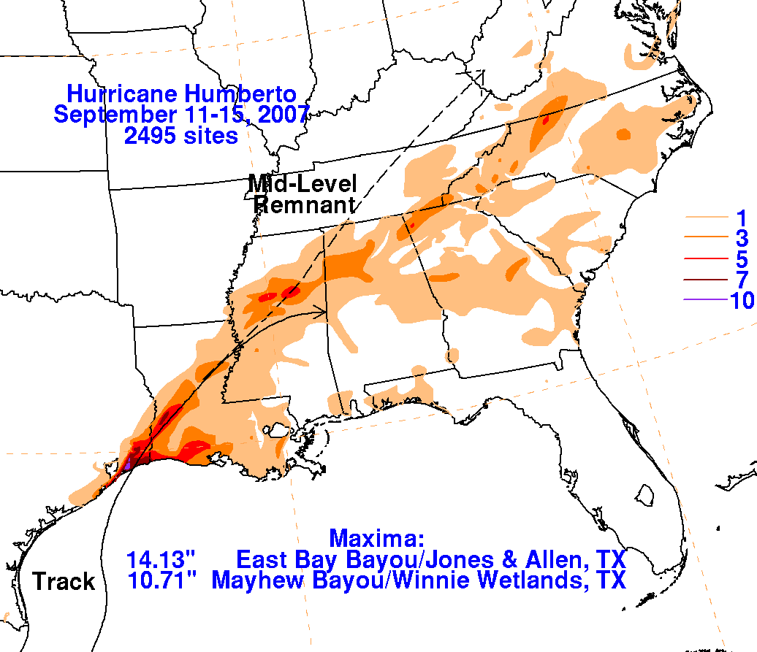

Figure 4. Storm total precipitation associated with Hurricane Humberto and its remnants over the southeastern United States. Figure courtesy David Roth at the Hydrometeorological Prediction Center, Camp Springs, MD.

