Tropical Cyclone Report
Tropical Storm Ana
(AL022009)
11-16 August 2009

Eric S. Blake
National Hurricane Center
26 September 2009

Ana was a weak tropical storm that remained over the tropical Atlantic Ocean and dissipated before reaching the Lesser Antilles.

- Synoptic History

Ana developed from a well-organized tropical wave that left the west coast of Africa on 8 August. A large curved band feature was noted as the wave moved slowly westward, and a small surface low formed along the wave axis on 10 August. Thunderstorms consolidated near the circulation center overnight, leading to the formation of a tropical depression by 0600 UTC August 11 while the system was located about 200 n mi west of the Cape Verde Islands. The “best track” chart of the tropical cyclone’s path is given in Figure 1, and the best track positions and intensities are listed in Table 1.

The depression was a tropical storm briefly on 12 August but deep convection near the center diminished late that day. Ana weakened into a tropical depression at 0000 UTC 13 August, and six hours later degenerated to a remnant low about 675 n mi west of the Cape Verde Islands. A combination of easterly shear, cooler sea-surface temperatures and dry air in the mid- to upper-levels appears to have caused the weakening of Ana.

For the next day or so, the remnant low moved westward at a faster forward speed and produced little convection. However, in the morning hours of 14 August, thunderstorm activity increased near the center, and Ana regenerated into a tropical depression by 0000 UTC 15 August, while centered about 935 n mi east of the Lesser Antilles. The depression became a tropical storm again six hours later and stayed at that strength for about a day before westerly shear and dry air aloft caused the system to weaken back to a depression by 1200 UTC 16 August, about 350 n mi east of the Lesser Antilles. Satellite and aircraft reconnaissance observations suggest that Ana lost its well-defined center later that day between 1200 and 1800 UTC as it moved rapidly westward at 20-25 kt, and it degenerated into a tropical wave before reaching the Lesser Antilles.

- Meteorological Statistics

Observations in Ana (Figs. 2 and 3) include satellite-based Dvorak technique intensity estimates from the Tropical Analysis and Forecast Branch (TAFB) and the Satellite Analysis Branch (SAB), as well as flight-level, stepped frequency microwave radiometer (SFMR), and dropsonde observations from flights of the 53rd Weather Reconnaissance Squadron of the U. S. Air Force Reserve Command and the NOAA G-IV aircraft . Data and imagery from NOAA polar-orbiting satellites including the Advanced Microwave Sounding Unit (AMSU) instrument, the NASA Tropical Rainfall Measuring Mission (TRMM), the NASA QuikSCAT, and Defense Meteorological Satellite Program (DMSP) satellites, among others, were also useful in constructing the best track of Ana.

The estimated peak intensity of 35 kt of Ana is based on satellite estimates from TAFB and SAB. The lowest pressure of 1003 mb is based off a surface dropsonde observation of 1004 mb from a NOAA G-IV mission. The AMSU-based estimates appeared to have a significant high bias for this storm and did not agree well with the conventional Dvorak intensity estimates.

There were no ship reports of winds of tropical storm force or reports of damage or casualties associated with Ana.

- Forecast and Warning Critique

The wave that eventually became Ana was introduced in the Tropical Weather Outlook (TWO) about 48 h before genesis. Although the possibility of tropical depression formation was mentioned 6 h after the initial introduction of the system in the TWO, the chance of formation did not reach the high (>50% percent) category before it formed.

A verification of NHC official track forecasts for Ana is given in Table 2a. Official forecast track errors were generally lower than the mean official errors for the previous five-year period. A homogeneous comparison of the official track errors with selected guidance models is given in Table 2b. The official forecasts were better than most of the available guidance, but the sample sizes are too small to draw any significant conclusions. Although advisories were maintained with this system into the eastern Caribbean Sea, post-analysis indicated that the system did not have a closed circulation by that time.

A verification of NHC official intensity forecasts for Ana is given in Table 3a. Official forecast intensity errors were lower than the mean official errors for the previous five-year period. A homogeneous comparison of the official track errors with selected guidance models is given in Table 3b. Although the forecast errors were not particularly high, the weakening and dissipation of Ana were poorly forecast, resulting in a high bias in the official forecasts. Most of the rest of the guidance was more skillful than the official forecasts, as they generally did not show much development with Ana.

Watches and warnings associated with Ana are given in Table 4. No tropical-storm-force winds were observed in the Lesser Antilles.
Table 1. Best track for Tropical Storm Ana, 11-16 August 2009.

Date/Time  (UTC) | Latitude  (°N) | Longitude  (°W) | Pressure  (mb) | Wind Speed  (kt) | Stage
10 / 0600 | 14.3 | 24.0 | 1008 | 25 | low
10 / 1200 | 14.4 | 24.9 | 1008 | 25 | "
10 / 1800 | 14.4 | 25.8 | 1008 | 25 | "
11 / 0000 | 14.4 | 26.8 | 1008 | 25 | "
11 / 0600 | 14.4 | 27.9 | 1007 | 25 | tropical depression
11 / 1200 | 14.5 | 29.0 | 1006 | 25 | "
11 / 1800 | 14.6 | 30.0 | 1006 | 25 | "
12 / 0000 | 14.6 | 31.0 | 1006 | 30 | "
12 / 0600 | 14.5 | 32.1 | 1006 | 30 | "
12 / 1200 | 14.4 | 33.3 | 1005 | 35 | tropical storm
12 / 1800 | 14.3 | 34.4 | 1005 | 35 | "
13 / 0000 | 14.1 | 35.3 | 1006 | 30 | tropical depression
13 / 0600 | 14.0 | 36.3 | 1007 | 30 | remnant low
13 / 1200 | 14.0 | 37.2 | 1008 | 25 | "
13 / 1800 | 14.1 | 38.2 | 1008 | 25 | "
14 / 0000 | 14.3 | 39.3 | 1008 | 25 | "
14 / 0600 | 14.5 | 40.5 | 1008 | 25 | "
14 / 1200 | 14.6 | 41.8 | 1008 | 25 | "
14 / 1800 | 14.6 | 43.2 | 1007 | 25 | "
15 / 0000 | 14.5 | 44.7 | 1005 | 30 | tropical depression
15 / 0600 | 14.4 | 46.1 | 1003 | 35 | tropical storm
15 / 1200 | 14.4 | 47.6 | 1003 | 35 | "
15 / 1800 | 14.4 | 49.2 | 1003 | 35 | "
16 / 0000 | 14.4 | 50.7 | 1003 | 35 | "
16 / 0600 | 14.5 | 52.6 | 1004 | 35 | "
16 / 1200 | 14.6 | 54.8 | 1006 | 30 | tropical depression
16 / 1800 |  |  |  |  | dissipated
15 / 0600 | 14.4 | 46.1 | 1003 | 35 | minimum pressure

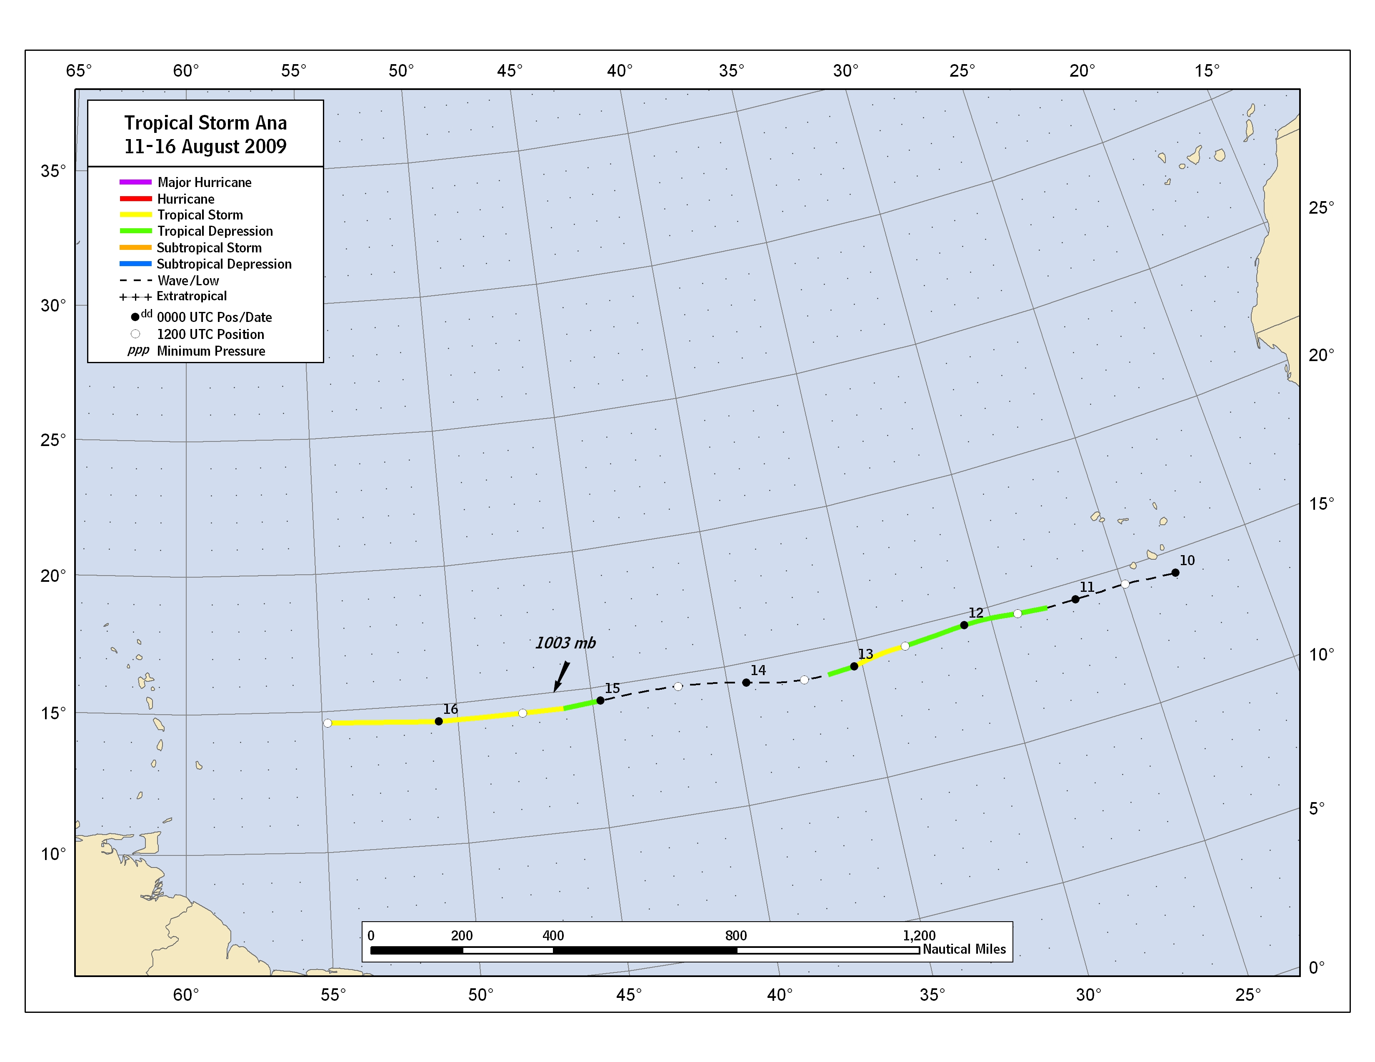
Figure 1. Best track positions for Tropical Storm Ana, 11-16 August 2009.

Figure 2. Selected wind observations and best track maximum sustained surface wind speed curve for Ana, 11-16 August 2009. Aircraft observations have been adjusted for elevation using 90%, 80%, and 80% adjustment factors for observations from 700 mb, 850 mb, and 1500 ft, respectively. Dashed vertical lines correspond to 0000 UTC.

Figure 3. Selected pressure observations and best track minimum central pressure curve for Ana, 11-16 August 2009. Dashed vertical lines correspond to 0000 UTC.

Table 2a. NHC official (OFCL) and climatology-persistence skill baseline (OCD5) track forecast errors (n mi) for Ana. Mean errors for the five-year period 2004-8 are shown for comparison. Official errors that are smaller than the five-year means are shown in boldface type.

 | Forecast Period (h)
 | 12 | 24 | 36 | 48 | 72 | 96 | 120
OFCL (Ana) | 18.0 | 35.6 | 61.8 | 13.3 | 116.7 | 233.8 | 355.1
OCD5 (Ana) | 30.8 | 71.1 | 114.1 | 68.3 | 220.5 | 412.6 | 606.2
Forecasts | 11 | 7 | 3 | 1 | 5 | 6 | 2
OFCL (2004-8) | 32.1 | 54.9 | 77.1 | 99.0 | 147.0 | 200.3 | 263.6
OCD5 (2004-8) | 45.8 | 95.7 | 152.8 | 208.6 | 306.2 | 393.6 | 472.9

Table 2b. Homogeneous comparison of selected track forecast guidance models (in n mi) for Ana. Errors smaller than the NHC official forecast are shown in boldface type. The number of official forecasts shown here will generally be smaller than that shown in Table 2a due to the homogeneity requirement.

Model ID | Forecast Period (h)
Model ID | 12 | 24 | 36 | 48 | 72 | 96 | 120
OFCL | 18.0 | 35.6 | 61.8 | 13.3 | 116.7 | 233.8 | 355.1
OCD5 | 30.8 | 71.1 | 114.1 | 68.3 | 220.5 | 412.6 | 606.2
HWFI | 44.6 | 91.0 | 135.3 | 132.3 | 301.3 | 484.8 | 617.5
TVCN | 22.1 | 38.0 | 63.9 | 40.0 | 124.2 | 239.0 | 340.1
TVCC | 22.7 | 37.5 | 57.8 | 39.2 | 96.7 | 236.0 | 302.1
BAMS | 40.0 | 84.5 | 139.6 | 54.3 | 218.6 | 414.0 | 555.2
BAMM | 47.3 | 96.4 | 162.2 | 97.6 | 250.9 | 464.6 | 699.7
BAMD | 53.5 | 107.3 | 166.6 | 139.9 | 298.3 | 557.1 | 993.6
LBAR | 38.5 | 93.9 | 154.7 | 171.0 | 327.6 | 606.3 | 1092.4
Forecasts | 11 | 7 | 3 | 1 | 5 | 6 | 2
Table 3a. NHC official (OFCL) and climatology-persistence skill baseline (OCD5) intensity forecast errors (kt) for Ana. Mean errors for the five-year period 2004-8 are shown for comparison. Official errors that are smaller than the five-year means are shown in boldface type.

 | Forecast Period (h)
 | 12 | 24 | 36 | 48 | 72 | 96 | 120
OFCL (Ana) | 2.7 | 5.7 | 6.7 | 15.0 | 14.0 | 14.2 | 15.0
OCD5 (Ana) | 4.5 | 6.6 | 4.0 | 12.0 | 15.2 | 18.8 | 20.5
Forecasts | 11 | 7 | 3 | 1 | 5 | 6 | 2
(AL) OFCL (2004-8) | 7.1 | 10.5 | 12.8 | 14.7 | 18.1 | 19.0 | 20.9
(AL) OCD5 (2004-8) | 8.5 | 12.3 | 15.3 | 17.7 | 20.8 | 23.1 | 23.2

Table 3b. Homogeneous comparison of selected intensity forecast guidance models (in kt) for Ana. Errors smaller than the NHC official forecast are shown in boldface type. The number of official forecasts shown here will generally be smaller than that shown in Table 3a due to the homogeneity requirement.

Model ID | Forecast Period (h)
Model ID | 12 | 24 | 36 | 48 | 72 | 96 | 120
OFCL | 2.5 | 5.8 | 10.0 | 15.0 | 14.0 | 14.0 | 15.0
OCD5 | 4.7 | 7.5 | 4.5 | 12.0 | 15.2 | 19.2 | 24.0
HWFI | 5.1 | 8.3 | 6.0 | 9.0 | 8.0 | 6.4 | 7.0
GHMI | 4.6 | 5.3 | 3.5 | 16.0 | 2.4 | 5.2 | 11.0
DSHP | 3.9 | 5.5 | 6.5 | 12.0 | 19.2 | 16.4 | 11.0
LGEM | 4.5 | 7.3 | 0.0 | 6.0 | 12.2 | 11.6 | 9.0
ICON | 4.4 | 6.2 | 2.5 | 11.0 | 10.0 | 7.8 | 6.0
Forecasts | 10 | 6 | 2 | 1 | 5 | 5 | 1

Table 4. Watches/warnings for Ana.

Date/Time (UTC) | Action | Location
15 / 2100 | Tropical Storm Watch issued | St. Maarten, Saba, St. Eustatius
16 / 0300 | Tropical Storm Watch issued | British Virgin Islands, Montserrat, Antigua, Barbuda, St. Kitts, Nevis, Anguilla
16 / 0300 | Tropical Storm Watch issued | U.S. Virgin Islands
16 / 0900 | Tropical Storm Watch issued | Puerto Rico
16 / 1500 | Tropical Storm Watch issued | Dominica, Guadeloupe, St. Martin, St. Barthelemy
16 / 2100 | Tropical Storm Watch issued | Dominican Republic from Cabo Engano to Cabo Beata
17 / 0000 | Tropical Storm Watch discontinued | Dominica
17 / 0900 | Tropical Storm Watch discontinued | Antigua, Barbuda, Montserrat
17 / 1500 | Tropical Storm Watch discontinued | St. Maarten, Saba, St. Eustatius, British Virgin Islands, Montserrat, Antigua, Barbuda, St. Kitts, Nevis, Anguilla, Guadeloupe, St. Martin, St. Barthelemy
17 / 1500 | Tropical Storm Watch discontinued | Cabo Engano to Cabo Beata
17 / 1500 | Tropical Storm Watch issued | Punta Palenque to N border Haiti/Dominican Republic
17 / 2100 | Tropical Storm Watch discontinued | All

A digital record of the complete best track, including wind radii, can be found on line at ftp://ftp.nhc.noaa.gov/atcf. Data for the current year’s storms are located in the btk directory, while previous years’ data are located in the archive directory.

