Tropical Cyclone Report
Tropical Storm Barry (AL022007)
1-2 June 2007

Lixion A. Avila
National Hurricane Center
22 June 2007

Barry was a short-lived tropical storm that brought beneficial rains to Florida.

- Synoptic History

The precursor of Barry was associated with a westward moving tropical wave that spawned a broad area of low pressure near the eastern coast of the Yucatan Peninsula on 30 May. By 31 May, surface observations indicated that a circulation had developed with the area of minimum pressure centered southeast of Cozumel, Mexico. At that time, the system was not classified as a tropical depression because the shower activity was disorganized and well-removed from the area of low pressure. As the low moved north-northeastward over the northwestern Caribbean Sea and the southeastern Gulf of Mexico, the deep convection became somewhat concentrated near the center and it is estimated that a tropical depression formed just to the northwest of the western tip of Cuba at 1200 UTC 1 June. Thereafter, the shower activity increased further and the surface circulation become a little better organized.

The depression became a tropical storm at 1800 UTC 1 June and it reached its peak intensity of 50 knots, with a minimum pressure of 997 mb, at 0000 UTC 2 June about 130 n mi west-southwest of the Dry Tortugas. Thereafter, a mid- to upper-level trough over the Central Gulf of Mexico produced strong upper-level southwesterly winds over the cyclone resulting in weakening. It is estimated that the center of the broad circulation reached the Tampa Bay area at 1400 UTC 2 June. By then, the system had weakened to a tropical depression and had begun to acquire extratropical characteristics.

The depression moved between north-northeast and northeast across northern Florida and became fully extratropical by 0000 UTC 3 June over eastern Georgia. The extratropical cyclone intensified and moved toward the northeast along the east coast of the United States. It became absorbed by a larger extratropical cyclone at 1800 UTC 5 June near the St. Lawrence River. Strong winds occurred off the coast of northeastern Florida, when Barry was just north of Cuba. These winds were associated with a strong high pressure system and a cold front and not directly with the cyclone’s circulation.

The “best track” chart of the tropical cyclone’s path is given in Fig. 1, with the wind and pressure histories shown in Figs. 2 and 3, respectively. The best track positions and intensities are listed in Table 1.

- Meteorological Statistics

Observations in Tropical Storm Barry (Figs. 2 and 3) include satellite-based Dvorak technique intensity estimates from the Tropical Analysis and Forecast Branch (TAFB) and the Satellite Analysis Branch (SAB), as well as observations from two flights of the 53rd Weather Reconnaissance Squadron of the U. S. Air Force Reserve Command. Microwave satellite imagery from NOAA polar-orbiting satellites, the NASA Tropical Rainfall Measuring Mission (TRMM), and the NASA QuikSCAT were also useful in tracking Barry.

Barry was embedded within strong southwesterly shear ahead of a mid-latitude trough and the cloud pattern had features of both a tropical and a subtropical cyclone. However, data from the Air Force Reconnaissance plane during the afternoon of 1 June indicated that the area of strongest winds was very close to the center, of the order of 5 to 10 n mi. This structure is typical of tropical cyclones, and because organized convection developed near the center during that period, Barry has been classified as a tropical cyclone. There was a flight level (1500 ft) peak wind of 67 knots in the northwest portion of the circulation reported at 2058 UTC 1 June. These winds were not representative of the intensity of the cyclone since they were short-lived and appeared to be associated with a convective downburst.

Data from a second reconnaissance mission on the morning of 2 June supported the weakening inferred by satellite. Flight-level winds at 1500 feet of 40 to 45 knots were observed in the southeastern quadrant over water just before landfall. However, that portion of the circulation was devoid of deep convection and the winds did not reach the surface as indicated by numerous observations nearby.

The cyclone produced heavy rains over Cuba and brought beneficial rains to Florida. There were reports of three tornadoes associated with Barry. One occurred in Playa Giron Cuba. The other two occurred in northern Sugarloaf Key in the Florida Keys, and in Cutler Bay, Florida. Selected surface observations from land stations and data buoys are given in Table 2. Fig 4 shows the total rainfall associated with the entire life of Barry.

- Casualty and Damage Statistics

The tornado that occurred on northern Sugarloaf Key produced moderate damage to roofing materials and the one in Cutler Bay produced roof damage to a home and uprooted large trees. In general, the rains produced by Barry were beneficial primarily to Florida. These rain totals are included in Table 2.

- Forecast and Warning Critique

While tropical cyclogenesis was not well anticipated, a special disturbance statement was issued about 20 hours prior to the formation of Barry indicating the potential for tropical or subtropical development. Advisories were initiated when data from a reconnaissance plane confirmed that the cyclone was not frontal. By then, the cyclone had already reached tropical storm intensity and tropical storm watches and warnings were immediately issued. Table 3 summarizes the watches and warnings associated with Barry.

Average official track errors for Barry were 77 and 50 n mi for the 12 and 24 h forecasts, respectively. There were three 12-hour forecasts and only one 24-h forecast. The official 5-yr period (2002-2006) average errors are 35 and 61 n mi for these two forecast periods, respectively.

Average official intensity errors were 7 and 15 kt for the 12 and 24 h forecasts, respectively. For comparison, the average official intensity errors over the 5-yr period 2002-2006 are 6 and 10 kt, respectively.

Table 1. Best track for Tropical Storm Barry, 1-2 June 2007.

Date/Time  (UTC) | Latitude  (◦N) | Longitude  (◦W) | Pressure  (mb) | Wind Speed  (kt) | Stage
31 / 0000 | 18.1 | 87.0 | 1008 | 25 | low
31 / 0600 | 18.7 | 86.9 | 1007 | 25 | "
31 / 1200 | 19.1 | 86.8 | 1006 | 25 | "
31 / 1800 | 19.6 | 86.6 | 1005 | 25 | "
01 / 0000 | 20.1 | 86.0 | 1005 | 25 | "
01 / 0600 | 21.2 | 85.8 | 1005 | 25 | "
01 / 1200 | 22.3 | 85.8 | 1004 | 30 | tropical depression
01 / 1800 | 23.6 | 85.7 | 1000 | 40 | tropical storm
02 / 0000 | 24.3 | 85.2 | 997 | 50 | "
02 / 0600 | 25.1 | 84.6 | 998 | 45 | "
02 / 1200 | 27.0 | 83.2 | 1000 | 40 | "
02 / 1800 | 29.7 | 82.1 | 1001 | 30 | tropical depression
03 / 0000 | 31.4 | 81.4 | 997 | 35 | extratropical
03 / 0600 | 32.1 | 81.0 | 994 | 40 | "
03 / 1200 | 32.8 | 80.0 | 994 | 40 | "
03 / 1800 | 33.7 | 78.4 | 994 | 40 | "
04 / 0000 | 35.3 | 76.0 | 992 | 40 | "
04 / 0600 | 37.2 | 74.6 | 990 | 40 | "
04 / 1200 | 39.0 | 73.2 | 990 | 40 | "
04 / 1800 | 40.7 | 72.1 | 991 | 35 | "
05 / 0000 | 42.4 | 70.8 | 992 | 35 | "
05 / 0600 | 44.6 | 69.5 | 992 | 30 | "
05 / 1200 | 47.5 | 68.5 | 992 | 30 | "
05/ 1800 |  |  |  |  | absorbed
02 / 1400 | 27.5 | 82.7 | 1000 | 30 | landfall near Tampa Bay
02 / 0000 | 24.3 | 85.2 | 997 | 50 | minimum pressure

Table 2. Selected surface observations for Tropical Storm Barry, 1-2 June, 2007.

Location | Minimum Sea Level Pressure |  | Maximum Surface  Wind Speed |  |  | Storm surge  (ft)^{c} | Storm  tide  (ft)^{d} | Total  rain  (in)
Location | Date/  time  (UTC) | Press.  (mb) | Date/  time  (UTC)ª | Sustained  (kt)^{b} | Gust  (kt) | Storm surge  (ft)^{c} | Storm  tide  (ft)^{d} | Total  rain  (in)
Cuba
Francia, Isla de la Juventud |  |  |  |  |  |  |  | 4.54
Arroyo de Mantua, Pinar del Rio (PR) |  |  |  |  |  |  |  | 11.02
Cabo San Antonio, (PR) |  |  |  |  |  |  |  | 8.85
Isabel Rubio,(PR) |  |  |  |  |  |  |  | 7.90
San Juan y Martinez,(PR) |  |  |  |  |  |  |  | 5.69
Playa Giron, Matanzas |  |  |  |  |  |  |  | 5.64
Tope de Collantes, Sancti Spiritus (SS) |  |  |  |  |  |  |  | 8.87
Caracusey, SS |  |  |  |  |  |  |  | 12.00
Condado, SS |  |  |  |  |  |  |  | 11.53
Trinidad , SS |  |  |  |  |  |  |  | 5.63
Florida
Key West Int. Arpt. (KWYW) |  |  | 2/0522 | 34 | 41
Pulaski Shoal (PLSF1)  (58 ft) |  |  | 2/0252 |  | 42
Sombrero Key Light (SMKF1)  (159 ft) |  |  | 2/0550 | 37 | 42
Long Key Light (LONF1)  (23 ft) |  |  | 2/0622 |  | 34
Islamorada  (53 ft) |  |  | 2/0932 |  | 34
Cudjoe Key  (30 ft) |  |  | 2/0538 |  | 40
Fort Lauderdale Int. Arpt |  |  |  |  |  |  |  | 3.96
West Palm Beach Int. Arpt |  |  |  |  |  |  |  | 6.99
West Palm Beach |  |  |  |  |  |  |  | 6.84
Dowling Park |  |  |  |  |  |  |  | 6.40
Melbourne WFO |  |  |  |  |  |  |  | 6.03
Largo (McKay Creek) |  |  |  |  |  |  |  | 6.01
Suwannee 6 NE |  |  |  |  |  |  |  | 5.25
Chiefland 5 NE |  |  |  |  |  |  |  | 5.15
Clearwater (Alligator Creek) |  |  |  |  |  |  |  | 4.95
Clearwater Beach | 2/1236 | 1000.6 | 2/1236 |  | 40
Manatee Springs |  |  |  |  |  |  |  | 4.88
Sarasota |  |  | 2/1400 |  | 34
Winter Haven |  |  | 2/2025 |  | 36
Bartow |  |  | 2/2050 |  | 34
Venice |  |  | 2/1200 |  | 36
Dunedin |  |  |  |  |  |  |  | 4.63
NASA Shuttle Facility |  |  |  |  |  |  |  | 4.57
Patrick AFB Cocoa Beach |  |  |  |  |  |  |  | 4.56
Tarpon Springs |  |  |  |  |  |  |  | 4.56
Wilcox |  |  |  |  |  |  |  | 4.34
MacDill AFB |  |  | 2/1301 |  | 39 |  |  | 4.24
Vero Beach Muni Airport |  |  |  |  |  |  |  | 4.15
Safety Harbor |  |  |  |  |  |  |  | 4.09
Jacksonville/ Mun. Airport |  |  |  |  |  |  |  | 4.07
Horseshoe Fire |  |  |  |  |  |  |  | 4.00
Town and Country |  |  |  |  |  |  |  | 3.95
Ft. Lauderdale/Hollywood |  |  |  |  |  |  |  | 3.94
St. Petersburg/Clearwater |  |  |  |  |  |  |  | 3.79
Pinellas Park |  |  |  |  |  |  |  | 3.74
Bronson Fawn |  |  |  |  |  |  |  | 3.67
Cross City Airport |  |  |  |  |  |  |  | 3.62
Albert Whitted |  |  |  |  |  |  |  | 3.54
Inverness |  |  |  |  |  |  |  | 3.50
Palm River |  |  |  |  |  |  |  | 3.34
Tampa Int. Airport |  |  |  |  |  |  |  | 3.17
Jacksonville Int. Airport |  |  |  |  |  |  |  | 3.17
Thonotosassa |  |  |  |  |  |  |  | 3.00
Georgia
Mount Vernon |  |  |  |  |  |  |  | 8.00
Nahunta |  |  |  |  |  |  |  | 6.20
Levy |  |  |  |  |  |  |  | 6.14
Downtown Savannah |  |  |  |  |  |  |  | 5.91
Midway |  |  |  |  |  |  |  | 5.70
Metter |  |  |  |  |  |  |  | 5.68
Savannah Mun. Arpt. |  |  |  |  |  |  |  | 5.21
Port Wentworth |  |  |  |  |  |  |  | 4.17
Alma/Bacon Co. Arpt. |  |  |  |  |  |  |  | 4.05
Hinesville |  |  |  |  |  |  |  | 4.00
Valdosta |  |  |  |  |  |  |  | 3.97
Appling |  |  |  |  |  |  |  | 3.70
Tybee Island |  |  |  |  |  |  |  | 3.68
Brunswick/Malcolm/ McKinnon Arpt. |  |  |  |  |  |  |  | 3.64
Clyattville |  |  |  |  |  |  |  | 3.63
Augusta Bush Field |  |  |  |  |  |  |  | 3.63
Fort Stewart |  |  |  |  |  |  |  | 3.50
Hunter Army Airfield |  |  |  |  |  |  |  | 3.20
Adel Raws |  |  |  |  |  |  |  | 3.18
Ouitman |  |  |  |  |  |  |  | 3.06

ª Date/time is for sustained wind when both sustained and gust are listed.
^{b} Except as noted, sustained wind averaging periods for C-MAN and land-based ASOS reports are 2 min; buoy averaging periods are 8 min.
^{c} Storm surge is water height above normal astronomical tide level.
^{d} Storm tide is water height above National Geodetic Vertical Datum (1929 mean sea level).
( ) anemometer height
Table 3. Watch and warning summary for Tropical Storm Barry, 1-2 June.

Date/Time (UTC) | Action | Location
1/ 2100 | Tropical Storm Warning issued | Bonita Beach to Keaton Beach, FL
1/ 2100 | Tropical Storm Watch issued | North of Keaton beach to St. Marks, FL
2 /1500 | Tropical Storm Warning discontinued | All
2 /1500 | Tropical Storm Watch discontinued | All

Figure 1. Best track positions for Tropical Storm Barry, 1-2 June, 2007.

Figure 2. Selected wind observations and best track maximum sustained surface wind speed curve for Tropical Storm Barry, 1 - 2 June 2007. Aircraft observations have been adjusted for elevation using 90%, 80%, and 80% reduction factors for observations from 700 mb, 850 mb, and 1500 ft, respectively. Vertical solid line represents the landfall time.

Figure 3. Selected pressure observations and best track minimum central pressure curve for Tropical Storm Barry, 1-2 June 2007. Vertical solid line represents the landfall time.
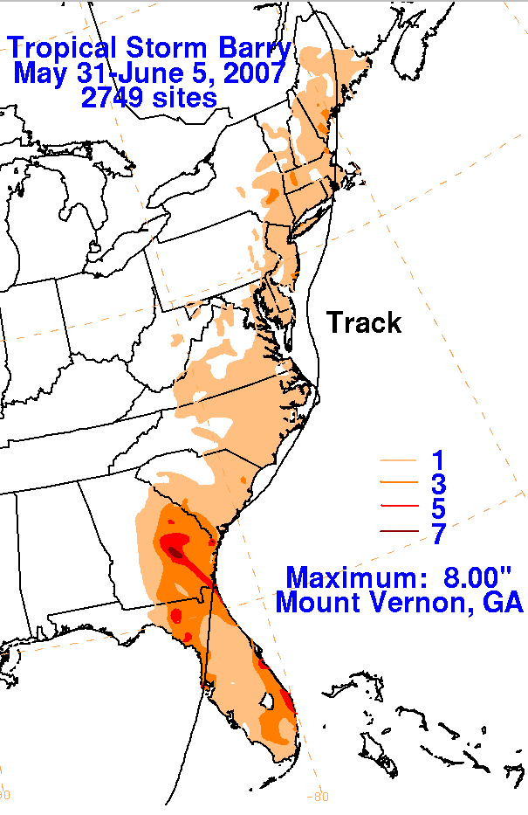

Figure 4. Total rainfall associated with Barry including the extratropical stage. Figure provided by the Hydrometeorological Prediction Center.

