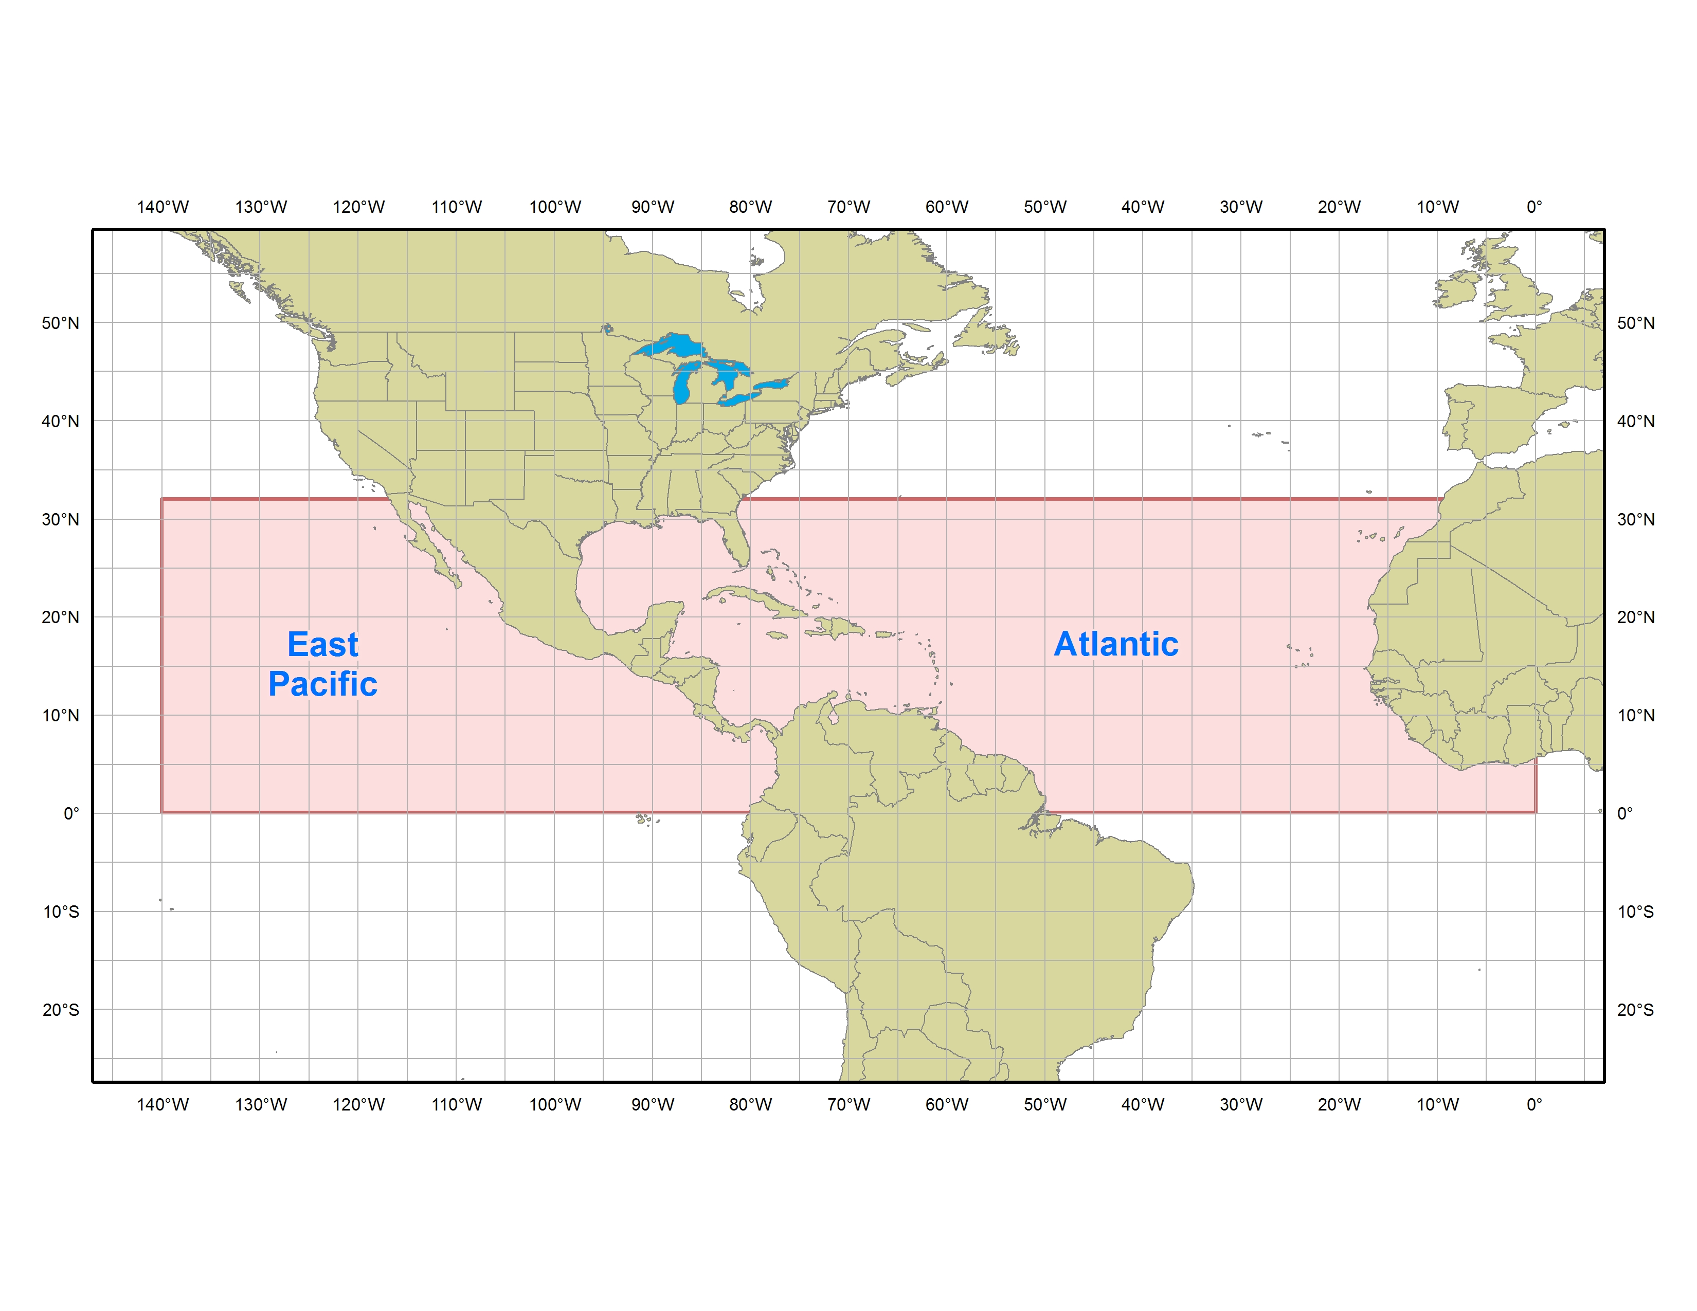   | TROPICAL WEATHER DISCUSSION | 

- Purpose
The Tropical Weather Discussion describes major synoptic weather features and significant areas of disturbed weather in the tropics. The product is intended to provide current weather information for those who need to know the current state of the atmosphere and expected trends to assist them in their decision making. The product gives significant weather features, areas of disturbed weather, expected trends, the meteorological reasoning behind the forecast, model performance, and in some cases a degree of confidence.

- Content
The Tropical Weather Discussion is a narrative explaining the current weather conditions across the tropics and the expected short-term changes. The product is divided into four different sections as outline below:

- SPECIAL FEATURES (event-driven)
The special features section includes descriptions of hurricanes, tropical storms, tropical depressions, subtropical cyclones, and any other feature of significance that may develop into a tropical or subtropical cyclone. For active tropical cyclones, this section provides the latest advisory data on the system. Associated middle and upper level interactions as well as significant clouds and convection are discussed with each system. This section is omitted if none of these features is present.
- TROPICAL WAVES (event-driven)
This section provides a description of the strength, position, and movement of all tropical waves analyzed on the surface analysis, from east to west. A brief reason for a wave’s position is usually given, citing surface observations, upper air time sections, satellite imagery, etc. The associated convection is discussed with each tropical wave as well as any potential impacts to landmasses or marine interests. This section is omitted if there are no tropical waves present.
- ITCZ
In this section, the Intertropical Convergence Zone (ITCZ) is depicted by coordinates from east to west with an outline of all associated convection referenced to the axis, if possible. The ITCZ is depicted based on the following definition: “a zonally elongated axis of surface wind confluence in the tropics, due to confluence of northeasterly and southeasterly trade winds, and/or confluence at the poleward extent of cross-equatorial flow into a near-equatorial ‘heat trough’ or ‘monsoon trough.’”
- DISCUSSION
The discussion section makes reference to middle and upper level features and provides connection to how these features are interacting with or influencing surface features. Convection is outlined with the features as warranted. This section will also provide short-term (up to 48 hours) trends and forecasts of features, especially if they are forecast to strengthen and/or affect landmasses. A discussion of model guidance may also be included. In general, this section is regionalized according to the current weather pattern (i.e. Gulf of Mexico, Caribbean, Western Atlantic, etc.)

Coverage and intensity for convective and non-convective weather is defined as follows:
COVERAGE FOR CONVECTIVE and NON-CONVECTIVE WEATHER:
Numerous Widespread >54%
Scattered Areas 25% - 54%
Widely scattered Local/Locally <25%
Isolated No %, implies circumnavigability
COVERAGE FOR SIGNIFICANT CLOUDS:
Clear 0
Few 1/8 – 2/8
Scattered 3/8 – 4/8
Broken 5/8 – 7/8
Overcast 8/8
INTENSITY OF CONVECTION (based on cloud top temperatures):
Strong < -70°C (summer) < -60°C (winter)
Moderate between -45°C and -70°C (summer) between -35°C and -60°C (winter)
Weak > -45°C (summer) > -35°C (winter)

- Coverage
The National Hurricane Center issues two Tropical Weather Discussions, as shown below:

- Atlantic
From the equator to 32°N west of the prime meridian including the Caribbean Sea, Gulf of Mexico, and adjacent land areas. These areas include the southeast United States [especially Florida], Mexico, Central America, northern South America, and western Africa
- East Pacific
From the equator to 32°N east of 140°W including coastal areas of Mexico, and Central and South America.

  - Issuance / Transmission
The Tropical Weather Discussion is transmitted under World Meteorological Organization (WMO) and NOAA Weather Wire Services (NWWS) headers as shown below:

 | WMO | NWWS
Atlantic | AXNT20 KNHC | MIATWDAT
East Pacific | AXPZ20 KNHC | MIATWDEP

Tropical Weather Discussions are issued on a regular six hourly schedule as shown below:

 | Issuance Time
MIATWDAT | 105 AM EST  (205 AM EDT) | 705 AM EST  (805 AM EDT) | 105 PM EST  (205 PM EDT) | 705 PM EST  (805 PM EDT)
MIATWDEP | 0405 UTC | 1005 UTC | 1605 UTC | 2205 UTC

