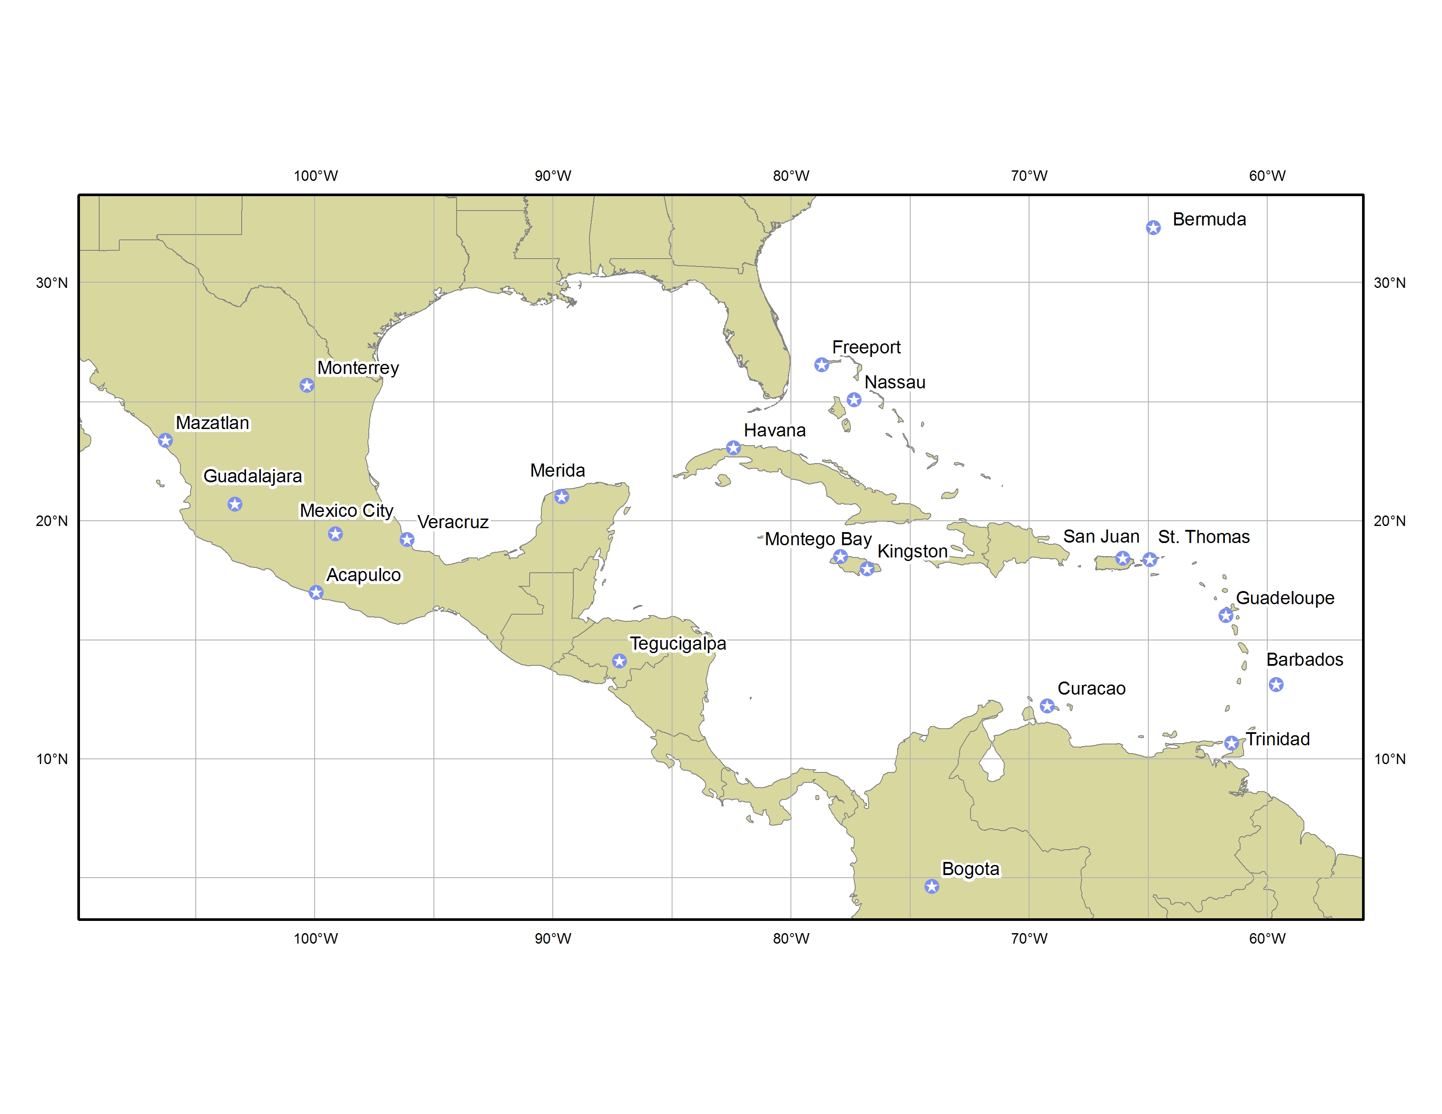   | PAN-AMERICAN TEMPERATURE AND PRECIPITATION TABLE | 

- Purpose
The Pan-American Temperature and Precipitation Table is a collection of temperature and precipitation data and present weather for selected cities in Mexico, Central and South America, and the Caribbean area. It provides general weather conditions two times per day for general public use domestically and internationally.

- Content
This product provides general weather conditions, high and low temperatures in degrees Fahrenheit (°F) and degrees Celsius (°C), and measured precipitation in the previous 6, 12, or 24 hours, as indicated, for selected cities in Mexico, Central and South America, and the Caribbean area. The morning product contains the low temperature for the current day and the high temperature for the previous day. The evening product contains the low and high temperature for the current day.

- Coverage
The Pan-American Temperature and Precipitation Table includes the following stations (as shown in the map above):

Acapulco, Mexico Merida, Mexico
Barbados Mexico City, Mexico
Bermuda Montego Bay, Jamaica
Bogotá, Colombia Monterrey, Mexico
Curaçao, Netherlands Antilles Nassau, Bahamas
Freeport, Bahamas San Juan, Puerto Rico
Guadalajara, Mexico St. Thomas, Virgin Islands
Guadeloupe Tegucigalpa, Honduras
Havana, Cuba Trinidad
Kingston, Jamaica Veracruz, Mexico
Mazatlán, Mexico

  - Issuance / Transmission
The Pan-American Temperature and Precipitation Table is transmitted under World Meteorological Organization (WMO) and NOAA Weather Wire Services (NWWS) headers as shown below:

 | WMO | NWWS
Pan-Am Table | SXCA01 KNHC | MIATPTPAN

The product is issued twice a day as shown below:

 | Valid Time | Issuance Time
Morning MIATPTPAN | 700 AM EST  (800 AM EDT) | by 950 AM EST  (1050 AM EDT)
Evening MIATPTPAN | 700 PM EST  (800 PM EDT) | by 950 PM EST  (1050 PM EDT)

