Tropical Cyclone Report
Tropical Storm Olaf
(EP182009)
1-3 October 2009

Eric S. Blake
National Hurricane Center
11 November 2009

Updated 11 June 2010 for rainfall information over Mexico

Olaf was a weak tropical storm that degenerated into a remnant low before impacting southern Baja California.

- Synoptic History

Olaf’s precursor wave was difficult to track across the tropical Atlantic Ocean due to its close proximity to Hurricane Fred and a stronger wave to the east. However, the wave became more distinct on 18 September, exhibiting a characteristic v-shape in visible satellite imagery when it was located a few hundred miles east of the Lesser Antilles. Moving westward, the wave interacted with an upper-level trough to produce a large area of thunderstorms over the western Caribbean Sea on 23 September. Convection was quite active for the next several days while the wave moved through Central America and into the eastern Pacific. An elongated low formed on 28 September, and late the next day, the large system began developing banding features. The broad low was close to becoming a tropical depression on 30 September before all of the associated deep convection dissipated. However, thunderstorms returned that night in the northern portion of the large circulation, causing the center to reform farther north, and a tropical depression developed near 1200 UTC October 1, when the system was located about 475 n mi west-southwest of the southern tip of Baja California. The “best track” chart of the tropical cyclone’s path is given in Figure 1, and the best track positions and intensities are listed in Table 1.

Shortly after formation, the depression turned toward the north and became a tropical storm. Olaf continued moving northward around the western periphery of a middle-level ridge over northern Mexico, and QuikSCAT data indicated that the storm reached a peak intensity of about 40 kt around 1200 UTC 2 October. The system turned sharply toward the east early the next day and weakened due to cooler waters and increasing southerly shear. Olaf weakened into a tropical depression at 0600 UTC 3 October, and 12 h later degenerated to a remnant low about 135 n mi west-southwest of Cabo San Lazaro, Mexico. The remnant low slowed down, turned toward the east-northeast and moved ashore over the southern Baja California peninsula early the next day before dissipating.

- Meteorological Statistics

Observations in Olaf (Figs. 2 and 3) include satellite-based Dvorak technique intensity estimates from the Tropical Analysis and Forecast Branch (TAFB) and the Satellite Analysis Branch (SAB). Data and imagery from NOAA polar-orbiting satellites including the Advanced Microwave Sounding Unit (AMSU) instrument, the NASA Tropical Rainfall Measuring Mission (TRMM), the NASA QuikSCAT, and Defense Meteorological Satellite Program (DMSP) satellites, among others, were also useful in constructing the best track of Olaf.

The estimated peak intensity of 40 kt is based on blend of satellite estimates from TAFB and SAB and QuikSCAT data. The estimated minimum pressure of 996 mb is lower than Dvorak estimates because of ship and land observations that showed rather low environmental pressures.

Two ships reported tropical-storm-force winds associated with Olaf. The Happy Rover, call sign PCBZ, reported 35 kt sustained winds at 2100 UTC 1 October and a minimum pressure of 1004.7 three hours later. The Nikkei Dragon, call sign 3FXY2, measured 37 kt winds and a pressure of 1003.6 mb near 1200 UTC 2 October.

Heavy rains associated with Olaf and its remnants fell in portions of northwestern Mexico and southern Baja California, with reports of flooding in the cities of La Paz and Comondu. The maximum reported rainfall in Baja California was 75.2 mm at Ciudad Constitucion, while in Sinaloa the peak rainfall total was 132.5 mm at El Carrizo.

- Forecast and Warning Critique

The wave that eventually spawned Olaf was introduced in the Tropical Weather Outlook (TWO) about 60 h before genesis. Although the formation of Olaf was generally well-anticipated in subsequent outlooks, the system entered the high category (>50% chance of genesis) only 12 h before genesis.

A verification of NHC official track forecasts for Olaf is given in Table 2a. Official forecast track errors were much larger than the mean official errors for the previous five-year period, although climatology/persistence (OCD5) errors were also quite large. A homogeneous comparison of the official track errors to selected guidance models is given in Table 2b. The large forecast errors occurred due to Olaf moving to the north unexpectedly after the antecedent wave had moved westward for several days. In addition, the system was expected to remain a shallow system, leading to NHC forecasts that were south of most of the guidance in agreement with low-level flow forecasts. The sharp eastward turn as Olaf approached Baja California was also not well forecast by the official forecast or the models.

A verification of NHC official intensity forecasts for Olaf is given in Table 3a. Official forecast intensity errors were considerably lower than the mean official errors for the previous five-year period. A homogeneous comparison of the official track errors with selected guidance models is given in Table 3b. Although there were relatively few forecasts, the official forecasts were mostly better than the available guidance.

Table 1. Best track for Tropical Storm Olaf, 1-3 October 2009.

Date/Time  (UTC) | Latitude  (°N) | Longitude  (°W) | Pressure  (mb) | Wind Speed  (kt) | Stage
01 / 1200 | 19.0 | 117.3 | 1003 | 30 | tropical depression
01 / 1800 | 19.6 | 117.4 | 1000 | 35 | tropical storm
02 / 0000 | 20.4 | 117.4 | 997 | 40 | "
02 / 0600 | 21.5 | 117.4 | 996 | 40 | "
02 / 1200 | 22.6 | 117.5 | 996 | 40 | "
02 / 1800 | 23.3 | 117.5 | 997 | 35 | "
03 / 0000 | 23.8 | 117.3 | 997 | 35 | "
03 / 0600 | 24.0 | 116.7 | 998 | 30 | tropical depression
03 / 1200 | 23.9 | 115.6 | 998 | 30 | "
03 / 1800 | 23.8 | 114.3 | 999 | 30 | remnant low
04 / 0000 | 23.9 | 113.0 | 1000 | 25 | "
04 / 0600 | 24.2 | 111.8 | 1002 | 25 | "
04 / 1200 | 24.5 | 111.2 | 1003 | 25 | "
04 / 1800 |  |  |  |  | dissipated
02 / 0600 | 21.5 | 117.4 | 996 | 40 | minimum pressure

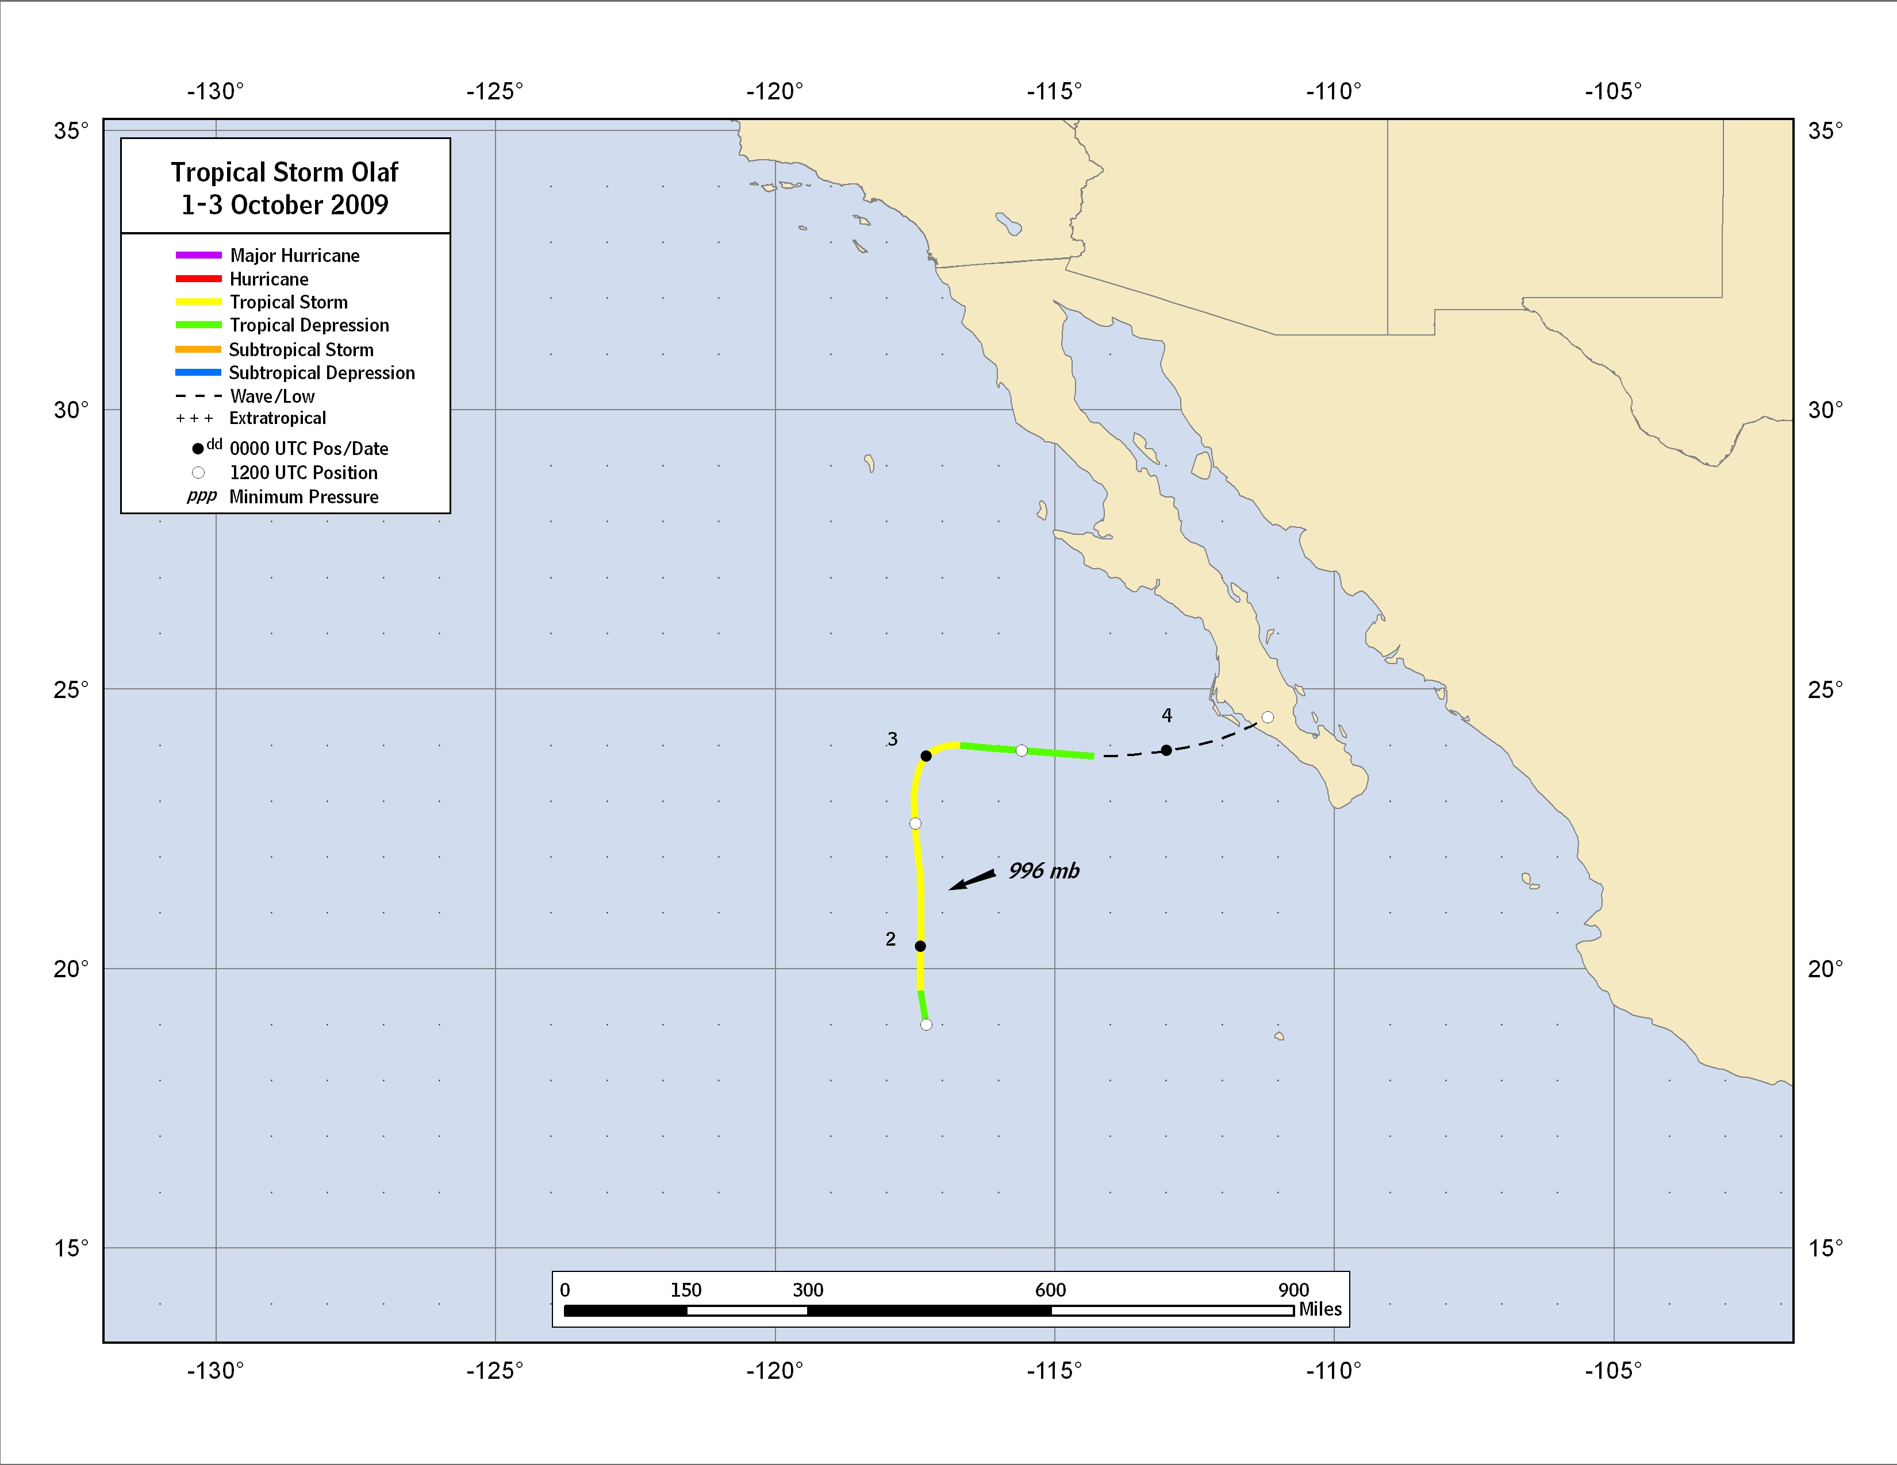
Figure 1. Best track positions for Tropical Storm Olaf, 1-3 October 2009.
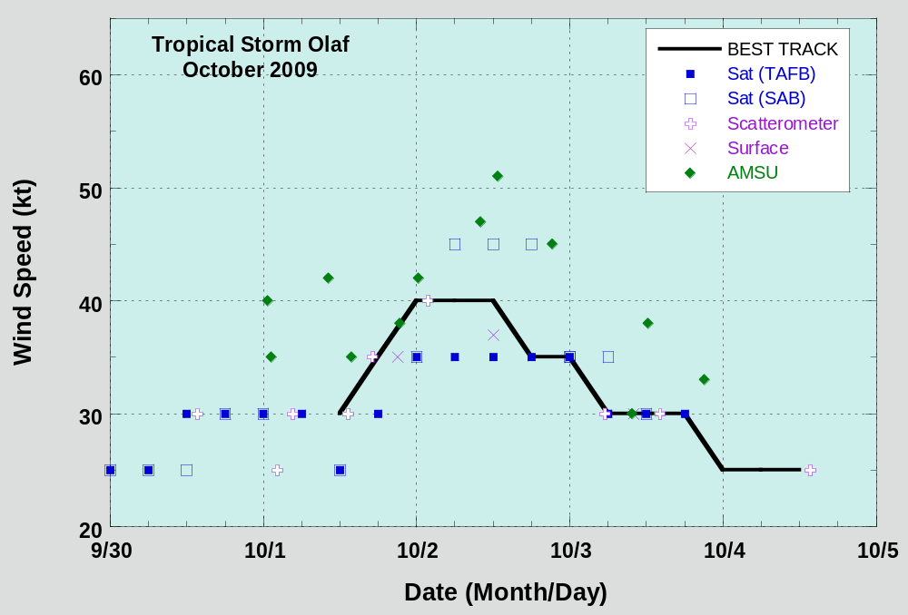

Figure 2. Selected wind observations and best track maximum sustained surface wind speed curve for Olaf, 1-3 October 2009. Dashed vertical lines correspond to 0000 UTC.

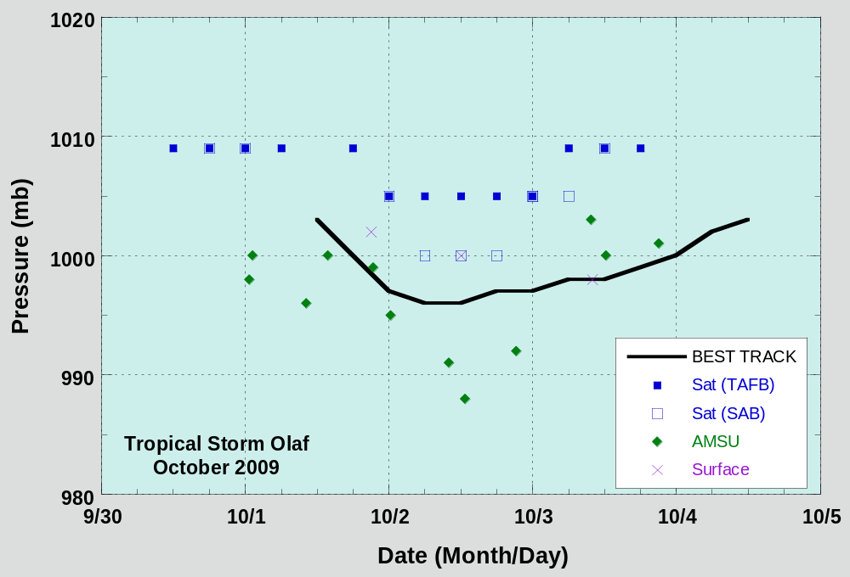
Figure 3. Selected pressure observations and best track minimum central pressure curve for Olaf, 1-3 October 2009. Dashed vertical lines correspond to 0000 UTC.
Table 2a. NHC official (OFCL) and climatology-persistence (CLIPER) skill baseline (OCD5) track forecast errors (n mi) for Olaf. Mean errors for the five-year period 2004-8 are shown for comparison. Official errors that are smaller than the five-year means are shown in boldface type.

 | Forecast Period (h)
 | 12 | 24 | 36 | 48 | 72 | 96 | 120
OFCL | 71.9 | 141.0 | 241.2 | 289.4
OCD5 | 86.7 | 167.7 | 279.7 | 532.7
Forecasts | 7 | 5 | 3 | 1
OFCL (2004-8) | 31.0 | 51.7 | 71.7 | 90.2
OCD5 (2004-8) | 38.4 | 73.6 | 111.9 | 149.1

Table 2b. Homogeneous comparison of selected track forecast guidance models (in n mi) for Olaf. Errors smaller than the NHC official forecast are shown in boldface type. The number of official forecasts shown here will generally be smaller than that shown in Table 2a due to the homogeneity requirement.

Model ID | Forecast Period (h)
Model ID | 12 | 24 | 36 | 48 | 72 | 96 | 120
OFCL | 81.5 | 148.1 | 231.0
OCD5 | 94.4 | 166.3 | 223.0
GFSI | 124.0 | 196.7 | 271.8
GHMI | 74.2 | 106.4 | 128.2
HWFI | 79.5 | 134.0 | 231.2
NGPI | 95.0 | 162.7 | 272.3
UKMI | 76.1 | 121.4 | 230.0
EMXI | 64.9 | 94.3 | 105.7
AEMI | 113.1 | 138.4 | 158.8
TVCN | 80.3 | 136.1 | 204.0
TVCC | 87.8 | 155.4 | 214.5
LBAR | 99.3 | 146.0 | 137.8
BAMS | 104.9 | 176.8 | 280.9
BAMM | 108.8 | 174.9 | 263.3
BAMD | 118.1 | 180.8 | 237.1
Forecasts | 4 | 3 | 2
Table 3a. NHC official (OFCL) and climatology-persistence (SHIFOR) skill baseline (OCD5) intensity forecast errors (kt) for Olaf. Mean errors for the five-year period 2004-8 are shown for comparison. Official errors that are smaller than the five-year means are shown in boldface type.

 | Forecast Period (h)
 | 12 | 24 | 36 | 48 | 72 | 96 | 120
OFCL | 2.1 | 3.0 | 1.7 | 5.0
OCD5 | 4.0 | 5.0 | 2.0 | 2.0
Forecasts | 7 | 5 | 3 | 1
OFCL (2004-8) | 6.2 | 10.2 | 13.3 | 15.1
OCD5 (2004-8) | 7.1 | 11.5 | 14.7 | 16.8

Table 3b. Homogeneous comparison of selected intensity forecast guidance models (in kt) for Olaf. Errors smaller than the NHC official forecast are shown in boldface type.

Model ID | Forecast Period (h)
Model ID | 12 | 24 | 36 | 48 | 72 | 96 | 120
OFCL | 2.1 | 3.0 | 1.7 | 5.0
OCD5 | 4.0 | 5.0 | 2.0 | 2.0
GHMI | 4.0 | 4.4 | 3.0 | 0.0
HWFI | 4.7 | 4.0 | 2.0 | 8.0
DSHP | 4.3 | 4.2 | 5.7 | 3.0
LGEM | 4.4 | 5.2 | 3.3 | 2.0
ICON | 4.1 | 3.8 | 1.7 | 1.0
IVCN | 3.7 | 2.8 | 1.7 | 1.0
Forecasts | 7 | 5 | 3 | 1

A digital record of the complete best track, including wind radii, can be found on line at ftp://ftp.nhc.noaa.gov/atcf. Data for the current year’s storms are located in the btk directory, while previous years’ data are located in the archive directory.

