Tropical Cyclone Report
Tropical Storm Polo
(EP182008)
2 – 5 November 2008

Robbie Berg
National Hurricane Center
9 December 2008

Polo was a small, short-lived tropical storm that formed at a low latitude and did not affect land.

- Synoptic History

Polo developed from a tropical wave that moved off the coast of west Africa on 15 October. The wave moved steadily westward across the Atlantic Ocean and Caribbean Sea with limited deep convection and then crossed Central America between 27 and 29 October. Once the wave moved into the eastern North Pacific Ocean, a small area of deep convection developed near the wave axis within the Intertropical Convergence Zone (ITCZ). A small area of low pressure then developed along the tropical wave axis and eventually became a tropical depression at 1200 UTC 2 November, approximately 680 n mi south-southwest of Manzanillo, Mexico. The depression continued to move westward and strengthened into a tropical storm 12 h later at 0000 UTC 3 November. The “best track” chart of Polo is given in Fig. 1, with the wind and pressure histories shown in Figs. 2 and 3, respectively. The best track positions and intensities are listed in Table 1. Polo became a tropical storm while centered at a latitude of 8.7°N. Historical records indicate that only four other tropical cyclones in the eastern North Pacific developed into tropical storms at a lower latitude—Tropical Storm Jimena (1979), Hurricane Agatha (1980), Hurricane Adolph (1983), and Tropical Storm Velma (1983).

Polo appeared to partially detach from the ITCZ but never fully separated. Yet early on 3 November, microwave satellite imagery indicated that Polo had developed a small, well-defined circulation and a ring of thunderstorm activity surrounding a tiny eye-like feature (Fig. 4). The thunderstorm activity then nearly vanished between 1200 UTC 3 November and 0000 UTC 4 November before re-developing as a larger area of deep convection on 4 November. The deep convection then became disorganized due to west-northwesterly shear, and Polo weakened to a tropical depression at 0000 UTC 5 November. Soon afterward, the low-level center degenerated into a surface trough, which continued to propagate westward through the ITCZ.

- Meteorological Statistics

Observations in Polo (Figs. 2 and 3) include satellite-based Dvorak technique intensity estimates from the Tropical Analysis and Forecast Branch (TAFB) and the Satellite Analysis Branch (SAB). Data and imagery from NOAA polar-orbiting satellites, Defense Meteorological Satellite Program (DMSP) satellites, and National Aeronautics and Space Administration (NASA) satellites, including the Tropical Rainfall Measuring Mission (TRMM), QuikSCAT, and Aqua, and the U.S. Navy WindSat were also useful in tracking Polo.

Polo’s peak intensity of 40 kt between 0600 UTC and 1200 UTC 3 November is based on a 1338 UTC 3 November QuikSCAT pass as well as objective satellite intensity technique estimates of 40 kt. This period coincides with the time when Polo developed the tight ring of deep convection and small eye-like feature as observed in microwave imagery (Fig. 4). A second peak of 40 kt occurred between 0600 UTC and 1200 UTC 4 November based on a consensus of subjective and objective satellite intensity estimates and an 0210 UTC 4 November QuikSCAT pass.

Like Atlantic Tropical Storm Marco, Polo was a small tropical cyclone. QuikSCAT data indicate that the radius of tropical storm force winds only extended out to 25 n mi from the center. The intensity of small tropical cyclones is often difficult to estimate with the Dvorak technique, and it is possible that Polo could have been more intense than indicated by satellite techniques. In Marco’s case, for example, satellite intensity techniques estimated a peak intensity between 30 and 45 kt, whereas aircraft reconnaissance measured a peak intensity of 55 kt.

There were no ship reports of winds to tropical storm force associated with Polo.

- Casualty and Damage Statistics

There were no reports of damage or casualties associated with Polo.

- Forecast and Warning Critique

The genesis of Polo was not well anticipated. The area of disturbed weather that eventually became Polo was first mentioned in the Tropical Weather Outlook (TWO) at 0000 UTC 1 November, 36 h before the system became a tropical depression. Subsequent TWOs downplayed the significance of the system, however, and the first mention of the possibility of the system becoming a tropical depression occurred 24 h later in the 0000 UTC 2 November TWO. The system was given a medium chance (20-50%) of becoming a tropical cyclone but was never given a high probability of genesis (>50%) before it developed into a depression.

A verification of official and guidance model track forecasts is given in Table 2. Average official track errors for Polo were 30, 42, 68, and 115 n mi for the 12, 24, 36, and 48 h forecasts, respectively. The number of forecasts ranged from nine at 12 h to three at 48 h. These errors are lower than the average 5-yr official track errors except at the 48 h forecast time, although the number of forecasts is too low for a meaningful comparison (Table 2). Only the ECMWF model (EMXI) had lower forecast errors than the official forecast at every forecast period.

A verification of official and guidance model intensity forecasts is given in Table 3. Average official intensity errors were 4, 7, 12, and 20 kt for the 12, 24, 36, and 48 h forecasts, respectively. For comparison, the average 5-yr official intensity errors are 6, 10, 14, and 16 kt, respectively. The official forecast intensity errors are lower than the 5-yr averages except at the 48 h forecast time, although the number of forecasts is too small for a meaningful comparison. In general, most of the intensity models had lower errors than the official intensity forecast, primarily because several of the early official forecasts showed a significant high bias. Some of these forecasts indicated a peak intensity as high as 60 kt, but Polo only reached a peak intensity of 40 kt.

There were no watches or warning issued in association with Polo.

Table 1. Best track for Tropical Storm Polo, 2 – 5 November 2008.

Date/Time  (UTC) | Latitude  (°N) | Longitude  (°W) | Pressure  (mb) | Wind Speed  (kt) | Stage
02 / 1200 | 8.3 | 108.0 | 1007 | 25 | tropical depression
02 / 1800 | 8.6 | 109.3 | 1006 | 30 | "
03 / 0000 | 8.7 | 110.5 | 1005 | 35 | tropical storm
03 / 0600 | 8.6 | 111.7 | 1003 | 40 | "
03 / 1200 | 8.7 | 112.8 | 1003 | 40 | "
03 / 1800 | 9.0 | 113.9 | 1004 | 35 | "
04 / 0000 | 9.4 | 114.9 | 1004 | 35 | "
04 / 0600 | 9.6 | 116.0 | 1003 | 40 | "
04 / 1200 | 9.7 | 117.1 | 1003 | 40 | "
04 / 1800 | 9.7 | 118.2 | 1004 | 35 | "
05 / 0000 | 9.7 | 119.4 | 1005 | 30 | tropical depression
05 / 0600 |  |  |  |  | dissipated
03 / 0600 | 8.6 | 111.7 | 1003 | 40 | minimum pressure and maximum wind

Table 2. Track forecast evaluation (heterogeneous sample) for Tropical Storm Polo, 2 – 5 November 2008. Forecast errors (n mi) are followed by the number of forecasts in parentheses. Errors smaller than the NHC official forecast are shown in boldface type.

Forecast Technique | Forecast Period (h)
Forecast Technique | 12 | 24 | 36 | 48 | 72 | 96 | 120
CLP5 | 37 ( 9) | 65 ( 7) | 86 ( 5) | 139 ( 3)
GFNI | 47 ( 4) | 38 ( 2)
GFDI | 40 ( 9) | 63 ( 7) | 86 ( 5) | 138 ( 3)
HWFI | 52 ( 9) | 86 ( 7) | 119 ( 5) | 162 ( 3)
GFSI | 29 ( 9) | 44 ( 7) | 42 ( 5) | 35 ( 3)
AEMI | 27 ( 9) | 47 ( 7) | 70 ( 5) | 88 ( 3)
NGPI | 48 ( 7) | 84 ( 5) | 113 ( 3) | 138 ( 3)
UKMI | 34 ( 6) | 80 ( 4) | 131 ( 2)
EGRI | 34 ( 6) | 80 ( 4) | 131 ( 2)
EMXI | 25 ( 9) | 38 ( 7) | 65 ( 5) | 109 ( 3)
BAMD | 40 ( 9) | 68 ( 7) | 93 ( 5) | 128 ( 3)
BAMM | 36 ( 9) | 58 ( 7) | 80 ( 5) | 114 ( 3)
BAMS | 27 ( 9) | 43 ( 7) | 64 ( 5) | 64 ( 3)
LBAR | 44 ( 9) | 94 ( 7) | 138 ( 5) | 217 ( 3)
TVCN | 31 ( 9) | 48 ( 7) | 66 ( 5) | 111 ( 3)
GUNA | 27 ( 4) | 65 ( 2)
FSSE | 29 ( 6) | 48 ( 4) | 70 ( 2)
OFCL | 26 ( 8) | 36 ( 6) | 59 ( 4) | 107 ( 2)
NHC Official  (2003-2007 mean) | 31.9 (1282) | 55.1 (1129) | 77.4 (979) | 97.9 (849) | 136.2 (620) | 180.1 (439) | 226.1 (293)

Table 3. Intensity forecast evaluation (heterogeneous sample) for Tropical Storm Polo, 2 – 5 November 2008. Forecast errors (kt) are followed by the number of forecasts in parentheses. Errors smaller than the NHC official forecast are shown in boldface type.

Forecast Technique | Forecast Period (h)
Forecast Technique | 12 | 24 | 36 | 48 | 72 | 96 | 120
OCD5 | 3.7 ( 9) | 10.9 ( 7) | 20.4 ( 5) | 30.0 ( 3)
GHMI | 5.3 ( 9) | 5.3 ( 7) | 8.8 ( 5) | 10.7 ( 3)
HWFI | 4.0 ( 9) | 5.4 ( 7) | 9.2 ( 5) | 11.7 ( 3)
LGEM | 4.4 ( 9) | 4.7 ( 7) | 7.0 ( 5) | 14.0 ( 3)
DSHP | 3.3 ( 9) | 6.1 ( 7) | 13.6 ( 5) | 21.0 ( 3)
FSSE | 4.0 ( 6) | 5.0 ( 4) | 14.0 ( 2)
ICON | 4.2 ( 9) | 4.3 ( 7) | 6.4 ( 5) | 11.0 ( 3)
OFCL | 4.4 ( 8) | 8.3 ( 6) | 13.8 ( 4) | 20.0 ( 2)
NHC Official  (2003-2007 mean) | 6.2 (1282) | 10.4 (1129) | 13.9 (979) | 16.3 (848) | 18.7 (620) | 19.2 (439) | 19.1 (293)

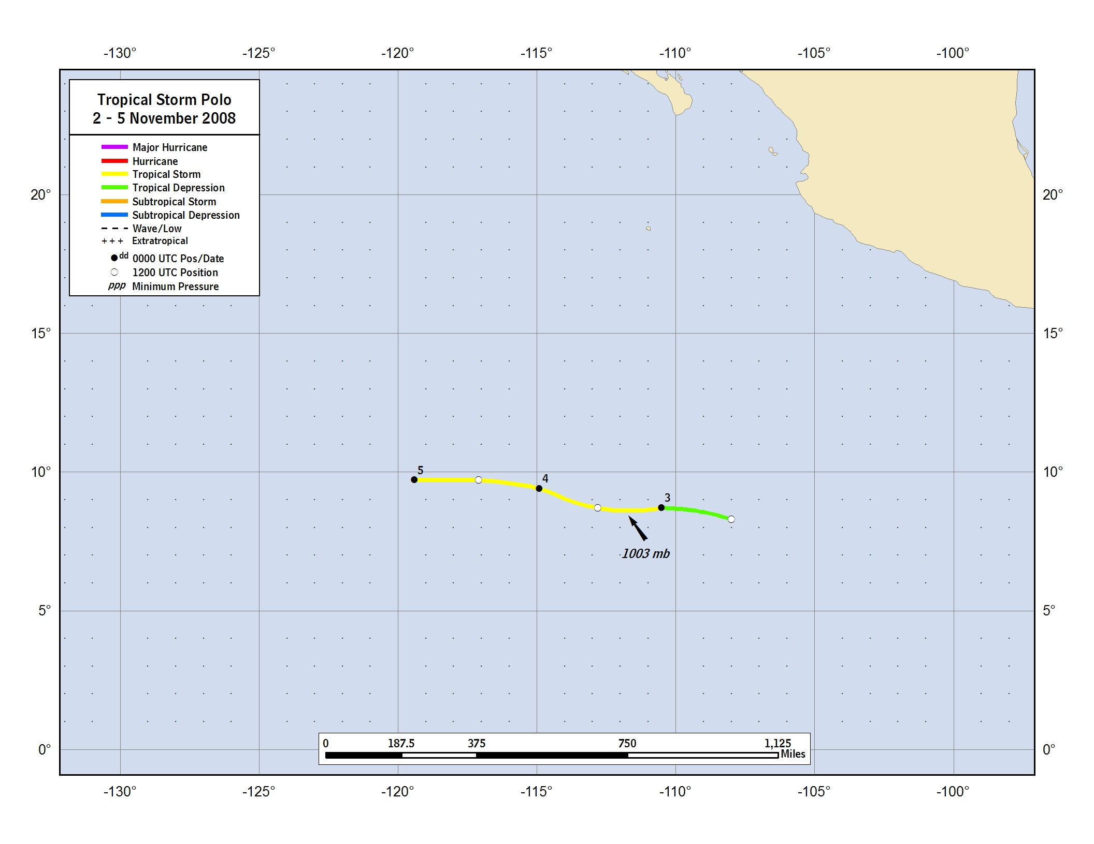
Figure 1. Best track positions for Tropical Storm Polo, 2 – 5 November 2008.
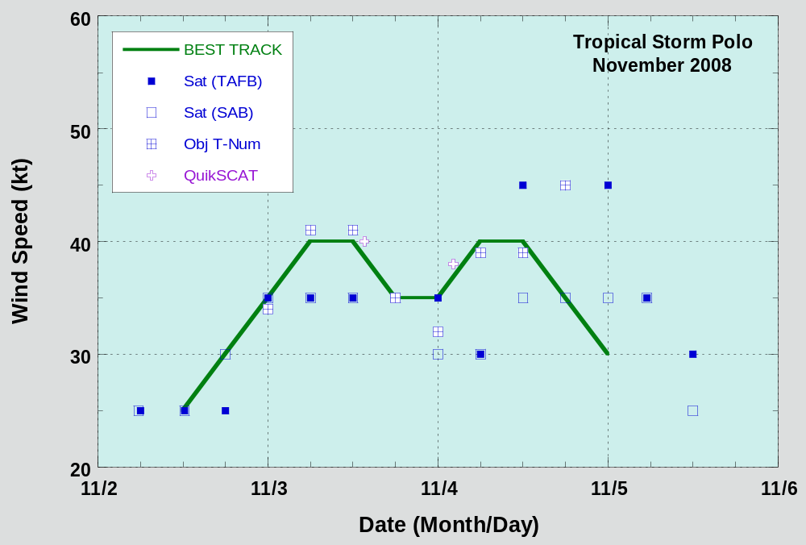

Figure 2. Selected wind observations and best track maximum sustained surface wind speed curve for Tropical Storm Polo, 2 – 5 November 2008. Objective Dvorak estimates represent linear averages over a three-hour period centered on the nominal observation time. Dashed vertical lines correspond to 0000 UTC.
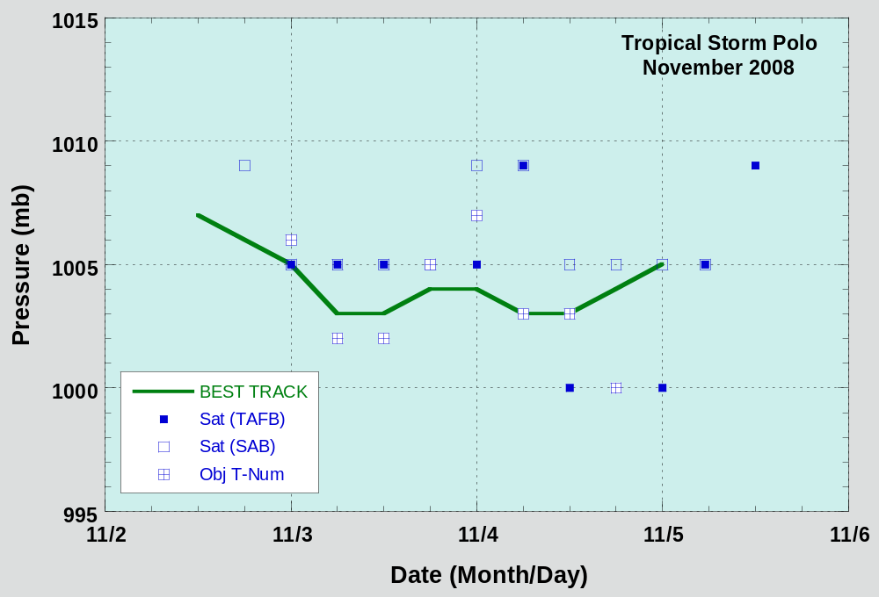

Figure 3. Selected pressure observations and best track minimum central pressure curve for Tropical Storm Polo, 2 – 5 November 2008. Objective Dvorak estimates represent linear averages over a three-hour period centered on the nominal observation time. Dashed vertical lines correspond to 0000 UTC.
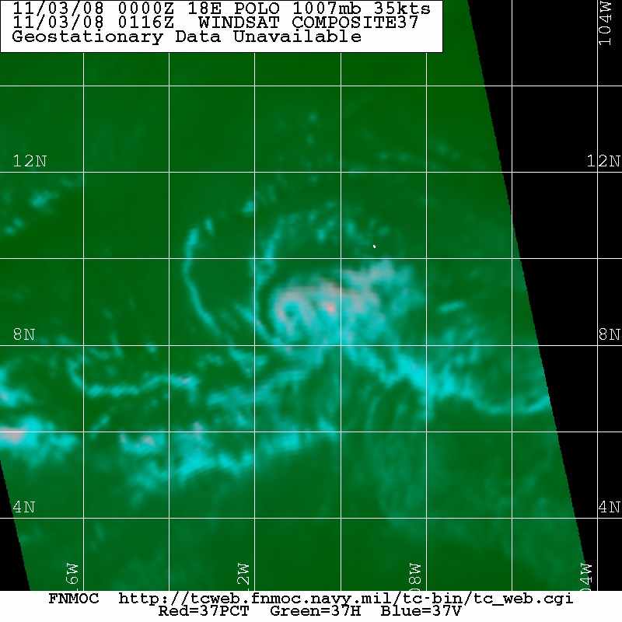
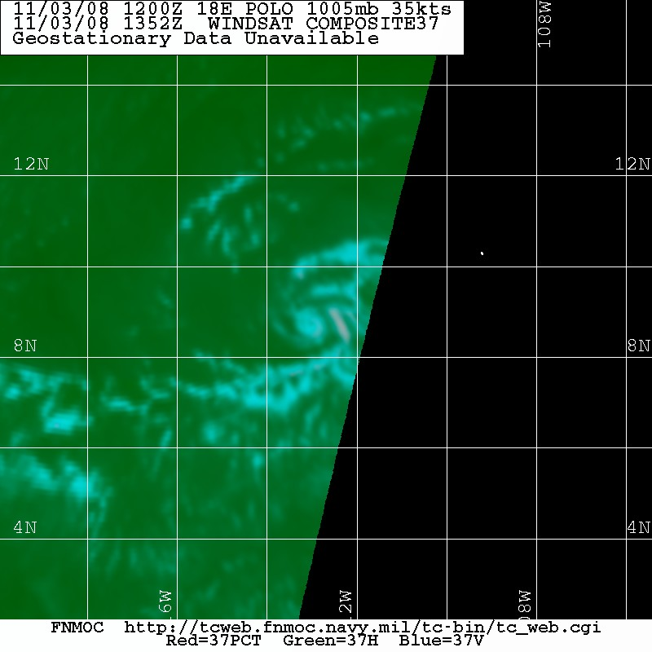

Figure 4. 37 GHz color composite WindSat images of Tropical Storm Polo at 0116 UTC 3 November (left) and at 1352 UTC 3 November (right). The images show that Polo had a small low-level circulation and a tiny eye-like feature around the time of its peak intensity. Images courtesy of the Fleet Numerical Meteorology and Oceanography Center.

A digital record of the complete best track, including wind radii, can be found on line at ftp://ftp.nhc.noaa.gov/atcf. Data for the current year’s storms are located in the btk directory, while previous years’ data are located in the archive directory.

