Tropical Cyclone Report
Tropical Storm Marty
(EP162009)
16-19 September 2009

Todd B. Kimberlain
National Hurricane Center
17 November 2009

Marty was a weak, short-lived tropical cyclone that moved on a northwesterly track a few hundred miles southwest of the Baja California peninsula and dissipated without affecting land.

- Synoptic History

The origins of Marty can be traced back to a tropical wave that departed the west coast of Africa on 28 August and moved across the tropical Atlantic with little or no deep convection. The minimal amount of convective activity associated with the wave made its identification difficult. However, upper-air data indicate that the wave passed through the Lesser Antilles and entered the Caribbean Sea on 5 September, and emerged into the eastern North Pacific on 10 September. Disorganized convection developed in association with the wave on 13 September and became more concentrated and better organized over the next day or two. In conjunction with the increase in organization a broad area of low pressure formed along the wave axis by 1200 UTC 15 September about 345 n mi south-southwest of the southern tip of Baja California. The appearance of banding features signaled that further development had occurred by 0000 UTC 16 September, when the system is estimated to have become a tropical depression, while located about 325 n mi south of the southern tip of Baja California. The “best track” chart of the tropical cyclone’s path is given in Fig. 1, with the wind and pressure histories shown in Figs. 2 and 3, respectively. The best track positions and intensities are listed in Table 1.

The depression moved slowly northwestward on the western periphery of a mid-level subtropical ridge close to Baja California, in an environment of moderate southeasterly shear. The southeasterly shear induced an asymmetric cloud pattern, with conventional and microwave satellite imagery showing the circulation center on the eastern edge of the deep convection. The shear, however, was not strong enough to prevent the cyclone from slowly strengthening, and the depression is estimated to have reached tropical storm strength at 1200 UTC 16 September, when it was located 285 n mi south-southwest of the southern tip of Baja California. Weak steering currents caused Marty’s forward speed to slow further, and the cyclone drifted northwestward to north-northwestward on 17 September without strengthening further. Around this time Marty began to encounter increasing southwesterly shear associated with a middle- to upper-level trough near Baja California and to ingest drier and more stable low-level air. These negative environmental factors contributed to a gradual weakening of the cyclone, and the weakening trend accelerated after Marty reached sub-26.5°C waters. Despite the shear and cooler waters, Marty maintained tropical storm strength until 1800 UTC 18 September, when it weakened to a tropical depression about 285 n mi west-southwest of the southern tip of Baja California. Devoid of deep convection, Marty became a remnant low the following day, with the remnant circulation moving on a steady west-northwesterly course for another three days over the open waters of the eastern North Pacific before dissipating about 1205 n mi west of the southern tip of Baja California.

- Meteorological Statistics

Observations in Marty (Figs. 2 and 3) include satellite-based Dvorak technique intensity estimates from the Tropical Analysis and Forecast Branch (TAFB) and the Satellite Analysis Branch (SAB). Data and imagery from NOAA polar-orbiting satellites, the Advanced Microwave Sounding Unit (AMSU), the NASA Tropical Rainfall Measuring Mission (TRMM), the NASA QuikSCAT, the NASA Aqua, the Department of Defense Windsat, and Defense Meteorological Satellite Program (DMSP) satellites, among others, were also useful in tracking Marty and later constructing its best track.

The estimated peak intensity of Marty is 40 kt, based on a blend of subjective and objective Dvorak intensity estimates. Several QuikSCAT passes were helpful in estimating the strength and position of Marty when it was a tropical storm.

No ship reports of tropical-storm-force winds or greater were received in association with Marty.

- Casualty and Damage Statistics

There were no reports of damage or casualties associated with Marty.

- Forecast and Warning Critique

The genesis of Marty was reasonably well forecast. The wave that eventually spawned Marty was introduced in the Tropical Weather Outlook 54 hours prior to genesis. The probability of genesis was increased to the high category (> 50 percent) 24 hours before Marty’s formation. This is significantly earlier than the average “high category” lead time of 6 h registered during the 2007-2008 seasons.

Verification of official and guidance model track forecasts is provided in Tables 2a and b, respectively. Average official track errors for Marty (with the number of cases in parentheses) were 18 (11), 30 (9), 47 (7), 70 (5), and 141 (1) n mi for the 12, 24, 36, 48, and 72 h forecasts, respectively. There were no verifying forecasts at 96 or 120 h. Although NHC forecast track errors for Marty were generally lower than the long-term averages, several dynamical models outperformed the official track forecasts. In fact, the model track consensus forecasts (TCON, TVCN, and GUNA) beat the official forecasts at all lead times through 48 h. It should be noted, however, that the sample sizes are generally too small to draw any significant conclusions.

A verification of NHC official intensity forecasts for Marty is given in Table 3a. Official forecast intensity errors were lower than the mean official errors for the previous five-year period, except at 24 h. A homogeneous comparison of the official intensity errors with selected guidance models is given in Table 3b. Although the sample size is rather small, the official NHC intensity forecasts performed quite well in comparison to nearly all the intensity guidance which consistently over-forecast the intensity of Marty. It is worth noting that OCD5 track and intensity errors were smaller-than-average, suggesting that Marty was easier to forecast.

Table 1. Best track for Tropical Storm Marty, 16-19 September 2009.

Date/Time  (UTC) | Latitude  (°N) | Longitude  (°W) | Pressure  (mb) | Wind Speed  (kt) | Stage
15 / 1200 | 17.3 | 111.3 | 1007 | 25 | low
15 / 1800 | 17.7 | 111.6 | 1007 | 25 | "
16 / 0000 | 18.0 | 111.9 | 1007 | 25 | tropical depression
16 / 0600 | 18.3 | 112.2 | 1005 | 30 | "
16 / 1200 | 18.6 | 112.4 | 1003 | 35 | tropical storm
16 / 1800 | 18.8 | 112.5 | 1002 | 40 | "
17 / 0000 | 19.0 | 112.6 | 1002 | 40 | "
17 / 0600 | 19.2 | 112.7 | 1003 | 40 | "
17 / 1200 | 19.4 | 112.8 | 1003 | 40 | "
17 / 1800 | 19.6 | 113.0 | 1003 | 40 | "
18 / 0000 | 19.9 | 113.4 | 1004 | 35 | "
18 / 0600 | 20.1 | 113.9 | 1004 | 35 | "
18 / 1200 | 20.5 | 114.4 | 1004 | 35 | "
18 / 1800 | 21.0 | 114.9 | 1004 | 30 | tropical depression
19 / 0000 | 21.5 | 115.6 | 1004 | 30 | "
19 / 0600 | 22.1 | 116.5 | 1004 | 30 | "
19 / 1200 | 22.4 | 117.5 | 1005 | 25 | low
19 / 1800 | 22.7 | 118.5 | 1005 | 25 | "
20 / 0000 | 22.8 | 119.6 | 1005 | 25 | "
20 / 0600 | 22.9 | 120.6 | 1005 | 25 | "
20 / 1200 | 23.0 | 121.6 | 1006 | 25 | "
20 / 1800 | 23.1 | 122.6 | 1006 | 25 | "
21 / 0000 | 23.1 | 123.7 | 1007 | 25 | "
21 / 0600 | 23.1 | 124.8 | 1008 | 20 | "
21 / 1200 | 23.1 | 125.9 | 1008 | 20 | "
21 / 1800 | 23.1 | 126.9 | 1008 | 20 | "
22 / 0000 | 23.1 | 127.9 | 1008 | 20 | "
22 / 0600 | 23.2 | 129.1 | 1009 | 20 | "
22 / 1200 | 23.3 | 130.4 | 1009 | 20 | "
22 / 1800 | 23.5 | 131.8 | 1010 | 20 | "
23 / 0000 |  |  |  |  | dissipated
16 / 1800 | 18.8 | 112.5 | 1002 | 40 | maximum wind and minimum pressure

Table 2a. NHC official (OFCL) and climatology-persistence skill baseline (OCD5) track forecast errors (n mi) for Marty. Mean errors for the five-year period 2004-8 are shown for comparison. Official errors that are smaller than the five-year means are shown in boldface type.

 | Forecast Period (h)
 | 12 | 24 | 36 | 48 | 72 | 96 | 120
OFCL (Marty) | 18.0 | 29.8 | 47.3 | 70.2 | 140.8
OCD5 (Marty) | 36.0 | 64.7 | 88.6 | 91.0 | 164.3
Forecasts | 11 | 9 | 7 | 5 | 1
OFCL (2004-8) | 31.0 | 51.7 | 71.7 | 90.2 | 123.6
OCD5 (2004-8) | 38.4 | 73.6 | 111.9 | 149.1 | 214.2

Table 2b. Homogeneous comparison of selected track forecast guidance models (in n mi) for Marty. Errors smaller than the NHC official forecast are shown in boldface type. The number of official forecasts shown here will generally be smaller than that shown in Table 2a due to the homogeneity requirement.

Model ID | Forecast Period (h)
Model ID | 12 | 24 | 36 | 48
OFCL | 15.0 | 25.5 | 48.8 | 66.6
OCD5 | 31.0 | 56.5 | 84.0 | 57.3
GFSI | 26.2 | 32.0 | 48.4 | 68.1
GHMI | 17.9 | 44.7 | 77.0 | 123.9
HWFI | 26.0 | 57.1 | 88.0 | 112.1
NGPI | 16.9 | 27.0 | 42.7 | 57.7
EMXI | 18.9 | 22.9 | 52.5 | 85.7
TCON | 12.2 | 20.1 | 38.7 | 65.6
TVCN | 12.2 | 21.2 | 38.7 | 64.3
TVCC | 19.1 | 31.9 | 58.1 | 106.4
GUNA | 12.2 | 17.9 | 35.1 | 51.6
FSSE | 14.5 | 28.1 | 59.7 | 99.0
AEMI | 19.5 | 18.1 | 22.3 | 42.1
BAMS | 25.1 | 40.9 | 60.3 | 67.3
BAMM | 25.4 | 51.9 | 87.1 | 92.8
BAMD | 38.7 | 96.8 | 172.2 | 248.3
LBAR | 26.2 | 53.3 | 89.1 | 89.5
Forecasts | 6 | 5 | 4 | 2
Table 3a. NHC official (OFCL) and climatology-persistence skill baseline (OCD5) intensity forecast errors (kt) for Marty. Mean errors for the five-year period 2004-8 are shown for comparison. Official errors that are smaller than the five-year means are shown in boldface type.

 | Forecast Period (h)
 | 12 | 24 | 36 | 48 | 72 | 96 | 120
OFCL (Marty) | 1.8 | 6.1 | 6.4 | 5.0 | 10.0
OCD5 (Marty) | 4.0 | 6.0 | 8.0 | 7.2 | 12.0
Forecasts | 11 | 9 | 7 | 5 | 1
OFCL (2004-8) | 6.2 | 10.2 | 13.3 | 15.1 | 17.7
OCD5 (2004-8) | 7.1 | 11.5 | 14.7 | 16.8 | 18.9

Table 3b. Homogeneous comparison of selected intensity forecast guidance models (in kt) for Marty. Errors smaller than the NHC official forecast are shown in boldface type. The number of official forecasts shown here will generally be smaller than that shown in Table 3a due to the homogeneity requirement.

Model ID | Forecast Period (h)
Model ID | 12 | 24 | 36 | 48 | 72 | 96 | 120
OFCL | 1.7 | 7.1 | 6.0 | 3.3
OCD5 | 3.6 | 6.3 | 10.4 | 11.3
HWFI | 8.6 | 14.6 | 17.4 | 19.7
GHMI | 1.9 | 6.6 | 8.4 | 7.7
DSHP | 3.6 | 7.3 | 10.4 | 15.0
LGEM | 4.0 | 7.6 | 10.6 | 13.3
ICON | 4.7 | 8.9 | 12.0 | 14.0
FSSE | 5.0 | 11.0 | 14.4 | 17.3
Forecasts | 9 | 7 | 5 | 3

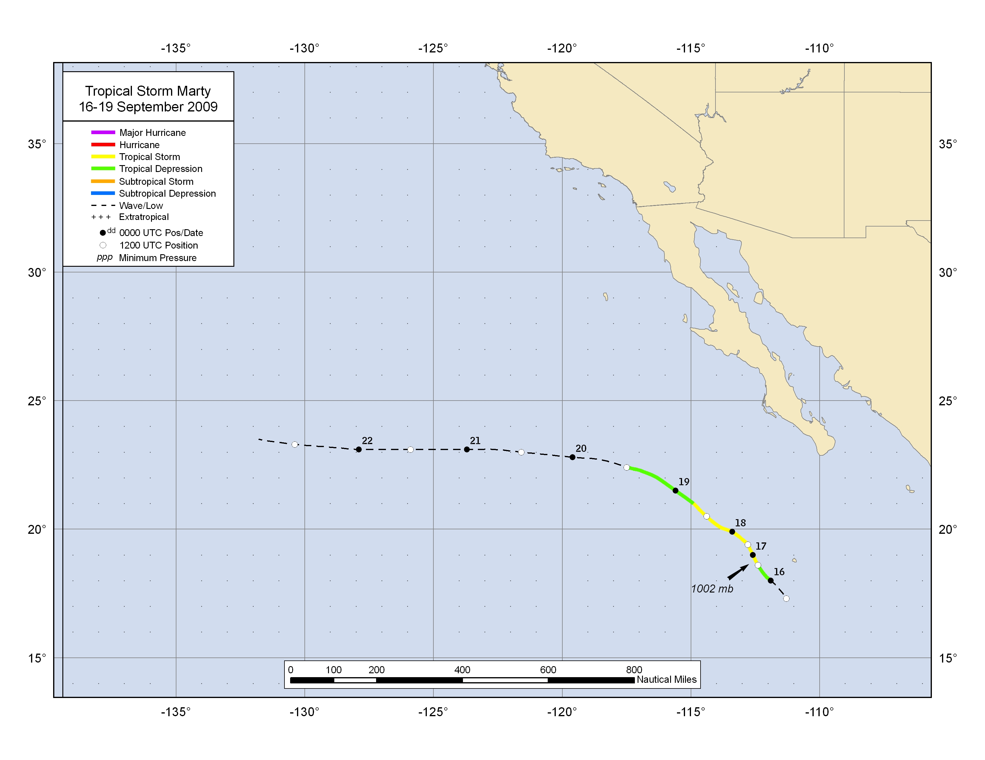

Figure 1. Best track positions for Tropical Storm Marty, 16-19 September 2009.
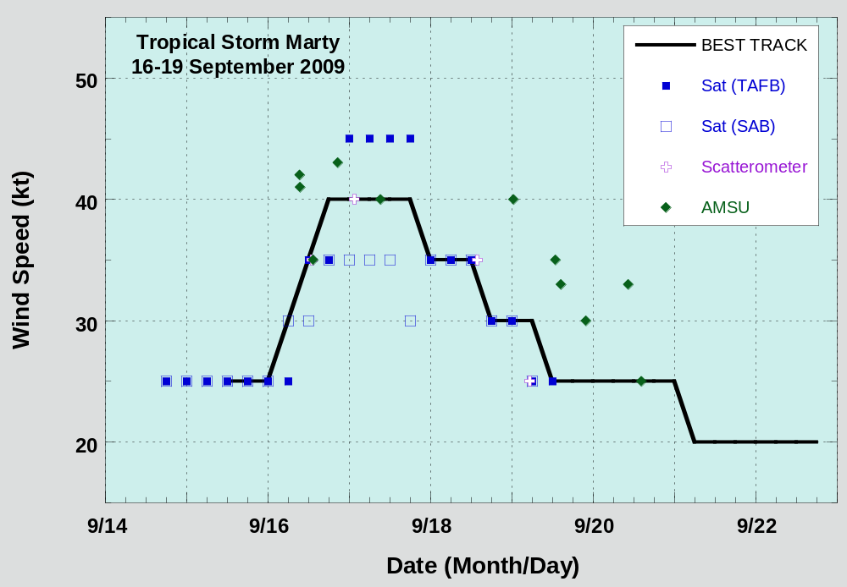

Figure 2. Selected wind observations and best track maximum sustained surface wind speed curve for Marty, 16-19 September 2009. Dashed vertical lines correspond to 0000 UTC.

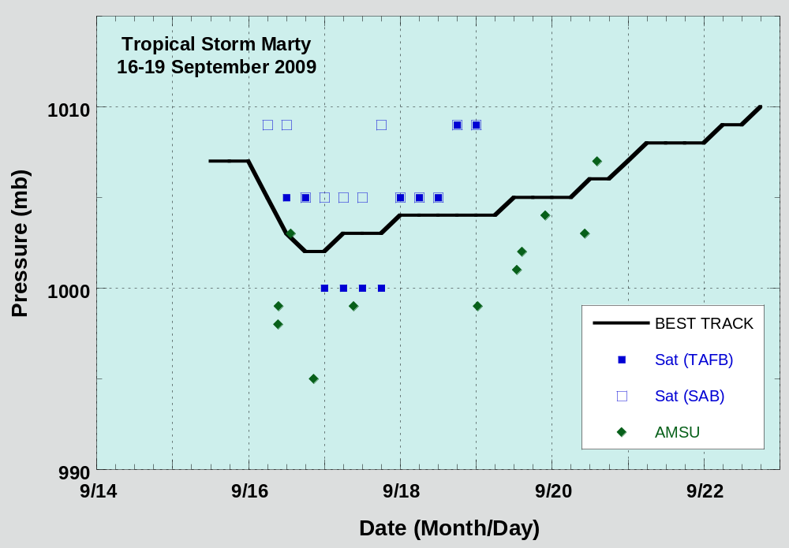

Figure 3. Selected pressure observations and best track minimum central pressure curve for Marty, 16-19 September 2009. Dashed vertical lines correspond to 0000 UTC.

A digital record of the complete best track, including wind radii, can be found on line at ftp://ftp.nhc.noaa.gov/atcf. Data for the current year’s storms are located in the btk directory, while previous year’s data are located in the archive directory.

