Tropical Cyclone Report
Hurricane Henriette
(EP112007)
30 August – 6 September 2007

Richard D. Knabb
National Hurricane Center
23 November 2007

Updated 30 May 2008 to correct damage cost estimates

Henriette made two landfalls in Mexico, on the southern Baja California peninsula as a category 1 hurricane (on the Saffir-Simpson Hurricane Scale) and on the mainland Gulf of California coast as a strong tropical storm. In addition, prior to becoming a hurricane, Henriette produced very heavy rains along the Pacific coast of Mexico, especially near Acapulco, as its center passed just offshore. At least nine fatalities are directly attributable to Henriette.

- Synoptic History

Henriette originated from a tropical wave that departed the west coast of Africa on 20 August and moved uneventfully across the tropical Atlantic. The wave produced some convection in the Caribbean Sea but reached Central America on 28 August before any significant development could occur. By 29 August the wave had moved westward into the eastern North Pacific basin, producing disorganized showers and thunderstorms, and late that day a small area of low pressure developed in association with the wave about 350 n mi southeast of Acapulco, Mexico. Convection with the low improved in organization early on 30 August, and by 0600 UTC that day the system became a tropical depression about 315 n mi southeast of Acapulco. The “best track” chart of the tropical cyclone’s path is given in Fig. 1, with the wind and pressure histories shown in Figs. 2 and 3, respectively. The best track positions and intensities are listed in Table 1.

The cyclone initially headed toward the west-northwest around a subtropical ridge that was centered over the western Gulf of Mexico. It gained organization and became a tropical storm by 1200 UTC 31 August, centered about 75 n mi south of Acapulco. During the next 36 h, Henriette slowly strengthened and continued west-northwestward and parallel to the Pacific coast of Mexico, with its center passing roughly 40-50 n mi offshore. Despite not making landfall during this period, the storm brought heavy rainfall to portions of the coast, especially near Acapulco.

Henriette turned westward and away from the Pacific coast of Mexico late on 1 September as the subtropical ridge built westward over northern Mexico. By 0600 UTC the next day, Henriette had reached an intensity of 55 kt while centered about 95 n mi southwest of Manzanillo, Mexico. The storm remained just shy of hurricane strength for the next two days as it headed generally northwestward, passing about 175 n mi west of Cabo Corrientes on the Pacific coast of Mexico. At about 0600 UTC 4 September, Henriette reached hurricane status as it turned north-northwestward toward the Baja California peninsula, ahead of a mid-latitude trough approaching the west coast of the United States. The hurricane reached its peak intensity of 75 kt at 1200 UTC that day while centered about 75 n mi south-southeast of Cabo San Lucas, Mexico. Henriette made landfall just east of Cabo San Lucas, near San Jose del Cabo, at about 2100 UTC 4 September with maximum winds near 70 kt. Continuing north-northwestward, Henriette emerged over the Gulf of California early on 5 September. The brief interaction with land caused a slight weakening, but Henriette remained a category 1 hurricane for most of that day. Very late on 5 September, however, Henriette began to weaken. It made its final landfall along the Gulf of California coast of mainland Mexico, near Guaymas, at about 0000 UTC 6 September with an estimated intensity of 60 kt. Henriette deteriorated quickly over land and dissipated over the mountains of northwestern Mexico shortly after 0600 UTC that day.

- Meteorological Statistics

Observations in Henriette (Figs. 2 and 3) include satellite-based Dvorak technique intensity estimates from the Tropical Analysis and Forecast Branch (TAFB) and the Satellite Analysis Branch (SAB), as well as flight-level and Stepped-Frequency Microwave Radiometer (SFMR) observations from one flight of the 53rd Weather Reconnaissance Squadron of the U. S. Air Force Reserve Command. Microwave satellite imagery from NOAA polar-orbiting satellites, the NASA Tropical Rainfall Measuring Mission (TRMM), the NASA QuikSCAT, and Defense Meteorological Satellite Program (DMSP) satellites were also useful in tracking Henriette.

The Air Force aircraft made two center “fixes” during the single reconnaissance mission into Henriette on 3 September. The central pressure on the last fix was 981 mb (a central pressure typically associated with hurricane intensity), but maximum flight-level winds at 850 mb during the mission were 71 kt, and the maximum surface wind speed estimate from the SFMR was 58 kt. These data support the best track intensity of 60 kt, just shy of hurricane status, at 1800 UTC 3 September. Geostationary satellite imagery suggests that Henriette slowly gained organization during the following several hours and became a hurricane early the next day. The peak intensity of 75 kt at 1200 UTC 4 September is based on subjective Dvorak intensity estimates. The best track intensity estimates at both Mexico landfalls are a little less than the nearest Dvorak estimates, since the satellite appearance of Henriette was gradually deteriorating during the last 36 hours or so of the cyclone’s existence.

No ship reported winds of tropical storm force in association with Henriette. A sustained wind of 66 kt and a gust to 102 kt were reported at Ciudad Obregon in the Mexican state of Sonora, at 2100 UTC 5 September (about three hours prior to the final landfall of Henriette at an estimated intensity of 60 kt). This station is situated several miles inland at an elevation of about 50 m above sea level, and was about 50 n mi east of the center of Henriette at the time of this observation; the 66 kt observation appears likely to be an overestimate of a sustained wind at 10 m.

Selected rainfall observations from land stations are given in Table 2. Rainfall totals of 5-9 in were common in the states of Oaxaca and Guerrero while the center of Henriette passed just offshore during 30 August - 1 September. Similar amounts fell over the southern Baja California peninsula and in the state of Sonora during 4-6 September.

- Casualty and Damage Statistics

Media reports indicate at least nine fatalities in Mexico are directly attributable to Henriette. Six of these deaths occurred near Acapulco due to mud slides induced by heavy rains while the center of Henriette passed just offshore, two fishermen perished near the coast of Sonora in the region where Henriette made its final landfall, and one person died in the surf along the southern Baja California peninsula. Four other persons were reported missing at sea on 6 September in association with Henriette. Media reports also indicate that Henriette caused about $25 million (U. S. dollar equivalent) in damages in the Mexican state of Sonora.

- Forecast and Warning Critique

The genesis of Henriette was not anticipated very well in NHC Tropical Weather Outlooks. The incipient system was first mentioned only about 31 hours before it became a tropical depression, and the potential for the formation of a depression was explicitly stated beginning only about 13 hours prior to genesis.

A verification of official and guidance model track forecasts is given in Table 3. Average official track errors for Henriette were 33, 58, 80, 101, 126, 172, and 196 n mi for the 12, 24, 36, 48, 72, 96, and 120 h forecasts, respectively. The number of forecasts ranged from 25 at 12 h to 7 at 120 h. The errors out to 48 h are comparable to the average long-term official track errors, while errors at 72-120 h are a bit smaller than the long-term averages (Table 3). The official track forecasts on average outperformed most of the individual models, with the exceptions being the EMXI (interpolated ECMWF global model) beyond 24 h, and the GFDI and GFNI (interpolated GFDL and GFDN) models at 96 and 120 h. The official forecasts generally exhibited a west bias for the latter portion of Henriette’s track (although not as much as several of the dynamical models), after the storm turned to the north on 4 September and strengthened into a hurricane. The GFDL and GFDN did not have nearly as much of a west bias, especially at 96 and 120 h. The ECMWF global model performed exceptionally well with Henriette, having smaller average errors than any individual or consensus model beyond 24 h (and by a wide margin at 3-5 days).

Average official and guidance model intensity forecast errors (Table 4) were 6, 7, 11, 9, 7, 9, and 8 kt for the 12, 24, 36, 48, 72, 96, and 120 h forecasts, respectively. These errors are generally much less than the average long-term official intensity errors (Table 4). The official intensity forecast errors were less than for all of the available guidance, except for the FSSE at 24-48 h. The official forecasts were biased somewhat high since they called for Henriette to strengthen more rapidly and reach hurricane strength sooner than it did. This bias was in part due to attention paid to the SHIPS model that forecast significant strengthening to a major hurricane. The GFDL model (using the GHMI interpolation) struggled early on, forecasting Henriette to remain a tropical storm or even dissipate in less than five days. Later GFDL intensity forecasts were much better and in many cases were more accurate than the official forecast.

Coastal watches and warnings issued for Henriette by the Government of Mexico are listed in Table 5.
Table 1. Best track for Hurricane Henriette, 30 August – 6 September 2007.

Date/Time  (UTC) | Latitude  (°N) | Longitude  (°W) | Pressure  (mb) | Wind Speed  (kt) | Stage
30 / 0600 | 13.1 | 95.9 | 1008 | 25 | tropical depression
30 / 1200 | 13.6 | 96.5 | 1007 | 30 | "
30 / 1800 | 14.1 | 97.2 | 1006 | 30 | "
31 / 0000 | 14.6 | 98.0 | 1006 | 30 | "
31 / 0600 | 15.1 | 98.8 | 1004 | 30 | "
31 / 1200 | 15.7 | 99.6 | 1002 | 35 | tropical storm
31 / 1800 | 16.3 | 100.6 | 1000 | 40 | "
01 / 0000 | 16.8 | 101.6 | 997 | 45 | "
01 / 0600 | 17.2 | 102.8 | 997 | 45 | "
01 / 1200 | 17.6 | 103.9 | 997 | 45 | "
01 / 1800 | 17.9 | 104.7 | 996 | 50 | "
02 / 0000 | 18.0 | 105.3 | 995 | 50 | "
02 / 0600 | 18.1 | 105.8 | 994 | 55 | "
02 / 1200 | 18.3 | 106.2 | 994 | 55 | "
02 / 1800 | 18.5 | 106.5 | 994 | 55 | "
03 / 0000 | 18.7 | 106.8 | 993 | 55 | "
03 / 0600 | 19.0 | 107.3 | 991 | 55 | "
03 / 1200 | 19.4 | 107.9 | 988 | 60 | "
03 / 1800 | 19.8 | 108.4 | 983 | 60 | "
04 / 0000 | 20.3 | 108.7 | 978 | 60 | "
04 / 0600 | 20.9 | 109.0 | 975 | 65 | hurricane
04 / 1200 | 21.7 | 109.3 | 972 | 75 | "
04 / 1800 | 22.6 | 109.6 | 972 | 70 | "
05 / 0000 | 23.6 | 109.8 | 975 | 65 | "
05 / 0600 | 24.6 | 110.1 | 980 | 65 | "
05 / 1200 | 25.6 | 110.4 | 983 | 65 | "
05 / 1800 | 26.6 | 110.7 | 986 | 65 | "
06 / 0000 | 27.9 | 110.9 | 990 | 60 | tropical storm
06 / 0600 | 29.5 | 110.5 | 1002 | 30 | tropical depression
06 / 1200 |  |  |  |  | dissipated
04 / 1200 | 21.7 | 109.3 | 972 | 75 | minimum pressure and maximum wind
04 / 2100 | 23.1 | 109.6 | 973 | 70 | landfall near San Jose del Cabo, Mexico
06 / 0000 | 27.9 | 110.9 | 990 | 60 | landfall near Guaymas, Mexico

Table 2. Selected storm-total rainfall observations for Hurricane Henriette, 30 August – 6 September 2007.

Location | Total  rain  (in)
Mexico, State of Oaxaca
Cerro de Oro | 8.74
Dique Pescaditos | 5.32
Papaloapan | 3.91
Mexico, State of Guerrero
Acapulco (76805) | 8.41
Cumbres de Figueroa | 9.69
La Garita (Tunel Alto) | 8.65
La Mira | 7.20
Costa Azul | 8.54
La Cruz (Brisas) | 9.13
Cumbres del Llano Grande | 8.46
Lazaro Cardenas (MMLC) | 7.95
Col Simon Bolivar | 7.63
Aeropuerto Acapulco (MMAA) | 7.09
Mexico, State of Baja California Sur
Los Planes | 9.02
El Sargento | 6.11
La Ribera | 4.83
La Paz | 2.84
Loreto (76305, MMLT) | 3.25
Mexico, State of Sonora
Presa a. R. Cortinez | 4.76
San Bernardo | 3.43
Tesocoma | 6.30
Basconcobe | 7.17
Etchojoa | 7.76
Huatabampo | 5.55
Jupare | 6.54
Lindero | 7.72
Mumuncuera | 5.16
Nachuquis | 6.10
Navojoa | 3.98
Sinahuiza | 6.50
Tesia | 4.44
Cocoraque | 6.89
P. Ignacio R. a la Torre | 4.17
San Ignacio | 7.52
San Pedro | 4.65
C. 200 y Canal Bajo | 4.33
C. 600 y Canal Bajo | 5.30
C. 1200 y Canal Bajo | 7.26
Ciudad Obregon | 6.61
Casa del Ciano | 5.67
Km. 25 de Canal Alto | 4.27
Km. 39 de Canal Alto | 7.64
Km. 58 de Canal Alto | 6.06
Km. 68 de Canal Alto | 4.49
Km. 79 de Canal Alto | 6.18
Km. 91 de Canal Alto | 5.59
Km. 108 de Canal Alto | 3.74
Porfirio Diaz | 3.35
Vicam | 3.93
Villa Juarez | 9.13
Veranito | 4.45
Empalme (76256) | 5.62
Km 20 | 7.76
Sebampo | 5.43
Nainari | 5.04
Mexico, State of Sinaloa
Presa Josefa Ortiz de Dominguez | 3.63
Presa Miguel Hidalgo | 3.35

Table 3. Preliminary track forecast evaluation (heterogeneous sample) for Hurricane Henriette, 30 August – 6 September 2007. Forecast errors (n mi) are followed by the number of forecasts in parentheses. Errors smaller than the NHC official forecast are shown in bold-face type. Verification includes the depression stage.

Forecast Technique | Forecast Period (h)
Forecast Technique | 12 | 24 | 36 | 48 | 72 | 96 | 120
CLP5 | 48 (27) | 87 (25) | 134 (23) | 177 (21) | 213 (17) | 226 (13) | 242 ( 9)
GFNI | 37 (23) | 63 (21) | 86 (19) | 103 (17) | 127 (13) | 164 ( 9) | 156 ( 4)
GFDI | 37 (27) | 59 (24) | 88 (22) | 106 (19) | 148 (14) | 164 (10) | 184 ( 6)
HWFI | 55 (27) | 94 (25) | 131 (23) | 157 (19) | 246 (14) | 352 (10) | 565 ( 6)
GFSI | 51 (27) | 84 (25) | 119 (23) | 136 (19) | 188 (14) | 246 (10) | 252 ( 6)
AEMI | 50 (27) | 84 (23) | 121 (21) | 159 (18) | 220 (14) | 316 (10) | 442 ( 5)
NGPI | 47 (27) | 77 (25) | 105 (23) | 138 (21) | 193 (16) | 262 (11) | 338 ( 7)
UKMI | 47 (22) | 82 (21) | 108 (19) | 135 (17) | 224 (11) | 444 ( 5)
EMXI | 42 (27) | 59 (25) | 71 (23) | 77 (21) | 79 (17) | 85 (13) | 120 (9)
BAMD | 41 (27) | 70 (25) | 92 (23) | 109 (21) | 131 (17) | 174 (13) | 231 ( 9)
BAMM | 43 (27) | 74 (25) | 104 (23) | 134 (21) | 184 (17) | 238 (13) | 250 ( 9)
BAMS | 42 (26) | 75 (24) | 109 (22) | 149 (20) | 219 (16) | 275 (12) | 296 ( 8)
CONU | 38 (27) | 61 (25) | 81 (23) | 105 (21) | 120 (16) | 167 (12) | 164 ( 8)
GUNA | 36 (22) | 57 (20) | 79 (18) | 104 (15) | 156 (10) | 238 ( 5)
FSSE | 34 (21) | 58 (19) | 72 (17) | 90 (15) | 146 (12) | 218 ( 8) | 247 ( 4)
OFCL | 33 (25) | 58 (23) | 80 (21) | 101 (19) | 126 (15) | 172 (11) | 196 ( 7)
NHC Official  (2002-2006 mean) | 33 (1349) | 57 (1192) | 79 (1039) | 99 (897) | 140 (655) | 188 (465) | 233 (311)

Table 4. Preliminary intensity forecast evaluation (heterogeneous sample) for Hurricane Henriette, 30 August – 6 September 2007. Forecast errors (kt) are followed by the number of forecasts in parentheses. Errors smaller than the NHC official forecast are shown in bold-face type. Verification includes the depression stage.

Forecast Technique | Forecast Period (h)
Forecast Technique | 12 | 24 | 36 | 48 | 72 | 96 | 120
SHF5 | 5.6 (27) | 7.0 (25) | 8.3 (23) | 9.3 (21) | 7.1 (17) | 9.5 (13) | 11.2 ( 9)
GHMI | 6.6 (27) | 10.3 (24) | 12.9 (22) | 13.2 (19) | 14.5 (14) | 14.3 (10) | 17.0 ( 6)
HWFI | 9.0 (27) | 12.7 (25) | 13.8 (23) | 14.8 (19) | 17.6 (14) | 23.1 (10) | 40.0 ( 6)
SHIP | 8.1 (27) | 13.6 (25) | 18.9 (23) | 21.8 (21) | 26.8 (17) | 25.2 (13) | 17.1 ( 9)
DSHP | 6.6 (27) | 11.6 (25) | 17.0 (23) | 21.8 (21) | 24.5 (17) | 24.5 (13) | 16.0 ( 9)
FSSE | 6.2 (21) | 6.5 (19) | 8.8 (17) | 7.5 (15) | 9.1 (12) | 13.5 ( 8) | 21.5 ( 4)
ICON | 6.6 (27) | 9.9 (25) | 11.0 (23) | 10.9 (20) | 8.5 (15) | 11.4 (11) | 15.3 ( 7)
OFCL | 5.6 (25) | 7.2 (23) | 10.5 (21) | 8.7 (19) | 6.7 (15) | 8.6 (11) | 7.9 ( 7)
NHC Official  (2002-2006 mean) | 6.3  (1349) | 11.0  (1192) | 14.6  (1039) | 16.9  (896) | 18.9  (655) | 18.5  (465) | 19.3  (311)

Table 5. Watch and warning summary for Hurricane Henriette, 30 August – 6 Sep. 2007.

Date/Time (UTC) | Action | Location
30 / 2100 | Tropical Storm Watch issued | Acapulco to Zihuatanejo
30 / 2100 | Tropical Storm Warning issued | Lagunas de Chacahua to Acapulco
31 / 0300 | Tropical Storm Watch discontinued | Acapulco to Zihuatanejo
31 / 0300 | Tropical Storm Watch issued | Tecpan de Galeana to Manzanillo
31 / 0300 | Tropical Storm Warning modified to | Lagunas de Chacahua to Tecpan de Galeana
31 / 0900 | Tropical Storm Watch modified to | Punta San Telmo to Manzanillo
31 / 0900 | Tropical Storm Warning modified to | Lagunas de Chacahua to  Punta San Telmo
31 / 1500 | Tropical Storm Watch modified to | Manzanillo to Cabo Corrientes
31 / 1500 | Tropical Storm Warning modified to | Lagunas de Chacahua to Manzanillo
31 / 2100 | Tropical Storm Watch changed to Hurricane Watch | Manzanillo to Cabo Corrientes
1 / 0600 | Tropical Storm Warning discontinued | Lagunas de Chacahua to Manzanillo
1 / 0600 | Tropical Storm Warning issued | Acapulco to Cabo Corrientes
1 / 1500 | Tropical Storm Warning modified to | Punta San Telmo to  Cabo Corrientes
1 / 1500 | Hurricane Watch discontinued | All
2 / 0300 | Tropical Storm Warning discontinued | All
3 / 0300 | Hurricane Watch issued | La Paz to Santa Fe
3 / 1500 | Hurricane Watch changed to Hurricane Warning | La Paz to Santa Fe
3 / 1500 | Hurricane Watch issued | Loreto to La Paz
3 / 1500 | Hurricane Watch issued | Puerto San Andresito to  Santa Fe
4 / 0900 | Tropical Storm Warning issued | Puerto San Andresito to  Bahia Magdalena
4 / 0900 | Hurricane Watch modified to | Loreto to Mulege
4 / 0900 | Hurricane Watch modified to | Puerto San Andresito to  Bahia Magdalena
4 / 0900 | Hurricane Watch issued | Altata to Guaymas
4 / 0900 | Hurricane Warning discontinued | La Paz to Santa Fe
4 / 0900 | Hurricane Warning issued | Loreto to Bahia Magdalena
4 / 1500 | Tropical Storm Warning issued | Loreto to Mulege
4 / 1500 | Tropical Storm Warning issued | Altata to Bahia Kino
4 / 1500 | Hurricane Watch modified to | Altata to Bahia Kino
5 / 0300 | Tropical Storm Warning discontinued | Puerto San Andresito to  Bahia Magdalena
5 / 0300 | Tropical Storm Warning modified to | Altata to Topolobampo
5 / 0300 | Hurricane Watch discontinued | Puerto San Andresito to  Bahia Magdalena
5 / 0300 | Hurricane Watch modified to | Altata to Topolobampo
5 / 0300 | Hurricane Warning issued | Topolobampo to Bahia Kino
5 / 0900 | Hurricane Warning modified to | Loreto to La Paz
5 / 1500 | Tropical Storm Warning modified to | La Paz to Mulege
5 / 1500 | Hurricane Watch discontinued | Loreto to Mulege
5 / 1500 | Hurricane Warning discontinued | Loreto to La Paz
5 / 1800 | Tropical Storm Warning modified to | San Evaristo to Mulege
6 / 0300 | Tropical Storm Warning discontinued | All
6 / 0300 | Hurricane Watch discontinued | All
6 / 0300 | Hurricane Warning discontinued | All

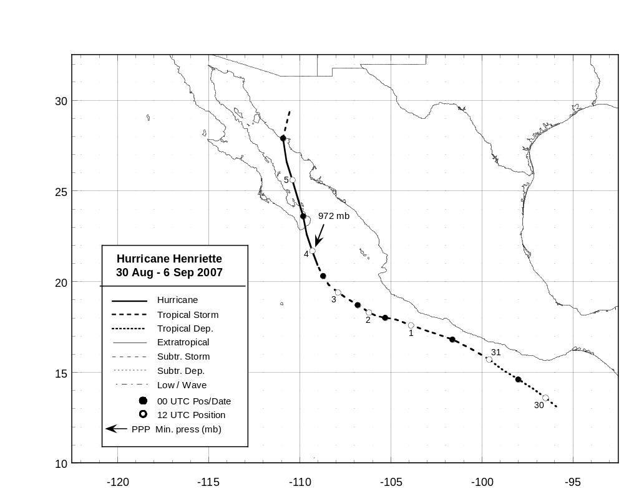

Figure 1. Best track positions for Hurricane Henriette, 30 August – 6 September 2007.
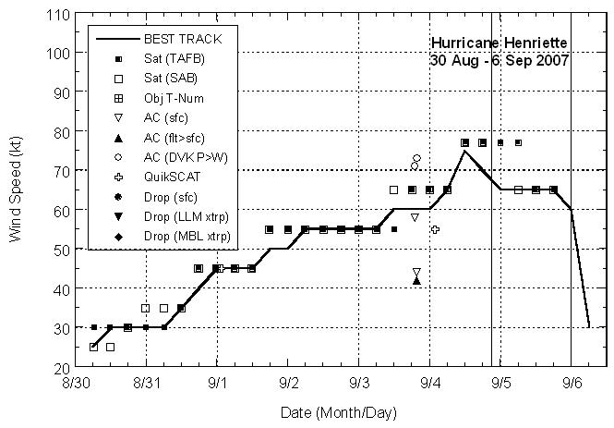

Figure 2. Selected wind observations and best track maximum sustained surface wind speed curve for Hurricane Henriette, 30 August – 6 September 2007. Flight-level aircraft observations at 850 mb have been adjusted for altitude using an 80% reduction factor. Solid vertical lines indicate the times of landfall of the center.
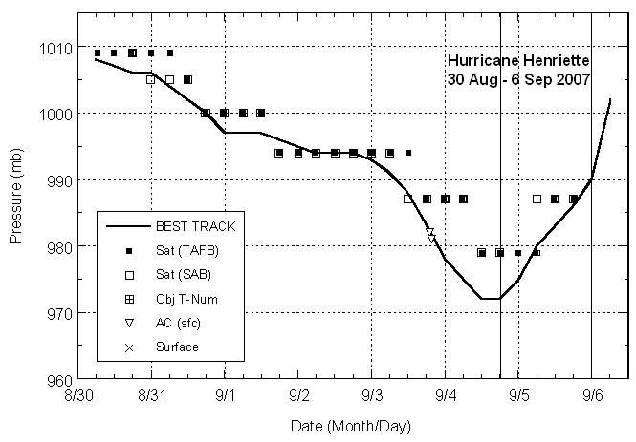

Figure 3. Selected pressure observations and best track minimum central pressure curve for Hurricane Henriette, 30 August – 6 September 2007.

