Tropical Cyclone Report
Hurricane Kenneth
14-30 September 2005

Richard J. Pasch
National Hurricane Center
April 20 2006

Kenneth was a category 4 hurricane on the Saffir-Simpson Hurricane Scale that had a long track into the Central Pacific hurricane basin. It dissipated just before reaching the Hawaiian Islands.

a. Synoptic History

The origin of this long-lived tropical cyclone can possibly be traced back to a tropical wave that crossed southern Central America and entered the eastern North Pacific Ocean by 9 September. This system moved westward within the Intertropical Convergence Zone for several days, and by 13 September, the associated deep convection started showing signs of organization. On 14 September, the cloud pattern became sufficiently well organized to indicate the formation of a tropical depression about 780 n mi southwest of Cabo San Lucas, Mexico. The “best track” chart of the tropical cyclone’s path is given in Fig. 1, with the wind and pressure histories shown in Figs. 2 and 3, respectively. The best track positions and intensities are listed in Table 1 (best track data west of 140ºW were furnished by the Central Pacific Hurricane Center). Kenneth’s motion was controlled largely by variations in the strength of the subtropical ridge to its north. Throughout its life cycle, the tropical cyclone moved mainly westward to west-northwestward, but steering currents weakened on a couple of occasions leading to a slow erratic motion.

After formation, the cyclone strengthened and it became a tropical storm around 0600 UTC 15 September. Within an environment of weak vertical shear and sufficiently high sea surface temperatures, Kenneth strengthened fairly rapidly and became a hurricane by about 0000 UTC 16 September. The hurricane continued to intensify while developing a well-defined eye, and Kenneth reached its peak intensity of 115 kt around 1200 UTC 18 September while located about 1500 n mi east of the Big Island of Hawaii. Gradual weakening began early on 19 September as north-northeasterly shear began to impact the system. Steering currents became weak, and the hurricane drifted erratically but generally southwestward on 19-20 September. Kenneth weakened to a tropical storm by 1800 UTC 20 September. Stable air and modest northeasterly shear caused additional slow weakening to an intensity of 45 kt around 1800 UTC 21 September. Kenneth’s intensity fluctuated between 45 and 55 kt over the next several days. The environment, however, eventually became conducive enough for the cyclone to regain hurricane strength around 0000 25 September. Steering currents again weakened, and Kenneth limped south-southwestward and entered the Central Pacific Hurricane basin by 0600 UTC 26 September, weakening below hurricane strength shortly thereafter.

The cyclone turned toward the northwest while continuing to gradually lose strength in an environment of increasing south-southwesterly shear. On 29 September, Kenneth turned toward the west and weakened to a depression as an intensifying upper-level trough in the vicinity of the Hawaiian Islands created a hostile environment for the tropical cyclone. Kenneth dissipated as it approached the Big Island of Hawaii on 30 September. The system’s remnants moved near or over the Hawaiian Islands and produced some locally heavy rains there.

b. Meteorological Statistics

Observations in Kenneth (Figs. 2 and 3) include satellite-based Dvorak technique intensity estimates from the Tropical Analysis and Forecast Branch (TAFB), the Satellite Analysis Branch (SAB) and the U. S. Air Force Weather Agency (AFWA). Microwave satellite imagery from NOAA polar-orbiting satellites, the NASA Tropical Rainfall Measuring Mission (TRMM), the NASA QuikSCAT, and Defense Meteorological Satellite Program (DMSP) satellites were also of great value for tracking Kenneth. The peak intensity of Kenneth at 1200 UTC 18 September is based on a blend of subjective and objective Dvorak T-numbers.

Kenneth’s remnants produced locally heavy rainfall totaling 6 to 12 inches, along with isolated flash floods, over portions of the Hawaiian Islands.

No ship reports of winds of tropical storm force or greater associated with Kenneth have been received at the National Hurricane Center (NHC).

c. Casualty and Damage Statistics

There were no reports of damages or casualties associated with Kenneth.

d. Forecast and Warning Critique

Tropical Weather Outlooks from the NHC began to describe the area of disturbed weather that developed into Kenneth only about 19 h prior to genesis.

Average official (NHC) track errors (with the number of cases in parentheses) for Kenneth were 28 (46), 50 (46), 69 (46), 86 (46), 106 (46), 119 (46), and 154 (45) n mi for the 12, 24, 36, 48, 72, 96, and 120 h forecasts, respectively. These errors are substantially lower than the average official track errors for the 10-yr period 1995-2004 of 37, 68, 97, 123, 175, 208, and 259 n mi, respectively. Table 4 lists the mean errors for selected numerical guidance techniques. The mean official forecasts were better than any of the numerical guidance except for BAMM from 12-48 h, CONU for 12 h and GUNA from 12-36 h.

Average official intensity errors for Kenneth were 7, 12, 17, 19, 20, 16, and 14 kt for the 12, 24, 36, 48, 72, 96, and 120 h forecasts, respectively. These mean wind speed errors are comparable to the average official intensity errors over the 10-yr period 1995-2004 of 6, 11, 14, 17, 19, 18, and 19 kt, respectively.
Table 1. Best track for Hurricane Kenneth, 14-30 September 2005. Track west of 140°W was provided by the Central Pacific Hurricane Center.

Date/Time  (UTC) | Latitude  (°N) | Longitude  (°W) | Pressure  (mb) | Wind Speed  (kt) | Stage
14 / 1800 | 12.3 | 118.0 | 1009 | 30 | tropical depression
15 / 0000 | 12.8 | 118.7 | 1006 | 30 | "
15 / 0600 | 12.9 | 119.3 | 1002 | 40 | tropical storm
15 / 1200 | 12.9 | 119.8 | 997 | 50 | "
15 / 1800 | 12.9 | 120.4 | 994 | 55 | "
16 / 0000 | 13.0 | 121.3 | 987 | 65 | hurricane
16 / 0600 | 12.9 | 122.2 | 979 | 75 | "
16 / 1200 | 13.0 | 123.0 | 979 | 75 | "
16 / 1800 | 13.0 | 124.0 | 979 | 75 | "
17 / 0000 | 13.2 | 124.7 | 975 | 85 | "
17 / 0600 | 13.5 | 125.5 | 956 | 105 | "
17 / 1200 | 13.6 | 126.3 | 952 | 110 | "
17 / 1800 | 13.9 | 127.2 | 952 | 110 | "
18 / 0000 | 14.1 | 127.9 | 952 | 110 | "
18 / 0600 | 14.2 | 128.6 | 951 | 110 | "
18 / 1200 | 14.2 | 129.2 | 947 | 115 | "
18 / 1800 | 14.2 | 129.6 | 948 | 115 | "
19 / 0000 | 14.1 | 130.1 | 949 | 115 | "
19 / 0600 | 13.7 | 130.4 | 952 | 110 | "
19 / 1200 | 13.5 | 130.5 | 956 | 105 | "
19 / 1800 | 13.4 | 130.6 | 970 | 90 | "
20 / 0000 | 13.4 | 130.8 | 979 | 80 | "
20 / 0600 | 13.4 | 130.9 | 983 | 70 | "
20 / 1200 | 13.3 | 131.0 | 987 | 65 | "
20 / 1800 | 13.2 | 131.2 | 994 | 55 | tropical storm
21 / 0000 | 13.4 | 131.4 | 994 | 55 | "
21 / 0600 | 13.9 | 132.0 | 997 | 50 | "
21 / 1200 | 14.3 | 132.5 | 997 | 50 | "
21 / 1800 | 14.6 | 133.2 | 1000 | 45 | "
22 / 0000 | 14.9 | 133.9 | 1000 | 45 | "
22 / 0600 | 15.1 | 134.7 | 997 | 50 | "
22 / 1200 | 15.4 | 135.5 | 994 | 55 | "
22 / 1800 | 15.7 | 135.7 | 994 | 55 | "
23 / 0000 | 15.9 | 136.0 | 994 | 55 | "
23 / 0600 | 16.0 | 136.4 | 994 | 55 | "
23 / 1200 | 16.0 | 136.8 | 994 | 55 | "
23 / 1800 | 16.0 | 137.2 | 997 | 50 | "
24 / 0000 | 16.0 | 137.7 | 997 | 50 | "
24 / 0600 | 16.0 | 138.1 | 1000 | 45 | "
24 / 1200 | 16.1 | 138.4 | 996 | 50 | "
24 / 1800 | 16.2 | 138.9 | 994 | 55 | "
25 / 0000 | 16.4 | 139.3 | 990 | 65 | hurricane
25 / 0600 | 16.5 | 139.4 | 987 | 65 | "
25 / 1200 | 16.3 | 139.6 | 987 | 65 | "
25 / 1800 | 15.9 | 139.7 | 987 | 65 | "
26 / 0000 | 15.7 | 139.9 | 987 | 65 | "
26 / 0600 | 15.3 | 140.1 | 988 | 65 | "
26 / 1200 | 14.8 | 140.2 | 995 | 60 | tropical storm
26 / 1800 | 14.4 | 140.5 | 1000 | 55 | "
27 / 0000 | 14.2 | 140.9 | 1000 | 55 | "
27 / 0600 | 14.3 | 141.4 | 1000 | 55 | "
27 / 1200 | 14.6 | 141.8 | 1003 | 50 | "
27 / 1800 | 15.2 | 142.4 | 1005 | 45 | "
28 / 0000 | 16.0 | 143.1 | 1005 | 45 | "
28 / 0600 | 16.7 | 143.9 | 1005 | 45 | "
28 / 1200 | 17.4 | 144.7 | 1006 | 45 | "
28 / 1800 | 18.0 | 145.5 | 1008 | 40 | "
29 / 0000 | 18.4 | 146.5 | 1010 | 35 | "
29 / 0600 | 18.7 | 147.6 | 1010 | 35 | "
29 / 1200 | 18.9 | 148.7 | 1012 | 30 | tropical depression
29 / 1800 | 19.0 | 149.8 | 1012 | 30 | "
30 / 0000 | 19.1 | 150.9 | 1012 | 30 | "
30 / 0600 | 19.2 | 152.0 | 1013 | 25 | "
30 / 1200 | 19.3 | 153.1 | 1013 | 25 | "
30 / 1800 | 19.4 | 154.2 | 1013 | 25 | "
31 / 0000 |  |  |  |  | dissipated
18 / 1200 | 14.2 | 129.2 | 947 | 115 | minimum pressure

Table 2. Preliminary forecast evaluation (heterogeneous sample) for Hurricane Kenneth, 14-30 September 2005. Forecast errors (n mi) are followed by the number of forecasts in parentheses. Errors smaller than the NHC official forecast are shown in bold-face type. Verification includes the depression stage.

Forecast Technique | Forecast Period (h)
Forecast Technique | 12 | 24 | 36 | 48 | 72 | 96 | 120
CLP5 | 35 (46) | 69 (46) | 107 (46) | 144 (46) | 213 (46) | 271 (46) | 327 (45)
GFNI | 33 (43) | 69 (43) | 101 (43) | 122 (43) | 176 (41) | 228 (41) | 267 (40)
GFDI | 36 (44) | 72 (44) | 113 (44) | 155 (44) | 238 (44) | 319 (44) | 388 (43)
GFSI | 37 (45) | 76 (45) | 119 (45) | 161 (45) | 240 (45) | 294 (45) | 315 (44)
AEMI | 41 (45) | 91 (45) | 142 (45) | 190 (45) | 268 (45) | 313 (45) | 318 (42)
NGPI | 37 (44) | 69 (44) | 97 (44) | 117 (44) | 156 (44) | 205 (44) | 262 (43)
UKMI | 40 (44) | 74 (44) | 108 (44) | 144 (44) | 240 (44) | 289 (42) | 362 (39)
BAMD | 30 (46) | 51 (46) | 75 (46) | 98 (46) | 156 (46) | 217 (46) | 270 (45)
BAMM | 30 (45) | 46 (45) | 64 (45) | 83 (45) | 136 (45) | 198 (45) | 253 (45)
BAMS | 38 (44) | 77 (44) | 117 (44) | 153 (44) | 214 (44) | 277 (44) | 329 (44)
CONU | 27 (45) | 50 (45) | 75 (45) | 94 (45) | 126 (45) | 152 (45) | 184 (44)
GUNA | 26 (42) | 44 (42) | 67 (42) | 88 (42) | 117 (42) | 132 (40) | 162 (37)
FSSE | 28 (44) | 54 (44) | 86 (42) | 116 (42) | 132 (41) | 158 (32) | 180 (28)
OFCL | 28 (46) | 50 (46) | 69 (46) | 86 (46) | 106 (46) | 119 (46) | 154 (45)
NHC Official  (1995-2004 mean) | 37 (2654) | 68 (2378) | 97 (2096) | 123 (1829) | 175 (1386) | 208 (355) | 259 (224)

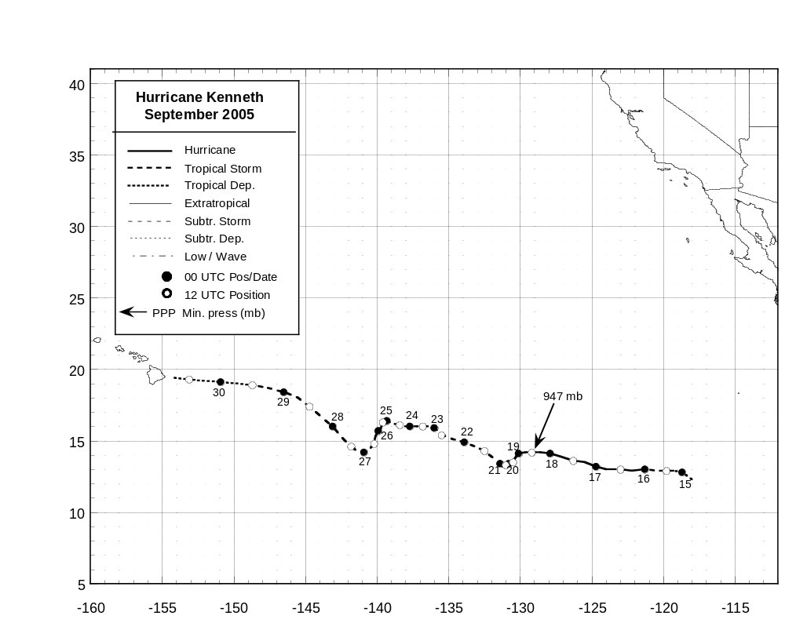
Figure 1. Best track positions for Hurricane Kenneth, 14-30 September 2005. Track west of 140ºW was provided by the Central Pacific Hurricane Center.
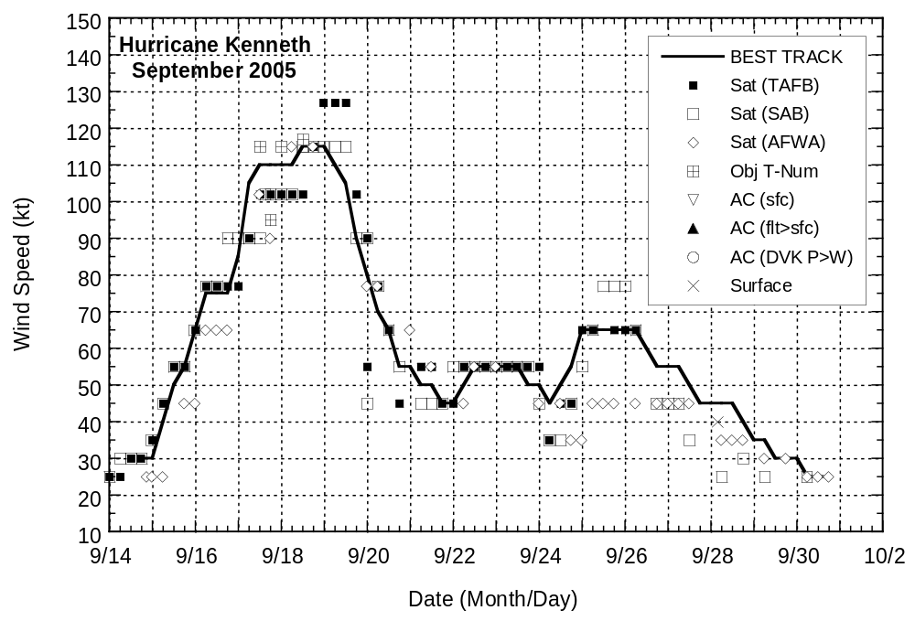
Figure 2. Selected wind observations and best track maximum sustained surface wind speed curve for Hurricane Kenneth, 14-30 September 2005. Objective Dvorak estimates represent linear averages over a three-hour period centered on the nominal observation time. Best track wind speeds after 0000 UTC 26 Sept were provided by the Central Pacific Hurricane Center.

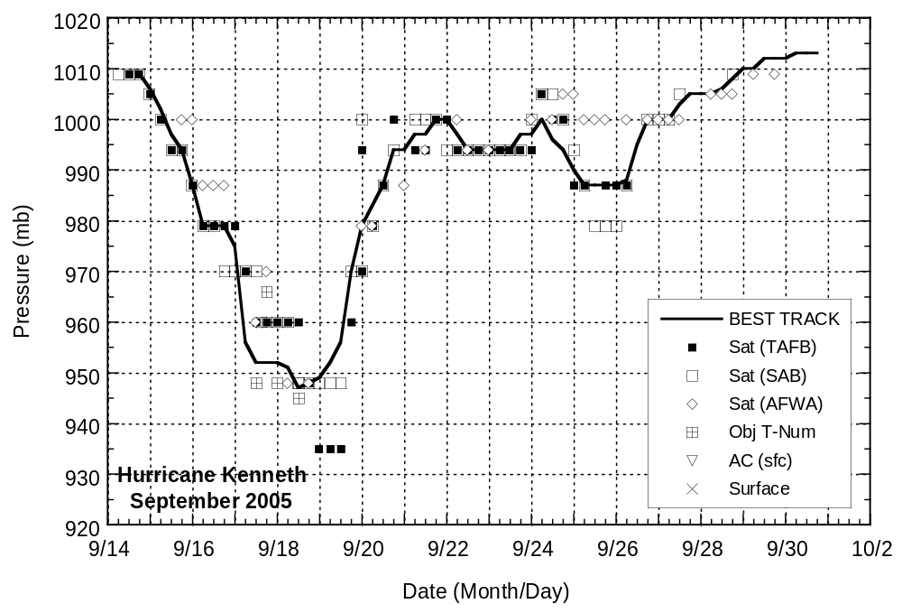

Figure 3. Selected pressure observations and best track minimum central pressure curve for Hurricane Kenneth, 14-30 September 2005. Objective Dvorak estimates represent linear averages over a three-hour period centered on the nominal observation time. Best track pressures after 0000 UTC 26 Sept were provided by the Central Pacific Hurricane Center.

Errors given for the 96 and 120 h periods are averages over the four-year period 2001-4.

