Tropical Cyclone Report
Tropical Storm Iselle
(EP102008)
13-16 Aug 2008

Eric S. Blake
National Hurricane Center
5 December 2008

Iselle was a weak tropical storm that passed just to the south of Socorro Island.

- Synoptic History

The easterly wave that generated Iselle left the African coast on 30 July. The wave moved across the Atlantic basin in about a week with little organized convection, eventually entering the eastern Pacific Ocean on 7 August. Showers and thunderstorms increased markedly near the wave while it was over Central America, and a surface low formed early on 8 August. However, this low weakened the next day, with only sporadic shower and thunderstorm activity occurring near the low over the next couple of days. Late on 12 August, thunderstorms increased near the center, and around 1200 UTC 13 August, the low became a tropical depression, centered about 180 n mi south-southwest of Manzanillo, Mexico. Six hours later, the depression intensified to a tropical storm. The “best track” chart of the tropical cyclone’s path is given in Fig. 1, with the wind and pressure histories shown in Figs. 2 and 3, respectively. The best track positions and intensities are listed in Table 1¹.

High pressure to the north of the tropical cyclone initially steered the system to the west-northwest at about 10 kt. Moderate easterly wind shear persisted near the system, allowing only a slight intensification, and Iselle achieved a peak intensity of 45 kt on the morning of 14 August. Thereafter, a combination of increasing wind shear, somewhat cooler waters and entrainment of stable air caused a gradual weakening of the tropical storm. After it reached its peak intensity, Iselle took an erratic track generally toward the west-northwest and northwest. These track changes were probably due to high pressure weakening north of the cyclone and the system becoming steered by varying levels in the atmosphere depending on the convective vigor and vertical depth of the cyclone. Early on 16 August, Iselle weakened to a tropical depression and became a remnant low about 24 hours later, about 1270 n mi west-southwest of the southern tip of Baja California. The low moved to the west for the next few days, then to the southwest, redeveloping a small amount of convection on 22 August before dissipating the next day.

- Meteorological Statistics

Observations in Iselle (Figs. 2 and 3) include satellite-based Dvorak technique intensity estimates from the Tropical Analysis and Forecast Branch (TAFB) and the Satellite Analysis Branch (SAB). Microwave satellite imagery from NOAA polar-orbiting satellites, the NASA Tropical Rainfall Measuring Mission (TRMM), the NASA QuikSCAT, and Defense Meteorological Satellite Program (DMSP) satellites, among others, were also useful in tracking the storm. The peak intensity of 45 kt is based on satellite estimates from TAFB and SAB. There were no reports of tropical-storm force winds received from ships or land stations.

- Casualty and Damage Statistics

There were no reports of damage or deaths related to Iselle.

- Forecast and Warning Critique

The genesis of Iselle was not well-anticipated. On 8 August, five days before genesis occurred, the system was judged to have a rather high likelihood of developing in the far eastern Pacific (80% experimentally) within 48 hours, but the system did not form at that time. Several days later, the possibility of the system becoming a tropical depression was explicitly included only about 12 hours before formation, and most of the experimental genesis forecasts during the previous 48 hours only indicated a low probability of development.

The average official track errors for Iselle were 40, 69, 95, 116 and 117 n mi for the 12, 24, 36, 48, 72 h forecasts, respectively. The number of forecasts ranged from 12 at 12 h to 2 at 72 h. These forecast errors were generally higher than the five-year average official track errors through 48 h (Table 2), and little smaller than that at 72 h. The official forecast was an improvement on most of the guidance, with the European Center (EMXI) model having the best performance.

Average official intensity errors were 3, 3, 5, 8, and 15 kt for the 12, 24, 36, 48, 72 h forecasts, respectively. These errors are considerably lower than the long-term averages (Table 3). Some of the model guidance was even a little better, with the Florida State Superensemble (FSSE) performing the best during the first 24 h and the LGEM model providing good guidance in the longer term. The intensity consensus (ICON) provided very good guidance at all time periods.

Table 1. Best track for Tropical Storm Iselle, 13-16 August 2008.
Date/Time  (UTC) | Latitude  (°N) | Longitude  (°W) | Pressure  (mb) | Wind Speed  (kt) | Stage
13 / 1200 | 16.3 | 105.4 | 1005 | 30 | tropical depression
13 / 1800 | 16.7 | 106.4 | 1003 | 35 | tropical storm
14 / 0000 | 17.1 | 107.3 | 1002 | 40 | "
14 / 0600 | 17.4 | 108.2 | 1002 | 40 | "
14 / 1200 | 17.6 | 109.1 | 999 | 45 | "
14 / 1800 | 17.6 | 109.9 | 1002 | 40 | "
15 / 0000 | 17.6 | 110.6 | 1002 | 40 | "
15 / 0600 | 17.7 | 110.9 | 1002 | 40 | "
15 / 1200 | 17.8 | 111.1 | 1002 | 40 | "
15 / 1800 | 17.9 | 111.3 | 1004 | 35 | "
16 / 0000 | 18.1 | 111.4 | 1006 | 30 | tropical depression
16 / 0600 | 18.3 | 111.5 | 1006 | 30 | "
16 / 1200 | 18.4 | 112.0 | 1006 | 30 | "
16 / 1800 | 18.4 | 112.4 | 1006 | 30 | "
17 / 0000 | 18.5 | 112.6 | 1007 | 25 | remnant low
17 / 0600 | 18.7 | 112.9 | 1008 | 25 | "
17 / 1200 | 18.8 | 113.6 | 1008 | 25 | "
17 / 1800 | 18.8 | 114.3 | 1008 | 25 | "
18 / 0000 | 18.8 | 114.9 | 1008 | 25 | "
18 / 0600 | 18.9 | 115.6 | 1009 | 25 | "
18 / 1200 | 19.0 | 116.4 | 1009 | 25 | "
18 / 1800 | 19.0 | 117.1 | 1009 | 25 | "
19 / 0000 | 18.8 | 117.8 | 1009 | 25 | "
19 / 0600 | 18.5 | 118.6 | 1009 | 25 | "
19 / 1200 | 18.2 | 119.2 | 1009 | 25 | "
19 / 1800 | 17.8 | 119.7 | 1009 | 25 | "
20 / 0000 | 17.3 | 120.1 | 1009 | 25 | "
20 / 0600 | 16.7 | 120.5 | 1009 | 25 | "
20 / 1200 | 16.1 | 120.9 | 1009 | 25 | "
20 / 1800 | 15.5 | 121.4 | 1009 | 25 | "
21 / 0000 | 14.9 | 121.9 | 1009 | 25 | "
21 / 0600 | 14.4 | 122.4 | 1009 | 25 | "
21 / 1200 | 14.1 | 123.0 | 1009 | 25 | "
21 / 1800 | 13.8 | 123.7 | 1010 | 20 | "
22 / 0000 | 13.6 | 124.2 | 1010 | 20 | "
22 / 0600 | 13.4 | 124.7 | 1010 | 20 | "
22 / 1200 | 13.3 | 125.2 | 1009 | 25 | "
22 / 1800 | 13.3 | 125.6 | 1009 | 25 | "
23 / 0000 | 13.5 | 125.8 | 1009 | 25 | "
23 / 0600 | 13.8 | 125.9 | 1009 | 25 | "
23 / 1200 | 13.9 | 125.9 | 1010 | 20 | "
23 / 1800 |  |  |  |  | dissipated
14 / 1200 | 17.6 | 109.1 | 999 | 45 | minimum pressure

Table 2. Track forecast evaluation (heterogeneous sample) for Tropical Storm Iselle, 13-16 August 2008. Forecast errors (n mi) are followed by the number of forecasts in parentheses. Errors smaller than the NHC official forecast are shown in boldface type.

Forecast Technique | Forecast Period (h)
Forecast Technique | 12 | 24 | 36 | 48 | 72 | 96 | 120
CLP5 | 46 (12) | 81 (10) | 126 ( 8) | 155 ( 6) | 187 ( 2)
GFNI | 44 ( 9) | 71 ( 7) | 116 ( 5) | 141 ( 3)
GFDI | 49 (12) | 97 (10) | 146 ( 8) | 202 ( 6) | 294 ( 2)
HWFI | 53 (12) | 109 (10) | 178 ( 8) | 238 ( 6) | 223 ( 2)
GFSI | 47 (12) | 91 ( 8) | 134 ( 6) | 160 ( 3)
AEMI | 38 (12) | 60 ( 9) | 87 ( 7) | 192 ( 3)
NGPI | 53 ( 9) | 89 ( 7) | 142 ( 5) | 170 ( 3)
EGRI | 54 (11) | 87 ( 9) | 126 ( 7) | 203 ( 3)
EMXI | 33 (10) | 52 ( 9) | 54 ( 7) | 63 ( 5) | 37 ( 1)
BAMD | 71 (12) | 151 (10) | 248 ( 8) | 343 ( 6) | 450 ( 2)
BAMM | 47 (12) | 92 (10) | 146 ( 8) | 197 ( 6) | 232 ( 2)
BAMS | 49 (10) | 83 ( 9) | 125 ( 7) | 147 ( 5) | 129 ( 2)
LBAR | 52 (10) | 112 ( 9) | 204 ( 7) | 281 ( 5) | 395 ( 2)
TVCN | 39 (12) | 69 (10) | 110 ( 8) | 139 ( 6) | 172 ( 2)
TVCC | 38 (12) | 72 (10) | 120 ( 8) | 151 ( 6) | 173 ( 2)
GUNA | 48 ( 9) | 80 ( 6) | 127 ( 4) | 171 ( 1)
FSSE | 48 ( 9) | 84 ( 9) | 130 ( 6) | 155 ( 5) | 127 ( 1)
OFCL | 40 (12) | 69 (10) | 95 ( 8) | 116 ( 6) | 117 ( 2)
NHC Official  (2003-2007 mean) | 31.9 (1282) | 55.1 (1129) | 77.4 (979) | 97.9 (849) | 136.2 (620) | 180.1 (439) | 226.1 (293)

Table 3. Intensity forecast evaluation (heterogeneous sample) for Tropical Storm Iselle, 13-16 Aug 2008. Forecast errors (kt) are followed by the number of forecasts in parentheses. Errors smaller than the NHC official forecast are shown in boldface type.

Forecast Technique | Forecast Period (h)
Forecast Technique | 12 | 24 | 36 | 48 | 72 | 96 | 120
OCD5 | 3.3 (12) | 7.7 (10) | 14.8 ( 8) | 19.7 ( 6) | 28.0 ( 2)
GHMI | 5.8 (12) | 6.9 (10) | 6.8 ( 8) | 7.2 ( 6) | 1.5 ( 2)
HWFI | 3.7 (12) | 4.4 (10) | 6.6 ( 8) | 9.2 ( 6) | 4.0 ( 1)
LGEM | 3.8 (12) | 3.6 (10) | 4.9 ( 8) | 7.0 ( 6) | 10.5 ( 2)
DSHP | 3.2 (12) | 3.3 (10) | 5.3 ( 8) | 9.3 ( 6) | 15.5 ( 2)
FSSE | 3.1 ( 9) | 2.0 ( 9) | 5.5 ( 6) | 7.8 ( 5) | 17.0 ( 1)
ICON | 3.2 (12) | 2.9 (10) | 3.8 ( 8) | 4.2 ( 6) | 8.0 ( 1)
OFCL | 3.3 (12) | 2.5 (10) | 5.0 ( 8) | 8.3 ( 6) | 15.0 ( 2)
NHC Official  (2003-2007 mean) | 6.2 (1282) | 10.4  (1129) | 13.9  (979) | 16.3  (848) | 18.7 (620) | 19.2 (439) | 19.1 (293)

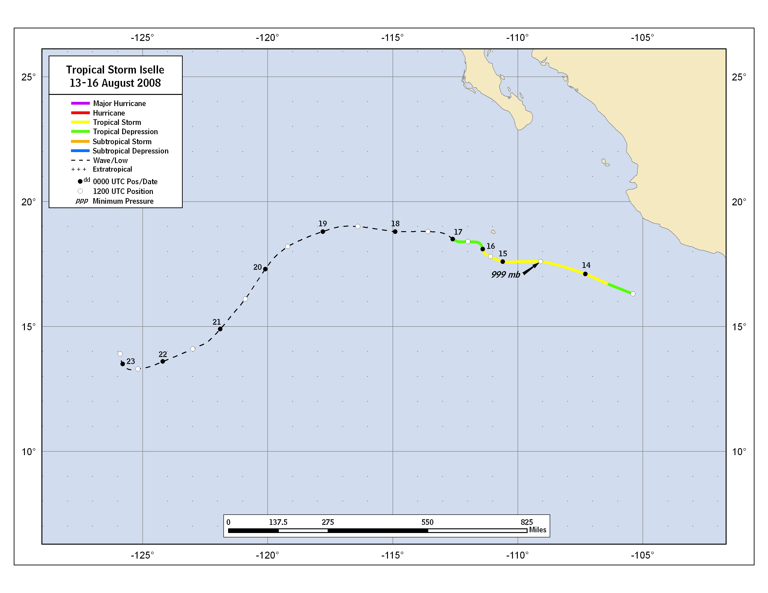

Figure 1. Best track positions for Tropical Storm Iselle, 13-16 August 2008.
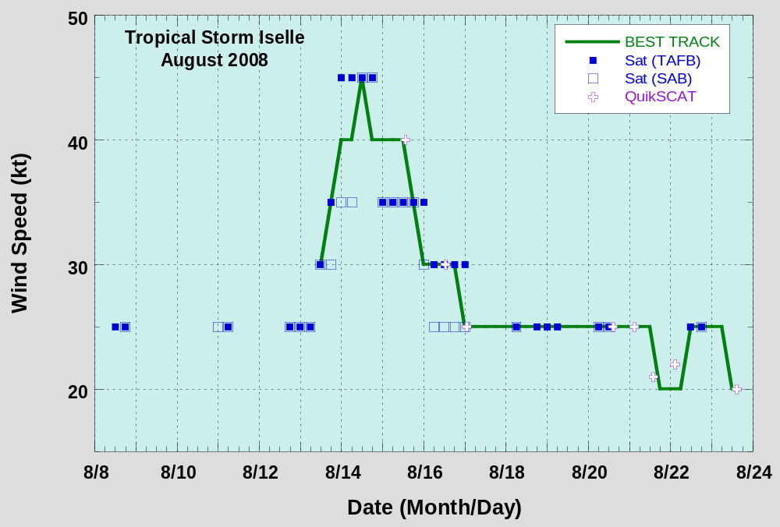
Figure 2. Selected wind observations and best track maximum sustained surface wind speed curve for Tropical Storm Iselle, 13-16 August 2008.

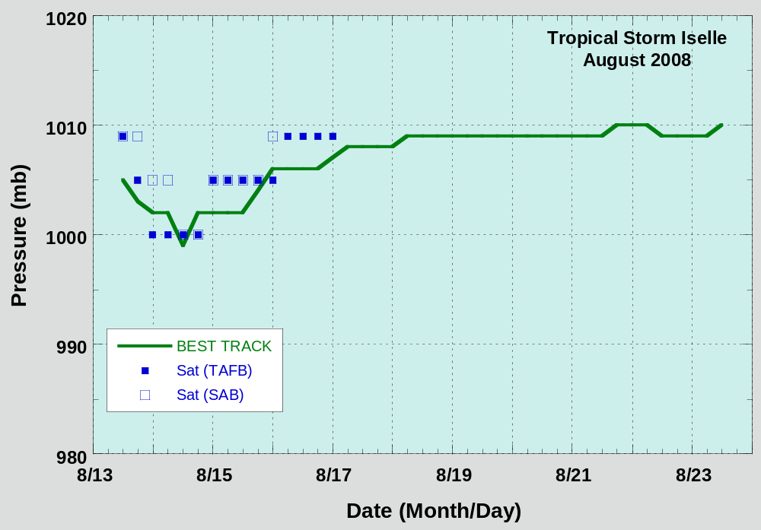
Figure 3. Selected pressure observations and best track minimum central pressure curve for Tropical Storm Iselle, 13-16 August 2008.

A digital record of the complete best track, including wind radii, can be found on line at ftp://ftp.nhc.noaa.gov/atcf. Data for the current year’s storms are located in the btk directory, while previous years’ data are located in the archive directory.

