Tropical Cyclone Report
Tropical Storm Dolores
(EP052009)
15-16 July 2009

John L. Beven II
National Hurricane Center
15 January 2010

Dolores was a large, but short-lived tropical storm. The only land it affected was Clarion Island.

- Synoptic History

Dolores formed from a tropical wave that moved westward from the coast of Africa on 1 July. After traversing the Atlantic and Caribbean Sea, the system crossed Central America into the eastern Pacific basin on 8 July. The wave then moved slowly westward, and a large, but poorly defined, low pressure area developed from it several hundred miles south of Acapulco, Mexico on 11 July. The circulation of the low became better defined and the associated shower activity became better organized on 14 July as the system moved west-northwestward. It is estimated that a tropical depression formed near 0000 UTC 15 July about 605 n mi west-southwest of Manzanillo, Mexico. The “best track” chart of the tropical cyclone’s path is given in Fig. 1, with the wind and pressure histories shown in Figs. 2 and 3, respectively. The best track positions and intensities are listed in Table 1

The cyclone moved generally northwestward on the southwestern side of a mid-level ridge over northern Mexico and the adjacent Pacific waters. Although located in an environment of southwesterly vertical wind shear caused in part by an upper-level trough to the northwest, the cyclone strengthened to a tropical storm about 12 h after genesis. Dolores reached a peak intensity of 50 kt near 0000 UTC 16 July about 540 n mi southwest of the southern tip of Baja California. The associated convection dissipated shortly afterward, possibly due to the entrainment of dry air associated with the upper-level trough. Dolores degenerated to a gale-force low around 1800 UTC 16 July, with the sustained winds falling below gale force 6 h later. The remnants of Dolores moved northwestward until 19 July, when they turned northward. The low dissipated the next day about 865 n mi west-southwest of Los Angeles, California.

- Meteorological Statistics

Observations in Dolores (Figs. 2 and 3) include satellite-based Dvorak technique intensity estimates from the Tropical Analysis and Forecast Branch (TAFB) and the Satellite Analysis Branch (SAB). Data and imagery from NOAA polar-orbiting satellites (including intensity estimates from the Advanced Microwave Sounding Unit), the NASA Tropical Rainfall Measuring Mission (TRMM), the NASA QuikSCAT, and Defense Meteorological Satellite Program (DMSP) satellites, among others, were also useful in constructing the best track of Dolores.

The best track peak intensity of 50 kt is based on QuikSCAT data at 0211 UTC 16 July. The only surface observation of note was from Clarion Island, which reported a wind gust of 39 kt on 16 July.

- Casualty and Damage Statistics

There were no reports of damage or casualties associated with Dolores.

- Forecast and Warning Critique

The genesis of Dolores was well anticipated. The potential for development was first noted in the Tropical Weather Outlook on 11 July, and the potential was rated as high (greater than 50% chance of development during the next 48 hours) starting on 13 July, about 36 h before genesis occurred.

A verification of NHC official track forecasts for Dolores is given in Table 2. Official forecast track errors were greater than the mean official errors for the previous five-year period for 12-24 h, and lower at 36 h. Dolores was a tropical cyclone for only 36 hr, so the number of forecasts is small. Thus, no model verification is included.

A verification of NHC official intensity forecasts for Dolores is given in Table 3. Official forecast intensity errors were lower than the mean official errors for the previous five-year period. However, the number of forecasts is again small.

No watches or warning were necessary or issued for Dolores.
Table 1. Best track for Tropical Storm Dolores, 15 – 16 July 2009.

Date/Time  (UTC) | Latitude  (°N) | Longitude  (°W) | Pressure  (mb) | Wind Speed  (kt) | Stage
14 / 0000 | 12.0 | 110.3 | 1008 | 25 | low
14 / 0600 | 12.3 | 111.2 | 1008 | 25 | "
14 / 1200 | 12.8 | 112.0 | 1008 | 25 | "
14 / 1800 | 13.3 | 112.7 | 1007 | 30 | "
15 / 0000 | 13.8 | 113.5 | 1006 | 30 | tropical depression
15 / 0600 | 14.2 | 114.4 | 1006 | 30 | "
15 / 1200 | 14.8 | 115.2 | 1005 | 35 | tropical storm
15 / 1800 | 15.8 | 116.1 | 1003 | 40 | "
16 / 0000 | 17.0 | 117.2 | 997 | 50 | "
16 / 0600 | 17.8 | 118.7 | 1000 | 45 | "
16 / 1200 | 18.4 | 120.3 | 1002 | 40 | "
16 / 1800 | 19.0 | 121.9 | 1004 | 35 | low
17 / 0000 | 19.5 | 123.4 | 1006 | 30 | "
17 / 0600 | 19.9 | 124.8 | 1006 | 30 | "
17 / 1200 | 20.2 | 126.3 | 1006 | 30 | "
17 / 1800 | 20.7 | 127.6 | 1007 | 30 | "
18 / 0000 | 21.3 | 128.8 | 1008 | 30 | "
18 / 0600 | 22.0 | 129.9 | 1010 | 25 | "
18 / 1200 | 22.8 | 131.0 | 1012 | 25 | "
18 / 1800 | 23.7 | 132.0 | 1014 | 20 | "
19 / 0000 | 24.8 | 132.9 | 1015 | 20 | "
19 / 0600 | 25.9 | 133.7 | 1016 | 20 | "
19 / 1200 | 27.0 | 134.3 | 1016 | 20 | "
19 / 1800 | 28.3 | 134.5 | 1016 | 15 | "
20 / 0000 | 29.5 | 134.5 | 1016 | 15 | "
20 / 0600 |  |  |  |  | dissipated
16 / 0000 | 17.0 | 117.2 | 997 | 50 | minimum pressure

Table 2. NHC official (OFCL) and climatology-persistence skill baseline (OCD5) track forecast errors (n mi) for Tropical Storm Dolores, 15 – 16 July 2009. Mean errors for the five-year period 2004-8 are shown for comparison. Official errors that are smaller than the five-year means are shown in boldface type.

 | Forecast Period (h)
 | 12 | 24 | 36 | 48 | 72 | 96 | 120
OFCL | 41.5 | 63.2 | 61.8
OCD5 | 72.5 | 150.5 | 198.5
Forecasts | 5 | 3 | 1
OFCL (2004-8) | 31 | 52 | 72 | 90 | 124 | 161 | 202
OCD5 (2004-8) | 38 | 74 | 112 | 149 | 214 | 261 | 312

Table 3. NHC official (OFCL) and climatology-persistence skill baseline (OCD5) intensity forecast errors (kt) for Tropical Storm Dolores, 15 – 16 July 2009. Mean errors for the five-year period 2004-8 are shown for comparison. Official errors that are smaller than the five-year means are shown in boldface type.

 | Forecast Period (h)
 | 12 | 24 | 36 | 48 | 72 | 96 | 120
OFCL | 5.0 | 6.7 | 0.0
OCD5 | 5.2 | 5.7 | 0.0
Forecasts | 5 | 3 | 1
OFCL (2004-8) | 6.2 | 10.2 | 13.3 | 15.1 | 17.7 | 19.0 | 18.8
OCD5 (2004-8) | 7.1 | 11.5 | 14.7 | 16.8 | 18.9 | 20.3 | 20.2

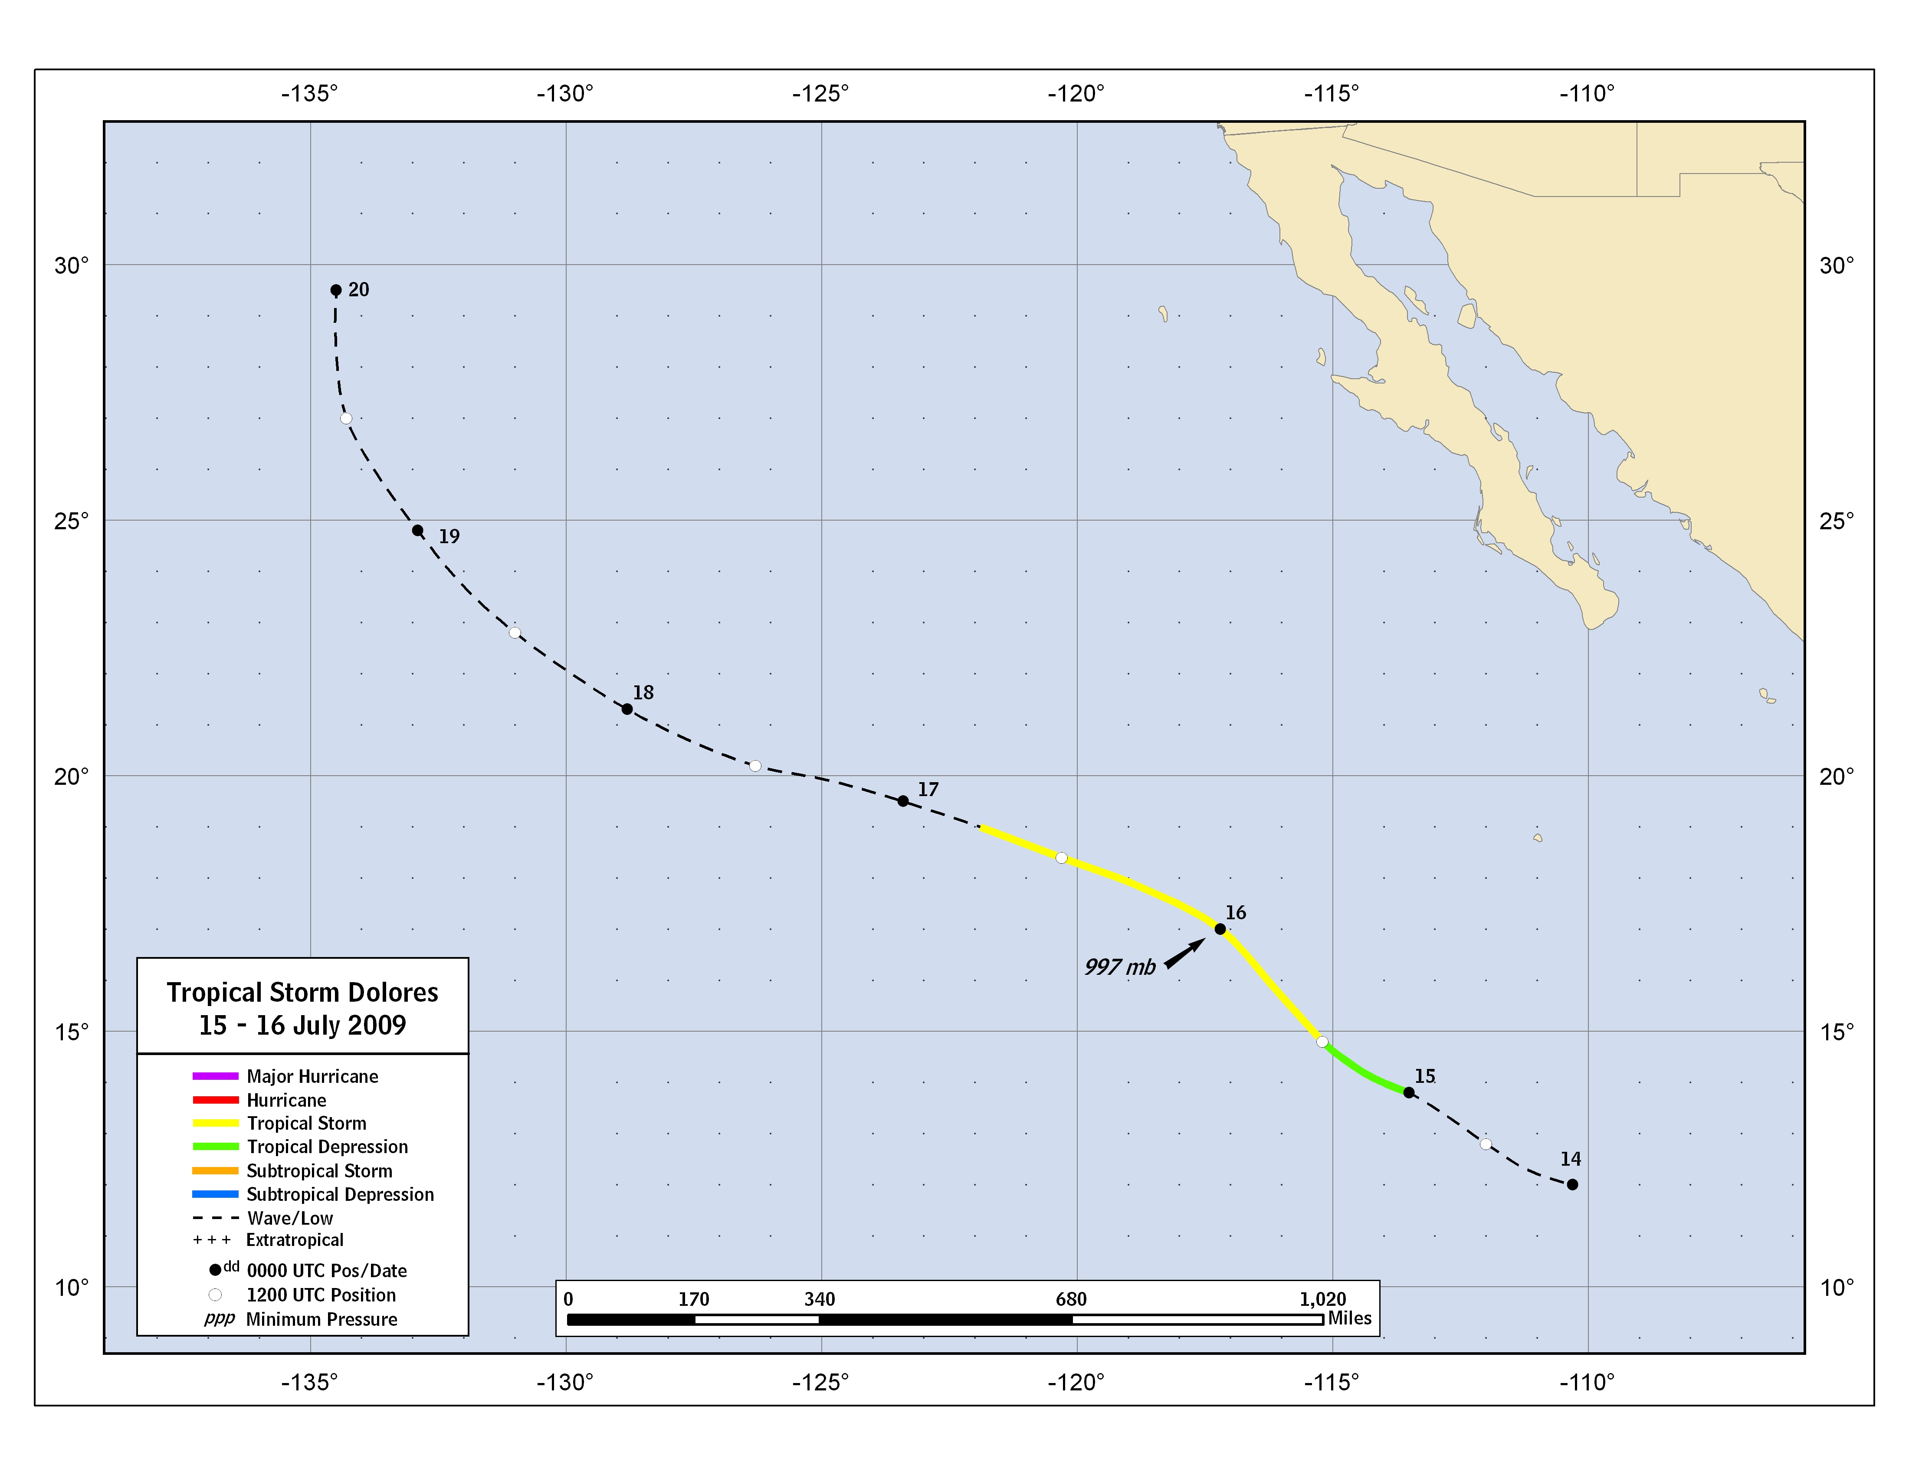
Figure 1. Best track positions for Tropical Storm Dolores, 16 – 17 July 2009.
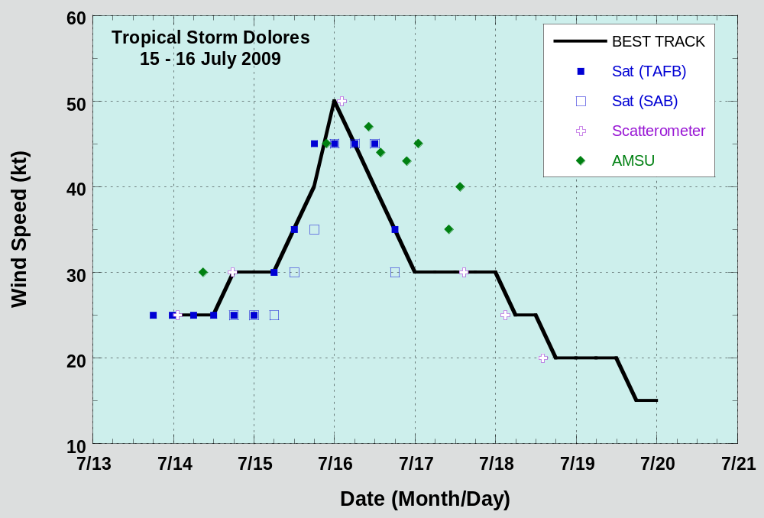
Figure 2. Selected wind observations and best track maximum sustained surface wind speed curve for Tropical Storm Dolores, 15 – 16 July 2009. Dashed vertical lines correspond to 0000 UTC.
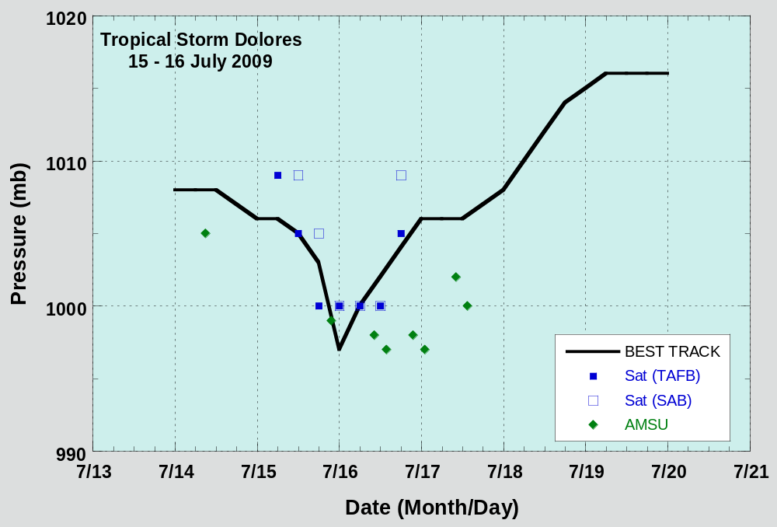
Figure 3. Selected pressure observations and best track minimum central pressure curve for Tropical Storm Dolores, 15 – 16 July 2009. Dashed vertical lines correspond to 0000 UTC.

A digital record of the complete best track, including wind radii, can be found on line at ftp://ftp.nhc.noaa.gov/atcf. Data for the current year’s storms are located in the btk directory, while previous years’ data are located in the archive directory.

