Tropical Cyclone Report
Hurricane Carlos (EP042009)
10-16 July 2009

Lixion A. Avila
National Hurricane Center
22 September 2009

Carlos was a small hurricane characterized by rapid changes in intensity. Carlos became the strongest hurricane so far south in the eastern North Pacific since reliable records began in 1971.

- Synoptic History

A tropical wave accompanied by a large area of cloudiness and thunderstorms moved off the west coast of Africa on 25 June. Upper-air data from Dakar, Senegal showed a distinct cyclonic wind shift as the wave axis crossed the station followed by a 35-kt middle-level jet. As the wave moved westward across the tropical Atlantic the thunderstorm activity decreased, but then increased as the wave entered the southeastern Caribbean Sea. Most of the shower activity associated with the wave continued westward over northern South America and reached the eastern North Pacific on 4 July. For the next two to three days, the wave continued westward with little shower activity. Convection increased on 8 July about 300 n mi south of Manzanillo, Mexico. Thereafter, the thunderstorm activity began to show signs of organization as cyclonically curved convective bands developed and it is estimated that a tropical depression formed at 0600 UTC 10 July about 780 n mi south of the southern tip of Baja California. The “best track” chart of the tropical cyclone’s path is given in Fig. 1, with the wind and pressure histories shown in Figs. 2 and 3, respectively. The best track positions and intensities are listed in Table 1.

The depression moved westward at an average speed of 10 knots while the cloud pattern continued to become better organized. A couple of hooking convective bands formed and it is estimated that the depression became a tropical storm at 1800 UTC 10 July. There was a steady intensification and at 1800 UTC 11 July an eyewall-like feature was observed in microwave imagery. Carlos, a small hurricane, reached an intensity of 75 knots at 0000 UTC 12 July, and maintained the same intensity for about 12 hours. Shortly thereafter, conventional satellite imagery showed that the eye had become obscured and the cloud pattern subsequently became disorganized. Carlos weakened as quickly as it had strengthened and became a 45-kt tropical storm at 0000 UTC 13 July. Thereafter, a new round of intensification began and Carlos redeveloped a small but well-defined eye in conventional imagery, and reached a peak intensity of 90 kt at 0000 UTC 15 July.

Carlos moved westward during most of its lifetime, embedded within the trade winds along 10°N over warm waters and within an environment of low wind shear. However, Carlos encountered strong shear as it approached 130°W on 15 July. This caused an abrupt deterioration of the cloud pattern. The cyclone weakened rapidly from a 90-kt hurricane to a tropical depression in about a day. By 0000 UTC 17 July, the circulation of Carlos dissipated about 1900 n mi west-southwest of the southern tip of Baja California.

- Meteorological Statistics

Observations in Carlos (Figs. 2 and 3) include satellite-based Dvorak technique intensity estimates from the Tropical Analysis and Forecast Branch (TAFB) and the Satellite Analysis Branch (SAB). Data and imagery from NOAA polar-orbiting satellites, the NASA Tropical Rainfall Measuring Mission (TRMM), the NASA QuikSCAT, and Defense Meteorological Satellite Program (DMSP) satellites, among others, were also useful in tracking Carlos.

A 1547 UTC 11 July SSMIS F-16 composite image showed the incipient formation of an eyewall and indicated that the low- and middle level circulations were becoming vertically aligned. Operationally, this was considered to be a precursor of intensification and indeed the eye became distinct on visible images at 1800 UTC 11 July. Although conventional satellite imagery showed a degradation of the cloud pattern during the weakening of Carlos, a sequence of 13 July microwave images revealed that Carlos maintained an eyewall structure at the middle levels during this period (Figs. 4a, b). Thereafter, the eye became distinct in conventional imagery during the second period of intensification, and continued to be distinct for several hours before it became obscured by high clouds. By 1030 UTC the eye had practically vanished in both conventional and microwave imagery. The peak intensity of Carlos is uncertain because it was solely based on Dvorak estimates and there are not many cases of very small hurricanes, like Carlos, in the statistical sample from which the Dvorak technique was developed.

- Casualty and Damage Statistics

There were no reports of damage or casualties associated with Carlos.

- Forecast and Warning Critique

The genesis of Carlos was not well anticipated. The “high” (greater than 50%) chance of formation was not indicated until 6 h before genesis. The precursor of the cyclone was mentioned in the Tropical Weather Outlook at 0000 UTC 9 July, about 32 h prior to genesis with only a “low” (less than 30%) chance of development.

Both track and intensity forecasts for Carlos were very poor. A verification of NHC official track forecasts for Carlos is given in Table 2a. Official forecast track errors were greater than the mean official errors for the previous five-year period. However, a comparison of the climatology-persistence skill baseline OCD5 with the 5-year mean of this quantity shows that Carlos was a difficult cyclone to predict. A homogeneous comparison of the official track errors with selected guidance models is given in Table 2b. The GFNI, which is the equivalent to the GFDL but using the Navy NOGAPS as a background model, was the best at longer ranges. It is interesting to note that the simple BAM models, which simply advect the cyclone using the GFS forecast fields, were also very good in this hurricane.

A verification of NHC official intensity forecasts for Carlos is given in Table 3a. Official forecast intensity errors were greater than the mean official errors for the previous five-year period. The official forecasts did not reflect the rapid intensification or the rapid weakening of the cyclone. A homogeneous comparison of the official track errors with selected guidance models is given in Table 3b. The models were better than the official forecast primarily at the longer ranges.

There were no watches and warnings associated with Carlos.
Table 1. Best track for Hurricane Carlos, 10-16 July 2009.
Date/Time  (UTC) | Latitude  (°N) | Longitude  (°W) | Pressure  (mb) | Wind Speed  (kt) | Stage
10 / 0600 | 10.0 | 111.0 | 1007 | 25 | tropical depression
10 / 1200 | 10.1 | 112.2 | 1007 | 30 | "
10 / 1800 | 10.2 | 113.4 | 1004 | 35 | tropical storm
11 / 0000 | 10.3 | 114.5 | 1000 | 45 | "
11 / 0600 | 10.3 | 115.5 | 997 | 50 | "
11 / 1200 | 10.4 | 116.4 | 991 | 60 | "
11 / 1800 | 10.5 | 117.3 | 987 | 65 | hurricane
12 / 0000 | 10.5 | 118.4 | 980 | 75 | "
12 / 0600 | 10.5 | 119.4 | 980 | 75 | "
12 / 1200 | 10.4 | 120.4 | 980 | 75 | "
12 / 1800 | 10.4 | 121.4 | 987 | 65 | "
13 / 0000 | 10.2 | 122.4 | 997 | 50 | tropical storm
13 / 0600 | 10.0 | 123.5 | 997 | 45 | "
13 / 1200 | 9.8 | 124.6 | 997 | 45 | "
13 / 1800 | 9.6 | 125.6 | 994 | 55 | "
14 / 0000 | 9.6 | 126.2 | 994 | 55 | "
14 / 0600 | 9.7 | 126.8 | 994 | 55 | "
14 / 1200 | 9.9 | 127.4 | 981 | 75 | hurricane
14 / 1800 | 10.0 | 127.9 | 978 | 80 | "
15 / 0000 | 10.1 | 128.3 | 971 | 90 | "
15 / 0600 | 10.1 | 128.8 | 972 | 90 | "
15 / 1200 | 10.1 | 129.4 | 978 | 75 | "
15 / 1800 | 10.2 | 130.4 | 994 | 55 | tropical storm
16 / 0000 | 10.2 | 131.5 | 1000 | 45 | "
16 / 0600 | 10.0 | 132.9 | 1003 | 30 | tropical depression
16 / 1200 | 9.7 | 134.3 | 1005 | 25 | "
16 / 1800 | 9.4 | 135.7 | 1007 | 25 | "
17 / 0000 |  |  |  |  | dissipated
15 / 0000 | 10.1 | 128.3 | 971 | 90 | minimum pressure

Table 2a. NHC official (OFCL) and climatology-persistence skill baseline (OCD5) track forecast errors (n mi) for Carlos. Mean errors for the five-year period 2004-8 are shown for comparison. Official errors that are smaller than the five-year means are shown in boldface type.

 | Forecast Period (h)
 | 12 | 24 | 36 | 48 | 72 | 96 | 120
OFCL | 35.8 | 68.8 | 101.5 | 138.1 | 223.8 | 321.3 | 314.0
OCD5 | 37.2 | 80.5 | 120.8 | 166.1 | 249.9 | 334.2 | 391.4
Forecasts | 25 | 23 | 21 | 19 | 15 | 11 | 7
OFCL (2004-8) | 31.0 | 51.7 | 71.7 | 90.2 | 123.6 | 161.3 | 201.8
OCD5 (2004-8) | 38.4 | 73.6 | 111.9 | 149.1 | 214.2 | 261.1 | 311.5

Table 2b. Homogeneous comparison of selected track forecast guidance models (in n mi) for Carlos. Errors smaller than the NHC official forecast are shown in boldface type. The number of official forecasts shown here will generally be smaller than that shown in Table 2a due to the homogeneity requirement.

Model ID | Forecast Period (h)
Model ID | 12 | 24 | 36 | 48 | 72 | 96 | 120
OFCL | 37.2 | 68.0 | 113.8 | 154.0 | 243.1 | 324.1 | 406.8
OCD5 | 40.1 | 77.0 | 127.8 | 177.8 | 260.0 | 343.7 | 418.9
GFSI | 51.2 | 97.1 | 147.6 | 200.2 | 315.3 | 401.6 | 524.1
GHMI | 43.6 | 76.7 | 127.2 | 180.3 | 299.5 | 398.9 | 505.5
HWFI | 48.1 | 86.0 | 134.2 | 182.6 | 293.0 | 423.5 | 556.3
NGPI | 49.2 | 81.9 | 131.2 | 165.8 | 223.3 | 291.6 | 275.7
GFNI | 44.5 | 58.3 | 92.2 | 123.3 | 193.8 | 245.9 | 225.0
UKMI | 45.3 | 83.3 | 122.5 | 155.2 | 234.1 | 305.4 | 355.4
EGRI | 45.8 | 83.7 | 123.1 | 154.9 | 235.2 | 305.4 | 317.2
TCON | 42.8 | 75.4 | 119.0 | 160.3 | 251.8 | 344.6 | 425.7
TVCN | 41.1 | 68.6 | 108.9 | 145.5 | 228.4 | 310.8 | 375.7
TVCC | 45.1 | 62.4 | 111.7 | 166.4 | 318.7 | 457.2 | 459.1
GUNA | 42.1 | 72.3 | 116.6 | 154.0 | 241.9 | 327.3 | 395.4
LBAR | 40.9 | 86.9 | 152.8 | 228.1 | 390.5 | 473.5 | 484.6
BAMD | 35.2 | 50.3 | 79.6 | 110.7 | 178.4 | 226.6 | 346.9
BAMM | 35.4 | 56.0 | 83.8 | 115.5 | 186.0 | 254.0 | 372.9
BAMS | 50.1 | 96.9 | 144.7 | 196.6 | 307.7 | 428.9 | 564.5
Forecasts | 19 | 15 | 15 | 13 | 10 | 8 | 4
Table 3a. NHC official (OFCL) and climatology-persistence skill baseline (OCD5) intensity forecast errors (kt) for Carlos. Mean errors for the five-year period 2004-8 are shown for comparison. Official errors that are smaller than the five-year means are shown in boldface type.

 | Forecast Period (h)
 | 12 | 24 | 36 | 48 | 72 | 96 | 120
OFCL | 11.4 | 24.3 | 30.2 | 26.6 | 16.7 | 24.1 | 32.1
OCD5 | 11.6 | 24.0 | 32.8 | 34.7 | 18.2 | 24.6 | 24.9
Forecasts | 25 | 23 | 21 | 19 | 15 | 11 | 7
OFCL (2004-8) | 6.2 | 10.2 | 13.3 | 15.1 | 17.7 | 19.0 | 18.8
OCD5 (2004-8) | 7.1 | 11.5 | 14.7 | 16.8 | 18.9 | 20.3 | 20.2

Table 3b. Homogeneous comparison of selected intensity forecast guidance models (in kt) for Hurricane Carlos. Errors smaller than the NHC official forecast are shown in boldface type. The number of official forecasts shown here will generally be smaller than that shown in Table 5a due to the homogeneity requirement.

Model ID | Forecast Period (h)
Model ID | 12 | 24 | 36 | 48 | 72 | 96 | 120
OFCL | 11.4 | 24.3 | 30.2 | 26.6 | 16.7 | 24.1 | 32.1
OCD5 | 11.6 | 24.0 | 32.8 | 34.7 | 18.2 | 24.6 | 24.9
HWFI | 11.3 | 23.3 | 33.4 | 31.1 | 10.8 | 24.4 | 25.6
GHMI | 14.4 | 21.0 | 23.1 | 23.3 | 25.3 | 27.5 | 30.4
DSHP | 12.2 | 22.8 | 29.5 | 26.8 | 15.3 | 22.1 | 23.0
LGEM | 11.9 | 23.2 | 29.8 | 29.3 | 15.5 | 23.2 | 25.9
ICON | 12.0 | 22.5 | 28.8 | 27.1 | 14.2 | 23.4 | 25.4
Forecasts | 25 | 23 | 21 | 19 | 15 | 11 | 7

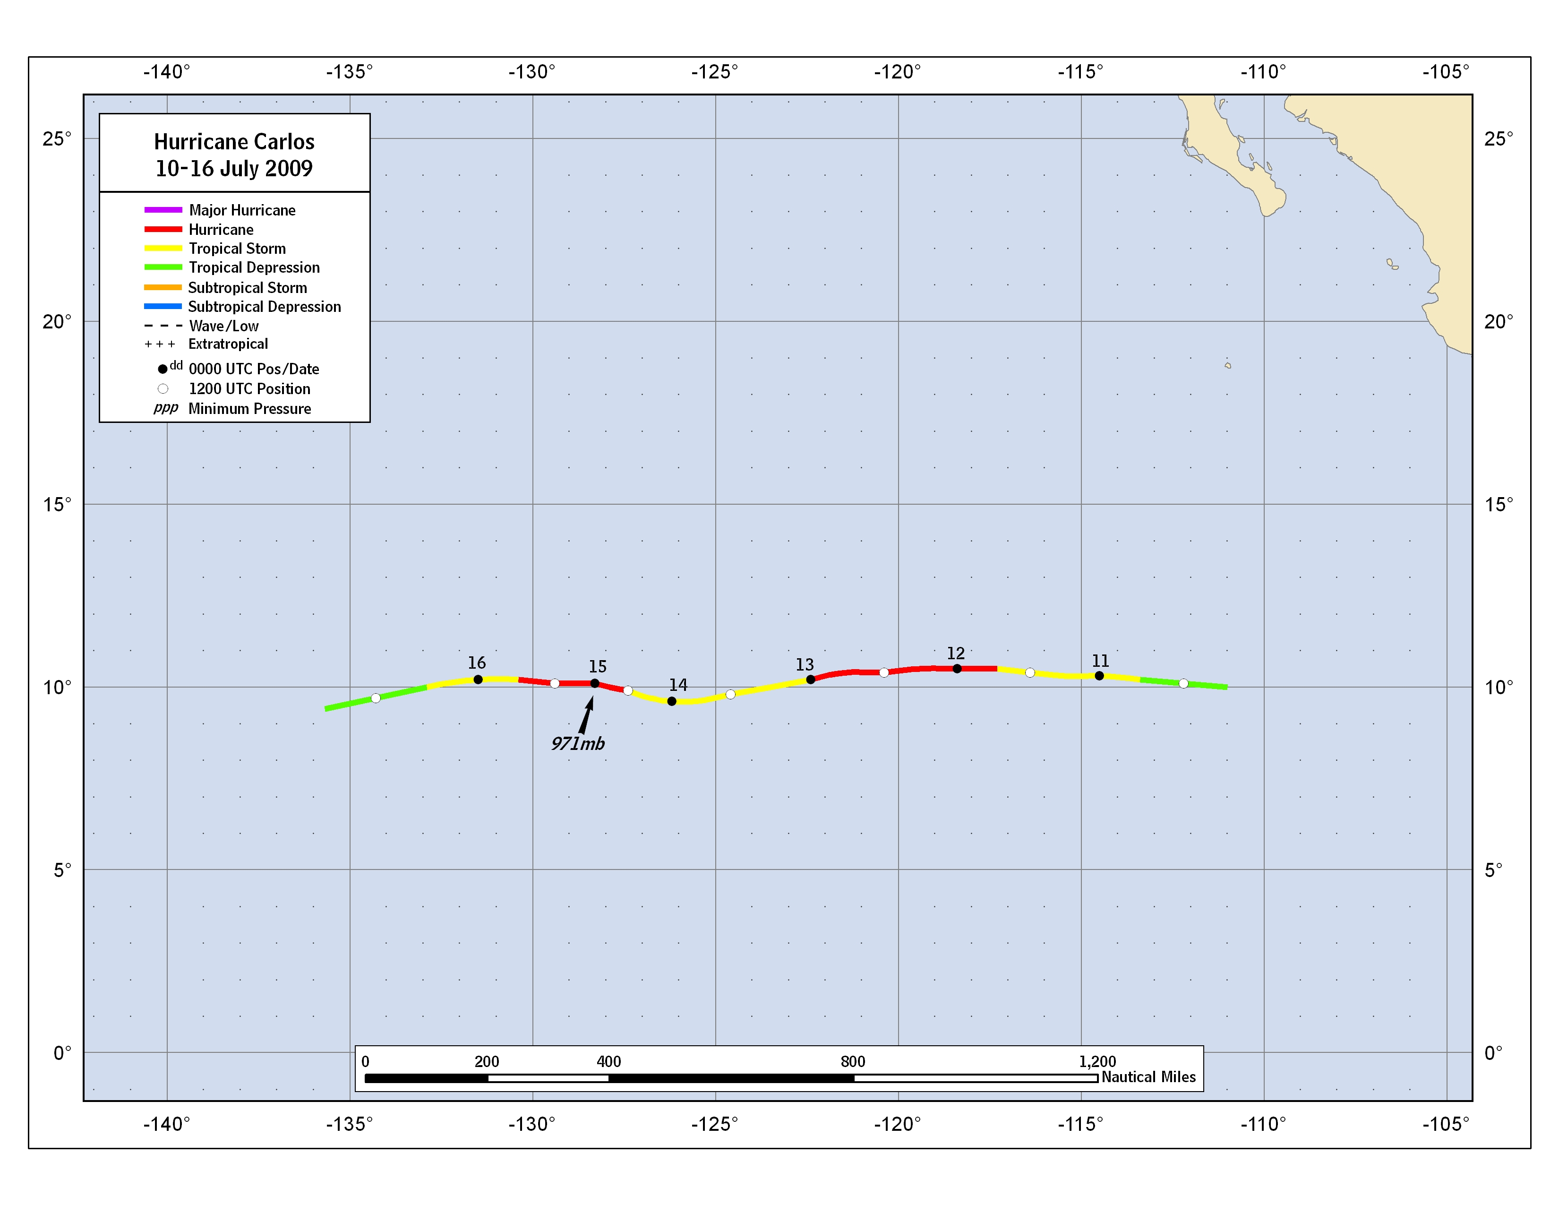
Figure 1. Best track positions for Hurricane Carlos, 10-16 July 2009.

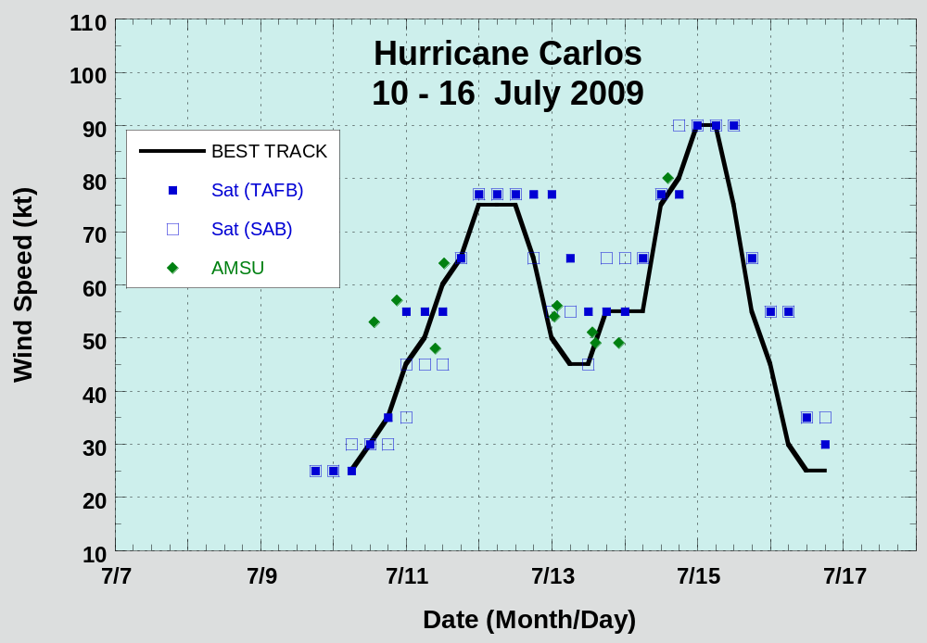

Figure 2. Selected wind observations and best track maximum sustained surface wind speed curve for Hurricane Carlos, 10-16 July 2009. Dashed vertical lines correspond to 0000 UTC.
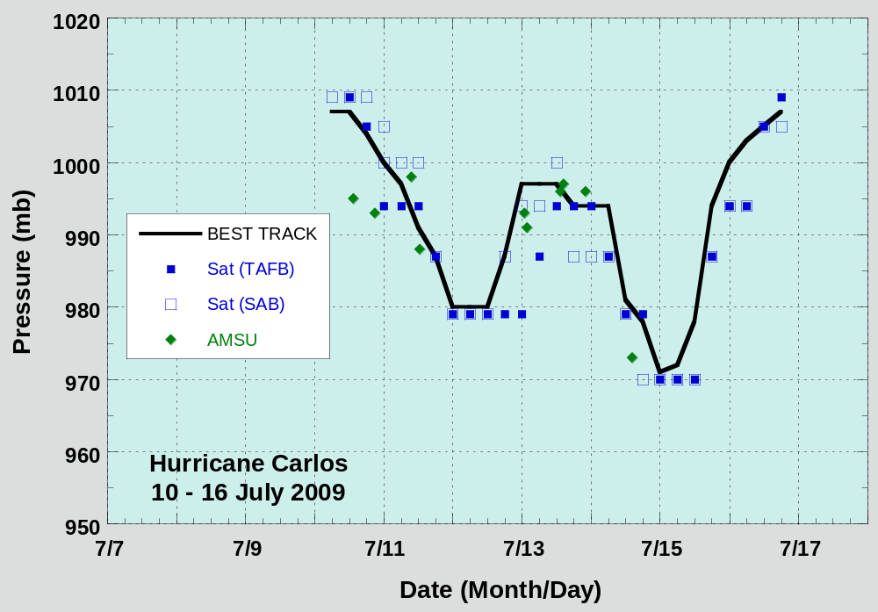

Figure 3. Selected pressure observations and best track minimum central pressure curve for Hurricane Carlos, 10-16 July 2009. Dashed vertical lines correspond to 0000 UTC.

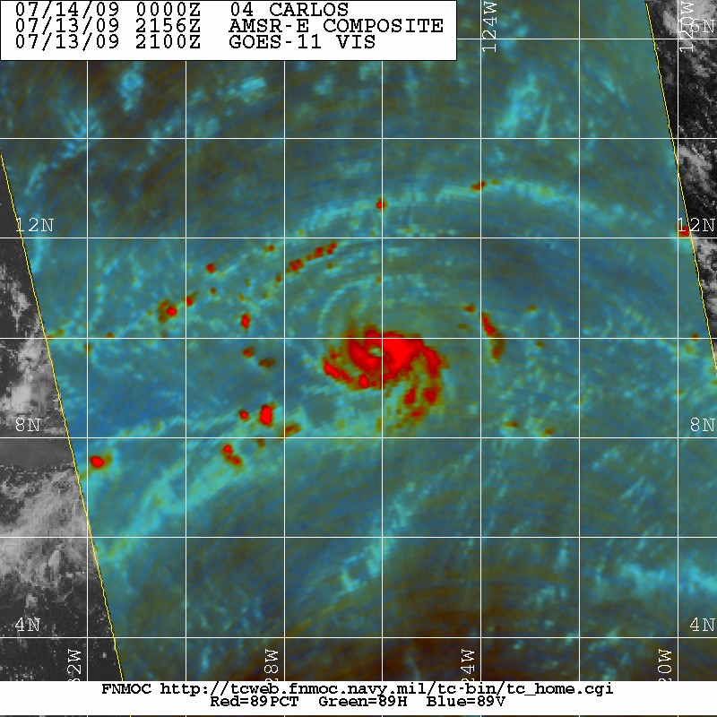
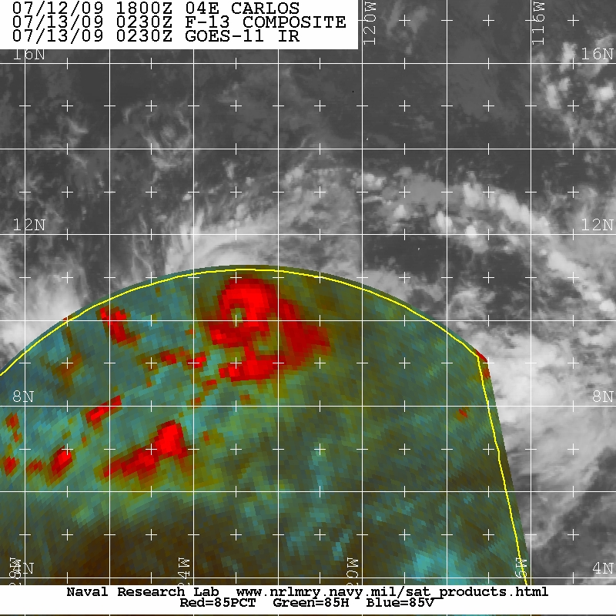

Figure 4. Microwave images of Carlos at 0230 UTC 13 July (left) and 2156 UTC 13 July (right). Images courtesy of the Naval Research Laboratory (NRL)

A digital record of the complete best track, including wind radii, can be found on line at ftp://ftp.nhc.noaa.gov/atcf. Data for the current year’s storms are located in the btk directory, while previous years’ data are located in the archive directory.

