Tropical Cyclone Report
Hurricane Andres
(EP022009)
21-24 June 2009

Daniel P. Brown
National Hurricane Center
21 July 2009

Andres was a tropical cyclone that attained category one hurricane status (on the Saffir-Simpson Hurricane Scale) as it paralleled the Pacific coast of Mexico. Though its center remained offshore, Andres produced locally heavy rainfall along portions of the coast of Mexico and was responsible for one fatality.

- Synoptic History

Andres originated from a tropical wave that crossed Central America and entered the eastern North Pacific Ocean on 16 June. The next day the wave produced an area of disorganized thunderstorms near the Gulf of Tehuantepec. During the next couple of days the wave moved slowly westward while the associated shower and thunderstorm activity gradually increased. The wave spawned an area of low pressure about 150 n mi south-southeast of Acapulco, Mexico, on 20 June. The low became better defined early the next day, and by 1200 UTC thunderstorm activity became organized enough for the system to be considered a tropical depression. The “best track” chart of the tropical cyclone’s path is given in Fig. 1, with the wind and pressure histories shown in Figs. 2 and 3, respectively. The best track positions and intensities are listed in Table 1.

The tropical cyclone initially moved westward and strengthened to a tropical storm 6 h after genesis, while centered about 155 n mi south-southwest of Acapulco. Andres then turned northwestward around the southwestern periphery of a mid-tropospheric ridge and continued on that heading for nearly the remainder of its existence. Over warm waters and in favorable atmospheric conditions, Andres steadily intensified during the next 36 hours. The cyclone attained hurricane strength with an estimated peak intensity of 70 kt by 0600 UTC 23 June while located about 70 n mi southwest of Lazaro Cardenas.

As Andres moved nearly parallel to the southwestern coast of Mexico, northeasterly shear increased, which initiated weakening. The center of Andres passed about 45-50 n mi off the southwestern coast of Mexico and by 0000 UTC 24 June the cyclone had weakened to a tropical storm. Shortly thereafter, Andres began moving over cooler waters and into a more stable air mass; this, combined with the northeasterly shear, led to rapid weakening of the cyclone. Deep convection associated with Andres began to wane after 0600 UTC 24 June, and the cyclone weakened to a tropical depression by 1200 UTC while centered about 85 n mi west of Cabo Corrientes. The depression then turned northward and became an open trough of low pressure by 1800 UTC.

- Meteorological Statistics

Observations in Andres (Figs. 2 and 3) include satellite-based Dvorak technique intensity estimates from the Tropical Analysis and Forecast Branch (TAFB) and the Satellite Analysis Branch (SAB), as well as flight-level, stepped frequency microwave radiometer (SFMR), and dropwindsonde observations from a single flight of the 53rd Weather Reconnaissance Squadron of the U.S. Air Force Reserve Command. Data and imagery from NOAA polar-orbiting satellites, the NASA Tropical Rainfall Measuring Mission (TRMM), the NASA QuikSCAT, the NASA Aqua, and the Department of Defense Windsat, and Defense Meteorological Satellite Program (DMSP) satellites, among others, were also useful in constructing the best track of Andres.

Andres was not assessed to have been a hurricane operationally as early as indicated in the post-storm best track. At 0600 UTC 23 June, the operational assessment was 60 kt, based on a blend of subjective Dvorak classifications. Over the ensuing 12 h, the satellite appearance of Andres had significantly degraded. Nevertheless, when the reconnaissance aircraft reached Andres around 1800 UTC, the SFMR found surface winds of 63 kt and 67 kt to the southeast and west of the center, respectively, and two dropwindsondes released to the east of the center measured hurricane force surface winds of 65 and 66 kt. These data indicate that Andres’ maximum winds at that time were at least 65 kt. It is therefore assumed that Andres was stronger at 0600 UTC and 1200 UTC when the cyclone appeared more organized in satellite imagery (Fig. 4).

It is possible that Andres produced tropical-storm-force winds along a portion of the southwestern coast of Mexico. However, no sustained tropical-storm-force wind measurements from land-based observing sites were received. The highest sustained wind recorded at a land-based station was 30 kt with a gust to 40 kt at Manzanillo late on 23 June. There were no reliable ship reports of winds of tropical storm force received in association with Andres.

There have been no rainfall reports received from southwestern Mexico.

- Casualty and Damage Statistics

Andres was responsible for one death in Mexico. A man drowned while fishing in rough seas near Tecpan de Galeana, between Acapulco and Zihuatanejo.

Press reports indicate that damage along the southwestern coast of Mexico was minimal. Heavy rainfall from Andres and its precursor disturbance flooded homes in a portion of Acapulco, which resulted in the evacuation of about 200 people. There were also reports that a few trees were blown down along the coast.

- Forecast and Warning Critique

The development of Andres was fairly well anticipated. The area of disturbed weather from which Andres formed was first mentioned in the Tropical Weather Outlook at 1800 UTC 19 June, about 42 h prior to genesis. At that time the disturbance was given a “low” (less than 30%) chance of formation. Twenty-four hours later the prospect of tropical cyclone formation was first mentioned and at that time the system was assigned a “medium” (30 to 50%) chance of development. The system, however, was not considered to have a “high” (greater than 50%) chance of development until about 12 h before genesis occurred.

A verification of NHC official track forecasts for Andres is given in Table 2a. Official forecast track errors were lower than the average long-term (2004-08) official errors. A homogeneous comparison of the official track errors with selected guidance models is given in Table 2b. The NHC track forecasts generally exhibited smaller mean errors than the guidance models.

A verification of NHC official intensity forecasts for Andres is given in Table 3a. Official intensity forecast errors were greater than the mean official errors for the previous five-year period through 36 h and comparable to the long-term mean at 48 h. The Decay-SHIFOR5 (OCD5) errors were also a little higher than the previous 5-year mean indicating the forecasts for Andres were a little more difficult than average. A homogeneous comparison of the official intensity errors with selected guidance models is given in Table 3b. The HWFI average errors were equal to or smaller than the average NHC intensity forecast errors at all time periods, albeit for relatively few forecasts.

Watches and warnings associated with Andres are given in Table 4. The government of Mexico issued a Hurricane Warning for a portion of the southwestern coast of Mexico at 2100 UTC 22 June. Hurricane-force winds never reached the coast and the warning was discontinued at 0300 UTC 24 June when Andres weakened to a tropical storm.
Table 1. Best track for Hurricane Andres, 21-24 June 2009.

Date/Time  (UTC) | Latitude  (°N) | Longitude  (°W) | Pressure  (mb) | Wind Speed  (kt) | Stage
21 / 1200 | 14.6 | 100.8 | 1003 | 30 | tropical depression
21 / 1800 | 14.6 | 101.2 | 1001 | 35 | tropical storm
22 / 0000 | 14.9 | 101.5 | 998 | 40 | "
22 / 0600 | 15.3 | 101.7 | 997 | 45 | "
22 / 1200 | 15.8 | 101.9 | 996 | 50 | "
22 / 1800 | 16.2 | 102.2 | 993 | 55 | "
23 / 0000 | 16.7 | 102.6 | 989 | 60 | "
23 / 0600 | 17.2 | 103.1 | 984 | 70 | hurricane
23 / 1200 | 17.8 | 103.9 | 985 | 70 | "
23 / 1800 | 18.4 | 104.8 | 988 | 65 | "
24 / 0000 | 18.9 | 105.6 | 993 | 55 | tropical storm
24 / 0600 | 19.5 | 106.5 | 997 | 45 | "
24 / 1200 | 20.2 | 107.2 | 1001 | 30 | tropical depression
24 / 1800 |  |  |  |  | dissipated
23 / 0600 | 17.2 | 103.1 | 984 | 70 | minimum pressure and maximum wind

Table 2a. NHC official (OFCL) and climatology-persistence skill baseline (OCD5) track forecast errors (n mi) for Andres. Mean errors for the five-year period 2004-8 are shown for comparison. Official errors that are smaller than the five-year means are shown in boldface type.

 | Forecast Period (h)
 | 12 | 24 | 36 | 48 | 72 | 96 | 120
OFCL | 25.7 | 39.8 | 55.5 | 76.1
OCD5 | 40.1 | 89.9 | 141.0 | 177.2
Forecasts | 10 | 8 | 6 | 4
OFCL (2004-8) | 31.0 | 51.7 | 71.7 | 90.2 | 123.6 | 161.3 | 201.8
OCD5 (2004-8) | 38.4 | 73.6 | 111.9 | 149.1 | 214.2 | 261.1 | 311.5

Table 2b. Homogeneous comparison of selected track forecast guidance models (in n mi) for Andres. Errors smaller than the NHC official forecast are shown in boldface type. The number of official forecasts shown here will generally be smaller than that shown in Table 2a due to the homogeneity requirement.

Model ID | Forecast Period (h)
Model ID | 12 | 24 | 36 | 48 | 72 | 96 | 120
OFCL | 26.8 | 39.8 | 55.5 | 76.1
OCD5 | 42.5 | 89.9 | 141.0 | 177.2
GFSI | 48.6 | 73.7 | 102.6 | 82.6
GHMI | 39.4 | 72.6 | 88.4 | 101.5
HWFI | 56.9 | 84.8 | 94.0 | 126.3
AEMI | 44.9 | 63.9 | 78.7 | 102.9
TVCN | 29.0 | 49.3 | 69.6 | 73.4
TVCC | 24.6 | 42.8 | 71.1 | 70.6
LBAR | 32.1 | 60.7 | 80.7 | 104.6
BAMD | 37.6 | 53.0 | 64.4 | 90.7
BAMM | 34.3 | 47.2 | 51.0 | 59.8
BAMS | 40.4 | 76.6 | 102.7 | 105.9
Forecasts | 9 | 8 | 6 | 4
Table 3a. NHC official (OFCL) and climatology-persistence skill baseline (OCD5) intensity forecast errors (kt) for Andres. Mean errors for the five-year period 2004-8 are shown for comparison. Official errors that are smaller than the five-year means are shown in boldface type.

 | Forecast Period (h)
 | 12 | 24 | 36 | 48 | 72 | 96 | 120
OFCL | 8.5 | 12.5 | 15.8 | 15.0
OCD5 | 11.6 | 15.0 | 16.0 | 17.5
Forecasts | 10 | 8 | 6 | 4
OFCL (2004-8) | 6.2 | 10.2 | 13.3 | 15.1 | 17.7 | 19.0 | 18.8
OCD5 (2004-8) | 7.1 | 11.5 | 14.7 | 16.8 | 18.9 | 20.3 | 20.2

Table 3b. Homogeneous comparison of selected intensity forecast guidance models (in kt) for Andres. Errors smaller than the NHC official forecast are shown in boldface type. The number of official forecasts shown here will generally be smaller than that shown in Table 3a due to the homogeneity requirement.

Model ID | Forecast Period (h)
Model ID | 12 | 24 | 36 | 48 | 72 | 96 | 120
OFCL | 8.5 | 12.5 | 15.8 | 15.0
OCD5 | 11.6 | 15.0 | 16.0 | 17.5
HWFI | 8.5 | 6.6 | 11.0 | 10.5
GHMI | 17.4 | 23.1 | 24.0 | 14.5
DSHP | 10.7 | 12.9 | 11.2 | 10.8
LGEM | 11.3 | 14.9 | 16.7 | 18.0
ICON | 10.1 | 12.5 | 12.2 | 9.5
Forecasts | 10 | 8 | 6 | 4

Table 4. Watch and warning summary for Hurricane Andres, 21-24 June 2009.

Date/Time (UTC) | Action | Location
22/0300 | Tropical Storm Watch issued | Zihuatanejo to Manzanillo
22/1500 | Tropical Storm Watch changed to Tropical Storm Warning | Lazaro Cardenas to Manzanillo
22/1500 | Hurricane Watch issued | Lazaro Cardenas to Cabo Corrientes
22/1500 | Tropical Storm Watch discontinued | Zihuatanejo to Lazaro Cardenas
22/2100 | Hurricane Warning issued | Punto San Telmo to Cabo Corrientes
22/2100 | Tropical Storm Warning and Hurricane Watch modified to | Lazaro Cardenas to Punto San Telmo
23/1500 | Hurricane Watch discontinued | Lazaro Cardenas to Punto San Telmo
23/2100 | Tropical Storm Warning discontinued | Lazaro Cardenas to Punto San Telmo
24/0300 | Hurricane Warning changed to Tropical Storm Warning | Manzanillo to Cabo Corrientes
24/0300 | Hurricane Warning discontinued | Punto San Telmo to Manzanillo
24/0900 | Tropical Storm Warning discontinued | Manzanillo to Cabo Corrientes

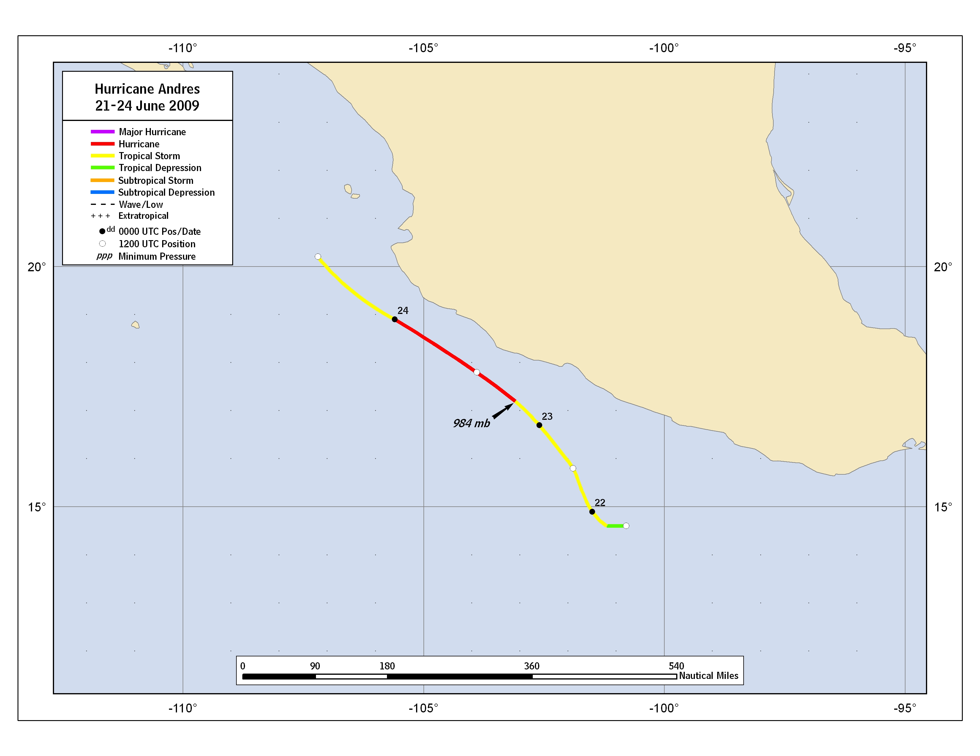
Figure 1. Best track positions for Hurricane Andres, 21-24 June 2009.
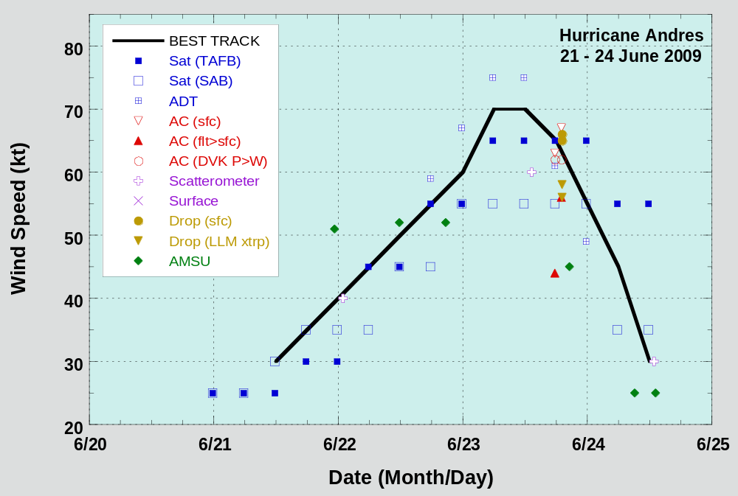

Figure 2. Selected wind observations and best track maximum sustained surface wind speed curve for Hurricane Andres, 21-24 June 2009. Aircraft observations have been adjusted for elevation using 90% adjustment factors for observations from 700 mb. Dropwindsonde observations include actual 10 m winds (sfc), as well as surface estimates derived from the mean wind over the lowest 150 m of the wind sounding (LLM). Advanced Dvorak Technique (ADT) estimates are provided by the Cooperative Institute for Meteorological Satellite Studies (CIMSS). Dashed vertical lines correspond to 0000 UTC.
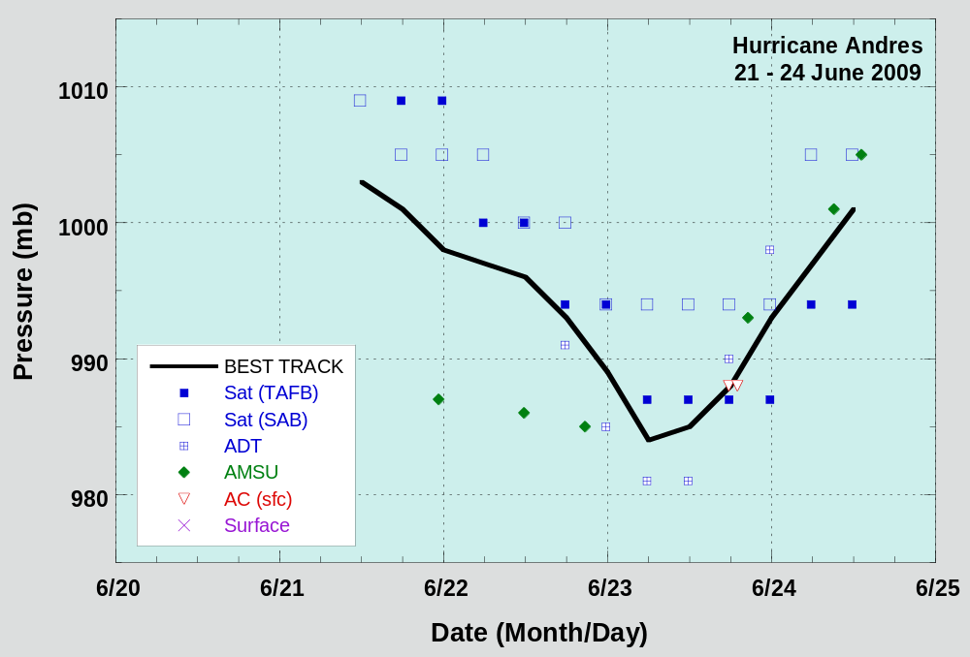

Figure 3. Selected pressure observations and best track minimum central pressure curve for Hurricane Andres, 21-24 June 2009. Advanced Dvorak Technique (ADT) estimates are provided by the Cooperative Institute for Meteorological Satellite Studies (CIMSS). Dashed vertical lines correspond to 0000 UTC.

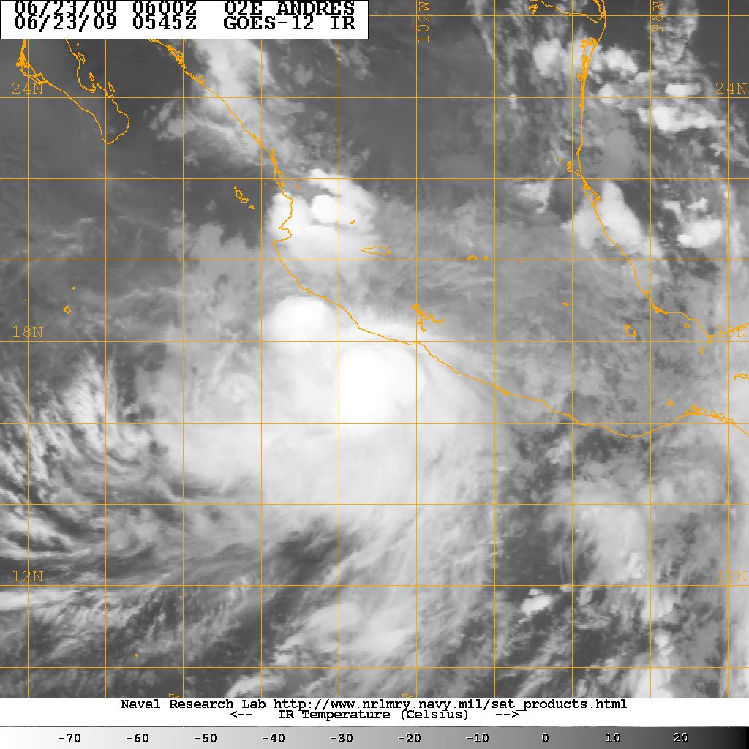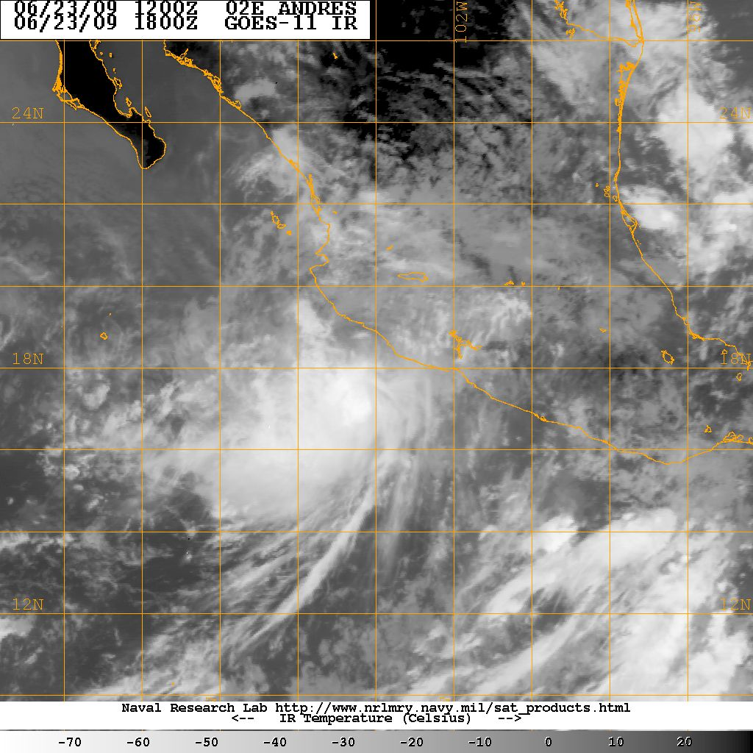

Figure 4. Infrared satellite images of Andres at 0545 UTC 23 June (left) and 1800 UTC 23 June (right). Images courtesy of the Naval Research Laboratory (NRL).

A digital record of the complete best track, including wind radii, can be found on line at ftp://ftp.nhc.noaa.gov/atcf. Data for the current year’s storms are located in the btk directory, while previous years’ data are located in the archive directory.

