Tropical Cyclone Report
Hurricane Ophelia
6-17 September 2005

Jack Beven and Hugh D. Cobb, III
National Hurricane Center
24 January 2006
Updated track near Nova Scotia 14 June 2006

Hurricane Ophelia was a category 1 hurricane on the Saffir-Simpson Hurricane Scale that brushed the North Carolina Outer Banks, its center staying just offshore from that coast. The storm’s erratic and slow movement in the vicinity of the North Carolina coastline was similar to Hurricanes Bonnie in August 1998 and Dennis in August 1999.

- Synoptic History

Ophelia formed from a non-tropical weather system. A cold front moved off the eastern coast of the United States on 1 September. The front moved southeastward and became part of an elongated trough of low pressure that extended from Tropical Depression Lee east of Bermuda to near the Florida Peninsula. Two areas of low pressure formed in the trough on 4 September. The eastern low, south of Bermuda, eventually became Hurricane Nate. The western low, near the Bahamas, became Ophelia.

The pre-Ophelia low initially drifted southward. It began a northward drift on 5 September while the associated shower activity became better organized. Based on satellite, surface, and radar observations, it is estimated the low became a tropical depression near 0600 UTC 6 September between Andros and Grand Bahama Islands. The “best track” chart of the tropical cyclone’s path is given in Fig. 1, with the wind and pressure histories shown in Figs. 2 and 3, respectively. The best track positions and intensities are listed in Table 1.

The depression moved generally northward, with the broad circulation center crossing Grand Bahama about 1600 UTC 6 September. It then moved north-northwestward parallel to the east coast of Florida, reaching a position about 70 n mi east-northeast of Cape Canaveral on 7 September. The cyclone became a tropical storm early on 7 September, and gradual strengthening would occur during the next 24 h as Ophelia made a slow counter-clockwise loop off the Florida east coast. Steering currents were very weak at this time, as Ophelia remained embedded in a broad trough that extended from Hurricane Maria east of Bermuda through the developing Nate and Ophelia and across Florida.

Ophelia was briefly a hurricane late on 8 September, with the cyclone weakening back to a tropical storm about 6 h later. A similarly short-lived hurricane phase occurred late on 9 September while Ophelia moved east-northeastward away from Florida. Ophelia became a hurricane for a third time on 10 September, this time holding hurricane status for 36 hours. The cyclone made a slow clockwise loop on 11-12 September, and it is possible that weakening back to a tropical storm on 12 September was due to Ophelia passing over its wake of upwelled cooler water. After completing the loop, the storm drifted northwestward on 13 September.

Ophelia moved slowly northward early on 14 September and became a hurricane for the fourth time. A gradual turn toward the north-northeast brought the northern portion of the 50 n mi wide eye over the coast of North Carolina near Cape Fear later that day, although the actual center of circulation stayed offshore. Ophelia moved generally east-northeastward parallel to the North Carolina coast for much of 14-15 September, with the northern eyewall passing over the coastal area from Wilmington to Morehead City. During this time, the hurricane reached its peak intensity of 75 kt, although these winds remained offshore.

Ophelia turned eastward late on 15 September while passing south of Cape Hatteras. A combination of increasing vertical shear and dry air intrusion caused weakening, and Ophelia became a tropical storm early on 16 September. As an upper-level trough and associated surface front approached from the west, the storm turned northeastward and accelerated late on 16 September. This motion brought the center about 60 n mi southeast of the Massachusetts coast on 17 September, then over eastern Nova Scotia and Newfoundland on 18 September. Ophelia gradually lost organization during this period, and it became extratropical early on 18 September. As an extratropical low, Ophelia moved east-northeastward across the Atlantic on 19-20 September, then northeastward on 21-22 September. The cyclone dissipated over the North Sea on 23 September.

- Meteorological Statistics

Observations in Ophelia (Figs. 2 and 3) include satellite-based Dvorak technique intensity estimates from the Tropical Analysis and Forecast Branch (TAFB), the Satellite Analysis Branch (SAB) and the U. S. Air Force Weather Agency (AFWA), as well as flight-level and dropwindsonde observations from flights of the 53rd Weather Reconnaissance Squadron of the U. S. Air Force Reserve Command and the NOAA Aircraft Operations Center. Microwave satellite imagery from NOAA polar-orbiting satellites, the NASA Tropical Rainfall Measuring Mission (TRMM), the NASA Aqua, the NASA QuikSCAT, the Department of Defense WindSat, and Defense Meteorological Satellite Program (DMSP) satellites were also useful in tracking Ophelia.

The Air Force Reserve and NOAA Hurricane Hunter aircraft made 105 center fixes during Ophelia’s lifetime. The maximum flight-level winds observed during the storm were 91 kt from a NOAA aircraft at 700 mb at 2124 UTC 11 September. While these winds would support surface winds of 80 kt using the normal 90% adjustment from 700 mb, the maximum surface winds the Stepped Frequency Microwave Radiometer (SFMR) were during the flight were only 64 kt. Winds from other flight-levels and dropsondes near that time also suggest surface winds closer to 65 kt. The peak intensity of 75 kt on 11 September is based on 85 kt winds at 700 mb at 0615 UTC that day, supported by a dropsonde wind of 80-kt at 13 m at 0434 UTC. The second peak intensity of 75 kt on 14-15 September is based on multiple occurrences of 80-85 kt winds at 700 mb, along with SFMR observations of 75-80 kt winds. A notable aircraft observation was a 74 kt wind at 925 mb on 16 September measured by the first ever successful Aerosonde robotic aircraft mission into the core of a tropical cyclone. The lowest aircraft-observed central pressure was 976 mb at 1218 UTC 10 September.

Ship reports of winds of tropical storm force associated with Ophelia are given in Table 2. The most noteworthy observations include a report of 64-kt winds from the Sanmar (call sign V2EX) at 0000 UTC 15 September, and a report of 62-kt winds from the Maersk New Orleans (call sign ELZY3) at 0600 UTC 14 September. Both ships were about 85 n mi east-northeast of the center at those times. A pair of drifting buoys reported winds of 70 kt and 62 kt, although the accuracy of these reports is uncertain.

Ophelia brought hurricane conditions to portions of the North Carolina coast; selected surface observations from land stations and data buoys are given in Table 3. The strongest reported winds were from the Coastal Marine Automated Network (C-MAN) Station at Cape Lookout, which reported 2-min average winds of 65 kt (9.8-m elevation) at 2309 UTC 14 September with a gust to 80 kt. The National Ocean Service (NOS) station at Wrightsville Beach reported 6-min average winds of 59 kt at 1700 UTC 14 September with a gust of 69 kt. There was an unofficial report of a gust of 90 kt in Davis.

Ophelia also brought tropical-storm force winds to portions of the east-central coast of Florida and the northeastern coast of South Carolina. A NASA station at Cape Canaveral reported sustained winds of 34 kt at 1520 UTC 8 September with a gust of 52 kt. Myrtle Beach, South Carolina reported a gust of 38 kt.

The lowest pressure observed by a coastal station or buoy was 980.7 mb at the Frying Pan Shoals, North Carolina C-MAN station at 1300 UTC 14 September. The nearby NOAA buoy 41013 measured a 980.8 mb pressure three hours earlier as the large eye drifted across both stations. The NOS station at Wrightsville Beach measured a 984.9 mb pressure at 1854 UTC 14 September.

Ophelia caused storm surges of 4 to 6 ft above normal tide levels in the Pamlico Sound including the lower reaches of the Neuse, Pamlico, and Newport Rivers. Surges of 4 to 6 ft also occurred along the open coasts in Onslow and Cataret counties. Storm surges of 3 to 4 ft above normal tide levels were common elsewhere along the affected areas of the North Carolina coast. Ophelia also caused tides of 1 to 2 ft above normal along the Florida coast.

Ophelia’s slow movement near the North Carolina coast helped produce locally heavy rains. The water treatment plant at Oak Island reported a storm-total rainfall of 17.50 in, while the Remote Automated Weather Stations (RAWS) station at the Nature Conservancy reported 11.74 inches.

No tornadoes have been reported with Ophelia.

- Casualty and Damage Statistics

One death was directly associated with Ophelia – a drowning in high surf in Palm Beach County, Florida. One death was indirectly associated with Opehlia after it became extratropical – a fall from a roof during rain in Nova Scotia.

The American Insurance Services Group estimates the property damage from Ophelia at $35 million. Applying a doubling of this to cover damage to uninsured property yields a total damage estimate of $70 million. It should be noted that the Insurance Information Institute originally provided an estimate of $800 million in damage, which was the basis for the $1.6 billion reported in the annual summary released by the Tropical Prediction Center in December. This figure was an estimate of damage by a model, not an actual report of damage claims.

- Forecast and Warning Critique

Average official track errors (with the number of cases in parentheses) for Ophelia were 23 (44), 38 (42), 53 (40), 68 (38), 103 (34), 157 (30), and 200 (26) n mi for the 12, 24, 36, 48, 72, 96, and 120 h forecasts, respectively. These errors are considerably lower than the average official track errors for the 10-yr period 1995-2004 (42, 75, 107, 138, 202, 236, and 310 n mi, respectively), with the Ophelia errors being about 50% less than the average from 12-72 hr (Table 4). The official forecasts were quite good in depicting the overall slow motion of Ophelia and the turn toward the west on 12-13 September. However, there were some larger errors for forecasts on 11-12 September that resulted from forecasting too fast of a northeastward motion as Ophelia passed near North Carolina.

The consensus models CONU, GUNS, and GUNA had lower track forecast errors than the official forecast at all times. Amongst the dynamical models, the ensemble mean of the National Weather Service Global Forecasting System had errors lower than the official forecast from 12-48 hr, while the United Kingdom Meteorological Office global model had lower errors than the official forecast at 96 and 120 hr.

Average official intensity errors were 5, 6, 8, 8, 8, 14, and 21 kt for the 12, 24, 36, 48, 72, 96, and 120 h forecasts, respectively. For comparison, the average official intensity errors over the 10-yr period 1995-2004 are 6, 10, 12, 15, 18, 20, and 22 kt, respectively. The intensity forecasts were accurate in predicting that Ophelia’s strengthening would be limited. Some errors resulted from the timing of the storm’s intensity cycles, while others resulted from landfall forecasts that did not verify.

Table 5 shows the coastal watches and warnings issued for Ophelia.

The development of Ophelia was fairly well forecast in TPC products. The surface trough that spawned both Ophelia and Nate was noted in the Tropical Weather Outlook (TWO) on 2 September, and the potential for Ophelia to develop was noted in both the TWO and the TAFB danger graphic product on 4 September.

Acknowledgements

Much of the data for this report was supplied by the National Weather Service WFOs in Melbourne and Jacksonville, Florida, Wilmington and Morehead City, North Carolina, and Charleston, South Carolina. Chris Fogarty of the Canadian Hurricane Center provided data showing that Ophelia made landfall in Nova Scotia as an extratropical low. NOAA buoy and C-MAN data were provided by the National Data Buoy Center, and were augmented by data from the Skidaway Institute of Oceanography, the Carolinas Coastal Ocean Observing and Prediction System (CARO-COOPS), the Coastal Ocean Research and Monitoring Program (CORMP), and the Gulf of Maine Ocean Observing System (GOMOOS). NOS data were provided by the NOAA National Ocean Service. Remote Automated Weather Stations (RAWS) data were provided by the National Interagency Fire Center. Much of the track for the extratropical portion of Ophelia was provided by the Ocean Prediction Center. Several of the unofficial observations were obtained from the Weather Underground web site.

Table 1. Best track for Hurricane Ophelia, 6-17 September 2005. East longitudes are expressed as negative numbers.
Date/Time  (UTC) | Latitude  (ºN) | Longitude  (ºW) | Pressure  (mb) | Wind Speed  (kt) | Stage
06 / 0600 | 25.8 | 78.6 | 1009 | 25 | tropical depression
06 / 1200 | 26.3 | 78.3 | 1010 | 25 | “
06 / 1800 | 26.8 | 78.3 | 1010 | 25 | “
07 / 0000 | 27.4 | 78.5 | 1006 | 30 | “
07 / 0600 | 27.9 | 78.8 | 1003 | 35 | tropical storm
07 / 1200 | 28.7 | 79.2 | 1000 | 40 | “
07 / 1800 | 28.8 | 79.3 | 997 | 45 | “
08 / 0000 | 28.8 | 79.3 | 994 | 45 | “
08 / 0600 | 28.7 | 79.6 | 994 | 50 | “
08 / 1200 | 28.6 | 79.6 | 988 | 55 | “
08 / 1800 | 28.6 | 79.5 | 988 | 60 | “
09 / 0000 | 28.6 | 79.3 | 990 | 65 | hurricane
09 / 0600 | 28.9 | 79.3 | 990 | 55 | tropical storm
09 / 1200 | 29.3 | 79.1 | 983 | 55 | “
09 / 1800 | 29.8 | 78.5 | 983 | 65 | hurricane
10 / 0000 | 30.2 | 77.5 | 983 | 60 | tropical storm
10 / 0600 | 30.9 | 76.9 | 984 | 60 | “
10 / 1200 | 31.5 | 76.6 | 976 | 65 | hurricane
10 / 1800 | 31.7 | 76.2 | 977 | 70 | “
11 / 0000 | 31.8 | 75.9 | 977 | 70 | “
11 / 0600 | 31.7 | 75.9 | 978 | 75 | “
11 / 1200 | 31.6 | 75.7 | 978 | 70 | “
11 / 1800 | 31.4 | 75.9 | 978 | 65 | “
12 / 0000 | 31.2 | 76.2 | 980 | 60 | tropical storm
12 / 0600 | 31.2 | 76.6 | 985 | 60 | “
12 / 1200 | 31.5 | 76.9 | 988 | 55 | “
12 / 1800 | 31.7 | 77.3 | 989 | 60 | “
13 / 0000 | 31.8 | 77.7 | 989 | 60 | “
13 / 0600 | 31.9 | 77.9 | 990 | 60 | “
13 / 1200 | 32.1 | 78.0 | 989 | 60 | “
13 / 1800 | 32.3 | 78.1 | 988 | 60 | “
14 / 0000 | 32.6 | 78.1 | 985 | 65 | hurricane
14 / 0600 | 32.9 | 78.0 | 980 | 70 | “
14 / 1200 | 33.4 | 77.7 | 980 | 75 | “
14 / 1800 | 33.9 | 77.5 | 979 | 75 | “
15 / 0000 | 34.2 | 76.9 | 979 | 75 | “
15 / 0600 | 34.5 | 76.3 | 982 | 70 | “
15 / 1200 | 34.7 | 75.8 | 984 | 65 | “
15 / 1800 | 34.7 | 75.6 | 986 | 65 | “
16 / 0000 | 34.6 | 75.1 | 987 | 60 | tropical storm
16 / 0600 | 34.7 | 74.8 | 993 | 55 | “
16 / 1200 | 35.4 | 74.4 | 995 | 50 | “
16 / 1800 | 36.4 | 73.6 | 993 | 55 | “
17 / 0000 | 37.3 | 72.7 | 995 | 55 | “
17 / 0600 | 38.7 | 71.4 | 1000 | 50 | “
17 / 1200 | 40.0 | 69.7 | 997 | 50 | “
17 / 1800 | 41.6 | 67.3 | 995 | 50 | “
18 / 0000 | 43.2 | 64.9 | 996 | 45 | extratropical
18 / 0600 | 44.8 | 62.6 | 1000 | 45 | “
18 / 1200 | 46.2 | 59.9 | 1000 | 45 | “
18 / 1800 | 47.4 | 56.2 | 999 | 45 | “
19 / 0000 | 48.4 | 52.3 | 1000 | 45 | “
19 / 0600 | 49.0 | 48.8 | 1001 | 45 | “
19 / 1200 | 49.5 | 45.7 | 1000 | 45 | “
19 / 1800 | 50.0 | 42.1 | 999 | 45 | “
20 / 0000 | 50.9 | 38.5 | 998 | 45 | “
20 / 0600 | 51.5 | 34.7 | 1000 | 40 | “
20 / 1200 | 52.2 | 30.5 | 1003 | 40 | “
20 / 1800 | 52.8 | 26.5 | 1001 | 40 | “
21 / 0000 | 53.8 | 22.0 | 998 | 40 | “
21 / 0600 | 55.3 | 17.7 | 998 | 35 | “
21 / 1200 | 57.6 | 14.6 | 998 | 35 | “
21 / 1800 | 59.8 | 11.9 | 996 | 35 | “
22 / 0000 | 61.7 | 8.4 | 993 | 35 | “
22 / 0600 | 63.6 | 4.5 | 993 | 35 | “
22 / 1200 | 65.6 | 1.0 | 994 | 35 | “
22 / 1800 | 67.5 | -1.9 | 995 | 30 | “
23 / 0000 | 68.8 | -6.6 | 997 | 30 | “
23 / 0600 |  |  |  |  | dissipated
06 / 1600 | 26.6 | 78.3 | 1010 | 25 | landfall on Grand Bahama Island
10 / 1200 | 31.5 | 76.6 | 976 | 65 | minimum pressure
14 / 1200 | 33.4 | 77.7 | 980 | 75 | maximum wind

Table 2. Selected ship and drifting buoy reports with winds of at least 34 kt for Hurricane Ophelia, 6-17 September 2005.
Date/Time (UTC) | Ship name/call sign | Latitude  (ºN) | Longitude  (ºW) | Wind  dir/speed (kt) | Pressure  (mb)
07 / 0100 | Lykes Liberator | 32.6 | 79.3 | 060 / 36 | 1016.5
07 / 1000 | CSX Discovery | 29.6 | 79.8 | 040 / 37 | 1008.0
07 / 1100 | CSX Discovery | 29.3 | 79.4 | 060 / 37 | 1006.0
07 / 1200 | P&O Nedlloyd Marseille | 33.3 | 76.8 | 090 / 38 | 1018.4
07 / 1800 | DSR Port Said | 33.5 | 77.2 | 040 / 35 | 1018.5
08 / 0600 | Leverkusen Express | 28.9 | 77.4 | 130 / 35 | 1010.0
08 / 1200 | Madison Maersk | 31.0 | 78.8 | 050 / 39 | 1013.0
08 / 1600 | Asphalt Commander | 29.5 | 77.5 | 190 / 50 | 1006.0
09 / 0000 | CSX Producer | 28.6 | 79.0 | 170 / 60 | 995.5
09 / 0300 | Buoy 41542 | 29.0 | 78.1 | *** / 54 | 1006.3
09 / 1100 | Lykes Navigator | 30.9 | 78.7 | 040 / 43 | 1007.0
09 / 1200 | Lykes Navigator | 31.2 | 78.7 | 030 / 44 | 1018.5
09 / 1800 | Paris Express | 31.9 | 79.9 | 020 / 41 | 1011.0
09 / 2100 | 9V6488 | 30.0 | 80.6 | 010 / 35 | 1010.0
09 / 2100 | Buoy 41542 | 29.4 | 77.8 | *** / 35 | 1000.8
09 / 2152 | Buoy 41934 | 28.9 | 76.3 | *** / 41 | 1007.2
09 / 2300 | Bonn Express | 30.4 | 76.9 | 130 / 45 | 1001.8
10 / 1800 | Star Istind | 32.8 | 76.2 | 050 / 44 | 1009.0
10 / 1800 | Singapore Bay | 33.7 | 74.8 | 090 / 40 | 1010.6
10 / 2100 | Green Dale | 33.7 | 77.0 | 040 / 40 | 1013.0
10 / 2200 | Singapore Bay | 32.2 | 74.8 | 260 / 39 | 1003.4
11 / 0019 | Buoy 41935 | 31.2 | 76.3 | *** / 62 | 1002.0
11 / 0236 | Buoy 41935 | 31.2 | 76.3 | *** / 70 | 1002.8
11 / 1700 | Fortune Pioneer I | 34.3 | 71.3 | 080 / 44 | 1021.0
11 / 2100 | Jens Maersk | 29.6 | 75.1 | 230 / 40 | 1010.5
11 / 2100 | OOCL Freedom | 33.6 | 77.1 | 030 / 47 | 1013.0
12 / 0600 | Shanghai Express | 29.9 | 78.4 | 320 / 35 | 1011.8
12 / 0600 | ZCAM5 | 31.5 | 74.6 | 130 / 37 | 1009.5
12 / 1800 | Sealand Performance | 33.6 | 77.2 | 080 / 43 | 1007.5
12 / 2100 | Sealand Performance | 34.1 | 76.6 | 090 / 42 | 999.8
13 / 0000 | Overseas New Orleans | 33.1 | 78.1 | 050 / 45 | 1005.2
13 / 0600 | Sealand Liberator | 31.5 | 77.4 | 200 / 50 | 994.0
13 / 1800 | OOCL Freedom | 33.7 | 77.0 | 120 / 35 | 1007.5
14 / 0000 | WABU | 31.1 | 77.2 | 230 / 37 | 1006.4
14 / 0600 | Montebello | 31.4 | 77.7 | 240 / 51 | 1003.0
14 / 0600 | Maersk New Orleans | 32.4 | 76.5 | 160 / 62 | 1003.0
15 / 0000 | Sanmar | 34.5 | 75.3 | 150 / 64 | 1004.5
15 / 0300 | Sanmar | 34.3 | 75.2 | 210 / 51 | 1004.0
15 / 1200 | Jens Maersk | 32.8 | 74.5 | 180 / 35 | 1011.1
15 / 1500 | SHIP | 33.5 | 75.5 | 210 / 51 | 1007.0
16 / 0000 | HPII | 33.4 | 73.3 | 190 / 40
17 / 0000 | ZDGR8 | 33.3 | 72.7 | 190 / 45 | 1015.6
17 / 0600 | V7DI7 | 36.2 | 69.6 | 210 / 36 | 1016.2
17 / 1800 | Afhankelijk | 40.9 | 65.7 | 190 / 45 | 1003.6
17 / 1900 | German Senator | 41.8 | 62.1 | 260 / 37

Table 3. Selected surface observations for Hurricane Ophelia, 6-17 September 2005.
Location | Minimum Sea Level Pressure |  | Maximum Surface  Wind Speed |  |  | Storm surge  (ft)^{c} | Storm  tide  (ft)^{d} | Total  rain  (in)
Location | Date/  time  (UTC) | Press.  (mb) | Date/  time  (UTC)ª | Sustained  (kt)^{b} | Gust  (kt) | Storm surge  (ft)^{c} | Storm  tide  (ft)^{d} | Total  rain  (in)
Florida
Bings Landing (NOS) | 09/0900 | 1009.5 |  |  |  | 1.55
Cape Canaveral  (NASA Wind Tower 394) |  |  | 08/1520 | 34 | 52
Fernandina Beach (NOS) | 09/0900 | 1010.7 | 09/1000 | 16 | 28 | 1.65
Mayport (KNRB) | 09/0826 | 1009.5 | 08/0412 | 28 | 34
Mayport (NOS) | 09/0824 | 1010.1 | 08/1018 |  | 37 | 3.03
Melbourne (NWS) |  |  |  |  |  |  |  | 1.96
NAS Jacksonville (KNIP) | 09/0848 | 1010.2 | 08/1838 | 33
NASA Shuttle Landing Facility (KTTS) | 08/0855 | 1006.4 | 08/1855 | 19 | 38 |  |  | 2.79
New Smyrna Beach (KEVB) | 09/1055 | 1008.8 | 08/2250 | 31 | 40
Patrick AFB (KCOF) | 08/1955 | 1006.1 | 08/1955 | 25 | 36 |  |  | 2.03
St. Augustine (KSGJ) | 09/0815 | 1008.8 | 07/1255 | 26 | 34
Vilano Beach (NOS) |  |  |  |  |  | 1.93
North Carolina
Back Island (RAWS) |  |  | 14/2315 |  | 55 |  |  | 7.04
Beaufort (KMRH) | 14/2356 | 991.8 | 14/2328 | 37e | 55e |  |  | 4.78
Beaufort (RAWS) |  |  | 15/0615 |  | 39 |  |  | 3.92
Bogue Field (KNJM) | 14/2033 | 993.2
Cape Hatteras (KHSE) | 15/1256 | 993.1 | 15/1256 | 57e | 72e |  |  | 2.85
Cherry Point (KNKT) | 15/0555 | 994.2 | 15/0655 | 37 | 64 |  |  | 4.57
Croatan (RAWS) |  |  | 15/0905 |  | 51 |  |  | 5.43
Elizabeth City (KECG) | 15/0854 | 1008 | 15/1552 | 30 | 39 |  |  | 0.53
Elizabethtown (KEYF) | 14/1820 | 1002.7 |  |  |  |  |  | 1.87
Hoffman Forest (RAWS) |  |  | 15/0105 |  | 41 |  |  | 4.26
Kinston (KISO) |  |  | 15/0643 | 23 | 34
Kenansville (KDPL) |  |  | 14/1903 | 23 | 35
Kitty Hawk (KFFA) |  |  | 15/1540 | 20 | 31
Manteo (KMQI) |  |  | 15/1726 | 28 | 33
Nature Conservancy (RAWS) |  |  | 14/1715 |  | 53 |  |  | 11.74
New Bern (KEWN) | 15/0354 | 1000.0 | 15/0241 | 32 | 44 |  |  | 3.46
New River (KNCA) | 14/2156 | 994.2 | 14/2156 | 38 | 55 |  |  | 5.12
Newport (KMHX) | 15/0420 | 990.5 | 15/0534 | 31 | 49 |  |  | 9.39
Onslow Beach (RSLN7) | 14/2322 | 985.0 | 14/2125 | 53 | 68
Pea Island (PEIN7) | 15/0850 | 1003.0 | 15/1236 |  | 57
Richlands (KOAJ) |  |  | 15/0015 | 30 | 49
Sandy Run (RAWS) |  |  | 15/0015 |  | 40 |  |  | 5.06
Southport (KSUT) | 14/1504 | 988.1 | 14/1824 | 36 | 56 |  |  | 7.38
Stumpy Point (SPON7) | 15/0750 | 1004.0 | 15/0740 |  | 37
Sunset Beach (CARO-COOPS) | 14/1324 | 995.6 | 14/1300 | 33 | 47 | 2.85
Sunny Point (RAWS) |  |  | 14/1815 |  | 59 |  |  | 10.74
Swan Quarter (SWQN7) | 15/0730 | 1000.0 | 15/0856 |  | 49
Turnbull Creek (RAWS) |  |  | 14/1815 |  | 42 |  |  | 2.81
Washington (KOCW) |  |  | 15/0643 | 20 | 33
Whiteville (RAWS) |  |  | 14/1815 |  | 39 |  |  | 3.18
Wilmington (KILM) | 14/1850 | 989.5 | 14/1658 | 42 | 59 |  |  | 8.23
Wrightsville Beach (NOS) | 14/1854 | 984.8 | 14/1700 | 59 | 69 | 4.19
South Carolina
Charleston (KCHS) | 13/2251 | 1006.8 | 13/2334 | 23 | 33 |  |  | 0.06
Charleston Harbor (NOS) |  |  |  |  |  | 1.64
Fripps Inlet (CARO-COOPS) |  |  |  |  |  | 1.78
Myrtle Beach (KMYR) | 14/1050 | 1000.7 | 14/0455 | 25 | 38
North Myrtle Beach (KCRE) | 14/1336 | 999.7 | 14/1253 | 20 | 33 |  |  | 6.30
Oyster Landing (NOS) |  |  |  |  |  | 2.75
South Capers Island (CARO-COOPS) |  |  |  |  |  | 1.74
Springmaid Pier (NOS) | 14/0942 | 1000.5 | 14/1800 | 24 | 37 | 2.81
Georgia
Fort Pulaski (NOS) |  |  |  |  |  | 1.87
Saint Simons Island (KSSI) | 09/0900 | 1011.5 | 09/1546 | 30 |  | 1.44 |  | 1.69
Buoy/CMAN
NOAA Buoy 41001 (34.7N 72.7W) | 15/2300 | 1011.5 | 16/1040 | 28^{f} | 37
NOAA Buoy 41002 (32.3N 75.4W) | 10/2200 | 998.7 | 11/2200 | 49 | 67
NOAA Buoy 41004 (32.5N 79.1W) | 13/2250 | 996.4 | 13/0030 | 45 | 57
NOAA Buoy 41009 (28.5N 80.2W) | 08/1050 | 1002.3 | 08/1750 | 37 | 47
NOAA Buoy 41010 (29.0N 78.5W) | 09/0820 | 1000.1 | 09/1350 | 37 | 49
NOAA Buoy 41012 (30.0N 80.6W) | 09/1100 | 1006.2 | 08/1300 | 30 | 43
NOAA Buoy 41013 (33.4N 77.4W) | 14/1000 | 980.8 | 14/1800 | 54 | 68
CARO-COOPS Buoy 41024 (33.8N 78.5W) | 14/1300 | 994.9 | 14/1500 | 38 | 41
NOAA Buoy 41025 (35.0N 75.4W) | 15/1500 | 988.7 | 15/1707 | 55^{f} | 73
CARO-COOPS Buoy 41030 (32.5N 79.3W) |  |  | 13/2330 | 38 | 45
NOAA Buoy 41035 (34.5N 77.3W) | 14/2120 | 982.0 | 14/2030 | 48^{f} | 62
CORMP Buoy 41038 (34.1N 77.7W) |  |  | 142100 | 50 | 52
NOAA Buoy 44004 (38.5N 70.6W) | 17/0800 | 1001.5 | 17/0730 | 40^{f} | 53
NOAA Buoy 44008 (40.5N 69.4W) | 17/1200 | 1001.1 | 17/1100 | 33 | 43
NOAA Buoy 44014 (36.6N 74.8W) |  |  | 16/1900 | 27^{f} | 35
GOMOOS Buoy 44024 (42.3N 65.9W) | 17/2100 | 996.9 | 17/1900 | 27 | 35
Cape Lookout, NC (CKLN7) | 15/0600 | 981.9 | 14/2309 | 65 | 80
Cedar Island, NC (CITN7) | 15/0840 | 988.0 | 15/0838 |  | 78
Duck, NC (DUCN7) | 15/0930 | 1008.5 | 15/1651 | 34 | 43
Frying Pan Shoals, NC (FPSN7) | 14/1300 | 980.7
Sabsoon Tower R8 (TYBG1) | 13/2136 | 1005.4 | 13/0630 | 38 | 44
Sabsoon Tower R2 (SPAG1) |  |  | 13/0431 | 31 | 35
Sabsoon Tower M2R6  (SKMG1) | 13/1934 | 1007.2 | 13/0234 | 35 | 41
St. Augustine, FL (SAUF1) | 09/0905 | 1008.8 | 09/0105 | 34 | 43
Settlement Point, Grand Bahama (SPGF1) | 08/2300 | 1008.5 | 07/0630 | 25 | 34
Unofficial Observations
Florida
Crescent City (CREF1) |  |  |  |  |  |  |  | 3.02
Deland (COOP) |  |  |  |  |  |  |  | 2.96
Hastings ARC (HTGF1) |  |  |  |  |  |  |  | 3.65
Orange Springs (OSPF1) |  |  |  |  |  |  |  | 1.59
Palm Bay (COOP) |  |  |  |  |  |  |  | 2.11
Palm Coast (WOGF1) |  |  |  |  |  |  |  | 3.95
Ponce Inlet (COOP) |  |  |  |  |  |  |  | 2.65
Scottsmoor (COOP) |  |  |  |  |  |  |  | 2.95
S. Merrit Island (Weather Underground) | 09/2000 | 1005.3 | 09/2050 |  | 34
Starke (SRKF1) |  |  |  |  |  |  |  | 1.16
Titusville (COOP) |  |  |  |  |  |  |  | 2.87
North Carolina
Bald Head Island |  |  |  |  | 73
Cedar Point (Weather Underground) | 14/2330 | 987.7 | 14/1730 |  | 45
Davis |  |  |  |  | 90
Jacksonville (JEON7) |  |  |  |  |  |  |  | 5.79
Jacksonville (Weather Underground) | 14/2130 | 994.8 | 14/2335 |  | 43
Kinston (KNNN7) |  |  |  |  |  |  |  | 3.59
Kure Beach La Que Center |  |  |  |  | 68 |  |  | 6.20
Morehead City |  |  |  |  | 70
Morehead City (waterfront) |  |  |  |  | 74
Morehead City (Weather Underground) | 15/0530 | 986.7 | 15/0100 |  | 45
Oak Island Brunswick Co Water Treatment Plant |  |  |  |  |  |  |  | 17.50
Oak Island (Weather Underground) | 14/1530 | 990.7 | 14/1815 |  | 57
St. James (Weather Underground) | 14/1530 | 985.7 | 14/1330 |  | 62
Southport (Weather Underground) | 14/1600 | 987.0 | 14/1600 |  | 51
Surf City Pender Co NC |  |  |  |  |  |  |  | 7.63
Tranters Creek (TRAN7) |  |  |  |  |  |  |  | 3.98
Wallace (WCEN7) |  |  |  |  |  |  |  | 3.28
Watha (Weather Underground) | 14/1818 | 997.2 | 15/0358 |  | 43
Wilmington (Weather Underground) | 14/1821 | 989.4 | 14/1845 |  | 68
Wrightsville Beach |  |  | 14/1649 |  | 70
Georgia
Woodbine |  |  |  |  |  |  |  | 1.90
South Carolina
Charleston |  |  | 13/1938 | 23 | 34 |  |  | 0.07
Isle of Palms | 13/2330 | 1004.5 | 14/0230 | 22 | 37 |  |  | 0.18
Pineville |  |  | 14/0102 | 19 | 32

ª Date/time is for sustained wind when both sustained and gust are listed.
^{b} Except as noted, sustained wind averaging periods for C-MAN and land-based ASOS reports are 2 min; buoy averaging periods are 8 min.
^{c} Storm surge is water height above normal astronomical tide level.
^{d} Storm tide is water height above National Geodetic Vertical Datum (1929 mean sea level).
^{e} Instrumentation failed
^{f} 10-minute average
Table 4. Preliminary forecast evaluation (heterogeneous sample) for Hurricane Ophelia, 6-17 September 2005. Forecast errors (n mi) are followed by the number of forecasts in parentheses. Errors smaller than the NHC official forecast are shown in bold-face type. Verification includes the depression stage, but does not include the extratropical stage, if any.
Forecast Technique | Forecast Period (h)
Forecast Technique | 12 | 24 | 36 | 48 | 72 | 96 | 120
CLP5 | 39 (45) | 85 (43) | 133 (41) | 163 (39) | 223 (35) | 332 (31) | 462 (27)
GFDI | 25 (42) | 42 (40) | 54 (38) | 75 (36) | 157 (32) | 278 (27) | 383 (23)
GFDL* | 30 (42) | 44 (40) | 59 (38) | 71 (36) | 136 (32) | 252 (27) | 353 (23)
GFNI | 25 (42) | 41 (39) | 64 (37) | 96 (35) | 164 (31) | 278 (26) | 425 (22)
GFDN* | 29 (41) | 46 (39) | 60 (36) | 89 (34) | 153 (30) | 263 (25) | 396 (22)
FV4 | 30 (41) | 62 (40) | 91 (39) | 128 (37) | 237 (33) | 379 (29) | 561 (25)
AF1I | 38 (16) | 68 (16) | 102 (16) | 150 (16) | 294 (16)
AFW1* | 53 (8) | 80 (8) | 105 (8) | 140 (8) | 256 (8)
COAI | 34 (43) | 57 (39) | 86 (37) | 120 (35) | 191 (31)
COAL* | 36 (21) | 59 (20) | 79 (19) | 109 (18) | 177 (16)
COEI | 32 (24) | 60 (24) | 93 (24) | 130 (22)
COCE* | 36 (12) | 60 (12) | 89 (12) | 122 (11)
ETAI | 55 (41) | 112 (39) | 168 (37) | 207 (34) | 318 (23)
ETA* | 50 (41) | 106 (39) | 158 (36) | 207 (30) | 292 (22)
GFSI | 20 (40) | 36 (38) | 55 (36) | 75 (34) | 156 (30) | 278 (26) | 357 (22)
GFSO* | 23 (40) | 34 (38) | 53 (36) | 69 (34) | 133 (30) | 247 (26) | 343 (22)
AEMI | 21 (41) | 35 (39) | 47 (37) | 62 (35) | 129 (31) | 221 (27) | 271 (23)
AEMN* | 22 (41) | 34 (39) | 44 (37) | 53 (35) | 104 (31) | 202 (27) | 255 (23)
NGPI | 24 (45) | 43 (43) | 57 (41) | 74 (39) | 112 (33) | 168 (29) | 275 (25)
NGPS* | 24 (44) | 40 (42) | 54 (40) | 70 (38) | 112 (33) | 167 (29) | 289 (25)
UKMI | 25 (43) | 40 (41) | 52 (39) | 60 (37) | 143 (33) | 129 (29) | 169 (25)
UKM* | 27 (22) | 45 (21) | 50 (20) | 68 (19) | 116 (17) | 129 (15) | 120 (13)
CMC* | 33 (18) | 51 (17) | 69 (16) | 78 (16) | 144 (14) | 271 (6) | 522 (5)
CEMN* | 33 (10) | 44 (9) | 62 (9) | 76 (8) | 122 (7) | 159 (6) | 127 (4)
EMXI | 27 (23) | 49 (22) | 74 (21) | 110 (20) | 198 (18) | 283 (16) | 362 (14)
EMX* | 24 (21) | 44 (20) | 62 (19) | 89 (18) | 167 (16) | 267 (14) | 354 (12)
EEMN* | 42 (10) | 67 (10) | 92 (9) | 128 (9) | 216 (8) | 283 (7) | 238 (4)
A98E | 35 (44) | 55 (42) | 91 (40) | 124 (38) | 227 (34) | 404 (30) | 515 (26)
A9UK | 34 (20) | 52 (20) | 87 (19) | 134 (18) | 246 (16)
BAMD | 30 (43) | 51 (41) | 78 (39) | 111 (37) | 223 (33) | 433 (29) | 653 (25)
BAMM | 34 (43) | 58 (41) | 85 (39) | 105 (37) | 151 (33) | 257 (29) | 382 (25)
BAMS | 49 (43) | 87 (41) | 117 (39) | 142 (37) | 177 (33) | 270 (29) | 385 (25)
LBAR | 29 (45) | 58 (43) | 105 (41) | 181 (39) | 450 (35) | 576 (24) | 592 (13)
CONU | 19 (44) | 30 (42) | 39 (40) | 48 (38) | 93 (33) | 131 (29) | 203 (25)
GUNA | 18 (40) | 29 (38) | 38 (36) | 47 (34) | 96 (30) | 133 (26) | 180 (22)
GUNS | 20 (41) | 32 (39) | 41 (37) | 49 (35) | 99 (30) | 123 (26) | 181 (22)
FSSE | 18 (41) | 28 (39) | 44 (37) | 62 (35) | 115 (31) | 180 (27) | 205 (23)
OHPC | 29 (41) | 43 (39) | 54 (37) | 68 (35) | 101 (31) | 157 (27) | 214 (23)
OFCI | 25 (43) | 42 (41) | 60 (39) | 79 (37) | 118 (33) | 165 (29) | 216 (25)
OFCL | 23 (44) | 38 (42) | 53 (40) | 68 (38) | 103 (34) | 157 (30) | 200 (26)
NHC Official  (1995-2004 mean) | 42 (3400) | 75 (3116) | 107 (2848) | 138 (2575) | 202 (2117) | 236 (649) | 310 (535)
* Output from these models was unavailable at forecast time.
Table 5. Watch and warning summary for Hurricane Ophelia, 6-17 September 2005.
Date/Time (UTC) | Action | Location
6 / 1500 | Tropical Storm Warning issued | Florida east coast from Jupiter to Titusville
6 / 1500 | Tropical Storm Warning issued | Grand Bahama, Abaco and Bimini Islands
7 / 0300 | Tropical Storm Watch issued | Florida east coast from Titusville to Flagler Beach
7 / 0900 | Tropical Storm Watch extended northward | Florida east coast from Flagler Beach to Fernandina Beach
7 / 0900 | Tropical Storm Warning issued | Florida east coast from Sebastian Inlet to Flagler Beach
7 / 0900 | Tropical Storm Warning discontinued | Florida east coast from Jupiter to Sebastian Inlet and the Bahamas
7 / 2100 | Tropical Storm Warning discontinued | Sebastian Inlet to Cocoa Beach
8 / 2100 | Tropical Storm Warning extended | Cocoa Beach to Sebastian Inlet
9 / 1500 | All watches and warnings discontinued | Florida east coast
10 / 1500 | Hurricane Watch issued | Savannah River, South Carolina to Cape Lookout, North Carolina
11 / 0900 | Hurricane Watch  discontinued | South Carolina coast from Savannah River to Edisto Beach
11 / 2100 | Tropical Storm Warning issued | South Santee River, South Carolina to Cape Lookout, North Carolina
12 / 0900 | Tropical Storm Warning extended | South Carolina coast from South Santee River to Edisto Beach
13 / 0300 | Hurricane Warning issued | South Santee River, South Carolina to Cape Lookout, North Carolina
13 / 0300 | Tropical Storm Warning issued | North Carolina coast from Cape Lookout to Oregon Inlet including Pamlico Sound
13 / 0900 | Hurricane Watch issued | North Carolina coast from Cape Lookout to Oregon Inlet including Pamlico Sound
13 / 2100 | Hurricane Warning issued | North Carolina coast from Cape Lookout to Cape Hatteras
13 / 2100 | Hurricane Watch and Tropical Storm Warning issued | North Carolina coast from Oregon Inlet to NC/VA border
13 / 2100 | Tropical Storm Watch issued | Virginia coast from the NC/VA border to Cape Charles Light
13 / 2200 | Hurricane Warning extended | North Carolina coast from Cape Hatteras to Oregon Inlet including Pamlico Sound
14 / 1500 | Hurricane Warning issued | Oregon Inlet to NC/VA border including Albemarle Sound
14 / 1500 | Hurricane Watch and Tropical Storm Warning issued | Virginia coast from the NC/VA border to Cape Charles Light including lower Chesapeake Bay
14 / 1500 | Hurricane Warning discontinued | South Carolina coast from South Santee River to Little River
14 / 1500 | Tropical Storm Warning discontinued | South Carolina coast south of South Santee River
14 / 1500 | Hurricane Watch discontinued | South Carolina coast from Edisto Beach to Little River Inlet
14 / 2100 | Tropical Storm Warning discontinued | South Carolina coast
15 / 0300 | Hurricane Warning changed to Tropical Storm Warning | North Carolina coast from Cape Fear to Surf City
15 / 0300 | Hurricane Warning discontinued | South of Cape Fear, North Carolina
15 / 0900 | Hurricane Watch discontinued | Virginia coast from the NC/VA border to Cape Charles Light including lower Chesapeake Bay
15 / 0900 | Tropical Storm Warning discontinued | North Carolina coast from Cape Fear to Surf City
15 / 2100 | Tropical Storm Watch issued | Massachuestts coast from Woods Hole to Plymouth including Martha’s Vineyard and Nantucket
15 / 2100 | Hurricane warning changed to Tropical Storm Warning | Cape Lookout to Cape Charles Light
16 / 0300 | Tropical Storm Watch extended | Plymouth, Massacuusetts to Point Judith, Rhode Island
16 / 0300 | Tropical Storm Warning discontinued | Virginia coast from the NC/VA Border to Cape Charles Light including lower Chesapeake Bay
16 / 0900 | Tropical Storm Watch issued | Nova Scotia from Yarmouth to Lunenburg
16 / 1500 | Tropical Storm Warning issued | Watch Hill, Rhode Island to Plymouth, Massachuestts
16 / 1500 | All warnings discontinued | North Carolina coast
16 / 2100 | Tropical Storm Watch issued | Nova Scotia from Yarmouth to Halifax
17 / 0300 | Tropical Storm Warning issued | Nova Scotia from Yarmouth to Lunenberg
17 / 0300 | Tropical Storm Watch extended | Nova Scotia from Yarmouth to Truno
17 / 0300 | Tropical Storm Watch extended | Nova Scotia from Lunenberg to Street Harbour
17 / 0300 | Tropical Storm Warning discontinued | Watch Hill, Rhode Island to Westport, Massachusetts
17 / 0900 | Tropical Storm Warning discontinued | Massachusetts coast from Westport to Woods Hole
17 / 1200 | Tropical Storm Warning issued | Nova Scotia except Cumberland and Colchester
17 / 1200 | Tropical Storm Watch issued | Prince Edward Island
17 / 1200 | Tropical Storm Watch issued | Nova Scotia from Cumberland to Colchester
17 / 1500 | All warnings discontinued | Massachusetts coast

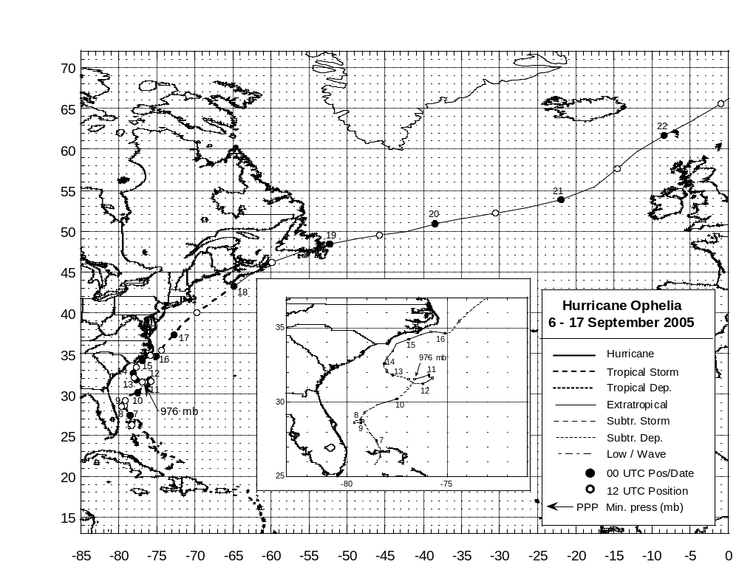
Figure 1. Best track positions for Hurricane Ophelia, 6 – 17 September 2005. Track during the extratropical stage is based on analyses from the NOAA Ocean Prediction Center.
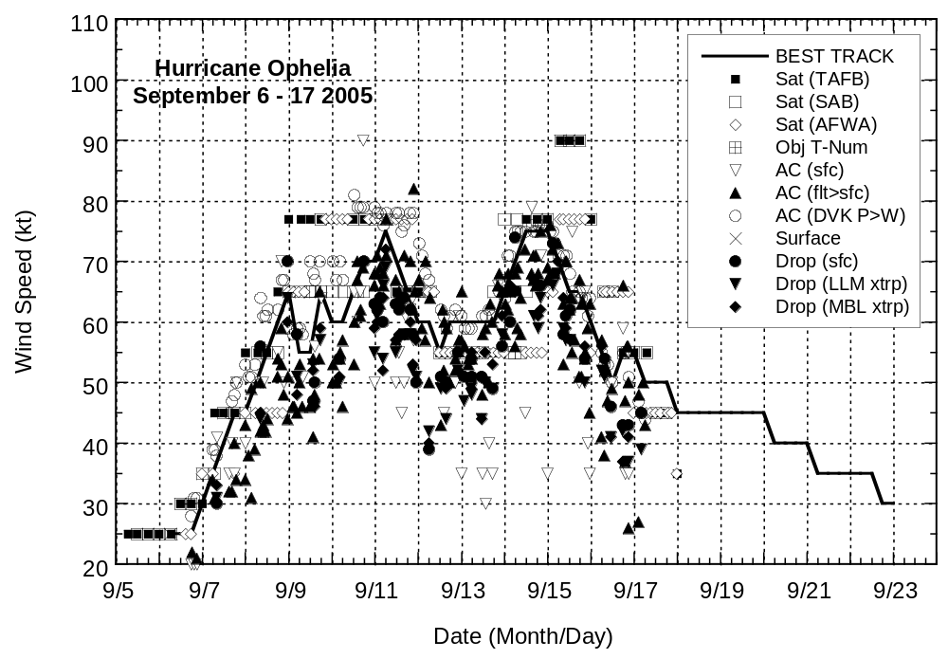
Figure 2. Selected wind observations and best track maximum sustained surface wind speed curve for Hurricane Ophelia, 6-17 September 2005. Aircraft observations have been adjusted for elevation using 90%, 80%, and 80% reduction factors for observations from 700 mb, 850 mb, and 1500 ft, respectively. Dropwindsonde observations include actual 10 m winds (sfc), as well as surface estimates derived from the mean wind over the lowest 150 m of the wind sounding (LLM), and from the sounding boundary layer mean (MBL). Objective Dvorak estimates represent averages over a three-hour period centered on the nominal observation time. Estimates during the extratropical stage are based on analyses from the NOAA Ocean Prediction Center.
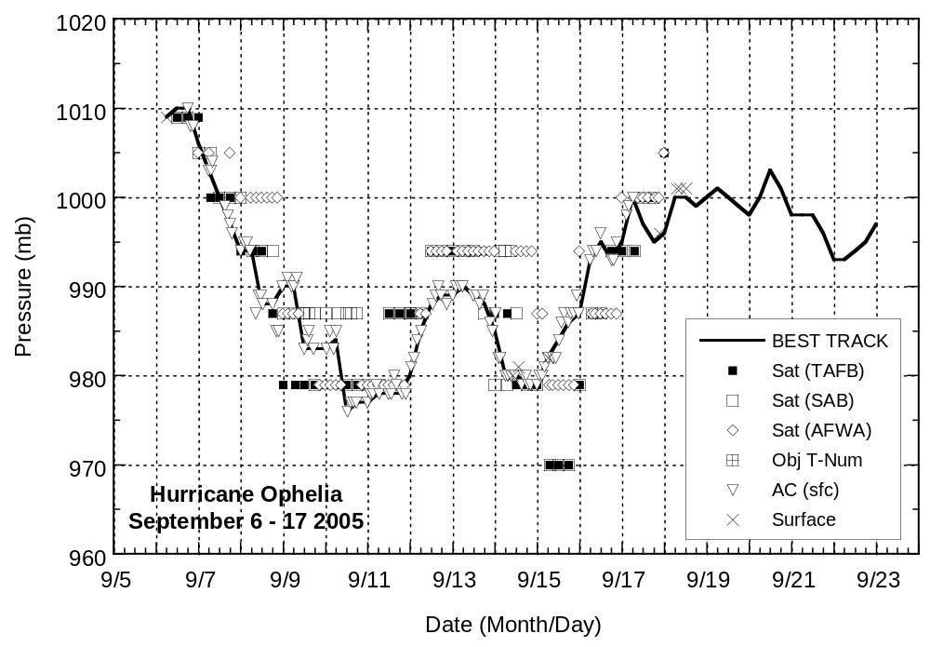
Figure 3. Selected pressure observations and best track minimum central pressure curve for Hurricane Ophelia, 6-17 September 2005. Objective Dvorak estimates represent averages over a three-hour period centered on the nominal observation time. Estimates during the extratropical stage are based on analyses from the NOAA Ocean Prediction Center.

Errors given for the 96 and 120 h periods are averages over the four-year period 2001-4.

