Tropical Cyclone Report
Tropical Storm Henri
(AL102009)
6-8 October 2009

Eric S. Blake
National Hurricane Center
17 November 2009

Henri was a short-lived tropical storm over the tropical Atlantic Ocean that dissipated due to strong vertical shear.

- Synoptic History

Henri was spawned from a tropical wave that left the west coast of Africa on 1 October. During the next couple of days, disorganized showers and thunderstorms occurred intermittently near the wave axis. On 4 October, convection increased over a large area around the wave and a broad low formed. Continuing westward, the low became better defined late on 5 October, as shown by satellite and ASCAT data. Although the deep convection was displaced to the east of the center, the system acquired enough organization to be considered a tropical depression near 0000 UTC 6 October while the system was centered about 675 n mi east of the Lesser Antilles. The “best track” chart of the Henri’s path is given in Figure 1, and the best track positions and intensities are listed in Table 1.

The depression moved to the west-northwest and became a tropical storm six hours after formation, but the center remained on the western edge of the associated deep convection due to southwesterly shear. Thunderstorms near the center increased in a bursting pattern early on 7 October, resulting in some strengthening, and Henri reached a peak intensity of 45 kt around 0600 UTC. Vertical wind shear increased, however, causing the center to become exposed later that day, and steady weakening then occurred. With all of its convection in the eastern semicircle and well-removed from the center, Henri weakened to a tropical depression near 0600 UTC 8 October, and twelve hours later degenerated to a remnant low about 135 n mi north-northeast of Anguilla. The remnant low moved west-northwestward for a day or so before high pressure built in over the western Atlantic Ocean. This synoptic feature caused a west-southwestward motion of the low for a couple of days before the circulation was distorted by the high terrain of Hispaniola, resulting in dissipation of the low.

- Meteorological Statistics

Observations in Henri (Figs. 2 and 3) include satellite-based Dvorak technique intensity estimates from the Tropical Analysis and Forecast Branch (TAFB) and the Satellite Analysis Branch (SAB). Data and imagery from NOAA polar-orbiting satellites including the Advanced Microwave Sounding Unit (AMSU) instrument, the NASA Tropical Rainfall Measuring Mission (TRMM), the NASA QuikSCAT, ASCAT and Defense Meteorological Satellite Program (DMSP) satellites, among others, were also useful in constructing the best track of Henri.

The estimated peak intensity of 45 kt of Henri is based on Dvorak satellite classifications.

There were no ship reports of winds of tropical storm force or reports of damage or casualties associated with Henri.

- Forecast and Warning Critique

The genesis of Henri was not well forecast. Although its incipient wave was introduced in the Tropical Weather Outlook about 36 h before genesis, the formation probability never reached the medium (30-50% percent) category. The global models showed some development associated with the system but failed to show tropical cyclogenesis.

A verification of NHC official track forecasts for Henri is given in Table 2a. Official forecast track errors were a little lower than the mean official errors for the previous five-year period at 12 h, near the mean at 24 h and higher than the mean at 36 h. A homogeneous comparison of the official track errors with selected guidance models is given in Table 2b. The official forecasts were better than most of the available guidance, but the sample sizes are too small to draw any significant conclusions.

A verification of NHC official intensity forecasts for Henri is given in Table 3a. Official forecast intensity errors were considerably lower than the mean official errors for the previous five-year period. A homogeneous comparison of the official track errors with selected guidance models is given in Table 3b. The official forecasts correctly predicted that Henri would dissipate faster than indicated by the numerical models; this contributed to the generally outstanding intensity forecasts for this storm.

Table 1. Best track for Tropical Storm Henri, 6-8 October 2009.

Date/Time  (UTC) | Latitude  (°N) | Longitude  (°W) | Pressure  (mb) | Wind Speed  (kt) | Stage
06 / 0000 | 15.1 | 49.2 | 1008 | 30 | tropical depression
06 / 0600 | 16.1 | 50.5 | 1007 | 35 | tropical storm
06 / 1200 | 17.0 | 51.9 | 1007 | 35 | "
06 / 1800 | 17.6 | 53.4 | 1007 | 35 | "
07 / 0000 | 18.0 | 54.6 | 1006 | 40 | "
07 / 0600 | 18.3 | 55.7 | 1005 | 45 | "
07 / 1200 | 18.7 | 56.8 | 1006 | 45 | "
07 / 1800 | 19.0 | 57.9 | 1007 | 40 | "
08 / 0000 | 19.3 | 59.1 | 1008 | 35 | "
08 / 0600 | 19.6 | 60.3 | 1010 | 30 | tropical depression
08 / 1200 | 20.0 | 61.4 | 1011 | 30 | "
08 / 1800 | 20.3 | 62.2 | 1012 | 25 | low
09 / 0000 | 20.5 | 62.9 | 1012 | 25 | "
09 / 0600 | 20.6 | 63.5 | 1012 | 20 | "
09 / 1200 | 20.7 | 64.1 | 1012 | 20 | "
09 / 1800 | 20.9 | 64.9 | 1012 | 20 | "
10 / 0000 | 21.0 | 65.7 | 1012 | 20 | "
10 / 0600 | 20.9 | 66.7 | 1012 | 20 | "
10 / 1200 | 20.6 | 67.6 | 1012 | 20 | "
10 / 1800 | 20.3 | 68.5 | 1012 | 20 | "
11 / 0000 | 20.2 | 69.4 | 1012 | 20 | "
11 / 0600 | 20.1 | 70.5 | 1012 | 20 | "
11 / 1200 | 20.2 | 71.7 | 1013 | 20 | "
11 / 1800 |  |  |  |  | dissipated
07 / 0600 | 18.3 | 55.7 | 1005 | 45 | minimum pressure

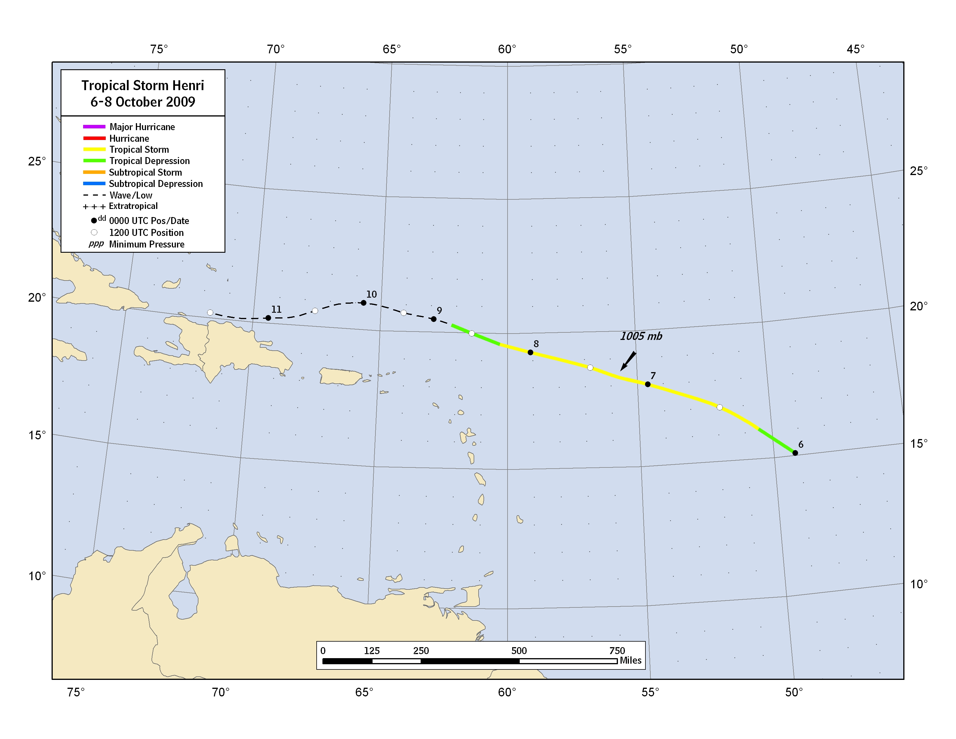
Figure 1. Best track positions for Tropical Storm Henri, 6-8 October 2009.
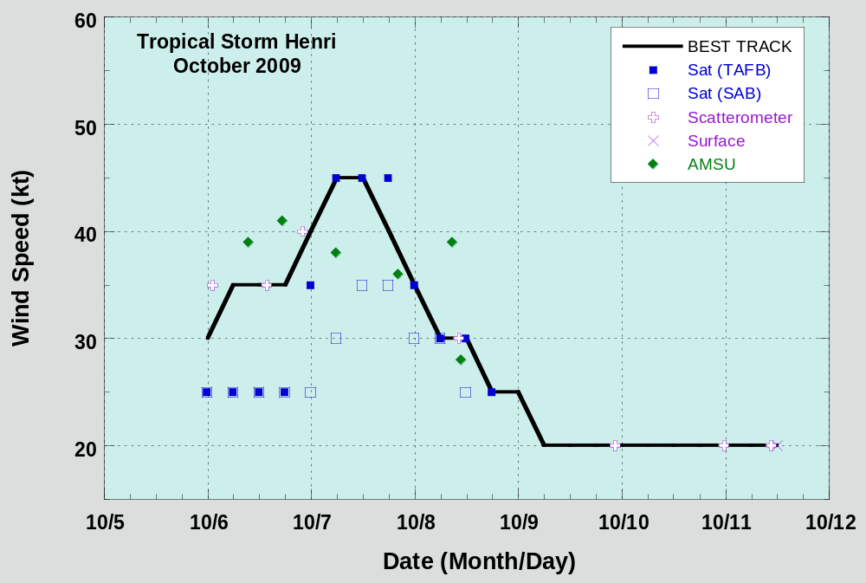

Figure 2. Selected wind observations and best track maximum sustained surface wind speed curve for Henri, 6-8 October 2009. Dashed vertical lines correspond to 0000 UTC.

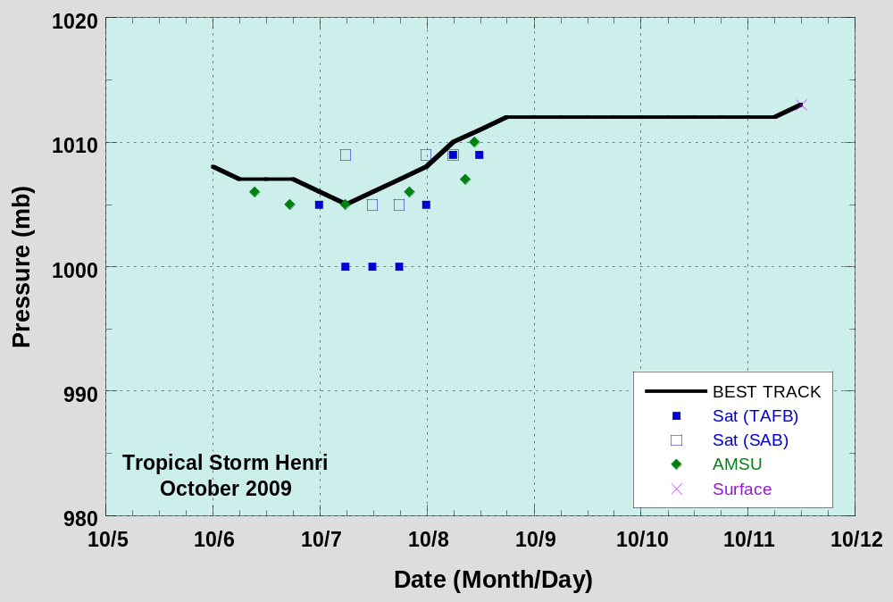

Figure 3. Selected pressure observations and best track minimum central pressure curve for Henri, 6-8 October 2009. Dashed vertical lines correspond to 0000 UTC.

Table 2a. NHC official (OFCL) and climatology-persistence (CLIPER) skill baseline (OCD5) track forecast errors (n mi) for Henri. Mean errors for the five-year period 2004-8 are shown for comparison. Official errors that are smaller than the five-year means are shown in boldface type.

 | Forecast Period (h)
 | 12 | 24 | 36 | 48 | 72 | 96 | 120
OFCL (Henri) | 26.1 | 58.5 | 116.1
OCD5 (Henri) | 31.4 | 58.7 | 108.9
Forecasts | 6 | 4 | 2
OFCL (2004-8) | 32.1 | 54.9 | 77.1
OCD5 (2004-8) | 45.8 | 95.7 | 152.8

Table 2b. Homogeneous comparison of selected track forecast guidance models (in n mi) for Henri. Errors smaller than the NHC official forecast are shown in boldface type. The number of official forecasts shown here will generally be smaller than that shown in Table 2a due to the homogeneity requirement.

Model ID | Forecast Period (h)
Model ID | 12 | 24 | 36 | 48 | 72 | 96 | 120
OFCL | 24.3 | 30.9
OCD5 | 27.9 | 40.2
GHMI | 35.2 | 30.6
HWFI | 46.3 | 102.6
NGPI | 40.6 | 75.3
AEMI | 32.6 | 18.4
TVCN | 30.3 | 59.5
TVCC | 26.3 | 59.1
LBAR | 42.2 | 102.6
BAMD | 40.1 | 82.9
BAMM | 23.0 | 39.6
BAMS | 42.6 | 54.8
Forecasts | 3 | 2
Table 3a. NHC official (OFCL) and climatology-persistence (Decay-SHIFOR) skill baseline (OCD5) intensity forecast errors (kt) for Henri. Mean errors for the five-year period 2004-8 are shown for comparison. Official errors that are smaller than the five-year means are shown in boldface type.

 | Forecast Period (h)
 | 12 | 24 | 36 | 48 | 72 | 96 | 120
OFCL (Henri) | 4.2 | 6.3 | 5.0
OCD5 (Henri) | 8.2 | 17.8 | 22.0
Forecasts | 6 | 4 | 2
OFCL (2004-8) | 7.1 | 10.5 | 12.8
OCD5 (2004-8) | 8.5 | 12.3 | 15.3

Table 3b. Homogeneous comparison of selected intensity forecast guidance models (in kt) for Henri. Errors smaller than the NHC official forecast are shown in boldface type. The number of official forecasts shown here will generally be smaller than that shown in Table 3a due to the homogeneity requirement.

Model ID | Forecast Period (h)
Model ID | 12 | 24 | 36 | 48 | 72 | 96 | 120
OFCL | 3.8 | 5.0 | 5.0
OCD5 | 10.5 | 21.7 | 22.0
GHMI | 5.0 | 6.3 | 3.0
HWFI | 8.5 | 6.0 | 9.0
DSHP | 8.8 | 12.3 | 7.0
LGEM | 9.0 | 13.0 | 6.0
ICON | 7.8 | 9.3 | 1.0
IVCN | 7.5 | 9.0 | 1.0
Forecasts | 4 | 3 | 1

A digital record of the complete best track, including wind radii, can be found on line at ftp://ftp.nhc.noaa.gov/atcf. Data for the current year’s storms are located in the btk directory, while previous years’ data are located in the archive directory.

