Tropical Cyclone Report

Hurricane Ike

(AL092008)

1 - 14 September 2008

Robbie Berg

National Hurricane Center

23 January 2009

Updated 18 March 2014 to correct intensities from 90 kt to 95 kt at
12 September 1200 and 1800 UTC in the intensity table (Table 1)

Updated 10 August 2011 to update total damage estimate, number of
direct deaths in the U.S., and number of missing people in Texas

Updated 3 May 2010 to revise total damage estimate and number of missing people

Updated 18 March 2009 for amended storm surge values in the observation table

Updated 4 February 2009 for adjustment of best track over Cuba, additional surface observations, an updated rainfall graphic, additional storm surge inundation maps,
revised U.S. damage estimate, and updated missing persons count

Ike was a long-lived Cape Verde hurricane that caused extensive damage and many deaths across portions of the Caribbean and along the coasts of Texas and Louisiana. It reached its peak intensity as a Category 4 hurricane (on the Saffir-Simpson Hurricane Scale) over the open waters of the central Atlantic, directly impacting the Turks and Caicos Islands and Great Inagua Island in the southeastern Bahamas before affecting much of the island of Cuba. Ike, with its associated storm surge, then caused extensive damage across parts of the northwestern Gulf Coast when it made landfall along the upper Texas coast at the upper end of Category 2 intensity.

- Synoptic History

Ike originated from a well-defined tropical wave that moved off the west coast of Africa on 28 August. An area of low pressure developed along the wave axis early the next day and produced intermittent bursts of thunderstorm activity as it moved south of the Cape Verde Islands on 29 and 30 August. The low was unable to maintain organized deep convection for several days, but it is estimated that the system gained sufficient convective organization to be designated as a tropical depression by 0600 UTC 1 September, about 675 n mi west of the Cape Verde Islands and 1400 n mi east of the Leeward Islands. The “best track” chart of Ike’s path is given in Figure 1, with the wind and pressure histories shown in Figures 2 and 3, respectively. The best track positions and intensities are listed in Table 1. The depression quickly strengthened to a tropical storm by 1200 UTC that day and then gradually intensified over the next two days as it moved west-northwestward over the tropical Atlantic, steered by a strong subtropical ridge to the north. During this period, Ike was surrounded by dry air and was unable to develop organized inner core convection, which possibly contributed to the slow rate of strengthening during the early part of the storm’s existence.

Visible and microwave satellite imagery indicates that strong convective banding had begun to wrap around the center of Ike by 1200 UTC 3 September. An eye became apparent by 1800 UTC, and Ike became a hurricane at that time when it was centered about 600 n mi east-northeast of the northern Leeward Islands. Around this time, a deep-layer low pressure area over the northwestern Atlantic weakened the subtropical ridge and allowed Ike to move on a west-northwestward track. Northerly upper-level winds on the west side of the low were strong enough to somewhat restrict the outflow on the north side of the hurricane although environmental conditions were otherwise favorable for intensification. Based on Dvorak satellite estimates, Ike is estimated to have strengthened from an intensity of 55 kt at 0600 UTC 3 September to its peak intensity of 125 kt (Category 4) at 0600 UTC 4 September—a 70-kt increase over a 24 h period. The 30-knot increase of winds between 1800 UTC 3 September and 0000 UTC 4 September ties Ike with four other Atlantic tropical cyclones for the fifth-fastest intensification rate over a 6-hour period. It should be stressed, however, that these wind estimates are based only on satellite observations since the hurricane was still out of range for sampling by aircraft reconnaissance.

After Ike reached its peak intensity, an upper-level high located northwest of the hurricane over the western Atlantic began to strengthen and contributed to 25-30 kt of northerly wind shear, causing the cloud pattern to become asymmetric. Weakening occurred over the next couple of days as the upper-level high continued to produce northeasterly shear over the storm, and Ike briefly fell below major hurricane status, with maximum sustained winds of 95 kt, at 1200 UTC 6 September. Microwave imagery at the time showed that much of the deep convection over the northern semicircle was severely eroded, including the northern eyewall, but a small eye remained present. Figure 4 shows a comparison of microwave images when Ike reached its peak intensity and after the shear had eroded the convection in the northern eyewall.

Building mid-level high pressure over the western Atlantic caused the hurricane to turn to the west late on 4 September. The high was strong enough to induce an unclimatological west-southwesterly motion by 0000 UTC 6 September. In fact, Ike is only the fifth tropical cyclone to reach a similar position in the Atlantic (near 24°N 60°W) and later move into the Gulf of Mexico, the last being Hurricane Andrew (1992). Ike went farther south and west than any of these storms, ultimately making landfall in Cuba and Texas.

Northeasterly shear relaxed over Ike early on 6 September while the hurricane was moving west-southwestward towards the Turks and Caicos Islands. The storm responded with deep convection redeveloping over the northern semicircle and quickly returned to Category 4 status by 1800 UTC 6 September. Although the center of Ike passed just south of the islands around 0600 UTC 7 September, the northern eyewall passed directly over Grand Turk, Salt Cay, South Caicos, and a few other smaller cays. Ike then weakened slightly to Category 3 status, with maximum sustained winds of 110 kt, before making landfall on Great Inagua Island in the southeastern Bahamas around 1300 UTC 7 September.

Ike weakened a little more after passing over Great Inagua, but this trend was short-lived. By the afternoon of 7 September, Ike once again re-strengthened to Category 4 status with winds of 115 kt by 0000 UTC 8 September. Ike made landfall at that intensity about two hours later near Cabo Lucrecia, Cuba, in the state of Holguín and near the city of Banes. The center of the hurricane traversed the states of Holguín, Las Tunas, and Camagüey during the early morning hours of 8 September, and Ike gradually lost strength, emerging over the waters of the northwestern Caribbean Sea around 1500 UTC with maximum sustained winds of 75 kt. Over the next day or so, Ike moved westward and maintained an intensity of 70 kt as its center hugged the southern coast of Cuba, at some points no more than 5-10 n mi offshore. Ike made a second landfall in Cuba around 1400 UTC 9 September near Punta La Capitana in the state of Pinar del Rio, not far from the city of San Cristóbal, then emerged over the Gulf of Mexico around 2030 UTC.

Ike’s interaction with Cuba caused much of the hurricane’s inner core to become disrupted, and the wind field expanded as the hurricane moved into the Gulf of Mexico. The storm moved slowly northwestward on 10 September over the southeastern Gulf, and an eyewall replacement began with outer banding beginning to enclose the small eyewall that had survived the crossing of Cuba. This likely prevented rapid intensification, and Ike’s winds only strengthened to 85 kt by 1800 UTC 10 September. In addition, the extent of tropical storm and hurricane force winds increased, reaching as far as 240 n mi and 100 n mi, respectively, from the center.

The subtropical ridge re-strengthened by late on 10 September and caused Ike to turn back to the west-northwest. The outer wind maximum started to contract and become the more dominant feature, and the inner wind maximum dissipated by 1800 UTC 11 September. Through the next day on 12 September, Ike continued to lack inner core convection and maintained its large wind field, making it difficult for the system to intensify quickly.

Ike reached the western periphery of the subtropical ridge and turned to the northwest towards the upper Texas coast late on 12 September. Microwave images and aircraft reconnaissance reports indicate that a 40 n mi diameter eye formed during the hours before landfall, and maximum winds increased to 95 kt. Ike turned to the north-northwest, and its center made landfall along the north end of Galveston Island, Texas, at 0700 UTC 13 September. The hurricane’s center continued up through Galveston Bay, just east of Houston, then northward across eastern Texas. Ike weakened to a tropical storm by 1800 UTC 13 September just east of Palestine, Texas, and then became extratropical when it interacted with a front around 1200 UTC 14 September while moving northeastward through northern Arkansas and southern Missouri. The vigorous extratropical low moved quickly northeastward, producing hurricane-force wind gusts across the Ohio Valley on the afternoon of the 14 September. Thereafter, the low weakened and moved across southern Ontario and southern Québec and was absorbed by another area of low pressure near the St. Lawrence River by 1800 UTC 15 September.

- Meteorological Statistics

Data sources for Ike (Figures 2 and 3) include satellites, aircraft, airborne and ground-based radars, conventional land-based surface and upper-air observing sites, Coastal Marine Automated Network (CMAN) stations, National Ocean Service (NOS) stations, ocean buoys, and ships. Ship reports of winds of tropical storm force or greater associated with Ike are given in Table 2, and selected surface observations from land stations and data buoys are given in Table 3.

Observations include satellite-based Dvorak technique intensity estimates from the Tropical Analysis and Forecast Branch (TAFB) and the Satellite Analysis Branch (SAB). Microwave data and imagery from National Oceanic and Atmospheric Administration (NOAA), Defense Meteorological Satellite Program (DMSP), and National Aeronautics and Space Administration (NASA), including the Tropical Rainfall Measuring Mission (TRMM), QuikSCAT, Aqua, and the U. S. Navy’s WindSat, were useful in tracking Ike.

Aircraft observations include flight-level, SFMR, and dropwindsonde observations, as well as 64 center fixes, from 16 operational missions into Ike by the 53rd Weather Reconnaissance Squadron of the U. S. Air Force Reserve Command. One additional mission was flown in conjunction with the NOAA G-IV for synoptic surveillance east of Florida and another was flown to drop buoys over the central Gulf of Mexico ahead of Ike. In addition, the NOAA Aircraft Operations Center WP-3D aircraft flew 12 missions before, during, and after Ike. These were mainly for research purposes but still provided important data for operational use, including 15 additional center fixes. The NOAA G-IV jet flew eight synoptic surveillance missions around Ike.

NWS WSR-88D Doppler radars from Key West, Florida, New Orleans and Lake Charles, Louisiana, and Houston/Galveston, Texas, were used to make center fixes and obtain velocity data while Ike was near the coast. Several inland Doppler radars, including radars at Fort Polk and Shreveport, Louisiana, and Little Rock, Arkansas, were also used for center fixes and velocity data once Ike moved inland. Data from multiple radar sites in Cuba were extremely helpful in tracking Ike as it moved across the island.

Winds and Pressure

Ike is estimated to have reached its peak intensity before it was sampled by reconnaissance aircraft. The estimated maximum sustained winds of 125 kt and minimum central pressure of 935 mb at 0600 UTC September 4 are based on subjective Dvorak data T-number estimates and 3-hour averaged Advanced Dvorak Technique (ADT) estimates of 127 kt from the University of Wisconsin Cooperative Institute for Meteorological Satellite Studies. Dvorak final T-number estimates from TAFB and SAB were both 115 kt at the time, but Ike had just gone through a period of rapid intensification, strengthening faster than allowed by the Dvorak technique rules. Therefore, the raw data T-numbers and the shorter-term ADT averages likely provided a better intensity estimate.

A Hurricane Hunter mission on the afternoon of 6 September, just as Ike was approaching the Turks and Caicos Islands, measured a maximum flight-level wind of 129 kt and an SFMR estimate of 114 kt, supporting an increase in intensity to 115 kt. A reporting station on Grand Turk (78118) measured a sustained wind of 101 kt as the northern eyewall moved across the island. Maximum flight-level winds changed very little during the next flight early on 7 September, and Ike is estimated to have had an intensity of 110 kt when it hit Great Inagua. Before reaching Cuba, microwave imagery and Cuban radar suggested that Ike was completing an eyewall replacement. The estimated landfall intensity in Cuba of 115 kt is based on an SFMR wind of 119 kt and a reduced mean boundary layer wind of 105 kt reported by a dropwindsonde.

The highest sustained winds reported in Cuba were 76 kt with a gust to 107 kt at Palo Seco, 77 kt with a gust to 104 kt at Puerto Padre, and 70 kt with a gust to 100 kt at Velasco (Table 3).

Aircraft reconnaissance reports indicated that Ike steadily intensified for about 18 h after moving off the northwestern coast of Cuba. However, both the aircraft data and microwave imagery showed that the hurricane had a structure which likely prevented rapid intensification. By 1800 UTC 10 September, the aircraft data suggest that Ike had two well-defined wind maxima of nearly equal strength. The unusually broad distribution of strong winds were associated with surface central pressures that were much lower than would be expected for the winds that were measured. The minimum pressure over the Gulf of Mexico was 944 mb near 0000 UTC 11 September based on a dropwindsonde from one of the NOAA missions. A central pressure this low would generally be associated with a 115-kt hurricane.

The estimated Texas landfall intensity of 95 kt is based on flight-level winds of 105 kt, SFMR winds up to 90 kt, and Doppler radar velocities from the Houston radar, which showed 114 kt winds at 6500 feet. The highest 1-minute sustained wind recorded by surface instruments was 83 kt from a WeatherFlow anemometer located at Crab Lake on the Bolivar Peninsula. The same instrument also reported the highest 3-second gust of 97 kt. A 1-minute sustained wind of 71 kt was recorded by a Texas Tech University Hurricane Research Team (TTUHRT) anemometer near Winnie, Texas, between Houston and Beaumont. A 3-second gust of 95 kt was reported by a separate TTUHRT sensor near Hankamer, Texas. The pressure of 950 mb at landfall is based on a minimum pressure of 950.7 mb reported by a TTUHRT sensor at Port Bolivar near the entrance to Galveston Bay and a pressure of 951.7 mb reported at the Galveston Pleasure Pier.

The post-tropical remnant low of Ike produced strong wind gusts as it moved across the Ohio Valley into southeastern Canada (Table 7). Wind gusts to hurricane force were reported at Louisville, Kentucky, and Cincinnati, Columbus, and Wilmington, Ohio.

Storm Surge

While storm surge associated with Ike affected the Turks and Caicos Islands, southern Bahamas, and Cuba, there are no available measurements of water level heights from these areas. Unofficial reports and state television from Cuba indicate that storm surge, and large waves as high as 50 ft, washed over and damaged coastal homes and other structures in the city of Baracoa near Ike’s first landfall in Cuba.

Higher-than-normal water levels affected virtually the entire U.S. Gulf Coast. As the hurricane grew in size, the large wind field pushed water towards the coastline well before Ike’s center made landfall near Galveston, Texas. Figure 5 shows maximum storm surge levels at various NOS tide stations, first occurring near the southwestern coast of Florida then migrating north and west along the Gulf Coast with time as Ike moved through the Gulf of Mexico.

NOS tide gauges (referenced to Mean Lower Low Water) indicate that storm surge along the west coast of Florida was generally 1 - 3 ft. Key West, Florida, measured a maximum storm surge of 1.66 ft at 1630 UTC 9 September. The highest water levels were subsequently recorded farther north along the west coast, and a maximum surge of 3.35 ft at Pensacola occurred around two days later at 2348 UTC 11 September.

Maximum storm surge along the coasts of Alabama, Mississippi, and southeastern Louisiana was generally in the 3 - 6 ft range. Dauphin Island, Alabama, recorded a storm surge of 3.27 ft, and Grand Isle, Louisiana, measured a surge of 3.84 ft. The concave orientation of the coastline in this region caused the highest surge values to occur along the coast of Mississippi and Louisiana east of the Mississippi River, including the New Orleans and Lake Pontchartrain areas. The Bay Waveland Yacht Club, Mississippi, measured a maximum surge of 5.81 ft while New Canal Station near New Orleans recorded a surge of 5.24 ft. The surge of 7.51 ft at Shell Beach, Louisiana, was higher than that recorded within most of the neighboring region.

Storm surge heights increased dramatically west of Grand Isle, Louisiana, and were generally 5 - 10 ft along the coast of south-central Louisiana, increasing to 10 - 13 ft along the southwestern Louisiana and extreme upper Texas coast near Sabine Pass and Port Arthur. Several United States Geological Survey (USGS) sensors, referenced to the North American Vertical Datum of 1988 (NAVD88), indicate that isolated areas in Jefferson County, Texas, and Cameron Parish, Louisiana, had surge heights up to 17 ft. The highest storm surge measured by any NOS tide gauge was at Sabine Pass North, Texas, where 12.79 ft was recorded at 0748 UTC 13 September, just as Ike was making landfall at Galveston. Port Arthur, located several miles inland at the head of Sabine Lake, measured a maximum surge of 11.03 ft. Storm surge inundation depths are indicated for Jefferson and Orange County in Figures 6 and 7, respectively.

The highest storm surge occurred on the Bolivar Peninsula and in parts of Chambers County, Texas (including the east side of Galveston Bay), roughly between the Galveston Bay entrance and just northeast of High Island. Complete tide gauge records for this area are unavailable since many of the sensors failed from salt water intrusion and large wave action, although ground assessment teams determined that the surge was generally between 15 and 20 ft. The highest water mark, collected by FEMA (referenced to NAVD88), was 17.5 ft located about 10 n mi inland in Chambers County. Figures 8 and 9 show that water depths of at least 4 ft covered all of the Bolivar Peninsula, with most areas covered by at least 10 ft of water (not including wave action). Much of the southern part of Chambers County was also inundated by at least 10 ft of water.

Storm surge levels on Galveston Island and on the west side of Galveston Bay are estimated to be between 10 and 15 ft. Here, too, several NOS tide gauges failed, although the gauge at Eagle Point on the west side of Galveston Bay recorded a maximum surge of 11.48 ft. The highest inundation, of at least 10 ft, occurred on the bay side of Galveston Island, the coast of mainland Galveston County, as well as over Apffel Park at the northern tip of Galveston Island where Ike made landfall (Figure 8).

NOS tide gauges indicated that water levels along the Texas and southwest Louisiana coasts began to rise rapidly on 12 September, approximately 24 h before the time of landfall. Numerous media reports the day before landfall showed water had already flooded areas near the coast and cut off evacuation routes from areas such as the Bolivar Peninsula, well before strong winds had reached the coast. By the evening of 12 September, about 6 - 8 h before landfall, storm tides were already running near 8 ft in the vicinity of Galveston.

Farther south along the Texas coast, storm surge of 5 - 10 ft was recorded in Brazoria County, including near Freeport. The highest recorded stillwater mark in the area was 10.69 ft. The remainder of the Texas coast south of Brazoria County recorded surge heights of 2 - 5 ft.

Rainfall

Although rainfall observations were scarce from the Turks and Caicos Islands and the southern Bahamas, several reports from the Morton Salt Company indicated that 5 - 7 inches of rain fell on Great Inagua. Comprehensive rainfall amounts from Haiti are also not available, but heavy rains there caused more flooding and mud slides in areas that were still recovering from Tropical Storm Fay and Hurricanes Gustav and Hanna. Cuba reported heavy rainfall on some parts of the island. In Cuba, the highest reports were 13.77 inches from Júcaro in the province of Ciego de Ávila and 12.11 inches from Topes de Collantes in Sancti Spiritus. Table 3 lists rainfall amounts for selected reporting stations in the affected areas.

In the United States, Ike’s outer rainbands produced some heavy rainfall over southern Florida. Highest reports were 6.33 inches near Ochopee and 5.98 inches near Chokoloskee. Figure 10 shows a map of accumulated rainfall from Ike over the United States. Ike produced a large area of rainfall 3 inches or greater over much of southeastern Texas and extreme southwestern Louisiana. The highest amount reported was 18.90 inches just north of Houston along Spring Creek at Farm Road 2979. The remnants of Ike produced heavy rainfall and exacerbated flooding across portions of Missouri, Illinois, and Indiana initiated a day earlier by the remnant moisture from Pacific Tropical Storm Lowell and a frontal system.

Tornadoes

A total of 29 tornadoes were reported in association with Ike in the United States. Two tornadoes occurred in the Upper Florida Keys when the far outer spiral bands moved across the area. An EF0 tornado touched down in North Key Largo on 9 September, and an EF1 tornado touched down on Lower Matecumbe Key on 10 September, both producing minor damage. From 12 - 14 September, 17 tornadoes occurred in Louisiana, 1 in Texas, and 9 in Arkansas—none rated higher than an EF1. No deaths were reported from the tornadoes.

- Casualty and Damage Statistics

Ike is directly responsible for 103 deaths across Hispaniola, Cuba, and parts of the United States Gulf Coast. Extensive damage from strong winds, storm surge, and rainfall occurred over Hispaniola, the Turks and Caicos Islands, the southern Bahamas, Cuba, and the U.S. Gulf Coast from Florida to Texas. Additional deaths and significant damage occurred across parts of the Ohio Valley and southeastern Canada after Ike lost tropical characteristics.

Hispaniola

Parts of Hispaniola, especially Haiti, were devastated by widespread flooding and mud slides from four consecutive impacts by Tropical Storm Fay and Hurricanes Gustav, Hanna, and Ike. Overall, 793 people died in Haiti from the four storms, with another 300 people reported missing. It is estimated that 74 deaths are directly attributable to the effects of Ike. Ike exacerbated the humanitarian disaster in Haiti, wiping out the food supply, shelter, and transportation networks across the nation. Two deaths have been reported in the Dominican Republic.

Turks and Caicos Islands

The Caribbean Disaster Emergency Response Agency estimates that 95% of the houses on Grand Turk were damaged, 20% of which sustained significant damage. Ninety-five percent of the houses on South Caicos were damaged with over one-third significantly damaged or destroyed. Among the damaged buildings was Carnival Cruise Line’s two-year old, $60 million cruise ship terminal on Grand Turk. In addition, the agricultural sector in North and Middle Caicos sustained damage and the fishing industry on South Caicos was significantly impacted. The airports in Providenciales, Grand Turk, and South Caicos were all flooded during the storm.

Bahamas

Approximately 70-80% of the houses on Great Inagua Island sustained roof damage, and 25% had major damage or were destroyed. The Morton Salt factory on the island was forced to halt operations as Ike damaged its offices and loading docks. A few West Indian flamingos were killed by Ike but most of the 50,000 flamingos in Inagua National Park—the world’s largest breeding colony—survived by taking shelter within the park’s mangroves or flying to other islands. Minor damage was reported to Mayaguana, Acklins, and Crooked Islands. Risk Management Solutions estimates that total damage costs are between $50 and $200 million (USD) for the Turks and Caicos and the Bahamas.

Cuba

Ike damaged 323,800 homes in Cuba, of which about 43,000 were a total loss, mainly in the provinces of Holguín, Las Tunas, Camagüey, Villa Clara, Santiago de Cuba, Guantanamo, Pinar del Rio, and the Isle of Youth. In advance of the hurricane, about 2.6 million people were evacuated, or about 23% of the entire Cuban population. Due to the massive evacuations and preparations, only seven direct deaths were reported due to falling structures and drowning.

Banana, coffee, yucca, and corn crops sustained serious damage across the country, and about 4,000 metric tons of foodstuffs were lost due to damage to storage facilities. Roadways sustained major damage across the island. In Ciego de Avila, the 24-km causeway linking mainland Cuba with the smaller islands of the Jardines del Rey archipelago, one of the major tourist destinations in the country, was damaged. The Granma Highway was severely damaged by storm surge, and the El Avispero bridge was washed away by a flooded river, stopping traffic along the coastal fringe of the Sierra Maestras. Several municipalities and communities were cut off from the rest of the country due to floodwaters. In Camagüey, the roofs and cupolas of several historic buildings were damaged, including the historic theater built in 1850. According to the United Nations, official sources in Cuba have estimated damages on the island to be between $3 and $4 billion (USD).

Florida

In the Florida Keys, almost 15,000 tourists evacuated as Ike approached. Tropical-storm-force winds caused some beach erosion on Key West’s Smathers and Higgs Beaches and downed some tree limbs, but no major damage was reported. Commercial flights and cruise ship calls were temporarily halted until Ike passed.

Texas, Louisiana, and Arkansas

The latest official counts and media reports indicate that 21 people died in Texas, Louisiana, and Arkansas as a direct result of Ike. Thirteen fatalities have been reported in Galveston and Chambers Counties, Texas, where the worst storm surge occurred, and several bodies were found within debris fields on the bay side of the Bolivar Peninsula, on Goat Island, and on the north side of Galveston Bay in Chambers County. Several of the deaths were Bolivar residents who did not leave after the first evacuation orders and were unable to leave once the rising waters cut off evacuation routes to the mainland. Three other drowning deaths were reported across Texas—one person drowned in the waters off Corpus Christi, one from storm surge in Orange County near Beaumont, and one after falling off a boat on Lake Livingston in Trinity County. In addition, one death in Montgomery County and one in Walker County resulted from trees falling onto the roofs of occupied houses. As many as 64 additional indirect deaths were reported in Texas due to factors such as electrocution, carbon monoxide poisoning, and pre-existing medical complications.

In Louisiana, a 16-year-old boy drowned in Bayou Dularge, and a man in Houma died after breaking his neck when a gust of wind blew him over.

One death occurred in Fisher, Arkansas, after a tree fell on a mobile home.

As of 10 August 2011, reports from the Laura Recovery Center (http://www.lrcf.net/Ike/display.names.cgi) indicate that 16 people, 11 of which are from Galveston, remain unaccounted for.

The Property Claim Services of the Insurance Services Office estimates that the insured damage (not including inland flooding or storm surge) from Ike in Texas, Louisiana, and Arkansas is about $12.5 billion dollars. The National Flood Insurance Program estimates that insured losses from inland flooding and storm surge is approximately $2.26 billion in the same three states. Because there is a $250,000 cap on each claim for inland flooding and storm surge, it is unlikely that this number is close to actual damage costs, considering the total devastation that occurred on some parts of the coast. Using these preliminary figures, total damage is estimated at about $29.52 billion dollars, based on a doubling of the total insured damage. These estimates suggest that Ike is the second costliest hurricane to affect the United States, after Hurricane Katrina (2005).

Significant storm surge and wave damage occurred along an extensive section of the upper Texas and southwestern Louisiana coast, with the worst devastation on the Bolivar Peninsula and parts of Galveston Island. Almost every structure on parts of the Bolivar Peninsula, including the communities of Crystal Beach, Gilchrist, and High Island, were completely razed from their foundations due to the surge and accompanying waves. Protected by a seawall, much of the city of Galveston was spared direct impact by storm surge and wave action from the Gulf of Mexico; however the city was still inundated by surge when water rose on the north side of the island from Galveston Bay (Figures 6 and 10). Ike downed numerous trees and powerlines across the Houston area, and many streets were blocked due to floodwaters. The U.S. Department of Energy estimated that 2.6 million customers lost power in Texas and Louisiana. Downtown Houston was spared significant wind damage, but streets were still littered with traffic signals and glass; one side of the 75-story JP Morgan Chase skyscraper, the city’s tallest, was missing many of its windows. Large chunks of the retractable roof of Reliant Stadium, home of the National Football League’s Houston Texans, were torn off during the storm, forcing the team to postpone a home game. In southwestern Louisiana, storm surge waters pushed up to 30 miles inland, including near Lake Charles, and inundated homes in parts of Cameron, lower Vermilion, St. Mary, and Terrebonne Parishes.

Ports from Corpus Christi to Lake Charles were closed in advance of Ike. Damage to the Ports of Galveston and Houston, as well as debris in Galveston Bay and the Houston Ship Channel, kept those ports closed after the storm for several days, leaving almost 150 tankers, cargo vessels, and container ships waiting offshore (Figure 7f). The U.S. Department of Energy said that 14 oil refineries were closed by the storm, as well as two Texas strategic petroleum reserve sites, causing rising gas prices and gas shortages across parts of the United States. In addition, the storm destroyed at least 10 offshore oil rigs and damaged several large pipelines. Before Ike reached the coast, a Cypriot freighter carrying petroleum coke, the 580-foot Antalina, lost propulsion about 90 miles southeast of Galveston with its 22-man crew. The U.S. Coast Guard could not rescue the crew during the storm due to the hazardous weather conditions, but the ship rode out the storm without casualties.

Ohio Valley

Although Ike became extratropical while moving northward over Arkansas, its remnants caused several deaths and produced significant wind damage across the Ohio Valley. At least 28 direct and indirect deaths were reported in Tennessee, Ohio, Indiana, Illinois, Missouri, Kentucky, Michigan, and Pennsylvania. In Ohio, almost 2.6 million people lost power with the most extensive damage reported in the areas near Cincinnati, Columbus, and Dayton. The Property Claim Services of the Insurance Services Office estimates that the post-tropical remnants of Ike produced $2.3 billion in non-flooding related insured losses—which equates to approximately $4.7 billion in damages. Insured losses in Ohio are estimated at $1.1 billion, rivaling the 1974 Xenia tornado as the costliest natural disaster in the state’s history.

Canada

High winds and record rainfall were reported across portions of southern Ontario and Québec from the remnants of Ike. Downed power lines and tree branches in these areas left at least 50,000 customers without power. Heavy rainfall caused some flooding and washed out several roads. High humidity associated with the system caused an electrical malfunction on one of the lines of the Montréal subway system, stranding commuters.

- Forecast and Warning Critique

Genesis

The genesis of Ike was well anticipated, even before the antecedent tropical wave moved off the coast of Africa. The Atlantic Tropical Weather Outlook (TWO) first mentioned the wave at 1200 UTC 28 August just as it was about to move off the coast, stating that gradual development was possible over the next couple of days. At this point, the system was given a “medium” chance to develop into a tropical cyclone within the following 48 h. By 1200 UTC 29 August, 66 h prior to genesis, the TWO explicitly mentioned that a tropical depression could form over the next couple of days. The genesis probability was elevated to “high” at 0600 UTC 30 August, exactly 48 h prior to the formation of a tropical depression.

Track

A verification of official and guidance model track forecasts is given in Table 4. Average official track errors for Ike (with number of cases in parentheses) were 17 (50), 32 (48), 46 (46), 59 (44), 91 (40), 121 (36), and 166 (32) n mi for the 12, 24, 36, 48, 72, 96, and 120 h forecasts, respectively. These errors are significantly lower than the average official track errors (Table 4), ranging from a 50% improvement for the 12 h forecast to a 39% improvement for the 120 h forecast. The official track forecasts were better than most of the available guidance, with a few exceptions. Impressively, the official track forecasts were better than the GUNA consensus at all forecast times and were only bested by the TVCN consensus at the 72 and 120 h period. The only single model that consistently outperformed the official forecast was the European Center for Medium-Range Weather Forecasts global model (EMXI). EMXI showed particular skill at the 36-120 h forecast times, where it performed 20-26% better than the official track forecast.

There were three periods during the life of Ike during which most of the track model guidance showed a consistent bias. The first was around the time Ike reached its peak intensity north of the Leeward Islands just before it was driven west-southwestward by the subtropical high. The track model guidance during this period had a considerable northward bias, with many of the models showing a less pronounced west-southwestward motion and a subsequent turn to the northwest across the Bahamas towards South Florida. Only the GFDI and EMXI performed well during this period by anticipating the west-southwestward motion towards eastern Cuba (Figure 11).

After the west-southwestward dive towards Cuba, model guidance indicated that Ike would reach the western periphery of the ridge and turn to the northwest. A few of the models, such as the GFDI, HWFI, and NGPI, were too quick with this scenario and brought Ike over the southeastern Gulf of Mexico closer to the west coast of Florida. The GFSI and EMXI performed much better during this period and were much closer to the actual track of Ike, whereas the EGRI actually showed a slight left-of-track bias closer to the Yucatan Peninsula.

Ike’s Texas landfall also highlighted certain model biases as the storm was moving into the Gulf of Mexico. The 2100 UTC 8 September forecast issued by National Hurricane Center (NHC), when Ike was still located near the southern coast of Cuba, indicated a U.S. landfall somewhere just south of Galveston Bay by 1800 UTC 13 September. However, in the following days many of the models were indicating a strong high developing over the southern U.S. and responded by showing a landfall farther south between Corpus Christi and Brownsville (the 0900 UTC 9 September forecast was the farthest south). After that point, the models began a slow shift back to the north as it became more apparent that the high would not be strong enough to induce the westward motion. Again, only the EMXI showed more consistent and skillful forecasts, never deviating from a landfall somewhere between High Island and far eastern Matagorda Bay. Most of the other major dynamical models showed a persistent westward bias over the western Gulf of Mexico several days before the landfall (Figure 11). While the NHC cone graphic highlighted the area at risk through this period, more quantitatively useful information was provided by the wind speed and experimental storm surge probability products.

Intensity

A verification of official and guidance model intensity forecasts is given in Table 5. Average official intensity errors for Ike (with number of cases in parentheses) were 8 (50), 11 (48), 13 (46), 14 (44), 18 (40), 18 (36), and 24 (32) knots for the 12, 24, 36, 48, 72, 96, and 120 h forecasts, respectively. These are close to the average 5-year official intensity errors for the Atlantic (7, 10, 12, 14, 18, 20, and 22 kt for the 12, 24, 36, 48, 72, 96, and 120 h forecasts, respectively). Several challenges in forecasting the intensity of Ike include its rapid intensification over the western Atlantic, the long periods of interaction with land (especially Cuba), and the anomalous structure the hurricane exhibited while over the Gulf of Mexico.

The NHC official forecasts did outperform many of the individual intensity models. Only the GHMI (at the 96 and 120 h periods) and the FSSE (at the 72-120 h periods) had smaller errors than the official intensity forecasts. However, the intensity model consensus (ICON) bested the official forecasts at all times except the 36 h period.

Watches and Warnings

Watches and warnings associated with Ike are given in Table 6. The government of the Bahamas first issued a hurricane watch for the Turks and Caicos Islands and the southeastern Bahamas approximately 24 h before tropical storm force winds began to spread across the easternmost Turks and Caicos but almost 33 h before these winds reached Great Inagua Island in the southeastern Bahamas. The watch was also issued 33 and 39 h before hurricane force winds reached the Turks and Caicos Islands and Great Inagua Island, respectively.

The government of Cuba issued a hurricane watch for the easternmost Cuban provinces from Guantanamo to Camagüey approximately 21 h before tropical storm force winds began spreading across the eastern end of Cuba and about 33 h before hurricane force winds reached the area around Cabo Lucrecia. Subsequent hurricane watches and warnings were issued for the entire length of Cuba.

A hurricane watch was issued for the Florida Keys from Ocean Reef to the Dry Tortugas when Ike was located over Great Inagua Island, with the anticipation that the hurricane would move close to the island chain. Although hurricane force winds remained well south of the keys, a tropical storm warning was required for the same area, including Florida Bay, and was issued approximately 24 h before tropical storm force winds began to spread across portions of the Middle and Lower Keys. Much of the Upper Keys remained outside the area of tropical storm force winds.

After Ike moved into the Gulf of Mexico, a hurricane watch was issued on the afternoon of 10 September from Cameron, Louisiana, to Port Mansfield, Texas, while a tropical storm warning was issued from the mouth of the Mississippi River to Cameron. The issuance of the tropical storm warning for parts of the Louisiana coast, without the previous issuance of a tropical storm watch, was required due to the unforeseen rapid expansion of Ike’s wind field once the storm moved across Cuba. However, the warning was still issued with appropriate lead time as tropical storm force winds began to affect the Mississippi Delta region about 24 h later. A hurricane watch was issued from Cameron, Louisiana, to Port Mansfield, Texas, earlier than the usual 36-hr threshold since significant storm surge was expected to impact the area well before tropical-storm-force winds reached the coast. A hurricane warning was issued from Morgan City, Louisiana, to Baffin Bay, Texas about 24 h before storm surge began to affect the region.

Acknowledgments

Weather Service Forecast Offices (WFOs) in Miami, Key West, Tampa, Mobile, New Orleans, Lake Charles, Houston/Galveston, Shreveport, Corpus Christi, Brownsville, Ft. Worth, and the National Data Buoy Center provided extensive post-storm reports and provided the many observations included in Table 3. WFOs in Little Rock, Paducah, Louisville, Indianapolis, Wilmington (OH), and Cleveland provided additional storm reports for Ike’s post-tropical remnants. The Instituto de Meteorología de la República de Cuba also provided a post-storm summary and observations. The National Ocean Service, the Harris County Flood Control District, and WFO Lake Charles provided storm surge charts and graphics. David Roth at the Hydrometeorological Prediction Center provided the rainfall graphic. The Office of Electricity Delivery and Energy Reliability of the U.S. Department of Energy provided information on Ike’s effects on the electrical grid and oil refineries. The Hurricane Specialists Unit and the Storm Surge Unit at the National Hurricane Center provided extensive insight and guidance in the writing of this report. Damage pictures in Figure 12 are from the Houston Chronicle, WFO Houston/Galveston, the Galveston County Office of Emergency Management, and the USGS. The NOAA Hurricane Research Division, NOAA Aircraft Operations Center Hurricane Hunters, and the 53rd Weather Reconnaissance Squadron of the U. S. Air Force Reserve Command spent countless hours gathering crucial data for Ike.
Table 1. Best track for Hurricane Ike, 1 – 14 September 2008.

Date/Time  (UTC) | Latitude  (°N) | Longitude  (°W) | Pressure  (mb) | Wind Speed  (kt) | Stage
01 / 0600 | 17.2 | 37.0 | 1006 | 30 |  | tropical depression
01 / 1200 | 17.3 | 38.4 | 1005 | 35 |  | tropical storm
01 / 1800 | 17.5 | 39.9 | 1003 | 45 |  | "
02 / 0000 | 17.8 | 41.3 | 1002 | 45 |  | "
02 / 0600 | 18.2 | 42.8 | 1000 | 45 |  | "
02 / 1200 | 18.7 | 44.3 | 999 | 50 |  | "
02 / 1800 | 19.3 | 45.8 | 996 | 55 |  | "
03 / 0000 | 19.8 | 47.3 | 994 | 55 |  | "
03 / 0600 | 20.2 | 48.8 | 992 | 55 |  | "
03 / 1200 | 20.6 | 50.3 | 989 | 60 |  | "
03 / 1800 | 21.1 | 51.9 | 979 | 75 |  | hurricane
04 / 0000 | 21.8 | 53.5 | 956 | 105 |  | "
04 / 0600 | 22.4 | 55.0 | 935 | 125 |  | "
04 / 1200 | 23.0 | 56.4 | 937 | 120 |  | "
04 / 1800 | 23.4 | 57.7 | 940 | 115 |  | "
05 / 0000 | 23.6 | 59.0 | 944 | 115 |  | "
05 / 0600 | 23.6 | 60.4 | 949 | 115 |  | "
05 / 1200 | 23.5 | 61.9 | 954 | 105 |  | "
05 / 1800 | 23.2 | 63.4 | 959 | 100 |  | "
06 / 0000 | 22.8 | 64.9 | 962 | 100 |  | "
06 / 0600 | 22.4 | 66.3 | 964 | 100 |  | "
06 / 1200 | 21.9 | 67.7 | 965 | 95 |  | "
06 / 1800 | 21.5 | 69.0 | 950 | 115 |  | "
07 / 0000 | 21.2 | 70.3 | 947 | 115 |  | "
07 / 0600 | 21.1 | 71.6 | 947 | 115 |  | "
07 / 1200 | 21.0 | 72.8 | 947 | 110 |  | "
07 / 1800 | 21.0 | 74.0 | 946 | 105 |  | "
08 / 0000 | 21.1 | 75.2 | 945 | 115 |  | "
08 / 0600 | 21.1 | 76.5 | 950 | 100 |  | "
08 / 1200 | 21.1 | 77.8 | 960 | 85 |  | "
08 / 1800 | 21.2 | 79.1 | 964 | 75 |  | "
09 / 0000 | 21.5 | 80.3 | 965 | 70 |  | "
09 / 0600 | 22.0 | 81.4 | 965 | 70 |  | "
09 / 1200 | 22.4 | 82.4 | 965 | 70 |  | "
09 / 1800 | 22.7 | 83.3 | 966 | 65 |  | "
10 / 0000 | 23.1 | 84.0 | 968 | 65 |  | "
10 / 0600 | 23.4 | 84.6 | 964 | 70 |  | "
10 / 1200 | 23.8 | 85.2 | 959 | 80 |  | "
10 / 1800 | 24.2 | 85.8 | 958 | 85 |  | "
11 / 0000 | 24.7 | 86.4 | 944 | 85 |  | "
11 / 0600 | 25.1 | 87.1 | 945 | 85 |  | "
11 / 1200 | 25.5 | 88.0 | 946 | 85 |  | "
11 / 1800 | 25.8 | 88.9 | 952 | 85 |  | "
12 / 0000 | 26.1 | 90.0 | 954 | 85 |  | "
12 / 0600 | 26.4 | 91.1 | 954 | 90 |  | "
12 / 1200 | 26.9 | 92.2 | 954 | 95 |  | "
12 / 1800 | 27.5 | 93.2 | 954 | 95 |  | "
13 / 0000 | 28.3 | 94.0 | 952 | 95 |  | "
13 / 0600 | 29.1 | 94.6 | 951 | 95 |  | "
13 / 1200 | 30.3 | 95.2 | 959 | 85 |  | "
13 / 1800 | 31.7 | 95.3 | 974 | 50 |  | tropical storm
14 / 0000 | 33.5 | 94.9 | 980 | 35 |  | "
14 / 0600 | 35.5 | 93.7 | 985 | 35 |  | "
14 / 1200 | 37.6 | 91.0 | 987 | 40 |  | extratropical
14 / 1800 | 40.3 | 87.2 | 988 | 50 |  | "
15 / 0000 | 43.3 | 81.5 | 988 | 50 |  | "
15 / 0600 | 45.8 | 75.3 | 986 | 40 |  | "
15 / 1200 | 47.2 | 71.1 | 986 | 35 |  | "
15 / 1800 |  |  |  |  |  | absorbed by another low
04 / 0600 | 22.4 | 55.0 | 935 | 125 |  | maximum wind and minimum pressure
07 / 1300 | 21.0 | 73.2 | 947 | 110 |  | landfall on Great Inagua Island, Bahamas
08 / 0215 | 21.1 | 75.7 | 945 | 115 |  | landfall near Cabo Lucrecia, Cuba
09 / 1400 | 22.6 | 82.9 | 965 | 70 |  | landfall near Punta La Capitana, Cuba
13 / 0700 | 29.3 | 94.7 | 950 | 95 |  | landfall at north end of Galveston Island, Texas
Table 2. Selected ship reports with winds of at least 34 kt for Hurricane Ike, 1 – 14 September 2008.

Date/Time (UTC) | Ship call sign | Latitude  (°N) | Longitude  (°W) | Wind  dir/speed (kt) | Pressure  (mb)
09 / 1200 | C6FZ7 | 19.6 | 81.0 | 200 / 43 | 1008.2
09 / 1700 | C6FZ7 | 19.5 | 79.2 | 170 / 43 | 1015.0
10 / 0900 | WPKD | 24.2 | 82.9 | 130 / 44 | 1000.0
10 / 1200 | WPKD | 24.6 | 83.7 | 130 / 55 | 995.5
10 / 1500 | WPKD | 25.3 | 83.9 | 110 / 59 | 1011.5
10 / 1800 | WPKD | 26.2 | 84.1 | 120 / 52 | 1002.5
10 / 2200 | V7HC9 | 28.0 | 86.5 | 090 / 50 | 1009.3
11 / 0000 | WPKD | 27.3 | 84.3 | 110 / 44 | 1004.2
11 / 0000 | V7HC9 | 28.1 | 86.4 | 050 / 52 | 1009.2
11 / 0200 | V7HC9 | 28.1 | 86.3 | 100 / 45 | 1009.9
11 / 0600 | C6FM5 | 21.8 | 86.8 | 220 / 45 | 1014.0
11 / 0600 | V7HD3 | 28.7 | 87.0 | 090 / 50 | 1014.0
11 / 0900 | WPKD | 27.4 | 84.4 | 110 / 41 | 1007.0
11 / 0900 | C6CL6 | 28.1 | 88.6 | 070 / 45 | 1008.0
11 / 1000 | WDD382 | 27.8 | 88.9 | 070 / 44 | 1002.1
11 / 1000 | V7HD3 | 28.7 | 87.0 | 110 / 60 | 1013.5
11 / 1100 | WDD382 | 27.9 | 88.8 | 070 / 47 | 1002.5
11 / 1100 | V7HC9 | 28.1 | 86.3 | 100 / 62 | 1008.5
11 / 1200 | WDD382 | 27.9 | 88.6 | 090 / 47 | 1002.2
11 / 1200 | C6CL6 | 28.1 | 88.4 | 090 / 46 | 1002.8
11 / 1200 | 3FMH7 | 28.6 | 88.8 | 190 / 48 | 1007.4
11 / 1200 | V7HD3 | 28.7 | 87.0 | 090 / 44 | 1014.0
11 / 1300 | WDD382 | 27.9 | 88.6 | 090 / 44 | 1002.0
11 / 1400 | WDD382 | 27.9 | 88.4 | 090 / 52 | 1002.0
11 / 1500 | WDD382 | 27.9 | 88.3 | 100 / 52 | 1001.5
11 / 1500 | C6CL6 | 28.1 | 88.4 | 090 / 55 | 1003.0
11 / 1600 | WDD382 | 27.9 | 88.2 | 100 / 52 | 1001.5
11 / 1700 | WDD382 | 27.9 | 88.2 | 100 / 44 | 1002.0
11 / 1800 | WDD382 | 27.9 | 88.0 | 120 / 49 | 1002.0
11 / 1800 | V7HC8 | 28.1 | 89.0 | 080 / 42 | 1007.0
11 / 1800 | C6CL6 | 28.2 | 88.3 | 090 / 55 | 1003.0
11 / 1800 | 3FMH7 | 28.7 | 88.3 | 080 / 54 | 1007.4
11 / 1900 | WDD382 | 27.9 | 87.9 | 120 / 52 | 1012.5
11 / 2000 | WDD382 | 27.9 | 87.8 | 120 / 44 | 1001.0
11 / 2000 | V7HC8 | 28.1 | 88.9 | 110 / 45 | 1003.0
11 / 2000 | V7HC9 | 28.1 | 86.3 | 180 / 50 | 1010.8
11 / 2100 | WDD382 | 27.9 | 87.7 | 120 / 42 | 1001.5
11 / 2100 | V7HC9 | 28.1 | 86.3 | 110 / 50 | 1010.2
11 / 2100 | C6CL6 | 28.2 | 88.3 | 090 / 55 | 1003.0
11 / 2100 | WPKD | 28.3 | 85.8 | 120 / 41 | 1008.0
11 / 2200 | WDD382 | 27.9 | 87.6 | 110 / 44 | 1001.5
11 / 2200 | V7HC9 | 28.1 | 86.3 | 180 / 45 | 1010.2
11 / 2300 | WDD382 | 27.8 | 87.4 | 100 / 44 | 1002.2
11 / 2300 | V7HC8 | 28.2 | 88.9 | 100 / 45 | 1008.0
12 / 0000 | KRGC | 23.0 | 89.5 | 210 / 46 | 1002.0
12 / 0000 | WDD382 | 27.8 | 87.3 | 110 / 44 | 1002.5
12 / 0000 | C6CL6 | 28.2 | 88.2 | 100 / 48 | 1002.0
12 / 0000 | 3FMH7 | 28.7 | 88.0 | 120 / 43 | 1005.7
12 / 0100 | WDD382 | 27.7 | 87.2 | 110 / 44 | 1003.5
12 / 0200 | WDD382 | 27.6 | 87.0 | 130 / 41 | 1006.5
12 / 0200 | V7HC9 | 28.1 | 86.3 | 110 / 47 | 1012.6
12 / 0300 | C6CL6 | 28.2 | 88.0 | 110 / 55 | 1005.0
12 / 0600 | C6CL6 | 28.1 | 87.9 | 140 / 58 | 1005.0
12 / 0600 | 3FMH7 | 28.5 | 87.7 | 120 / 46 | 1007.9
12 / 0600 | WPKD | 28.8 | 86.6 | 120 / 43 | 1009.8
12 / 0900 | WGZK | 23.6 | 92.1 | 220 / 41 | 1000.0
12 / 0900 | C6CL6 | 28.0 | 87.8 | 140 / 55 | 1006.0
12 / 1200 | WGZK | 23.9 | 91.7 | 210 / 45 | 1000.7
12 / 1200 | C6CL6 | 27.8 | 87.7 | 120 / 51 | 1007.8
12 / 1500 | WGZK | 24.3 | 91.2 | 210 / 44 | 1005.5
12 / 1500 | C6CL6 | 27.6 | 87.6 | 130 / 48 | 1009.0
12 / 1800 | C6CL6 | 27.3 | 87.5 | 170 / 50 | 1010.0
12 / 2100 | C6CL6 | 27.0 | 87.5 | 160 / 45 | 1010.0
13 / 0000 | C6CL6 | 26.7 | 87.5 | 160 / 42 | 1010.0

Table 3. Selected surface observations for Hurricane Ike, 1 – 14 September 2008.

Location | Minimum Sea Level Pressure |  | Maximum Surface  Wind Speed |  |  | Storm surge  (ft)^{c} | Storm  tide  (ft)^{d} | Total  rain  (in)
Location | Date/  time  (UTC) | Press.  (mb) | Date/  time  (UTC)ª | Sustained  (kt)^{b} | Gust  (kt) | Storm surge  (ft)^{c} | Storm  tide  (ft)^{d} | Total  rain  (in)
Haiti
Camp Perrin |  |  |  |  |  |  |  | 2.23
Dominican Republic
Santo Domingo |  |  |  |  |  |  |  | 9.40
Barahona |  |  |  |  |  |  |  | 8.86
Aerop. Joaquin Balaguer |  |  |  |  |  |  |  | 8.75
Polo |  |  |  |  |  |  |  | 8.15
San Cristobal |  |  |  |  |  |  |  | 7.63
Yamasa |  |  |  |  |  |  |  | 7.33
Rancho Arriba |  |  |  |  |  |  |  | 6.74
Neyba |  |  |  |  |  |  |  | 4.49
Monte Plata |  |  |  |  |  |  |  | 4.19
Juma Bonao |  |  |  |  |  |  |  | 4.11
Aeropuerto Catey |  |  |  |  |  |  |  | 4.09
Bonao |  |  |  |  |  |  |  | 4.01
Punta Cana |  |  |  |  |  |  |  | 2.17
Santiago |  |  |  |  |  |  |  | 1.80
Turks and Caicos Islands
Grand Turk (78118) | 07/0300 | 975.3 | 07/0300 | 101
Pine Cay (DW0758) | 07/0312 | 991.8 | 07/0358 | 57 | 62
Pine Cay (MD0758) | 07/0333 | 992.4 | 07/0412 | 57
Bahamas
Great Inagua
#4 Pump |  |  |  |  |  |  |  | 6.48
P. Point |  |  |  |  |  |  |  | 6.90
Y-2 |  |  |  |  |  |  |  | 5.48
Y. House |  |  |  |  |  |  |  | 6.90
Cuba
Holguín
La Jíquima | 08/0600 | 956.0 | 08/0635 | 59 | 84 |  |  | 6.51
Guaro | 08/0220 | 980.0 | 08/0220 | 60 | 86 |  |  | 5.00
Holguín | 08/0400 | 972.5 | 08/0412 | 68 | 97 |  |  | 5.73
Velasco | 08/0420 | 949.0 | 08/0440 | 70 | 100 |  |  | 4.84
Las Tunas
Las Tunas | 08/0700 | 952.5 | 08/0625 | 65 | 93 |  |  | 4.10
Puerto Padre | 08/0650 | 950.5 | 08/0525 | 77 | 104 |  |  | 6.84
Camagüey
Florida | 08/1300 | 984.6 | 08/0830 | 49 | 69 |  |  | 11.88
Santa Cruz del Sur | 08/1150 | 992.9 | 08/1035 | 48 | 65 |  |  | 5.83
Esmeralda | 08/1200 | 997.0 |  |  |  |  |  | 3.94
Nuevitas | 08/0830 | 987.8 | 08/0804 | 71 | 96 |  |  | 5.05
Palo Seco | 08/0830 | 945.5 | 08/0759 | 76 | 107 |  |  | 5.98
Camagüey |  |  | 08/0935 | 53 | 76 |  |  | 8.39
Santiago de Cuba
Contramaestre | 08/0700 | 995.2 | 08/1655 | 23 | 38 |  |  | 2.65
Santiago de Cuba | 08/0600 | 1001.2 | 08/1200 | 29 | 49 |  |  | 5.06
La Gran Piedra |  |  | 08/1100 |  | 71
Granma
Cabo Cruz |  |  | 08/1620 | 49 | 65 |  |  | 1.30
Manzanillo |  |  | 08/0841 | 35 | 49 |  |  | 2.96
Jucarito |  |  | 08/0754 | 48 | 68 |  |  | 3.11
Veguitas |  |  | 08/0850 | 32 | 46 |  |  | 3.05
Guantánamo
Guantánamo |  |  | 07/1650 | 25 | 37 |  |  | 3.93
Punta de Maisí | 07/1500 | 990.8 | 07/2315 | 61 | 83 |  |  | 5.89
Jamal, Baracoa | 07/1600 | 992.9 | 07/1740 |  | 76 |  |  | 6.95
Palenque de Yateras | 07/2300 | 987.7 | 07/2030 |  | 65 |  |  | 10.63
Valle de Caujerí |  |  | 08/0000 | 31 | 51 |  |  | 6.72
Ciego de Ávila
Falla | 08/1810 | 995.0 | 08/1700 | 49 | 70 |  |  | 6.32
Ciego de Ávila | 08/1700 | 994.9 | 08/1800 | 48 | 68 |  |  | 9.28
Júcaro | 08/1700 | 991.2 | 08/1800 | 55 | 75 |  |  | 13.77
Cayo Coco | 08/1140 | 1003.3 | 08/1908 | 51 | 69 |  |  | 1.66
Sancti Spíritus
Sancti Spíritus | 08/2230 | 990.2 | 08/2100 | 37 | 62 |  |  | 9.76
Topes de Collantes |  |  | 08/2238 |  | 78 |  |  | 12.11
Trinidad | 08/2300 | 976.1 | 08/2259 | 43 | 71 |  |  | 4.41
El Jíbaro | 08/2050 | 986.5 | 08/1802 | 47 | 67 |  |  | 8.18
Villa Clara
Sagua la Grande | 08/2100 | 1000.0 | 08/1940 | 50 | 67 |  |  | 3.73
Santa Clara | 08/2200 | 983.0 | 08/1928 | 43 | 62 |  |  | 3.46
Caibarién | 08/2300 | 998.0 | 08/2145 | 49 | 65 |  |  | 2.91
Santo Domingo | 08/1900 | 992.5 | 08/2020 | 42 | 59 |  |  | 4.16
Cienfuegos
Aguada de Pasajeros | 09/0300 | 994.3 | 09/0030 | 43 | 62 |  |  | 7.72
Cienfuegos | 09/0000 | 989.0 | 08/1830 | 45 | 64 |  |  | 3.08
Matanzas
Playa Girón | 09/0400 | 986.5 | 09/1300 | 48 | 65 |  |  | 3.72
Varadero |  |  | 09/0445 | 48 | 64 |  |  | 2.54
Unión de Reyes | 09/0900 | 993.7 | 09/0150 | 42 | 59 |  |  | 10.24
Colón | 09/0720 | 996.6 | 09/0050 | 42 | 59 |  |  | 8.28
Jovellanos | 09/0700 | 996.4 | 09/0300 | 42 | 59 |  |  | 5.59
Indio Hatuey | 09/0600 | 997.9 |  |  |  |  |  | 6.72
Jagüey Grande |  |  |  |  |  |  |  | 9.11
La Habana
Güines | 09/1200 | 992.4 | 09/1114 | 54 | 77 |  |  | 4.42
Bainoa |  | 982.7 | 09/0420 | 36 | 59 |  |  | 5.76
Bauta |  | 984.6 | 09/1605 | 46 | 66 |  |  | 8.46
Melena del Sur | 09/1200 | 988.6 | 09/1202 | 41 | 58 |  |  | 6.80
Güira de Melena | 09/1300 | 987.5 | 09/0710 | 37 | 52 |  |  | 6.13
Batabanó | 09/1200 | 986.6 | 09/0605 | 42 | 59 |  |  | 4.67
Ciudad de La Habana
Casa Blanca | 09/1220 | 989.7 | 10/0045 | 49 | 70 |  |  | 3.35
Santiago de las Vegas |  | 982.7 | 09/1148 | 39 | 56 |  |  | 7.70
Isla de la Juventud
La Fe | 09/1200 | 991.4 | 09/1600 | 36 | 51 |  |  | 1.37
Pinar del Río
Cabo de San Antonio | 10/0600 | 996.2 | 10/1335 | 49 | 66 |  |  | 2.30
Santa Lucía | 09/2200 | 984.0 | 10/1425 | 39 | 56 |  |  | 3.14
Isabel Rubio | 09/2000 | 984.2 | 09/2305 | 34 | 47 |  |  | 9.01
San Juan y Martínez | 09/2225 | 989.2 | 10/1209 | 41 | 58 |  |  | 7.86
Pinar del Río | 10/1500 | 980.6 | 10/1150 | 41 | 59 |  |  | 8.95
La Palma | 09/1900 | 965.9 | 09/1845 | 48 | 68 |  |  | 11.09
Paso Real de San Diego | 09/1640 | 960.8 | 09/1658 | 72 | 103 |  |  | 11.91
Bahía Honda | 09/1800 | 986.2 | 09/1445 | 43 | 58 |  |  | 4.64
Florida
International Civil Aviation Organization (ICAO) Sites
Boca Chica NAS (KNQX) |  |  | 09/1736 | 39 | 52
Fort Myers (KFMY) |  |  |  |  |  |  |  | 5.01
Hollywood (KHWO) | 09/0853 | 1010.5 | 09/1833 | 27 | 36
Homestead (KHST) | 09/1917 | 1009.5 | 09/1141 | 24 | 37
Key West (KEYW) | 09/2051 | 1004.4 | 09/1747 | 45 | 52 |  |  | 2.31
Marathon (KMTH) | 09/0836 | 1005.4 | 09/0906 | 30 | 43 |  |  | 2.47
Opa Locka (KOPF) | 09/0853 | 1009.8 | 10/0040 | 34 | 40
St. Petersburg (KSPG) | 09/1953 | 1010.0 | 10/1153 | 20 | 40
West Kendall (KTMB) | 09/0853 | 1008.8 | 09/1657 | 28 | 36
RAWS^{f}
Big Pine Key – Key Deer NWR (TS607) |  |  | 09/0338 | 21 | 38
Big Pine Key |  |  | 09/1350 | 27 | 36
Ochopee 2 NE (OCOF1) |  |  |  |  |  |  |  | 6.33
CWOP^{g}
Cudjoe Key (CW0925) | 09/0931 | 1004.4 | 09/0311 | 30 | 42
Long Key (CW0922) | 09/0830 | 1005.4 | 09/1040 | 44 | 55 |  |  | 2.37
Ramrod Key (CW0924) | 09/0830 | 1004.3 | 09/0311 | 32 | 43
SFWMD^{h}
Belle Glade (BELLW) |  |  | 09/1800 | 20e | 35
Chokoloskee (BCA19) |  |  |  |  |  |  |  | 5.98
Far NW Miami-Dade County (G3ASWX) |  |  | 09/1515 | 25e | 37
Far Western Broward County (S140W) |  |  | 09/1845 | 20e | 35
Loxahatchee Wildlife Refuge (LXWS) |  |  | 09/1700 | 20e | 34
Redland (S331W) |  |  | 09/1515 | 25e | 36
WeatherFlow
South Key Largo |  |  | 09/1905 | 27 | 39
Upper Matecumbe Key |  |  | 09/1255 | 37 | 53
USCGG Key West |  |  | 09/1310 | 33 | 50
Other
Medley (XURB) |  |  | 09/1455 | 25e | 38
NWS Key West (KKEY) |  |  | 09/1820 |  | 57
Sunshine Skyway Bridge |  |  | 09/2036 |  | 52
Marine
Belle Meade (XCAP) |  |  | 09/1600 | 20e | 34
Big Carlos Pass COMPS | 10/1800 | 1010.0 | 10/1100 | 25 | 35
Cedar Key |  |  |  |  |  | 2.89 | 5.80
Clearwater Beach |  |  |  |  |  | 1.90 | 4.80
COMPS Buoy (C10) | 10/2120 | 1009.0 | 09/2140 | 31 | 34
Deering Bay (XCUT) |  |  | 09/1545 | 25e | 37
Destin (EPSF1) |  |  |  |  |  | 2.45 | 3.95
Everglades City (KEGC) |  |  | 10/1045 | 27 | 43
Flamingo (KFLM) |  |  | 09/1246 | 45 | 55
Fort Myers |  |  |  |  |  | 1.86 | 3.25
Fowey Rocks (FWYF1) |  |  | 09/1210 | 35 | 44
Key West Harbor |  |  |  |  |  | 1.66 | 3.07
Long Key Light (LONF1) | 09/0900 | 1006.7 | 09/0500 | 34 | 50
Marco Island (Mesonet) |  |  | 09/1600 |  | 34
Molasses Reef Light (MLRF1) | 09/0900 | 1007.0 | 09/0700 | 40 | 49
Naples |  |  |  |  |  | 2.23 | 3.15
NOAA Buoy 42036 | 10/2150 | 1009.5 | 11/0450 | 29 | 35
Panama City |  |  |  |  |  | 2.55 | 4.09
Pensacola |  |  |  |  |  | 3.35 | 4.34
Pulaski Shoal Light (PLSF1) | 09/2200 | 1001.1 | 09/2210 | 51 | 65
Saint Petersburg |  |  |  |  |  | 2.46 | 4.23
Sand Key Light (SANF1) | 09/2000 | 1004.5 | 09/1610 | 55 | 76
Sombrero Key Light (SMKF1) | 09/1000 | 1004.5 | 09/0310 | 48 | 61 | 0.50 | 1.70
Turkey Point (XTKY) |  |  | 09/1455 | 25e | 37
Vaca Key NOS (VCAF1) | 09/0836 | 1005.8 | 09/0142 | 26 | 39 | 1.00 | 1.20
Virginia Key (KVIK) |  |  | 09/1347 | 36 | 44 | 1.15 | 1.86
Alabama
Marine
Bayou La Batre |  |  |  |  |  | 3.93 | 5.43
Dauphin Island (DPIA1) | 12/2205 | 1011.0 | 11/1550 | 37 | 56 | 3.27 | 4.50
Fort Morgan |  |  |  |  |  | 6.25 | 7.75
Mobile |  |  |  |  |  | 2.98 | 4.48
Mobile Coast Guard Sector |  |  |  |  |  | 3.82 | 5.25
Mobile State Docks |  |  |  |  |  | 3.30 | 4.83
NOAA Buoy 42040 | 11/2050 | 1006.0 | 11/1150 | 34 | 47
Mississippi
ICAO Sites
Biloxi (KBIX) | 12/1018 | 1010.4 | 12/1138 | 28 | 39
Gulfport (KGPT) | 12/2122 | 1009.1 | 12/1236 | 32 | 42 |  |  | 0.03
Pascagoula (KPQL) | 12/2206 | 1010.8 | 11/1621 | 24 | 34 |  |  | 0.12
Marine
Bay - Waveland Yacht Club |  |  |  |  |  | 5.81 | 7.62
Gulfport |  |  |  |  |  | 3.62 | 4.46
Pascagoula NOAA |  |  |  |  |  | 4.07 | 5.43
Louisiana
ICAO Sites
Abbeville (K0R3) | 12/2200 | 999.7 | 13/0700 | 30 | 48
Acadiana (KARA)^{i} | 13/2156 | 1000.3 | 13/1605 | 31 | 42
Alexandria (KAEX)^{i} | 13/1146 | 1000.7 | 13/1528 | 33 | 43 |  |  | 2.17
Alexandria - Esler (KESF) | 13/1334 | 1002.0 | 13/1624 | 27 | 39 |  |  | 1.85
Barksdale AFB (KBAD) | 13/2210 | 994.6 | 13/2130 | 34 | 44 |  |  | 1.63
Baton Rouge (KBTR) | 12/2130 | 1003.7 | 12/1132 | 31 | 45
Belle Chasse NAS (KNBG) | 12/2252 | 1006.5 | 12/1149 | 30 | 46
De Ridder (KDRI) | 13/1101 | 996.5 | 13/1200 | 29 | 45
Fort Polk (KPOE) | 13/1240 | 997.3 | 13/1319 | 34 | 49
Fort Polk (KDNK) | 13/1303 | 997.6 | 13/1922 | 29 | 43
Galliano (KGAO)^{i} |  |  | 11/2102 | 28 | 38
Hammond (KHDC) |  |  | 12/1116 | 32 | 42
Houma (KHUM)^{i} |  |  | 12/1850 | 31 | 44
Lafayette (KLFT) | 13/2242 | 1000.7 | 13/1437 | 26 | 42 |  |  | 2.21
Lake Charles – Chennault (KCWF)^{i} | 13/0600 | 997.7 | 13/0600 | 36 | 42
Lake Charles (KLCH) | 13/0642 | 995.3 | 13/0842 | 46 | 67 |  |  | 1.93
Monroe (KMLU) | 13/2237 | 1002.4 | 14/0237 | 26 | 35 |  |  | 1.39
New Orleans Intl Airport (KMSY) | 12/2244 | 1005.8 | 12/1217 | 35 | 50 |  |  | 1.55
New Orleans Lakefront (KNEW) | 12/2302 | 1006.1 | 12/1045 | 44 | 60 |  |  | 1.28
Oakdale (KACP) | 13/1000 | 999.9 | 13/1900 | 22 | 37
Patterson (KPTN)^{i} | 12/2155 | 1002.1 | 13/1055 | 26 | 38
Salt Point (KP92)^{i} | 12/1253 | 1002.4 | 12/1453 | 21 | 36
Shreveport Downtown (KDTN) | 13/2153 | 994.0 | 13/2253 | 30 | 48
Shreveport (KSHV) | 13/2202 | 992.9 | 13/2316 | 33 | 49 |  |  | 1.09
Slidell (KASD) | 12/2149 | 1007.5 | 12/1925 | 25 | 39
Sulphur (KUXL)^{i} | 13/0758 | 994.6 | 13/0720 | 34 | 54
RAWS^{f}
Caney (CANL1) |  |  | 13/2258 |  | 38 |  |  | 0.62
Gum Springs (GUML1) |  |  | 13/1809 |  | 38 |  |  | 2.26
Hackberry (HCKL1)^{i} |  |  | 13/0400 | 42 | 60 |  |  | 2.63
Holmwood (CLCL1) |  |  | 13/0700 | 40 | 58 |  |  | 3.93
Lacassine (LACL1) |  |  | 13/1100 | 33 | 49 |  |  | 3.30
LAIS^{j}
Alexandria (ALDL1) |  |  | 13/1500 |  | 46 |  |  | 4.18
Crowley (CRRL1) |  |  | 13/1300 |  | 45
Jeanerette (JNRL1) |  |  | 12/2100 |  | 45 |  |  | 1.78
Lake Charles (LCPL1) |  |  | 13/1000 |  | 55 |  |  | 2.59
Port Barre (RDRL1) |  |  | 13/1600 |  | 40 |  |  | 2.30
Rosepine (RPRL1) |  |  | 13/1400 |  | 49 |  |  | 1.72
Other
Arcadia |  |  |  |  | 52
Bellwood |  |  |  |  |  |  |  | 5.50
Benton |  |  |  |  | 45
Caillou Lake USGS (DCLL1)^{i} |  |  | 12/2030 |  | 48
Natchitoches |  |  |  |  | 54
Marine
Amerada Pass (AMRL1) | 12/2100 | 999.2 | 12/1424 | 35 | 49 | 7.06 | 8.02
Barataria – Lafitte |  |  |  |  |  | 4.70 | 5.11
Bayou Bienvenue |  |  |  |  |  | 7.70 | 8.16
Bayou Dupre |  |  |  |  |  | 6.90 | 7.44
Bayou Grand Caillou |  |  |  |  |  | 7.00 | 7.45
Caillou Lake SW |  |  |  |  |  | 7.30 | 7.80
Calcasieu Pass (CAPL1) | 13/0936 | 989.5 | 13/0818 | 61 | 75 | 10.40 | 11.94
Cypremort Point |  |  |  |  |  | 1.82 | 3.19
Freshwater Canal Locks (8766072) |  |  |  |  |  | 9.93 | 10.08
Grand Isle (GISL1) | 12/2030 | 1006.4 | 12/1730 | 29 | 45 | 3.84 | 5.22
Lake Charles |  |  |  |  |  | 2.14 | 3.20
Lake Pontchartrain – Mid-Lake (MDLL1) |  |  | 12/1010 | 37 | 49 | 5.70 | 6.02
Lake Pontchartrain – Rigolets |  |  |  |  |  | 3.80 | 4.24
Lake Pontchartrain – West End |  |  |  |  |  | 5.00 | 5.40
Mandeville |  |  |  |  |  | 5.80 | 6.19
Marsh Island (MRSL1) | 12/2200 | 995.5 | 12/1800 | 47 | 64
New Canal Station |  |  |  |  |  | 5.24 | 5.58
NOAA Buoy 42007 | 11/2050 | 1008.3 | 12/1120 | 31 | 41
Port Fourchon |  |  |  |  |  | 4.17 | 5.58
Shell Beach (SHBL1) | 12/0948 | 1005.5 | 12/1012 | 23 | 30 | 7.51 | 7.81
Southwest Pass – Pilot’s Station E (PSTL1) | 12/0924 | 1004.6 | 12/0630 | 48 | 53 | 3.21 | 4.71
Tesoro Marine Terminal (8764044) |  |  |  |  |  | 4.32 | 4.64
West Bank |  |  |  |  |  | 3.00 | 3.19
Texas
ICAO Sites
Angleton / Brazoria (KLBX)^{i} | 13/0753 | 974.6 | 12/2353 | 32 | 49
Bay City (KBYY) | 13/0625 | 985.8 | 13/0625 | 33 | 46
Beaumont (KBPT) | 13/0905 | 982.4 | 13/0814 | 61 | 83 |  |  | 5.45
Brenham (K11R) | 13/1148 | 987.5 | 13/1212 | 33 | 44
College Station (KCLL) | 13/1338 | 985.8 | 13/1153 | 30 | 43 |  |  | 3.45
Conroe (KCXO)^{i} | 13/1153 | 962.4 | 13/1002 | 36 | 52
Corsicana (KCRS) | 13/1845 | 987.8 | 13/1543 | 34 | 44 |  |  | 1.56
Galveston (KGLS)^{i} | 13/1652 | 1002.3 | 13/1652 | 24 | 33
Houston / Bush (KIAH) | 13/1011 | 961.1 | 13/0951 | 49 | 71
Houston / D.W. Hooks (KDWH)^{i} | 13/1053 | 967.5 | 13/0840 | 28 | 47
Houston / Hobby (KHOU)^{i} | 13/0853 | 960.0 | 13/1102 | 65 | 80
Huntsville (KUTS) | 13/1344 | 968.2 | 13/1316 | 29 | 50 |  |  | 4.90
Longview (KGGG)^{i} | 13/2053 | 984.1 | 13/2009 | 32 | 49
Lufkin (KLFK)^{i} | 13/1353 | 982.5 | 13/1239 | 34 | 60 |  |  | 2.59e
Orange (KORG)^{i} | 13/0326 | 994.6 | 13/0326 | 34 | 44
Palacios (KPSX) | 13/0753 | 991.2 | 12/2353 | 30 | 43
Palestine (KPSN)^{i} | 13/1328 | 991.2 | 13/1308 | 23 | 34
Paris (KPRX) | 13/2355 | 988.5 | 14/0015 | 25 | 35 |  |  | 2.17
Pearland (KLVJ)^{i} | 13/0453 | 982.4 | 13/0419 | 37 | 56
Port Lavaca (KPKV) | 13/0826 | 993.9 | 13/0326 | 29 | 36
Sugarland (KSGR)^{i} | 13/0353 | 991.2 | 13/0353 | 37 | 47
Sulphur Springs (KSLR) | 13/2227 | 987.5 | 13/2347 | 28 | 35
Terrell (KTRL) | 13/2103 | 989.2 | 13/1733 | 29 | 39 |  |  | 1.82
Tyler (KTYR) | 13/2053 | 976.9 | 13/2007 | 28 | 40 |  |  | 2.69
Victoria (KVCT) | 13/0847 | 993.9 | 13/0720 | 25 | 34
Wharton (KARM) | 13/0840 | 987.5 | 13/0840 | 34 | 44
RAWS^{f}
Anahuac (TR474)^{i} |  |  | 13/0559 | 47 | 63
Attwater NWR (ANWT2) |  |  | 13/0956 | 28 | 40
Brazoria NWR (BZRT2) |  |  | 13/0809 | 34 | 62
Buna (KRBT2) |  |  | 13/1400 | 28 | 56 |  |  | 6.62
Conroe (CKNT2) |  |  | 13/1503 | 20 | 49
Coldsprings (CPGT2) |  |  | 13/1002 | 13 | 41
Dayton (TR968) |  |  | 13/1207 | 45 | 68 |  |  | 11.88
Henderson (HDRT2) |  |  | 13/2106 |  | 49 |  |  | 2.05
Linden (DENT2) |  |  | 14/0005 |  | 35 |  |  | 2.17
Lufkin (LRWT2) |  |  | 13/1603 |  | 42 |  |  | 2.59
Sabine Pass (FADT2)^{i} |  |  | 12/2300 | 34 | 44 |  |  | 0.10
Sabine South (SSRT2) |  |  | 13/1907 |  | 36 |  |  | 4.19
San Bernard (SRDT2) |  |  | 13/0807 | 28 | 49
Texarkana (TEXT2) |  |  | 14/0104 |  | 35 |  |  | 2.45
Warren (WRRT2) |  |  | 13/1500 | 21 | 46 |  |  | 5.40
Woodville (WVLT2) |  |  | 13/1400 | 30 | 59 |  |  | 7.11
AWS^{k}
Brenham (BRENH) | 13/1029 | 988.1 | 13/0959 | 17 | 38
Damon (DAMON)^{i} | 13/0814 | 978.0 | 13/0659 | 30 | 56
Freeport (FRPAL) | 13/0644 | 971.6 | 13/0659 | 42 | 66
Galveston (GLVST)^{i} | 12/2114 | 993.9 | 12/2114 | 40 | 57
Houston (HSSLS)^{i} | 13/0544 | 988.1 | 13/0444 | 16 | 41
Houston (HSTN0)^{i} | 13/0643 | 985.8 | 13/0614 | 21 | 35
Livingston (LVING)^{i} | 13/1028 | 979.0 | 13/1014 | 23 | 44
Prairie View (PRRV2) | 13/1114 | 980.4 | 13/1214 | 23 | 48
Spring (TWOOD) | 13/0928 | 974.6 | 12/1814 | 6 | 38
TBCD^{l}
Anahuac (2150) | 13/0745 | 962.8 | 13/1026 | 52 | 73 |  |  | 7.16
Anahuac (2550)^{i} | 13/0448 | 978.7 | 13/0448 | 51 | 52 |  |  | 1.68
Baytown (7050) | 13/0726 | 962.8 | 13/0745 | 28 | 44 |  |  | 6.84
Baytown (7150) | 13/0821 | 962.8 | 13/0753 | 52 | 62
Baytown (7151) |  |  |  |  |  |  |  | 8.20
Hankamer (6050) | 13/0856 | 962.8 | 13/0928 | 67 | 73 |  |  | 5.64
Winnie (5250) | 13/0609 | 972.2 | 13/0820 | 39 | 50 |  |  | 8.28
TCOON^{m}
Port Arthur (8770475) |  |  | 13/0654 | 47 | 73 | 11.25 | 11.93
Rainbow Bridge (8770520) |  |  |  |  |  | 9.29 | 9.69
Sabine Pass (8770570) |  |  |  |  |  | 12.54 | 14.24
Texas Point (8770520)^{i} |  |  | 13/0406 | 57 | 80 | 11.79 | 13.37
TTUHRT^{n}
Anahuac (0103A) | 13/0923 | 955.4 | 13/0746 | 59 | 74
Beaumont 5 SW (0108B) | 13/0855 | 977.3 | 13/1106 | 53 | 66
China 5 ESE (0111A) | 13/0937 | 975.7 | 13/1033 | 58 | 73
Danbury (0220B) | 13/0743 | 965.3 | 13/0650 | 54 | 66
Devers (0218B) | 13/0909 | 957.2 | 13/0910 | 59 | 72
Fannett 2 N (0107A) | 13/0903 | 971.4 | 13/0708 | 52 | 64
Felicia (0112A) | 13/0936 | 968.0 | 13/1045 | 55 | 67
Hamshire 2 S (0105A) | 13/0925 | 965.7 | 13/0830 | 56 | 73
Hankamer (0104B) | 13/0828 | 960.6 | 13/0710 | 69 | 83
Hankamer (0216B) | 13/0901 | 957.1 | 13/0718 | 64 | 95
Hankamer (0217A) | 13/0907 | 964.2 | 13/0837 | 55 | 76
Hankamer (0222B) | 13/0912 | 960.2 | 13/0901 | 62 | 78
Hankamer (0224B) | 13/0903 | 956.8 | 13/0800 | 53 | 68
Liverpool (0214B) | 13/0745 | 956.3 | 13/0639 | 53 | 69
Nome 6 SSE (0106B) | 13/0847 | 967.0 | 13/0829 | 59 | 72
Port Bolivar (0110A) | 13/0759 | 950.7 | 13/1016 | 64 | 76
Raywood (0109A) | 13/0942 | 958.7 | 13/1123 | 61 | 82
Winnie (0102B) | 13/0833 | 963.7 | 13/0844 | 55 | 73
Winnie (0213A)^{i} | 13/0940 | 965.6 | 13/0752 | 71 | 80
Winnie (0223A) | 13/0908 | 964.2 | 13/0859 | 55 | 70
WeatherFlow
Crab Lake – Bolivar |  |  | 13/0555 | 83 | 97
Houston - Chinatown |  |  | 13/0800 | 50 | 65
Kemah |  |  | 13/1045 | 53 | 66
New Territory |  |  | 13/0820 | 41 | 59
Pierce Junction |  |  | 13/0824 | 60 | 76
Rosharon |  |  | 13/0447 | 50 | 70
Texas City |  |  | 13/0522 | 60 | 77
Other
Addicks (BAKT2)^{i} |  |  |  |  |  |  |  | 7.97
Addicks (LLYT2) |  |  |  |  |  |  |  | 9.90
Aldine (HGBT2)^{i} |  |  |  |  |  |  |  | 7.28
Barrett (SHLT2)^{i} |  |  |  |  |  |  |  | 6.42
Beaumont (BEAT2)^{i} |  |  |  |  |  |  |  | 10.50
Beaumont (JYTT2) |  |  |  |  |  |  |  | 5.16
Beaumont (JYUT2) |  |  |  |  |  |  |  | 5.55
Beaumont (JYVT2) |  |  |  |  |  |  |  | 12.56
Beaumont (JYWT2) |  |  |  |  |  |  |  | 5.87
Beaumont (JZET2) |  |  |  |  |  |  |  | 6.70
Beaumont (JZFT2) |  |  |  |  |  |  |  | 7.44
Beaumont (JZGT2) |  |  |  |  |  |  |  | 8.94
Beaumont (JZHT2) |  |  |  |  |  |  |  | 6.66
Beaumont (JZIT2) |  |  |  |  |  |  |  | 7.60
Beaumont (JZKT2) |  |  |  |  |  |  |  | 6.58
Beaumont (JZLT2) |  |  |  |  |  |  |  | 7.08
Beaumont (JZMT2) |  |  |  |  |  |  |  | 9.96
Beaumont (JZRT2) |  |  |  |  |  |  |  | 7.52
Bevil Oaks (JTWT2) |  |  |  |  |  |  |  | 7.12
Bevil Oaks (JYNT2) |  |  |  |  |  |  |  | 6.61
Bevil Oaks (JYOT2) |  |  |  |  |  |  |  | 7.68
Bevil Oaks (JZCT2) |  |  |  |  |  |  |  | 7.05
Bevil Oaks (JZDT2) |  |  |  |  |  |  |  | 6.46
Bunker Hill Village (WSBT2) |  |  |  |  |  |  |  | 10.10
Dickinson (DCKNW)^{i} | 13/0829 | 954.3 | 13/0944 | 43 | 64
Central Gardens (JZJT2) |  |  |  |  |  |  |  | 8.94
China (JYQT2) |  |  |  |  |  |  |  | 8.39
China (JZST2) |  |  |  |  |  |  |  | 8.59
China (JZUT2) |  |  |  |  |  |  |  | 8.82
Clear Lake Shores (CLCT2) |  |  |  |  |  |  |  | 6.32
Cleveland (CPGT2)^{i} |  |  |  |  |  |  |  | 5.94
Cypress (LKLT2) |  |  |  |  |  |  |  | 8.70
Fannett (JZPT2) |  |  |  |  |  |  |  | 6.30
Fannett (JZQT2) |  |  |  |  |  |  |  | 5.71
Fannett (JZXT2) |  |  |  |  |  |  |  | 6.06
Friendswood (FNDT2) |  |  |  |  |  |  |  | 10.47
Gary City |  |  |  |  | 74
Groveton (WDLT2)^{i} |  |  |  |  |  |  |  | 5.42
Hamshire (JYST2) |  |  |  |  |  |  |  | 7.41
Hillcrest (ALVT2) |  |  |  |  |  |  |  | 12.02
Hilshire Village (DEHT2) |  |  |  |  |  |  |  | 11.01
Hockley (KHOT2) |  |  |  |  |  |  |  | 5.66
Hooks Apt. (KYKT2)^{i} |  |  |  |  |  |  |  | 7.05
Hooks Apt. (STUT2) |  |  |  |  |  |  |  | 10.67
Houston (BBST2) |  |  |  |  |  |  |  | 12.40
Houston (BKHT2) |  |  |  |  |  |  |  | 12.13
Houston (BSFT2) |  |  |  |  |  |  |  | 10.82
Houston (C9180) | 13/0928 | 967.8 | 13/0928 | 51 | 83
Houston (ELBT2) |  |  |  |  |  |  |  | 17.59
Houston (HABT2)^{i} |  |  |  |  |  |  |  | 5.00
Houston (HBMT2) |  |  |  |  |  |  |  | 10.44
Houston (HTGT2)^{i} |  |  |  |  |  |  |  | 10.16
Houston (MGOT2) |  |  |  |  |  |  |  | 10.31
Houston (MRFT2) |  |  |  |  |  |  |  | 11.22
Houston (RLPT2) |  |  |  |  |  |  |  | 8.85
Houston (SMWT2) |  |  |  |  |  |  |  | 10.67
Houston (VGBT2) |  |  |  |  |  |  |  | 12.83
Houston (WSHT2)^{i} |  |  |  |  |  |  |  | 5.78
Humble (HMMT2) |  |  |  |  |  |  |  | 10.79
Jacksonville |  |  |  |  | 53
Jersey Village (FHNT2) |  |  |  |  |  |  |  | 11.14
Jersey Village (JVLT2) |  |  |  |  |  |  |  | 8.86
Jersey Village (SUMT2) |  |  |  |  |  |  |  | 9.14
Katy (BBKT2) |  |  |  |  |  |  |  | 7.65
Katy (SMAT2)^{i} |  |  |  |  |  |  |  | 7.76
Livingston (LIVT2) |  |  |  |  |  |  |  | 8.17
Lumberton (LLBT2) |  |  |  |  |  |  |  | 7.37
Lumberton |  |  | 13/0955 |  | 72
Meyerland (WWHT2) |  |  |  |  |  |  |  | 8.82
Nederland |  |  | 13/0727 |  | 89
Nome (JZAT2) |  |  |  |  |  |  |  | 8.03
Nome (JZBT2) |  |  |  |  |  |  |  | 9.37
Nome (JZWT2) |  |  |  |  |  |  |  | 10.63
North Cleveland (CVLT2)^{i} |  |  |  |  |  |  |  | 6.90
North Cleveland (CLDT2)^{i} |  |  |  |  |  |  |  | 7.47
Port Arthur (JYHT2) |  |  |  |  |  |  |  | 8.15
Port Arthur |  |  | 13/0925 |  | 92
San Leon (MOKT2) |  |  |  |  |  |  |  | 13.92
Saratoga |  |  | 13/1013 |  | 77
Shenandoah (CFKT2)^{i} |  |  |  |  |  |  |  | 9.43
Shenandoah (CKNT2) |  |  |  |  |  |  |  | 14.46
Sour Lake (JYMT2) |  |  |  |  |  |  |  | 6.62
South Houston (BFOT2)^{i} |  |  |  |  |  |  |  | 8.31
Spring Valley (BSBT2)^{i} |  |  |  |  |  |  |  | 9.68
Stagecoach (HEGT2) |  |  |  |  |  |  |  | 8.54
Sugar Land (SGLT2) |  |  |  |  |  |  |  | 5.75
The Woodlands (PBST2) |  |  |  |  |  |  |  | 11.71
The Woodlands (PGRT2)^{i} |  |  |  |  |  |  |  | 6.01
Thicket (JYLT2) |  |  |  |  |  |  |  | 8.11
Town West (SGRT2) |  |  |  |  |  |  |  | 5.75
Westbury (HWET2)^{i} |  |  |  |  |  |  |  | 8.25
Wildwood (WWDT2) |  |  |  |  |  |  |  | 6.99
Winnie (GTOT2)^{i} |  |  |  |  |  |  |  | 10.47
Marine
Battleship Texas SP (NP114)^{i} |  |  |  |  |  | 7.31 | 7.89
Bob Hall Pier |  |  |  |  |  | 3.84 | 5.39
Copano Bay |  |  |  |  |  | 2.86 | 3.41
Corpus Christi |  |  |  |  |  | 4.23 | 5.92
Eagle Point (EGPT2) |  |  |  |  |  | 11.48 | 11.95
Eagle Point (EPPT2) | 13/0748 | 954.3 | 13/0606 | 59 | 78
Entrance to Clear Lake (CLLT2)^{i} |  |  |  |  |  | 7.95 | 8.19
Freeport (FCGT2) |  |  |  |  |  | 6.25 | 7.42
Freeport (FPPT2) |  |  | 13/0524 | 51 | 76
Galveston Bay Entrance (GNJT2)^{i} |  |  |  |  |  | 9.41 | 9.75
Galveston Pleasure Pier (GPST2) | 13/0754 | 951.7 | 13/0448 | 52 | 76 | 10.80 | 12.25
Galveston Ship Channel North Jetty (GSJT2) |  |  | 13/0218 | 51 | 67
Ingleside |  |  |  |  |  | 3.20 | 3.83
Manchester (TX035) |  |  |  |  |  | 11.74 | 12.28
Morgans Point (MGPT2)^{i} |  |  | 13/0612 | 46 | 69 | 8.82 | 9.01
NOAA Buoy 42019 | 13/0150 | 984.9 | 13/0150 | 42 | 56
NOAA Buoy 42035 | 13/0450 | 952.1 | 13/0850 | 54 | 74
Packery Channel |  |  |  |  |  | 2.89 | 3.27
Port Aransas |  |  |  |  |  | 3.52 | 4.51
Port Aransas |  |  |  |  |  |  | 5.37
Port Arthur |  |  |  |  |  | 11.03 | 11.93
Port Isabel |  |  |  |  |  | 2.84 | 4.14
Port Lavaca |  |  |  |  |  | 2.96 | 3.86
Port O’Connor |  |  |  |  |  | 3.71 | 4.24
Port of Galveston Pier 21 (GTOT2) |  |  |  |  |  | 10.05 | 10.82
Rainbow Bridge |  |  |  |  |  | 9.16 | 9.67
Rockport |  |  |  |  |  | 2.57 | 3.03
Rollover Pass (ROLT2)^{i} |  |  |  |  |  | 11.06 | 11.23
Sabine (SRST2)^{i} | 13/0600 | 977.5 | 13/0600 | 65 | 86
Sabine Pass North (SBPT2) | 13/0718 | 983.8 | 13/0548 | 61 | 83 | 12.79 | 14.49
Seadrift |  |  |  |  |  | 2.94 | 3.29
Texas State Aquarium |  |  |  |  |  | 3.18 | 3.70
White Point |  |  |  |  |  | 2.68 | 3.44
Arkansas
ICAO Sites
Arkadelphia (KM89) | 14/0324 | 994.8 | 14/0440 | 24 | 37
Camden (KCDH) | 14/0320 | 997.9 | 14/0020 | 23 | 49
De Queen (KDEQ) | 14/0216 | 982.7 | 14/0522 | 25 | 34 |  |  | 1.91
El Dorado (KELD) | 13/2339 | 996.9 | 13/1819 | 23 | 41 |  |  | 1.63
Hot Springs (KHOT) | 14/0453 | 992.2 | 14/0343 | 25 | 43 |  |  | 1.58
Little Rock (KLIT) | 14/0653 | 996.2 | 14/0333 | 28 | 40 |  |  | 0.96
Little Rock AFB (KLRF) | 14/0520 | 996.6 | 14/0934 | 27 | 36 |  |  | 1.39
Pine Bluff (KPBF) | 14/0653 | 994.4 | 14/0253 | 26 | 40 |  |  | 0.92
Stuttgart (KSGT) | 14/0715 | 998.5 | 14/0915 | 33 | 42
Texarkana (KTXK)^{i} | 14/0053 | 988.2 | 14/0037 | 34 | 49 |  |  | 1.29
Other
Nashville |  |  |  |  | 62
Saratoga |  |  |  |  | 54
Offshore
NOAA Buoy 41046 – East of Bahamas | 06/1950 | 1011.4 | 07/1228 | 36 | 43
NOAA Buoy 42001 – Central Gulf of Mexico | 11/2050 | 959.7 | 12/0240 | 59 | 76
Shell Platform Auger (42361)^{o,i} | 12/1145 | 966.8 | 12/1145 | 109
TABS Buoy 42047 | 12/2130 | 956.6 | 12/2330 | 50 | 66

ª Date/time is for sustained wind when both sustained and gust are listed.
^{b} Except as noted, sustained wind averaging periods for C-MAN and land-based ASOS reports are 2 min; buoy averaging periods are 8 min.
^{c} Storm surge is referenced above Mean Lower Low Water (MLLW).
^{d} Storm tide is referenced above Mean Lower Low Water (MLLW).
^{e} Estimated
^{f} Remote Automated Weather Station
^{g} Citizen Weather Observer Program
^{h} South Florida Water Management District
^{i} Incomplete data
^{j} Louisiana Agriclimate Information System
^{k} Automatic Weather Station
^{l} Trinity Bay Conservation District
^{m} Texas Coastal Ocean Observation Network
^{n} Texas Tech University Hurricane Research Team
º Anemometer height 122 meters
Table 4. Track forecast evaluation (heterogeneous sample) for Hurricane Ike, 1 – 14 September 2008. Forecast errors (n mi) are followed by the number of forecasts in parentheses. Errors smaller than the NHC official forecast are shown in boldface type.

Forecast Technique | Forecast Period (h)
Forecast Technique | 12 | 24 | 36 | 48 | 72 | 96 | 120
CLP5 | 35 (51) | 79 (49) | 128 (47) | 181 (45) | 325 (41) | 513 (37) | 774 (33)
GFNI | 27 (46) | 48 (43) | 67 (41) | 78 (39) | 114 (35) | 166 (32) | 205 (28)
GFDI | 21 (51) | 31 (49) | 44 (47) | 61 (45) | 98 (41) | 134 (36) | 172 (32)
HWFI | 20 (51) | 34 (49) | 49 (47) | 68 (45) | 106 (41) | 125 (35) | 188 (31)
GFSI | 29 (51) | 53 (49) | 77 (47) | 100 (45) | 141 (41) | 169 (37) | 225 (33)
AEMI | 25 (51) | 47 (49) | 68 (47) | 88 (44) | 120 (31) | 117 (23) | 179 (18)
NGPI | 24 (50) | 46 (48) | 67 (46) | 86 (44) | 117 (40) | 175 (36) | 250 (32)
UKMI | 27 (48) | 51 (46) | 75 (44) | 94 (42) | 127 (38) | 185 (35) | 253 (29)
EGRI | 26 (49) | 49 (47) | 75 (45) | 98 (43) | 128 (39) | 184 (33) | 265 (29)
EMXI | 19 (44) | 29 (42) | 37 (41) | 45 (39) | 73 (35) | 95 (32) | 123 (29)
BAMD | 24 (51) | 46 (49) | 74 (47) | 103 (45) | 166 (41) | 243 (37) | 332 (33)
BAMM | 26 (50) | 46 (48) | 69 (46) | 96 (44) | 150 (40) | 193 (36) | 243 (32)
BAMS | 49 (48) | 86 (46) | 120 (44) | 153 (43) | 196 (39) | 215 (35) | 228 (32)
LBAR | 22 (48) | 46 (46) | 69 (44) | 93 (43) | 131 (39) | 131 (35) | 186 (25)
TVCN | 20 (51) | 33 (49) | 48 (47) | 59 (45) | 86 (41) | 123 (37) | 163 (33)
GUNA | 21 (48) | 37 (46) | 56 (44) | 71 (42) | 98 (38) | 132 (32) | 195 (28)
FSSE | 20 (49) | 34 (47) | 47 (45) | 61 (43) | 94 (39) | 131 (35) | 174 (31)
OFCL | 17 (50) | 31 (48) | 46 (46) | 59 (44) | 91 (40) | 121 (36) | 166 (32)
NHC Official  (2003-2007 mean) | 34.0 (1742) | 58.2 (1574) | 82.2 (1407) | 106.2 (1254) | 154.2 (996) | 207.5 (787) | 272.5 (627)

Table 5. Intensity forecast evaluation (heterogeneous sample) for Hurricane Ike, 1 – 14 September 2008. Forecast errors (kt) are followed by the number of forecasts in parentheses. Errors smaller than the NHC official forecast are shown in boldface type.

Forecast Technique | Forecast Period (h)
Forecast Technique | 12 | 24 | 36 | 48 | 72 | 96 | 120
OCD5 | 8.6 (51) | 12.3 (49) | 16.4 (47) | 17.6 (45) | 23.3 (41) | 27.9 (37) | 27.4 (33)
GHMI | 9.1 (51) | 14.5 (49) | 19.1 (47) | 19.6 (45) | 17.9 (41) | 14.8 (36) | 15.9 (32)
HWFI | 9.1 (51) | 13.5 (49) | 18.5 (47) | 19.5 (45) | 24.6 (41) | 24.2 (35) | 25.5 (31)
LGEM | 8.1 (51) | 11.4 (49) | 15.1 (47) | 14.8 (45) | 21.3 (41) | 24.2 (37) | 22.0 (33)
DSHP | 8.8 (51) | 12.6 (49) | 17.1 (47) | 18.2 (45) | 28.3 (41) | 34.0 (37) | 32.8 (33)
FSSE | 7.9 (49) | 11.4 (47) | 13.7 (45) | 16.0 (43) | 14.4 (39) | 13.7 (35) | 16.4 (31)
ICON | 7.6 (51) | 10.2 (49) | 13.6 (47) | 13.7 (45) | 15.6 (41) | 14.3 (35) | 18.2 (31)
OFCL | 7.8 (50) | 10.9 (48) | 13.3 (46) | 14.3 (44) | 17.5 (40) | 18.3 (36) | 23.8 (32)
NHC Official  (2003-2007 mean) | 6.7 (1742) | 10.0 (1574) | 12.3 (1407) | 14.3 (1254) | 18.2 (996) | 19.7 (787) | 21.8 (627)

Table 6. Watch and warning summary for Hurricane Ike, 1 – 14 September 2008.

Date/Time (UTC) | Action | Location
5 / 1800 | Hurricane Watch issued | Southeastern Bahamas /  Turks and Caicos
6 / 0300 | Hurricane Watch upgraded to  Hurricane Warning | Southeastern Bahamas /  Turks and Caicos
6 / 0300 | Hurricane Watch issued | Central Bahamas
6 / 0600 | Tropical Storm Warning issued | Cabo Frances Viejo, Dominican Republic to Gonaives, Haiti
6 / 1500 | Hurricane Watch issued | Guantanamo to Camaguey
6 / 2100 | Hurricane Warning modified to | Southeastern and Central Bahamas /  Turks and Caicos
6 / 2100 | Hurricane Watch upgraded to  Hurricane Warning | Guantanamo to Holguin and  Santiago de Cuba
6 / 2100 | Hurricane Watch modified to | Granma to Camaguey
7 / 0300 | Hurricane Warning modified to | Guantanamo to Las Tunas
7 / 0300 | Hurricane Watch modified to | Camaguey to Sancti Spiritus
7 / 0900 | Hurricane Warning modified to | Guantanamo to Ciego de Avila
7 / 0900 | Hurricane Watch modified to | Sancti Spiritus to Villa Clara and Cienfuegos
7 / 0900 | Hurricane Watch issued | Andros Island
7 / 1200 | Tropical Storm Watch issued | Cayman Islands
7 / 1500 | Hurricane Warning modified to | Guantanamo to Villa Clara and Cienfuegos
7 / 1500 | Hurricane Watch issued | Matanzas to La Habana
7 / 1500 | Hurricane Watch issued | Ocean Reef to Dry Tortugas
7 / 1500 | Tropical Storm Warning discontinued | Cabo Frances Viejo to Dominican Republic / Haiti border
7 / 1500 | Tropical Storm Warning modified to | Dominican Republic / Haiti border to Gonaives
7 / 2100 | Hurricane Warning modified to | Guantanamo to Matanzas
7 / 2100 | Hurricane Watch modified to | La Habana to Pinar del Rio and  Isle of Youth
7 / 2100 | Tropical Storm Warning issued | Andros Island
7 / 2100 | Tropical Storm Watch issued | Jamaica
8 / 0300 | Tropical Storm Warning discontinued | Dominican Republic / Haiti border to Gonaives
8 /0600 | Hurricane Warning discontinued | Southeastern and Central Bahamas /  Turks and Caicos
8 / 0600 | Tropical Storm Warning modified to | Central Bahamas, Andros Island, Southeastern Bahamas excluding Inaguas and Mayaguana
8 / 0900 | Tropical Storm Warning issued | Ocean Reef to Dry Tortugas
8 / 0900 | Hurricane Watch discontinued | Andros Island
8 / 0900 | Tropical Storm Warning discontinued | Southeastern and Central Bahamas, excluding Ragged Island
8 / 0900 | Tropical Storm Warning modified to | Andros and Ragged Islands
8 / 0900 | Tropical Storm Warning issued | La Habana to Pinar del Rio and  Isle of Youth
8 / 1500 | Tropical Storm Warning and  Hurricane Watch discontinued | La Habana to Pinar del Rio and  Isle of Youth
8 / 1500 | Hurricane Warning modified to | Guantanamo to Pinar del Rio and  Isle of Youth
8 / 1500 | Tropical Storm Warning issued | Little Cayman and Cayman Brac
8 / 1500 | Tropical Storm Watch modified to | Grand Cayman
8 / 1800 | Tropical Storm Watch discontinued | Jamaica
8 / 2100 | Hurricane Watch discontinued | Ocean Reef to Dry Tortugas
8 / 2100 | Tropical Storm Warning discontinued | Andros and Ragged Islands
9 / 0000 | Hurricane Warning discontinued | Guantanamo to Camaguey
9 / 0000 | Hurricane Warning modified to | Ciego de Avila to Pinar del Rio and Isle of Youth
9 / 0900 | Hurricane Warning discontinued | Ciego de Avila to Villa Clara and Cienfuegos
9 / 0900 | Hurricane Warning modified to | Matanzas to Pinar del Rio and  Isle of Youth
9 / 1200 | Tropical Storm Warning discontinued | Little Cayman and Cayman Brac
9 / 1200 | Tropical Storm Watch discontinued | Grand Cayman
10 / 0300 | Tropical Storm Warning discontinued | Ocean Reef to Seven Mile Bridge
10 / 0300 | Tropical Storm Warning modified to | Seven Mile Bridge to Dry Tortugas
10 / 0300 | Hurricane Warning downgraded to  Tropical Storm Warning | Matanzas to Pinar del Rio and  Isle of Youth
10 / 0900 | Tropical Storm Warning discontinued | Seven Mile Bridge to Key West
10 / 0900 | Tropical Storm Warning modified to | Key West to Dry Tortugas
10 / 1800 | Tropical Storm Warning discontinued | Matanzas to Pinar del Rio and  Isle of Youth
10 / 2100 | Tropical Storm Warning issued | Mississippi River to Cameron
10 / 2100 | Hurricane Watch issued | Cameron to Port Mansfield
11 / 0300 | Tropical Storm Warning discontinued | Key West to Dry Tortugas
11 / 0900 | Tropical Storm Warning modified to | Alabama / Mississippi border to Cameron
11 / 1500 | Hurricane Warning issued | Morgan City to Baffin Bay
11 / 1500 | Tropical Storm Warning modified to | Alabama / Mississippi border to Morgan City
11 / 1500 | Tropical Storm Warning issued | Baffin Bay to Port Mansfield
11 / 1500 | Hurricane Watch modified to | Baffin Bay to Port Mansfield
12 / 0300 | Hurricane Watch changed to  Tropical Storm Warning | Baffin Bay to Port Mansfield
12 / 1800 | Hurricane Warning modified to | Morgan City to Port Aransas
12 / 1800 | Tropical Storm Warning modified to | Port Aransas to Port Mansfield
13 / 0700 | Tropical Storm Warning discontinued | Port Aransas to Port Mansfield
13 / 0900 | Hurricane Warning modified to | Morgan City to Port O’Connor
13 / 0900 | Tropical Storm Warning discontinued | Alabama / Mississippi border to Morgan City
13 / 1500 | Hurricane Warning discontinued | Morgan City to Port O’Connor
13 / 1500 | Tropical Storm Warning issued | Morgan City to Sargent
13 / 2100 | Tropical Storm Warning discontinued | Morgan City to Sargent

Table 7. Selected maximum wind gusts due to the post-tropical remnants of Hurricane Ike, 1 – 14 September 2008.
Location | Maximum Wind Gust (kt) | Location | Maximum Wind Gust (kt)
Missouri |  | Ohio (continued)
Poplar Bluff (KPOF) | 57 | Cleveland – Lakefront (KBKL) | 55
 |  | Columbus (KCMH) | 65
Illinois |  | Dayton International Apt. (KDAY) | 52
Carbondale (KMDH) | 53 | Dayton Wright Brothers Apt. (KMGY) | 59
 |  | Findlay (KFDY) | 56
Indiana |  | Lorain (KLPR) | 62
Evansville (KEVV) | 56 | Marion (KMNN) | 56
Huntingburg (KHNB) | 58 | OSU Aiport (KOSU) | 55
Indianapolis (KIND) | 55 | Rickenbacker (KLCK) | 60
 |  | Wilmington (KILN) | 64
Kentucky |  | Youngstown (KYNG) | 53
Cincinnati – N Kentucky Int’l Apt. (KCVG) | 64
Fort Knox (KFTK) | 56 | Pennsylvania
Lexington (KLEX) | 52 | Beaver Falls (KBVI) | 60
Louisville (KSDF) | 65 | Du Bois (KDUJ) | 53
Owensboro (KOWB) | 55
 |  | Ontario, Canada
Ohio |  | Long Point (CWPS) | 55
Bolton Field (KTZR) | 60 | Point Petre (CWQP) | 52
Cincinnati (KLUK) | 53 | Port Colborne (CWPC) | 57
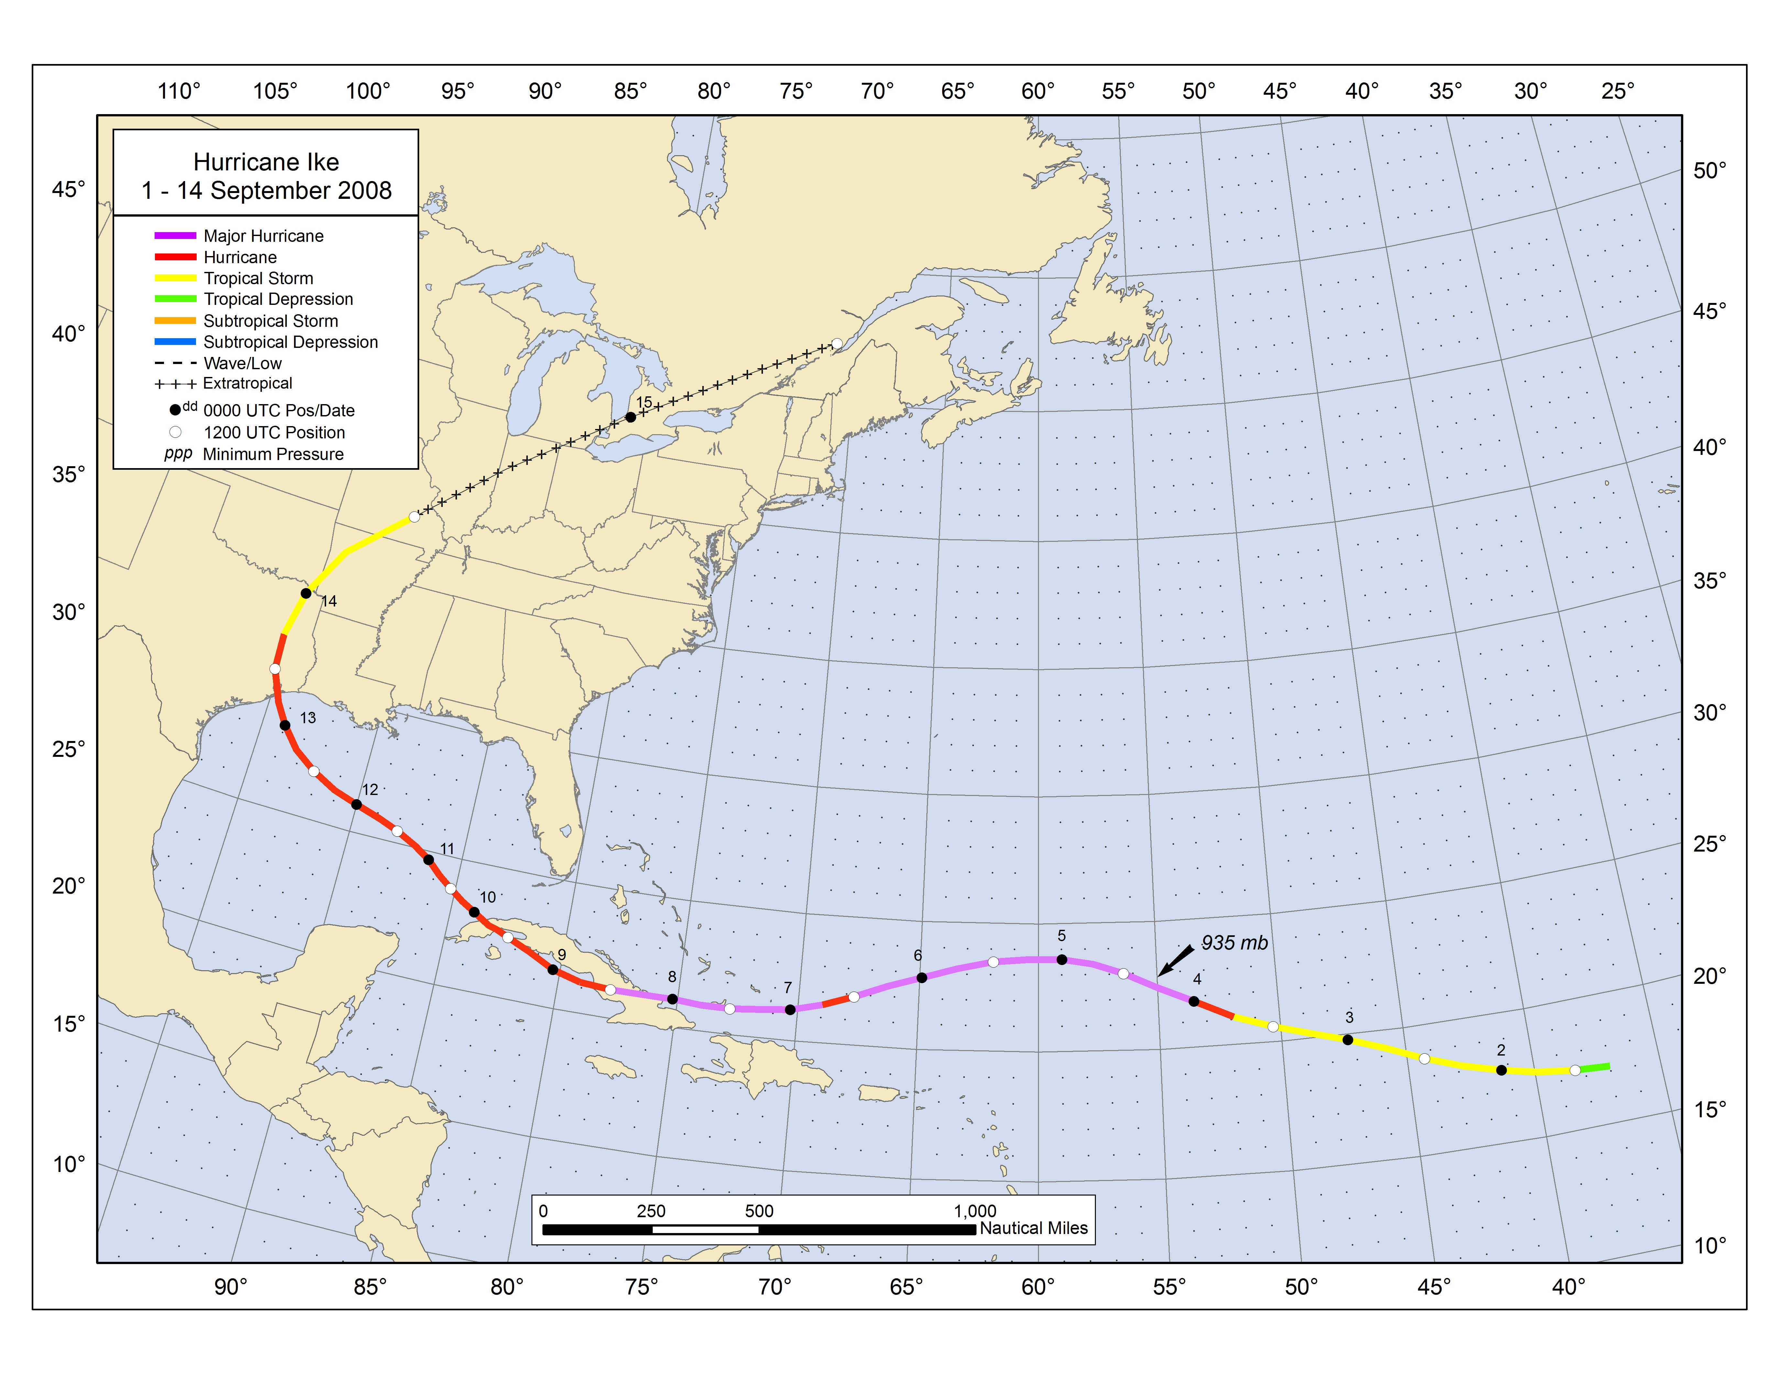
Figure 1. Best track positions for Hurricane Ike, 1 – 14 September 2008. Track during the extratropical stage is based on analyses from the NOAA Hydrometeorological Prediction Center and Environment Canada.
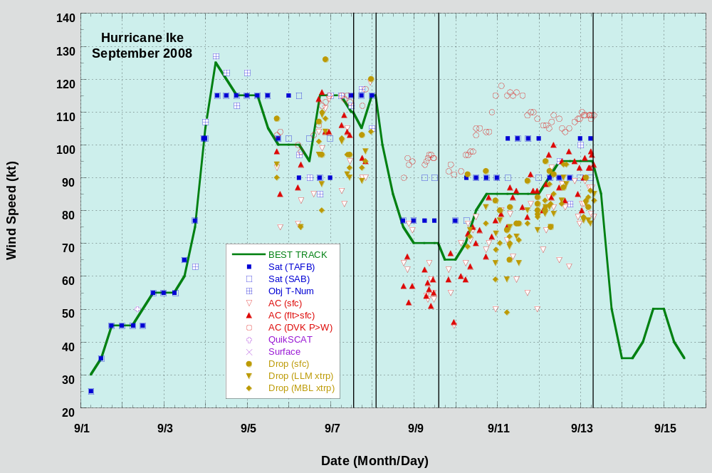
Figure 2. Selected wind observations and best track maximum sustained surface wind speed curve for Hurricane Ike, 1 – 14 September 2008. Aircraft observations have been adjusted for elevation using 90%, 80%, and 80% reduction factors for observations from 700 mb, 850 mb, and 1500 ft, respectively. Dropwindsonde observations include actual 10 m winds (sfc), as well as surface estimates derived from the mean wind over the lowest 150 m of the wind sounding (LLM), and from the sounding boundary layer mean (MBL). Objective Dvorak estimates represent linear averages over a three-hour period centered on the nominal observation time. Dashed vertical lines correspond to 0000 UTC. Solid vertical lines correspond to landfalls.
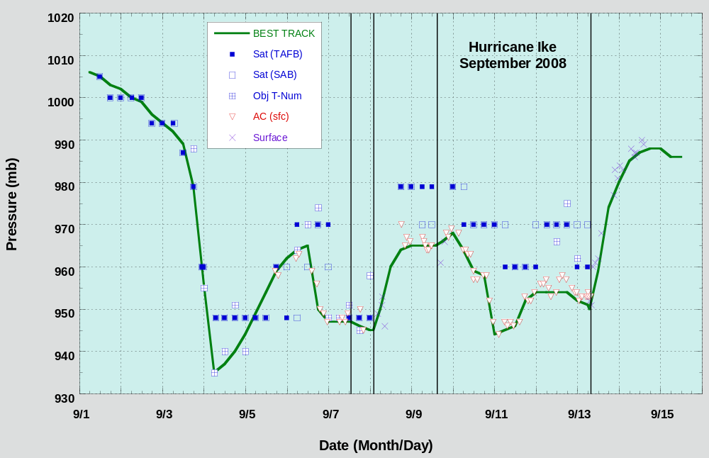
Figure 3. Selected pressure observations and best track minimum central pressure curve for Hurricane Ike, 1 – 14 September 2008. Objective Dvorak estimates represent linear averages over a three-hour period centered on the nominal observation time. Dashed vertical lines correspond to 0000 UTC. Solid vertical lines correspond to landfalls.
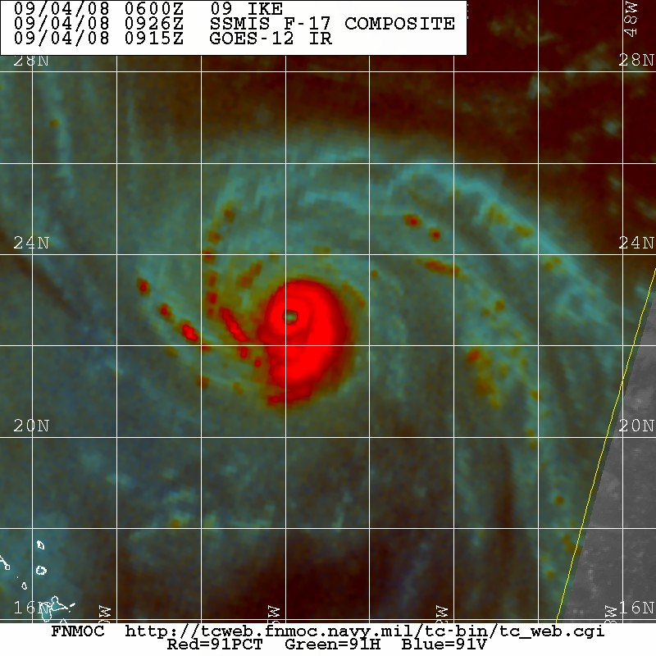
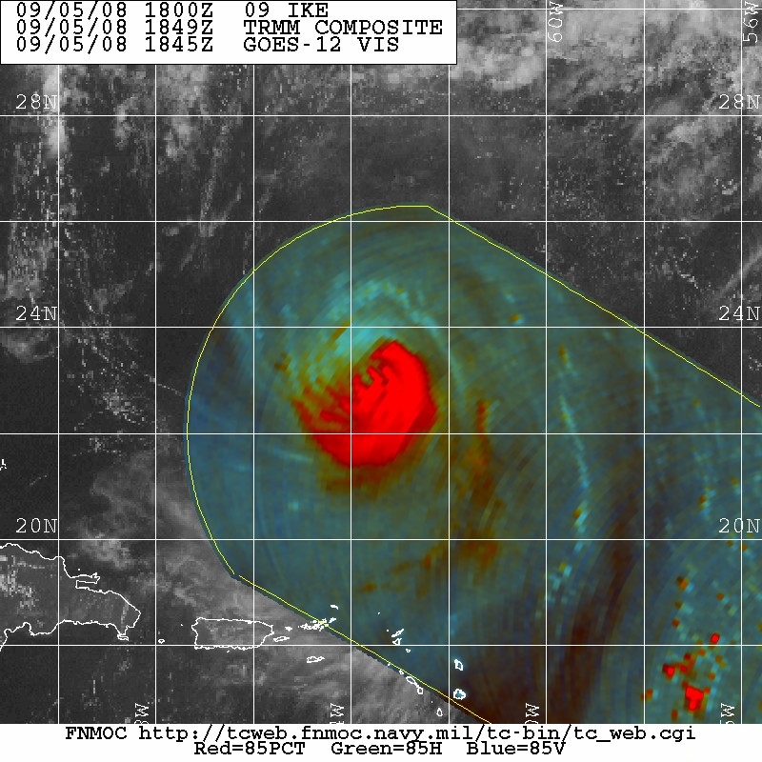
Figure 4. A comparison of microwave imagery for Hurricane Ike near the time of its peak intensity (left) and after it had endured several days of northerly and northeasterly shear. The left image is a 91 GHz SSMIS image at 0926 UTC 4 September, and the right image is an 85 GHz TRMM image at 1849 UTC 5 September. Note in the right image that an eye is still present despite the strong northerly shear that has completely eroded the deep convection in the northern eyewall. Image courtesy of the Fleet Numerical Meteorology and Oceanography Center.
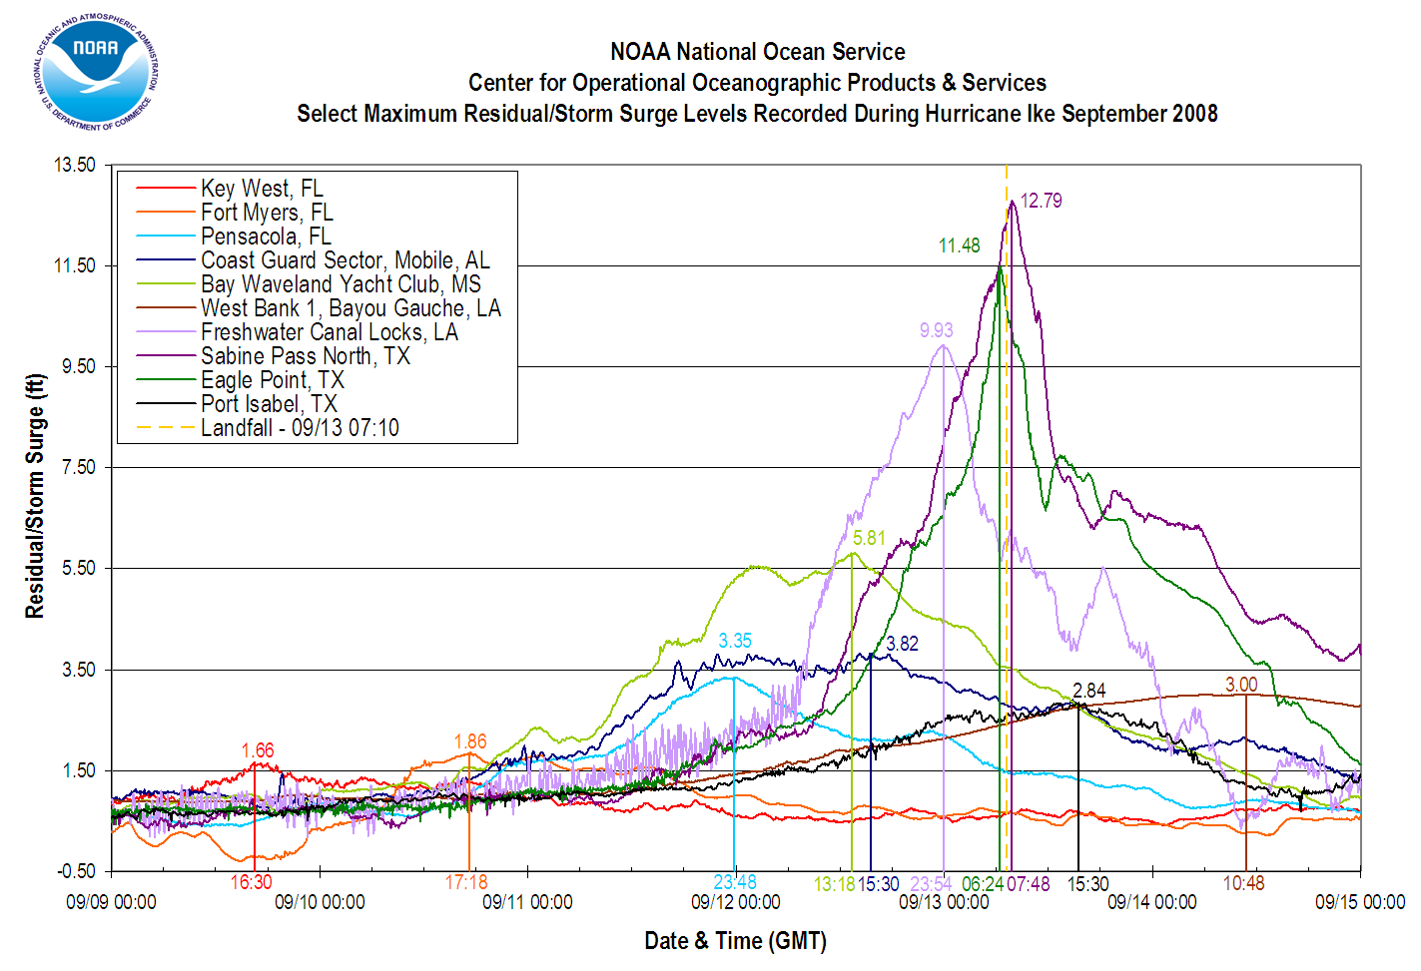

Figure 5. A synopsis of the progression of storm surge associated with Hurricane Ike across the Gulf of Mexico. The time and magnitude of maximum storm surge levels (referenced to Mean Lower Low Water) are shown at geographically representative National Ocean Service observation stations. Figure courtesy of the National Ocean Service.
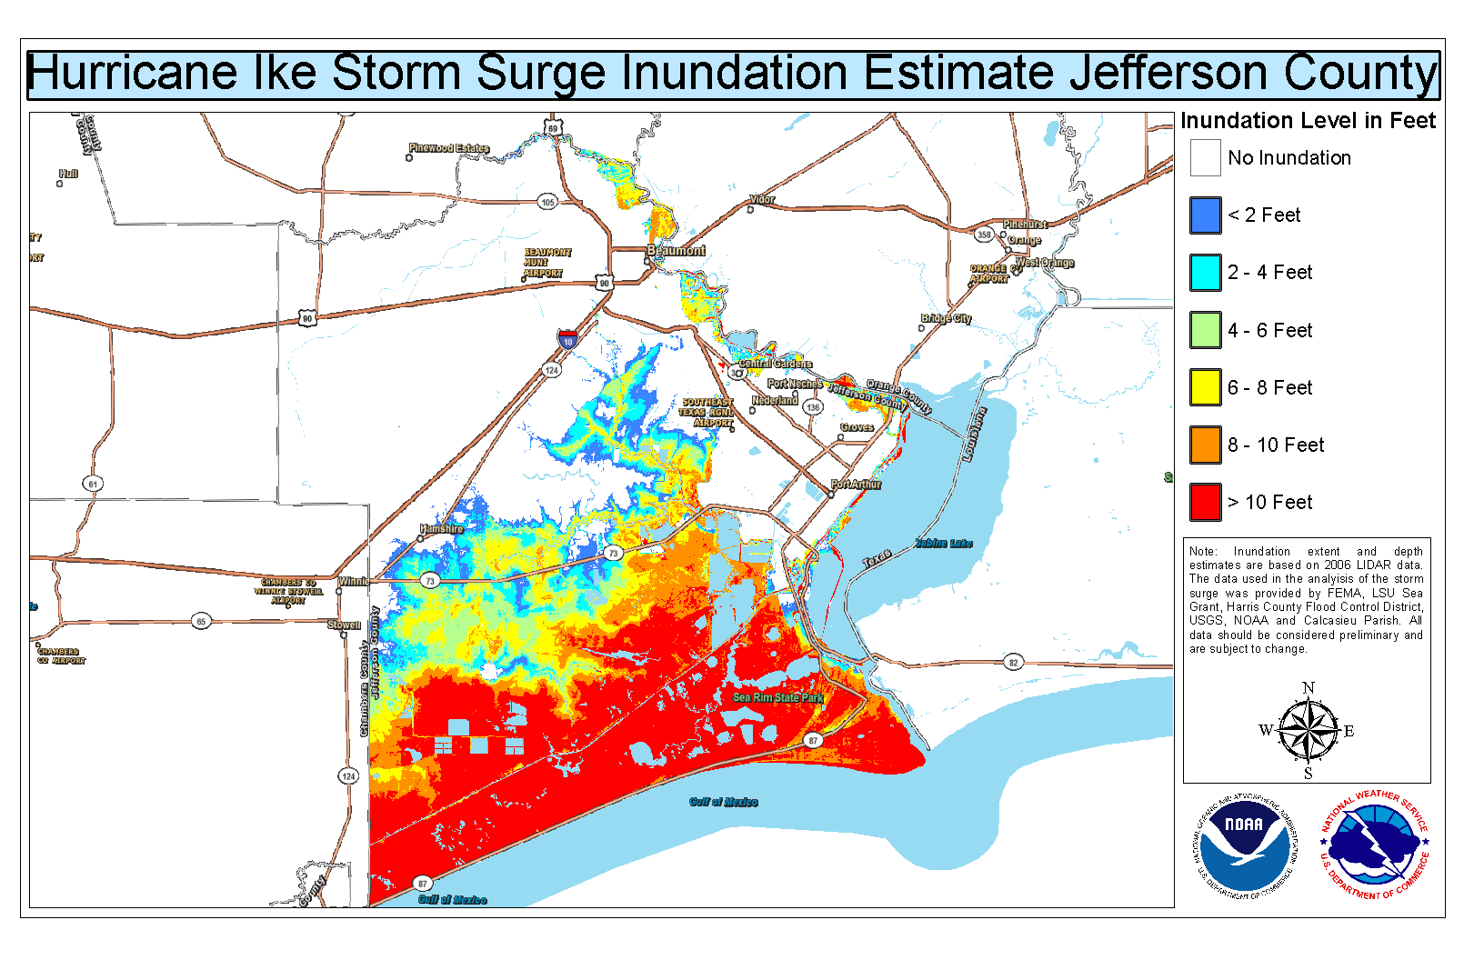
Figure 6. Maximum storm surge inundation levels (water depth) across Jefferson County, Texas, during Hurricane Ike. Areas shaded in red indicate where the water depths exceeded 10 ft. Image courtesy of the Lake Charles WFO.

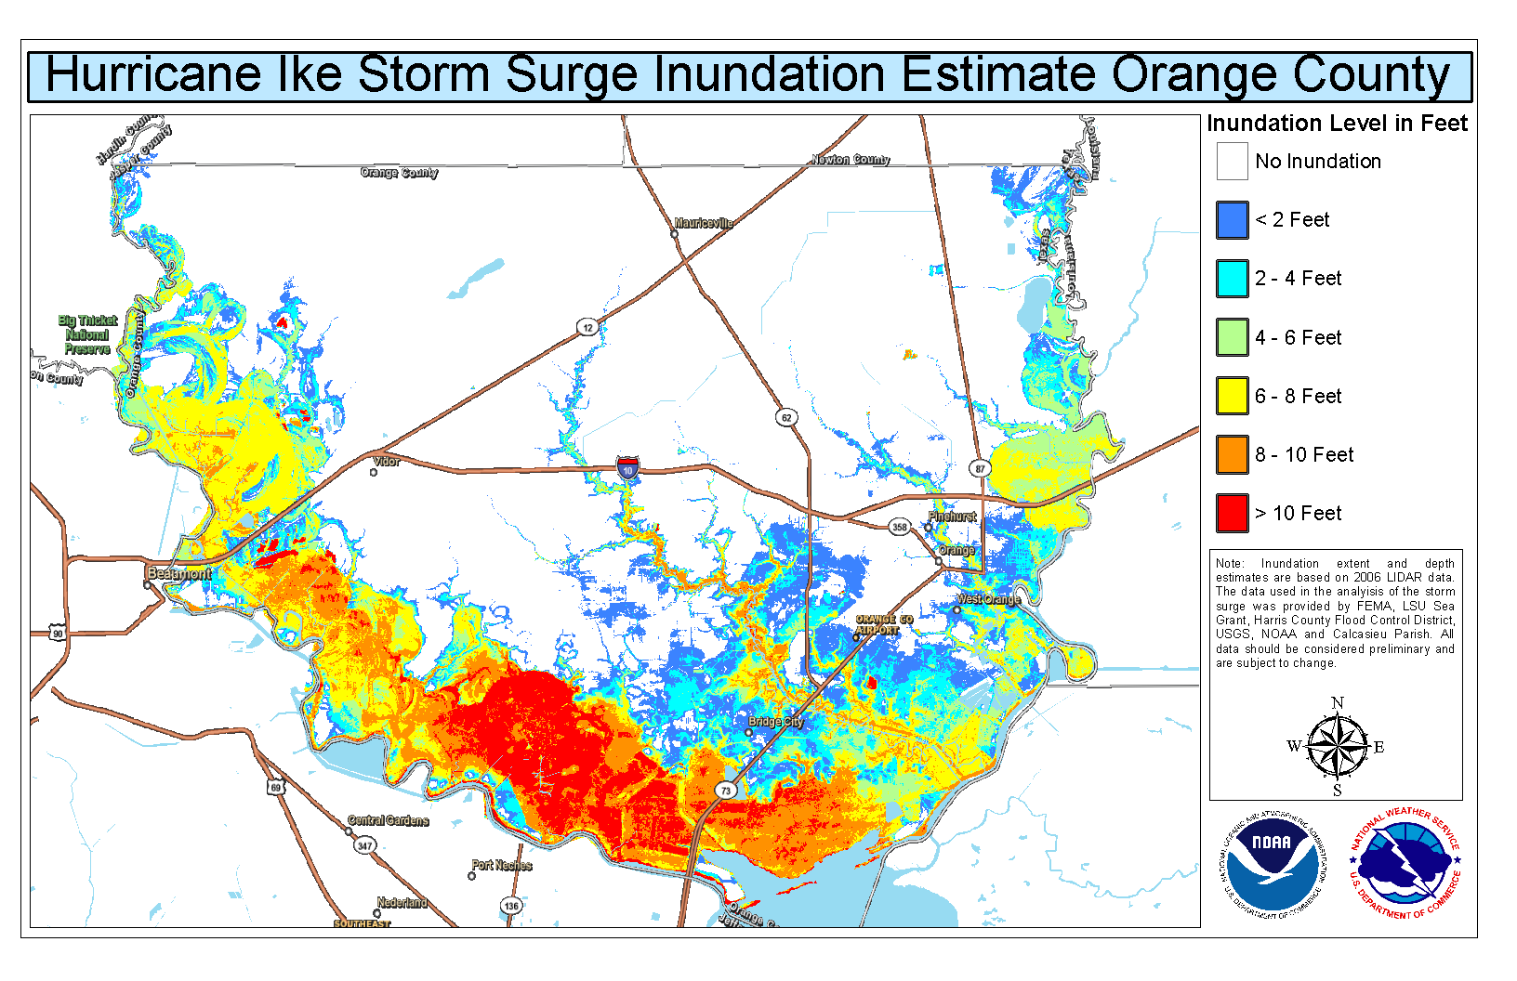
Figure 7. Maximum storm surge inundation levels (water depth) across Orange County, Texas, during Hurricane Ike. Areas shaded in red indicate where the water depths exceeded 10 ft. Image courtesy of the Lake Charles WFO.
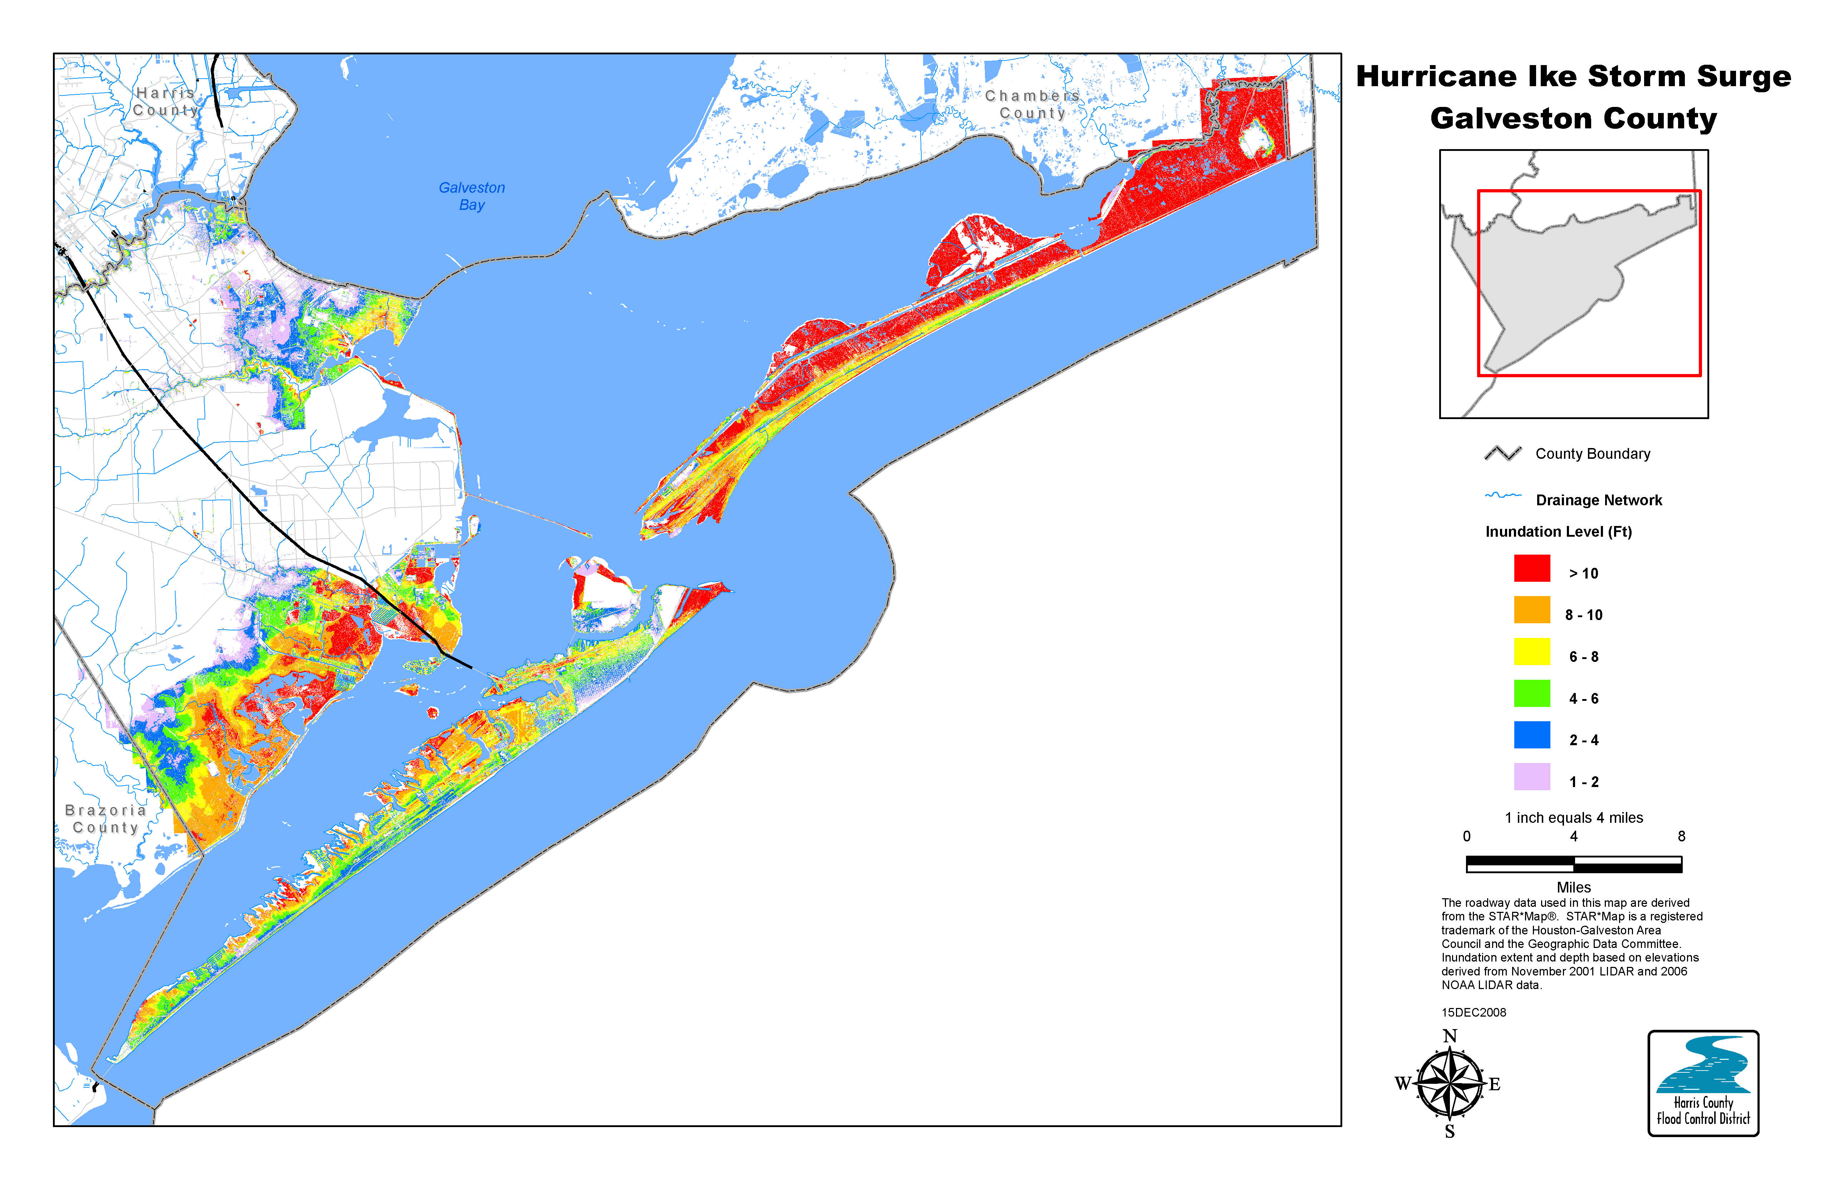
Figure 8. Maximum storm surge inundation levels (water depth) for Galveston County, Texas, including Galveston Island and the Bolivar Peninsula, during Hurricane Ike. Areas shaded in red indicate where the water depths exceeded 10 ft. Image courtesy of the Harris County Flood Control District.
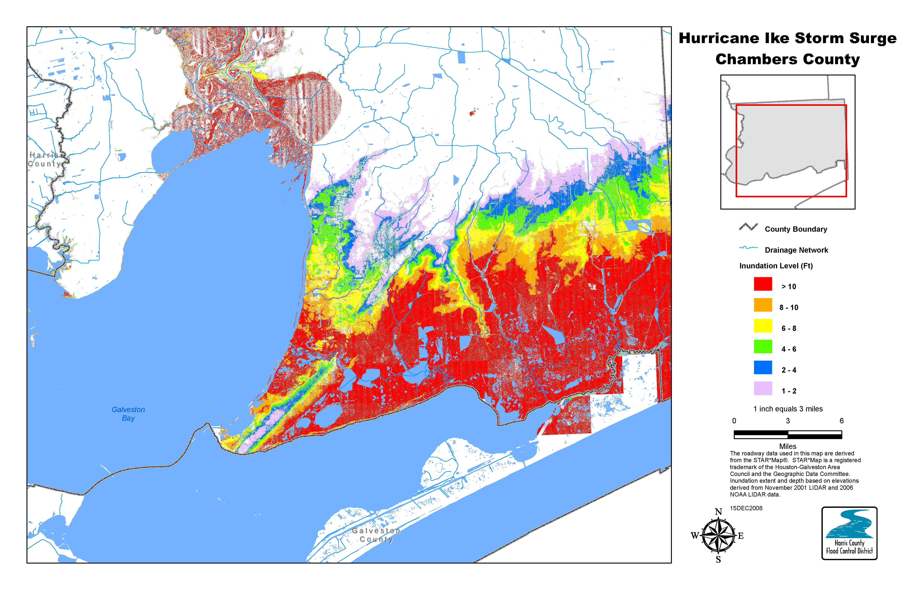
Figure 9. Maximum storm surge inundation levels (water depth) across Chambers County, Texas, during Hurricane Ike. Areas shaded in red indicate where the water depths exceeded 10 ft. Image courtesy of the Harris County Flood Control District.

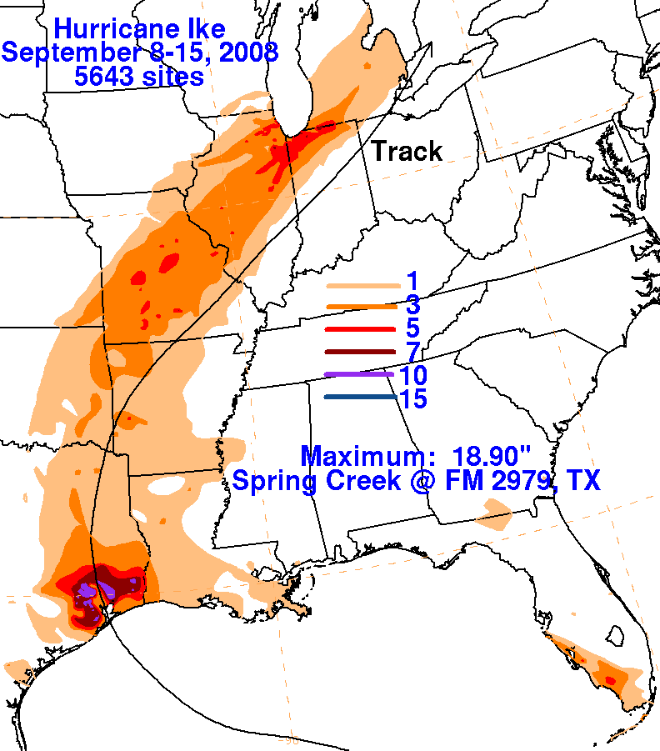

Figure 10. Storm total precipitation associated with Hurricane Ike, 1 – 14 September 2008, and its remnants. Figure courtesy of David Roth at the Hydrometeorological Prediction Center.
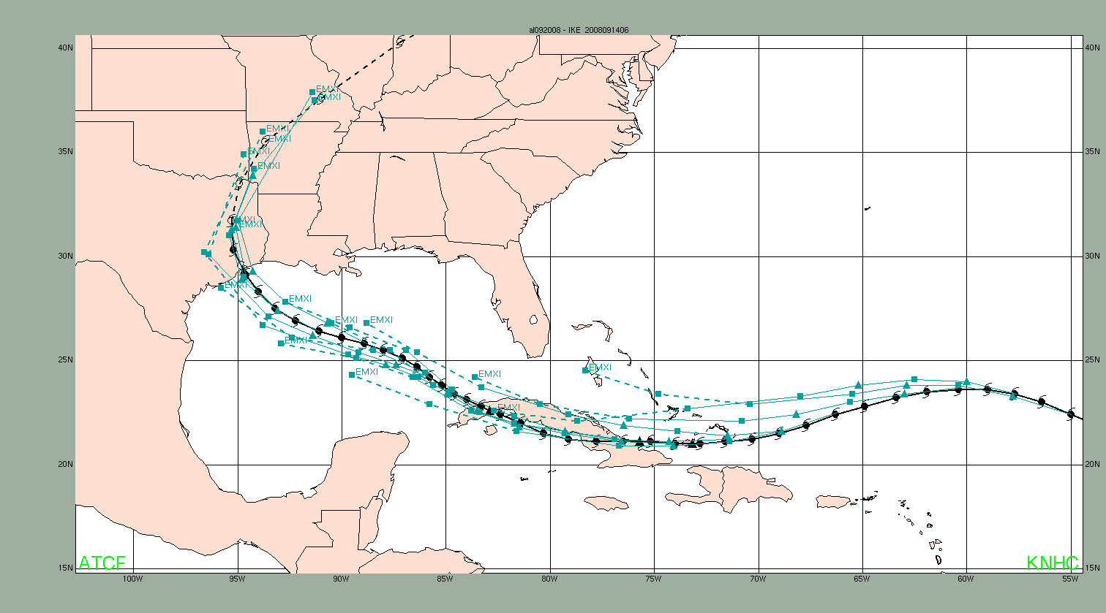
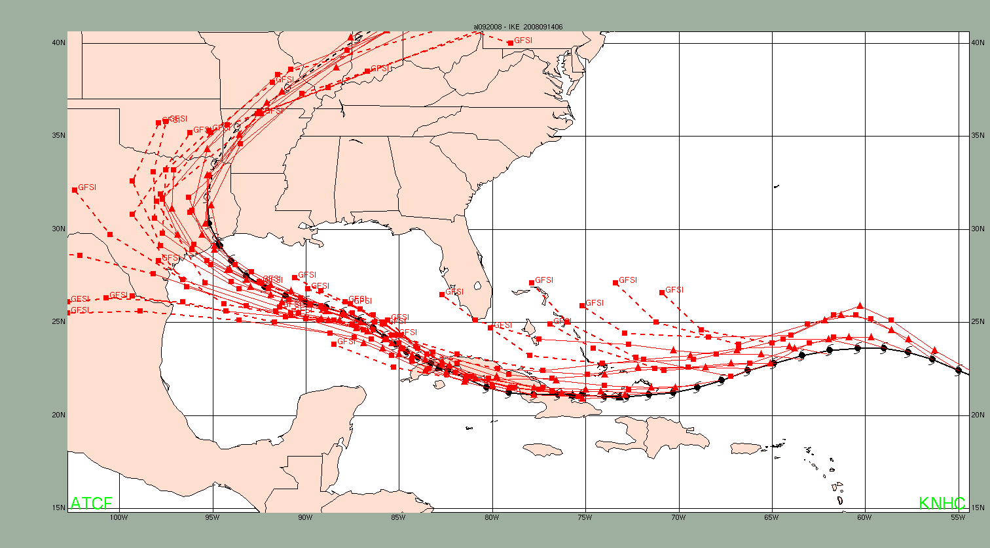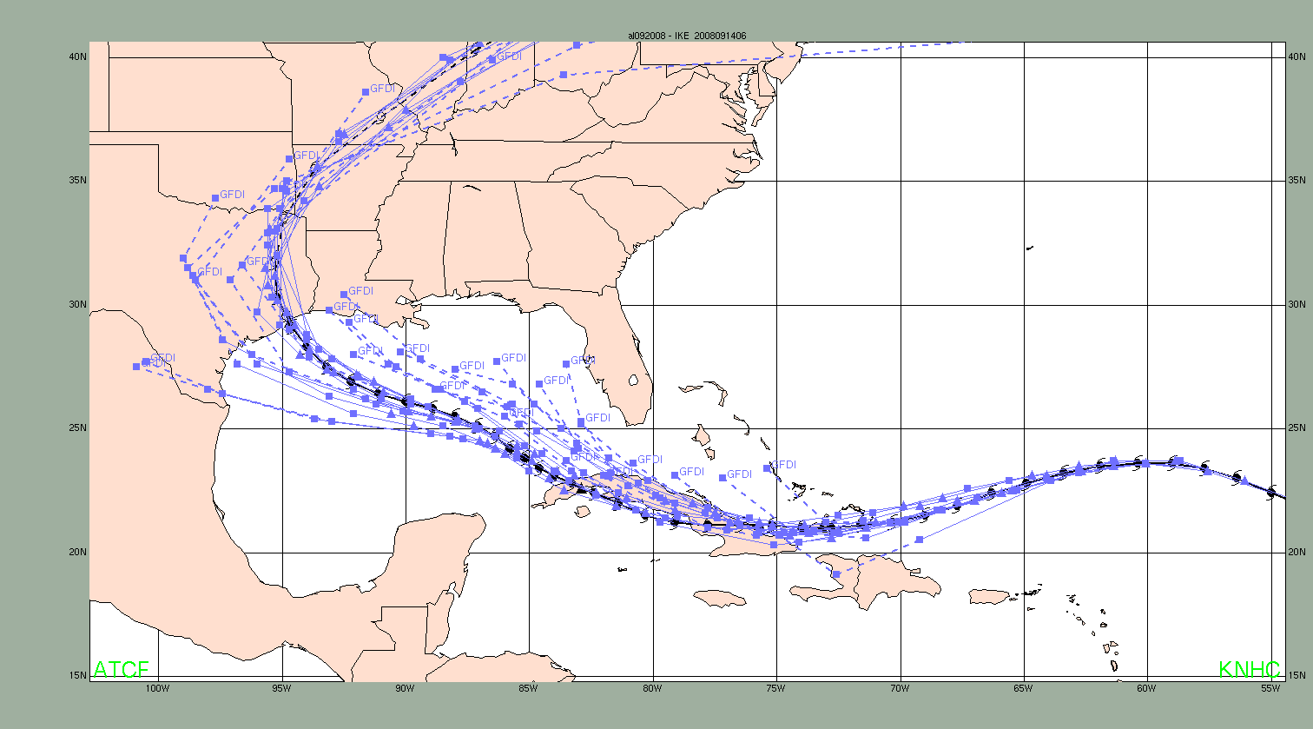
(a)
(b)
(c)
(d)
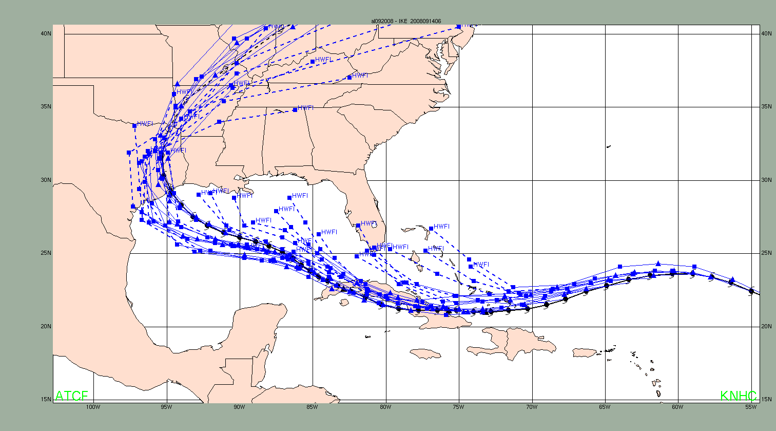
Figure 11. Guidance track forecasts from 0000 UTC 4 September through 0600 UTC 14 September from (a) GFSI (red), (b) EMXI (teal), (c) GFDI (purple), and (d) HWFI (blue) for Hurricane Ike, 1 – 14 September 2008. The best track is given by the thick solid black line with positions given at 6 h intervals.
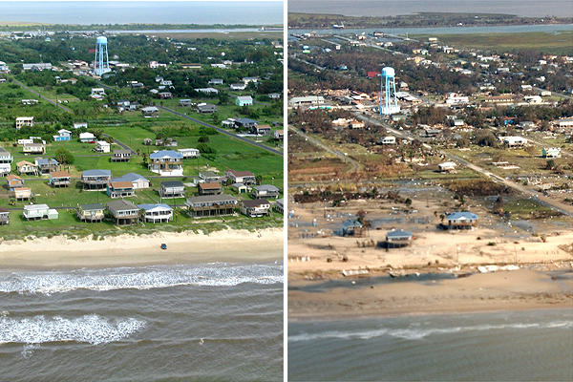
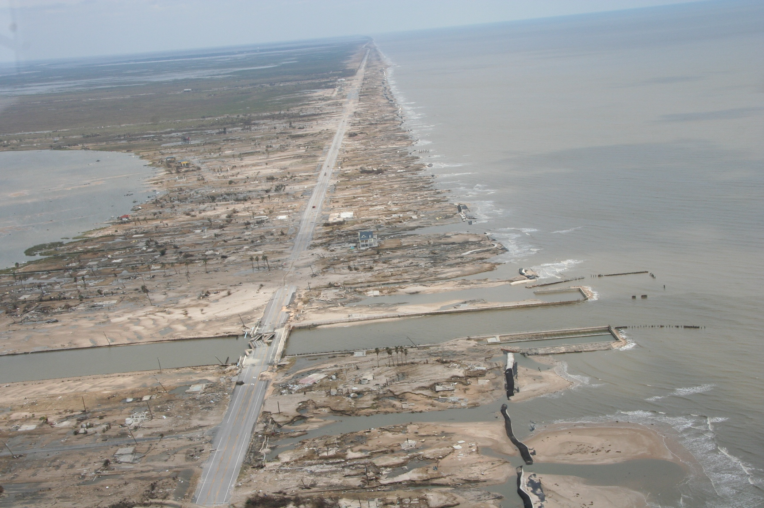
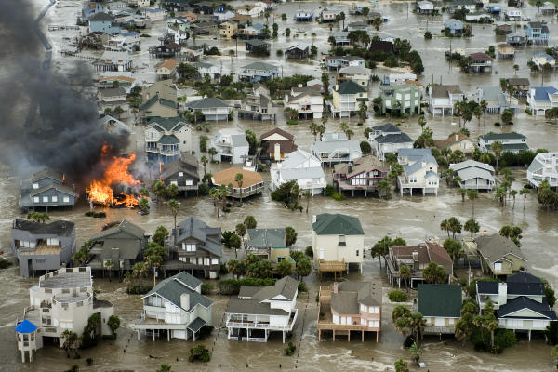

(a)
(b)
(c)
(d)
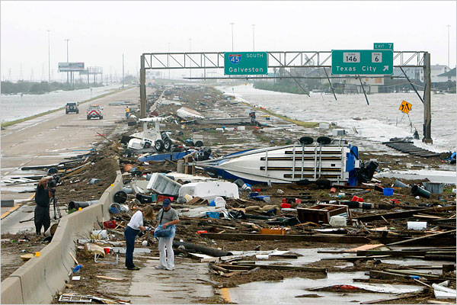

(e)
(f)

Figure 12. (a) Waves crash over the Galveston Seawall and the memorial for the 1900 Galveston Hurricane before the arrival of Hurricane Ike (courtesy Johnny Hanson, Houston Chronicle). (b) House on fire on Galveston Island as storm surge waters rise in advance of Ike (courtesy Smiley N. Pool, Houston Chronicle). (c) Devastation on the Bolivar Peninsula due to storm surge from Ike (courtesy NWS Houston/Galveston and Galveston County Office of Emergency Management). (d) Before and after image of the Bolivar Peninsula depicting the effects of storm surge (courtesy U.S. Geological Survey). (e) Debris, boats, and trailers on the southbound lanes of I-45 heading towards Galveston (courtesy Eric Kayne, Houston Chronicle). (f) Ships waiting to enter Galveston Bay after Hurricane Ike (image courtesy Smiley N. Pool, Houston Chronicle).

A digital record of the complete best track, including wind radii, can be found on line at ftp://ftp.nhc.noaa.gov/atcf. Data for the current year’s storms are located in the btk directory, while previous years’ data are located in the archive directory.

