Tropical Cyclone Report
Hurricane Ernesto
(AL062006)
24 August – 1 September 2006

Richard D. Knabb and Michelle Mainelli
National Hurricane Center
15 December 2006

Updated 10 January 2007 to adjust storm ID from AL052006 to AL062006

Ernesto was briefly a marginal category 1 hurricane (on the Saffir-Simpson Hurricane Scale) over the central Caribbean Sea, and it was a strong tropical storm over the extreme western Atlantic Ocean, including at its final landfall in North Carolina. While impacts from landfalls in Florida and Cuba were limited, the storm produced torrential rainfall and floods in portions of Hispaniola and eastern North Carolina. Gale-force winds and heavy rains associated with Ernesto also impacted portions of Virginia, Maryland, Delaware, and New Jersey. Ernesto was directly responsible for five fatalities in Haiti.

- Synoptic History

Ernesto formed from a tropical wave that emerged from the west coast of Africa on 18 August and moved steadily but uneventfully westward across the tropical Atlantic during the following several days. On 23 August, however, convection associated with the wave increased, and Dvorak satellite classifications from the Tropical Analysis and Forecast Branch (TAFB) of the Tropical Prediction Center/National Hurricane Center (TPC/NHC) began at 1200 UTC, when the wave was located about 500 n mi east of the Lesser Antilles. As the wave approached the Lesser Antilles, a surface low formed near the southern Windward Islands. The system soon acquired enough of a circulation to be designated a tropical depression at 1800 UTC 24 August while centered about 40 n mi north-northwest of Grenada. The “best track” chart of the tropical cyclone’s path is given in Fig. 1, with the wind and pressure histories shown in Figs. 2 and 3, respectively. The best track positions and intensities are listed in Table 1.

Convection increased over the low-level center of the depression as it moved toward the west-northwest along the southern periphery of a mid-level ridge over the western Atlantic. The cyclone became a tropical storm at 1200 UTC 25 August while centered about 280 n mi south of San Juan, Puerto Rico. Tropical Storm Ernesto gradually turned toward the northwest and continued to intensify as it moved into the central Caribbean Sea on 26 August. The next day at about 0600 UTC, while Ernesto was centered about 70 n mi south of the southern coast of Haiti, it very briefly reached hurricane status with maximum sustained winds of 65 kt and a minimum pressure of about 992 mb. Shortly thereafter, the small inner core of the storm deteriorated and the circulation interacted with the mountainous terrain of Haiti, and Ernesto quickly weakened back to a tropical storm. The center of circulation passed offshore very near the southwestern tip of Haiti at about 0000 UTC 28 August, and by that time the intensity had decreased to 40 kt. Aided by southwesterly shear associated with an upper-level low over the Bahamas, the weakening trend continued early on 28 August as Ernesto moved northwestward toward Cuba. The storm had maximum sustained winds of 35 kt as its center made landfall along the southeastern coast of Cuba, near Playa Cazonal and just west of Guantanamo Bay, at 1115 UTC 28 August. Ernesto turned northwestward and its center remained inland over Cuba for about 18 hours, but it remained a tropical storm with an intensity of 35 kt during that time. The center emerged off the north-central coast of Cuba by 0600 UTC 29 August and the intensity increased slightly to 40 kt. A mid-level high pressure area over the southeastern United States was migrating eastward during this period, allowing Ernesto to continue northwestward. The storm began to traverse the warm waters of the Straits of Florida late on 29 August, and convection gradually increased. Apparently still hindered by disruption of the inner core over Cuba, and possibly influenced by moderate easterly wind shear, Ernesto did not gain any strength between Cuba and southern Florida.

Ernesto made landfall at Plantation Key, Florida, in the upper Florida Keys, around 0300 UTC 30 August. A short time later, around 0500 UTC, a second Florida landfall occurred on the Florida mainland in southwestern Miami-Dade County. At both landfalls Ernesto had maximum sustained winds of 40 kt and a minimum central pressure of 1003 mb. Thereafter, Ernesto weakened only slightly, and it remained a tropical storm with maximum sustained winds of 35 kt throughout the remainder of its path over Florida. The storm moved northward along the center of the Florida peninsula and within a weakness in the mid-level ridge, and the cyclone passed over Lake Okeechobee around 1800 UTC 30 August. Ernesto gradually turned north-northeastward, and its center emerged over the Atlantic Ocean near Cape Canaveral, Florida very early on 31 August.

Fueled by the warm waters of the Atlantic, convection increased over the center of the cyclone, and Ernesto intensified to a strong tropical storm as it continued north-northeastward ahead of a deep layer trough approaching from the west. It reached an intensity of 60 kt by 1800 UTC 31 August while centered about 150 n mi south-southwest of Wilmington, North Carolina. The central pressure continued to gradually fall and an eye was becoming discernible in satellite imagery as the storm center approached the coast. The center came ashore at 0340 UTC 1 September on Oak Island, North Carolina, a few miles south-southwest of Wilmington and just west of Cape Fear. At the time of final landfall, Ernesto was very near the threshold between tropical storm and hurricane status, with an intensity of 60 kt and a minimum pressure of 985 mb. Thereafter, Ernesto weakened as it moved across eastern North Carolina where it became a tropical depression by 1200 UTC 1 September. Even before Ernesto made final landfall, however, it combined with a high pressure system centered over southeastern Canada to indirectly produce gale-force winds near the coasts of Virginia, Maryland, Delaware, and New Jersey.

Ernesto reached the North Carolina/Virginia border at about 1800 UTC 1 September, although by that time it had transformed into an extratropical cyclone, as it interacted with a pre-existing frontal zone that extended eastward from Virginia. The intensity of Ernesto as an extratropical cyclone as it moved slowly northward over Virginia and Maryland on 2 September is estimated at 40 kt. By 1800 UTC that day, extratropical Ernesto was centered very near Washington, D.C., and after that time the system began to weaken. On 3 September, it was no longer producing gale-force winds as it accelerated across Pennsylvania and New York into southeastern Canada, and it was absorbed into a larger extratropical low pressure system the next day.

- Meteorological Statistics

Observations in Ernesto (Figs. 2 and 3) include data from satellites, aircraft, airborne and ground-based radars, conventional land-based surface and upper-air observing sites, Coastal-Marine Automated Network (C-MAN) stations, National Ocean Service (NOS) stations, ocean data buoys, and ships. Selected ship reports of winds of tropical storm force associated with Ernesto are given in Table 2, and selected surface observations from land stations and from coastal data buoys are given in Table 3.

Satellite observations include geostationary satellite-based Dvorak Technique intensity estimates from TAFB, the Satellite Analysis Branch (SAB), and the U. S. Air Force Weather Agency (AFWA). Microwave satellite data and imagery from National Oceanic and Atmospheric Administration (NOAA) near-polar-orbiting satellites, Defense Meteorological Satellite Program (DMSP) satellites, and National Aeronautics and Space Administration (NASA) satellites including the Tropical Rainfall Measuring Mission (TRMM), QuikSCAT, and Aqua, were also useful in tracking Ernesto.

Aircraft reconnaissance missions were tasked on an almost continuous schedule, from the genesis of Ernesto until its final landfall, except for periods when the cyclone was over the landmasses of Cuba and Florida. Observations from aircraft include flight-level and dropwindsonde data from 13 operational missions conducted by the 53rd Weather Reconnaissance Squadron of the U. S. Air Force Reserve Command. Two missions were flown by the NOAA Aircraft Operations Center (AOC) Hurricane Hunter WP-3D aircraft, which provided real-time data from the Stepped-Frequency Microwave Radiometer (SFMR).

NWS WSR-88D Doppler radars in coastal regions of the southeastern United States provided data for center fixes on Ernesto. NWS WSR-88D velocity data were used to help estimate the intensity of Ernesto when it was near or over land.

Ernesto was briefly near the threshold between tropical storm and hurricane strength over the central Caribbean Sea early on 27 August. Flight-level and dropwindsonde observations from a U. S. Air Force reconnaissance aircraft were available during this period, but NOAA aircraft equipped with the SFMR did not investigate Ernesto over the Caribbean Sea. A dropsonde at 0832 UTC provided a surface wind estimate, derived from the mean wind over the lowest 150 m of the sounding (labeled ‘LLM’ in Fig. 2), of 56 kt. This dropsonde also directly measured a wind speed of 64 kt at 10 m, but post-storm analysis of the vertical profile suggests that this single observation was more likely a gust and not representative of the maximum sustained surface wind. The strongest flight-level wind measurement that day was 78 kt at 0732 UTC, corresponding to about 62 kt at the surface using the average adjustment from 850 mb. One hour later at 0834 UTC, the aircraft measured a flight-level wind of 69 kt at 700 mb, which also corresponds to about 62 kt at the surface. Given our inability to sample the entire circulation, somewhat stronger winds could be expected to have occurred elsewhere during this period and would be consistent with the operational estimate of Ernesto briefly having 65 kt winds near 0600 UTC 27 August. The hurricane-force winds would likely have occurred only in a very small area near the center.

Ernesto is estimated to have made landfall in the Florida Keys and the southern Florida peninsula with an intensity of 40 kt based on aircraft data. The strongest sustained surface wind measured in Florida was 35 kt on Lake Okeechobee, by an instrument operated by the South Florida Water Management District (SFWMD), at 2030 UTC 30 August (Table 3). The Lake Worth C-MAN station, on the Atlantic coast in Palm Beach County, also reported a sustained wind of 35 kt that day. Since both of these SFWMD observations were 15-minute averages, the 1-minute sustained wind at these locations could have been stronger, but no other data were available to confirm this. These data provide supporting evidence that Ernesto remained a tropical storm throughout its entire path over Florida, although the only areas to receive sustained winds of tropical storm force were near or over water.

Ernesto was again near the threshold between tropical storm and hurricane status before and at the time of landfall in North Carolina. The strongest flight-level (850-mb) wind on 31 August was 73 kt at 1947 UTC, corresponding to about 58 kt at the surface. The SFMR estimated 60–65 kt near 1800 UTC, but the higher end of this range results from isolated peak values that appear slightly inflated by rain and therefore are not considered representative of the maximum sustained surface wind. Radar velocities measured from the WSR-88D at Wilmington, North Carolina reached 80–84 kt at an altitude of 1500 ft just west of the circulation center less than three hours prior to landfall, corresponding to about 60–63 kt at the surface, but the highest values were associated with a transient, mesoscale feature. Fig. 4 is a WSR-88D radar reflectivity depiction of Ernesto at about that same time. The aircraft and radar data reveal no wind observations corresponding to sustained surface winds of 64 kt or greater during the several hours prior to and including final landfall of the center, and the best track intensity during that period is set to 60 kt. Since it is possible, however, that the maximum wind was not sampled, Ernesto might have reached hurricane strength near North Carolina.

The lowest central pressure of 985 mb occurred near the time of final landfall as indicated by a surface observation of 985.4 mb at Wilmington. The central pressure remained relatively low as Ernesto proceeded inland. For example, a pressure of 988.5 mb was measured at Kinston, North Carolina, located about 90 n mi inland from the center’s landfall location, at 0940 UTC 1 September or about six hours following landfall. The strongest sustained wind measured by an official surface-based anemometer in North Carolina was 50 kt at the NOS station at Wrightsville Beach (Johnny Mercer Pier), where a gust to 64 kt was also reported. An unofficial gust to 79 kt was reported at Cedar Island (just northeast of Cape Lookout). Based on gage data, the storm surge produced by Ernesto was as high as about 3 ft (e.g., 2.9 ft at Wrightsville Beach NOS), although a total water rise (storm tide) of about 6 ft was reported in a few locations. The surge affected a long stretch of the North Carolina coastline, including in bays, harbors, and rivers adjacent to Pamlico Sound as far north as Dare County (north of Cape Hatteras) (Table 3).

A large area of high pressure centered over southeastern Canada combined with the approaching Ernesto, even prior to its landfall, to produce sustained gale-force winds and some rather heavy rains over and near the coasts of Virginia, Maryland, Delaware, and New Jersey (Table 3). Those winds were indirectly related to Ernesto and are therefore not reflected in the best track intensity. As the extratropical remnant of Ernesto moved slowly over eastern Virginia and Maryland late on 1 September and on the following day, it was directly responsible for the gale-force winds in those areas. The intensity of 40 kt for extratropical Ernesto during that period is based on several surface observations near the coast that were directly involved in the cyclonic circulation. This complex series of events resulted in some storm surge flooding along the western shores of Chesapeake Bay and the adjacent rivers, where storm tides of up to about 6 ft were reported.

Ernesto, its extratropical remnant, and the combination of Ernesto and the high pressure system to its north resulted in significant rainfall over the mid-Atlantic coastal regions of the United States. The storm also produced some large rainfall amounts over portions of Florida and the Greater Antilles (Table 3 and Fig. 5). Storm-total rainfall amounts exceeded 5 in throughout a broad swath across eastern portions of South Carolina, North Carolina, and Virginia, as well as southern Maryland. More than 10 in of rain fell in several locations in North Carolina and Virginia, including a maximum of 14.61 in at Wrightsville Beach, North Carolina. The heavy rains also led to river flooding for several days after Ernesto’s landfall. In particular, the Northeast Cape Fear River crested at 18.8 ft at Chinquapin, well north of Wilmington, and remained in major flood stage during 2–7 September. The large metropolitan areas of southeastern Florida escaped with no more than an inch or two of rain from Ernesto. The storm dropped 3–6 in of rain, however, in many areas near the path of the storm’s center, from the Cape Canaveral area to Lake Okeechobee, in portions of southwestern Florida, and in isolated spots in the Upper Florida Keys. A storm-total maximum of 8.72 in was reported at the South Golden Gate Estates SFWMD station located in Collier County east of Naples. In the Caribbean, 3–5 in of rain were common over much of eastern Cuba as Ernesto moved over the island, with a maximum of 7.46 in reported at Nuevitas in the province of Camaguey. About 7 in of rain fell at Barahona, Dominican Republic as the center of Ernesto passed to the southwest (Table 3).

A total of five weak tornadoes have been reported in association with Ernesto. Two of these touched down in Osceola County in central Florida on the afternoon of 30 August, and the other three were reported in eastern North Carolina on the evening of 31 August.

- Casualty and Damage Statistics

Ernesto was directly responsible for five fatalities reported in Haiti. Two deaths also occurred in Virginia when a tree fell on a residence in Gloucester, although these were not associated with Ernesto as a tropical cyclone. Ernesto was associated with damages in Haiti, the Dominican Republic, and coastal regions of the eastern United States. Most of the damages were caused by fresh water floods and storm surge, but some wind damage was also reported. The estimate of insured losses in the United States caused by Ernesto, provided by the Property Claim Services of the Insurance Services Office, is $245 million. Accounting for uninsured losses by doubling this amount yields an estimated total U. S. damage cost of $500 million.

In eastern North Carolina, heavy rains resulted in the flooding of several homes, and other homes were damaged by strong winds. For days following landfall, rain-induced river floods inundated several homes, such as in Chinquapin along the Northeast Cape Fear River north of Wilmington. Storm surge caused minor coastal flooding and beach erosion along the immediate Atlantic coastline. The surge along bays and rivers, such as the Pamlico and Pungo Rivers in Beaufort County and Collington Harbor in Dare County, flooded several homes and businesses. Minor property damages were caused by the three tornadoes in eastern North Carolina. In Virginia, storm surge along the western shores of the Chesapeake Bay and into tidal sections of adjacent rivers flooded several homes, and some piers and boats were significantly damaged. Strong winds downed trees and power lines in coastal areas of North Carolina, Virginia, Delaware, and New Jersey. Ernesto’s heavy rains in southwestern Florida caused flood waters to enter at least 13 homes in Palmdale, located a few miles west of Lake Okeechobee in Glades County. Ernesto caused mud slides and flooded many residences across the mountainous terrain of Hispaniola. At least six homes were destroyed and dozens more were damaged in Haiti, and a bridge was destroyed in Port-au-Prince. More than 400 homes were flooded in the city of Santo Domingo, Dominican Republic. Only minor damage was reported in Cuba.

- Forecast and Warning Critique

The genesis of Ernesto was anticipated very well in Tropical Weather Outlook products (TWOs) issued by the NHC. The incipient tropical wave was first mentioned in the TWO in the 11:30 am EDT issuance on 22 August, and the possibility of some slow development was indicated. Beginning at 10:30 pm EDT 22 August, more than 39 hours prior to the formation of a tropical depression, the TWO conveyed that the system had the potential to become a tropical cyclone within the next day or two.

A verification of official and guidance model track forecasts is given in Table 4. Average official track errors for Ernesto were 27, 47, 72, 102, 160, 260, and 415 n mi for the 12, 24, 36, 48, 72, 96, and 120 h forecasts, respectively. The number of verified forecasts ranged from 30 at 12 h to 12 at 120 h. These errors through 72 h are smaller than the average long-term official track errors (Table 4), but the 96-h and 120-h forecasts had errors larger than the long-term averages. The official track forecasts issued during the first few days of Ernesto’s existence were biased too far left, or west. These forecasts were based on the most reliable guidance models that were, especially on 25 and 26 August, tightly clustered on a path into the Gulf of Mexico. The model tracks shifted dramatically eastward on 27 August. As a result, after the storm reached Cuba early on 28 August, the official forecasts were fairly accurate in anticipating where Ernesto would go, including passage over Florida and the Carolinas. The official track forecasts had generally smaller average errors than most of the individual dynamical models at most forecast times, with the exceptions being the GFDI (interpolated GFDL) and the GFSI (interpolated GFS) and its ensemble mean (AEMI). The GFSI performed well, with average errors comparable to, and in some cases lesser than, those of the various consensus models, in part since it shifted farther eastward on 27 August than did the other models. Among the consensus models, the GUNA (combination of the GFDI, UKMI, NGPI, and GFSI tracks) had the smallest average errors, which were considerably smaller than the official errors at all forecast times.

A verification of official and guidance model intensity forecasts is given in Table 5. Average official intensity errors were 9, 15, 17, 18, 28, 34, and 35 kt for the 12, 24, 36, 48, 72, 96, and 120 h forecasts, respectively. For comparison, the average long-term official intensity errors are 6, 10, 12, 14, 18, 20, and 22 kt, respectively. Overall, official intensity forecasts were considerably poorer than the long-term averages and were biased quite high, largely because there was more interaction with land than anticipated. Ernesto provides an excellent example of how track and intensity forecasts are interdependent, especially near land areas. Since the official track forecasts issued during 24–26 August indicated Ernesto would move through the western Caribbean Sea and then into the Gulf of Mexico as a hurricane, they did not anticipate the storm’s weakening near Hispaniola and lack of strengthening over and beyond Cuba. Even the forecasts issued on 27 August, which included a track forecast directly over Cuba, could not confidently anticipate how much time Ernesto would spend over that island and how strong it would be thereafter. Once Ernesto emerged north of Cuba on 28 August, official forecasts called for the storm to strengthen before reaching Florida. The reasons for the lack of any strengthening over the warm waters between Cuba and Florida are not fully understood, but contributing factors might have included some modest easterly wind shear and the lingering effects of land interaction that disrupted the storm’s inner core. Official forecasts of the intensity of Ernesto issued within a couple of days of final landfall in North Carolina were reasonably accurate in anticipating a strengthening tropical storm, but they were biased slightly low. Although the official intensity forecasts had large errors, so did most of the intensity guidance models. A notable exception is the GFDI, which had much smaller errors than the official forecast and the remaining intensity models at 48–96 h, in part because of forecast tracks that went directly over Cuba and resulted in lower intensity forecasts.

Coastal watches and warnings that were issued in association with Ernesto are listed in Table 6. Hurricane watches (indicating the possibility of hurricane-force winds) were issued for portions of Florida beginning more than two days prior to the storm’s landfall in the Florida Keys, but Ernesto did not approach hurricane strength as it neared southern Florida. Hurricane watches were also issued for portions of the coasts of Georgia, South Carolina, and North Carolina, but Ernesto made landfall in North Carolina as a strong tropical storm. It is therefore important to note that a hurricane warning (indicating the expectation of hurricane-force winds) was never issued for any part of the United States. Tropical storm warnings were issued, however, in a timely manner (24 h or more in advance of landfall) for most areas directly affected by Ernesto from Florida to North Carolina. Additionally, gale warnings were issued for areas farther north by local NWS forecast offices in advance of the gale-force winds that occurred in those areas.

- Acknowledgements

Dr. Michael Brennan (UCAR Visiting Scientist at TPC) provided substantial assistance with data collection, assembling the data tables, and constructing the synoptic history. Large amounts of surface observations were provided by several National Weather Service Forecast Offices in the eastern United States and by the State Climate Office of North Carolina at North Carolina State University. Mr. Colin McAdie (NHC) conducted a thorough analysis of archived WSR-88D radar data provided by the NWS Weather Forecast Office in Wilmington, North Carolina. Appreciation is also extended to Dr. Peter Black and Mr. Eric Uhlhorn of the NOAA Hurricane Research Division for their analysis of the SFMR data.
Table 1. Best track for Hurricane Ernesto, 24 August – 1 September 2006.

Date/Time  (UTC) | Latitude  (°N) | Longitude  (°W) | Pressure  (mb) | Wind Speed  (kt) | Stage
24 / 1800 | 12.7 | 61.6 | 1008 | 30 | tropical depression
25 / 0000 | 13.0 | 63.0 | 1007 | 30 | "
25 / 0600 | 13.3 | 64.4 | 1005 | 30 | "
25 / 1200 | 13.7 | 65.8 | 1005 | 35 | tropical storm
25 / 1800 | 14.0 | 67.1 | 1004 | 35 | "
26 / 0000 | 14.3 | 68.3 | 1002 | 40 | "
26 / 0600 | 14.6 | 69.5 | 999 | 45 | "
26 / 1200 | 15.1 | 70.4 | 997 | 50 | "
26 / 1800 | 15.7 | 71.2 | 997 | 55 | "
27 / 0000 | 16.3 | 72.0 | 995 | 55 | "
27 / 0600 | 16.9 | 72.7 | 992 | 65 | hurricane
27 / 1200 | 17.4 | 73.4 | 997 | 55 | tropical storm
27 / 1800 | 17.8 | 74.0 | 1002 | 45 | "
28 / 0000 | 18.3 | 74.6 | 1003 | 40 | "
28 / 0600 | 19.1 | 75.2 | 1004 | 40 | "
28 / 1200 | 20.0 | 75.6 | 1005 | 35 | "
28 / 1800 | 20.8 | 76.4 | 1007 | 35 | "
29 / 0000 | 21.6 | 77.4 | 1007 | 35 | "
29 / 0600 | 22.4 | 78.5 | 1006 | 40 | "
29 / 1200 | 23.2 | 79.3 | 1006 | 40 | "
29 / 1800 | 23.9 | 79.9 | 1005 | 40 | "
30 / 0000 | 24.7 | 80.4 | 1004 | 40 | "
30 / 0600 | 25.3 | 80.8 | 1003 | 40 | "
30 / 1200 | 26.1 | 81.0 | 1002 | 35 | "
30 / 1800 | 27.0 | 80.9 | 1001 | 35 | "
31 / 0000 | 28.1 | 80.7 | 1000 | 35 | "
31 / 0600 | 29.4 | 80.4 | 999 | 45 | "
31 / 1200 | 30.6 | 79.9 | 995 | 55 | "
31 / 1800 | 31.9 | 79.2 | 993 | 60 | "
01 / 0000 | 33.2 | 78.4 | 988 | 60 | "
01 / 0600 | 34.5 | 78.0 | 985 | 50 | "
01 / 1200 | 35.8 | 77.6 | 991 | 30 | tropical depression
01 / 1800 | 36.6 | 77.2 | 997 | 40 | extratropical
02 / 0000 | 37.1 | 77.0 | 1002 | 40 | "
02 / 0600 | 37.6 | 76.8 | 1005 | 40 | "
02 / 1200 | 38.2 | 76.7 | 1007 | 40 | "
02 / 1800 | 38.9 | 76.7 | 1010 | 40 | "
03 / 0000 | 39.9 | 76.7 | 1012 | 35 | "
03 / 0600 | 41.3 | 77.1 | 1014 | 25 | "
03 / 1200 | 43.1 | 77.5 | 1014 | 20 | "
03 / 1800 | 44.5 | 77.0 | 1015 | 20 | "
04 / 0000 | 45.6 | 75.8 | 1015 | 20 | "
04 / 0600 | 46.5 | 74.4 | 1014 | 20 | "
04 / 1200 |  |  |  |  | merged with larger extratropical low
27 / 0600 | 16.9 | 72.7 | 992 | 65 | maximum wind over the central Caribbean Sea
28 / 1115 | 19.9 | 75.5 | 1005 | 35 | landfall at Playa Cazonal, Cuba
30 / 0300 | 24.9 | 80.6 | 1003 | 40 | landfall at Plantation Key, FL
30 / 0500 | 25.2 | 80.7 | 1003 | 40 | landfall in southwestern Miami-Dade County, FL
01 / 0340 | 33.9 | 78.1 | 985 | 60 | minimum pressure and landfall at Oak Island, NC

Table 2. Selected ship reports with winds of at least 34 kt for Hurricane Ernesto, 24 August – 1 September 2006.

Date/Time (UTC) | Ship call sign | Latitude  (°N) | Longitude  (°W) | Wind  dir/speed (kt) | Pressure  (mb)
26/1100 | C6FN4 | 13.9 | 68.8 | 170/52 | 1006.0
26/1200 | 6ZXG | 15.1 | 68.9 | 110/40 | 1008.5
26/1800 | V2AD6 | 14.1 | 68.0 | 110/37 | 1010.0
29/0600 | ZCDG8 | 19.0 | 75.8 | 140/35 | 1010.6
29/0900 | MSDM7 | 24.4 | 74.5 | 030/34 | 1012.9
29/1900 | KXDB | 25.7 | 77.2 | 130/35 | 1011.0
01/0000 | 3FUO7 | 32.3 | 77.9 | 130/52 | 987.5
01/0600 | A8BZ6 | 33.4 | 75.9 | 170/47 | 1008.0
01/1200 | ZIPR7 | 36.1 | 73.6 | 120/50 | 1009.3

Table 3. Selected surface observations for Hurricane Ernesto, 24 August – 1 September 2006. Note that some observations occurred when Ernesto was an extratropical cyclone or were indirectly associated with Ernesto.

Location | Minimum Sea Level Pressure |  | Maximum Surface  Wind Speed |  |  | Storm surge  (ft)^{c} | Storm  tide  (ft)^{d} | Total  rain  (in)
Location | Date/  time  (UTC) | Press.  (mb) | Date/  time  (UTC)ª | Sustained  (kt)^{b} | Gust  (kt) | Storm surge  (ft)^{c} | Storm  tide  (ft)^{d} | Total  rain  (in)
Puerto Rico
Official
Sabana Grande ALERT |  |  |  |  |  |  |  | 4.69
Dominican Republic
Las Americas (MDSD) | 27/0900 | 1012.0 |  |  |  |  |  | 4.13
Barahona (MDBH) | 28/2100 | 1011.2 |  |  |  |  |  | 7.01
Cuba
Guantánamo (78334) |  |  |  |  |  |  |  | 5.50
Guantánamo (78356) |  |  |  |  |  |  |  | 4.23
Guantánamo (78368) |  |  |  |  |  |  |  | 5.39
Punta de Maisi, Guantánamo (78369) |  |  |  |  |  |  |  | 5.13
Contramaestre, Santiago de Cuba (78363) |  |  |  |  |  |  |  | 3.54
Universidad, Santiago de Cuba (78364) |  |  |  |  |  |  |  | 3.60
Gran Piedra, Santiago de Cuba (78366) |  |  |  |  |  |  |  | 3.99
Punta Lucrecia, Holguín (78365) |  |  | 28/1715 |  | 49 |  |  | 3.41
Pinares de Mayari, Holguín (78371) |  |  |  |  |  |  |  | 2.87
Velasco, Holguín (78378) |  |  |  |  |  |  |  | 3.11
Nuevitas, Camagüey (78353) |  |  | 28/2015 |  | 45 |  |  | 7.46
Palo Seco, Camagüey (78354) |  |  |  |  |  |  |  | 3.28
Florida
Official
Marathon (KMTH) | 30/0910 | 1007.1 | 30/0839 | 23 | 28 |  |  | 3.18
Key West (KEYW) | 30/0942 | 1008.1 | 30/1008 | 25 | 34 |  |  | 1.35
Opa-Locka (KOPF) | 30/1153 | 1004.3 | 30/1315 | 30 | 35 |  |  | 0.34
Homestead (KHST) | 30/0655 | 1004.5 | 29/1655 | 22 | 33
Miami (KMIA) | 30/1153 | 1004.6 | 30/1257 | 22 | 32 |  |  | 0.72
West Kendall (KTMB) | 30/1116 | 1003.7 | 30/0638 | 22 | 32 |  |  | 1.53
Pompano Beach (KPMP) | 30/1353 | 1005.5 | 30/1238 | 29 | 40 |  |  | 0.86
Fort Lauderdale Executive Airport (KFXE) | 30/1353 | 1005.3 | 30/1731 | 26 | 34 |  |  | 0.73
Fort Lauderdale (KFLL) | 30/1312 | 1004.7 | 30/1312 | 25 | 37 |  |  | 1.26
Pembroke Pines (KHWO) | 30/1335 | 1005.1 | 30/1253 | 23 | 37 |  |  | 1.35
West Palm Beach (KPBI) | 30/1837 | 1006.1 | 30/1336 | 28 | 37 |  |  | 1.30
Naples (KAPF) |  |  | 30/2131 | 20 | 27 |  |  | 1.22
Miles City (RAWS) |  |  |  |  |  |  |  | 6.69
Tenraw (RAWS) |  |  |  |  |  |  |  | 2.97
Cache (RAWS) |  |  | 30/1015 |  | 38 |  |  | 3.52
17W Boynton Beach (RAWS) |  |  |  |  |  |  |  | 2.61
Lake Okeechobee LZ40^{i} (SFWMD) |  |  | 30/2030 | 35^{h} | 45
Lake Okeechobee L005^{i} (SFWMD) |  |  | 30/2000 | 34^{h} | 51
Lake Okeechobee L006^{i} (SFWMD) |  |  | 30/1900 | 25^{h} | 31
Lake Okeechobee L001^{i} (SFWMD) |  |  | 30/1945 | 23^{h} | 36
Loxahatchee^{i} (SFWMD) |  |  | 30/1745 | 24^{h} | 35
Chekika (CHKF1) |  |  | 30/1235 |  | 37
S331W^{i} (SFWMD) |  |  | 30/1245 |  | 34
S7WX^{i} (SFWMD) |  |  | 30/1645 |  | 32
Oasis (OASF1) |  |  | 30/1335 |  | 32
Clewiston (CFSW) |  |  | 30/1945 |  | 27
South Golden Gate^{i} (SFWMD) |  |  |  |  |  |  |  | 8.72
Fakahatchee Strand^{i} (SFWMD) |  |  |  |  |  |  |  | 8.37
Palmdale^{i} (SFWMD) |  |  |  |  |  |  |  | 6.19
Big Cypress Station 14^{i} (SFWMD) |  |  |  |  |  |  |  | 6.31
Big Cypress Station 17^{i} (SFWMD) |  |  |  |  |  |  |  | 5.17
Big Cypress Station 18^{i} (SFWMD) |  |  |  |  |  |  |  | 4.85
Immokalee Landfill^{i} (SFWMD) |  |  |  |  |  |  |  | 5.81
Hendry Landfill^{i} (SFWMD) |  |  |  |  |  |  |  | 4.71
Punta Gorda (KPGD) | 30/2018 | 1007.1 | 30/2113 | 17 | 21 |  |  | 2.27
Sebring (RAWS) |  |  |  |  |  |  |  | 3.82
Fort Pierce (KFPR) | 30/2201 | 1002.0 | 30/1717 | 26 | 34 |  |  | 1.12
Vero Beach (KVRB) | 30/2224 | 1001.7 | 30/2027 | 27 | 34 |  |  | 1.51
Melbourne (KMLB) | 30/2339 | 1001.0 | 31/0213 | 25 | 32 |  |  | 3.06
Orlando International (KMCO) | 30/2306 | 1003.7 | 30/2306 | 22 | 28 |  |  | 1.21
WFO Melbourne |  |  |  |  |  |  |  | 3.47
Unofficial
Cudjoe Key (Spotter) |  |  |  |  |  |  |  | 2.01
Big Pine Key (Handar) |  |  |  |  |  |  |  | 2.84
Big Pine Key (NWS Employee) |  |  |  |  |  |  |  | 4.59
Curry Hammock State Park/Vaca Key (COOP) |  |  |  |  |  |  |  | 3.91
Duck Key (Spotter) |  |  |  |  |  |  |  | 3.63
Tavernier (COOP) |  |  |  |  |  |  |  | 2.50
John Pennekamp State Park/Key Largo (COOP) |  |  |  |  |  |  |  | 2.32
Immokalee (IMKF1) |  |  |  |  |  |  |  | 5.96
Chokoloskee (CHOF1) |  |  |  |  |  |  |  | 4.90
Devils Garden (DVLF1) |  |  |  |  |  |  |  | 4.80
Moore Haven (MHVF1) |  |  |  |  |  |  |  | 4.78
Ortona (ORTF1) |  |  |  |  |  |  |  | 4.23
Clewiston (CWEF1) |  |  |  |  |  |  |  | 3.94
Big Cypress (BCIF1) |  |  |  |  |  |  |  | 3.30
Ochopee (OCOF1) |  |  |  |  |  |  |  | 3.24
Brighton Reservation (BRRF1) |  |  |  |  |  |  |  | 3.19
South Bay (SBYF1) |  |  |  |  |  |  |  | 3.10
Boca Raton |  |  | 30/1230 |  | 44
Port Everglades |  |  | 30/0830 |  | 32
Delray Beach |  |  | 30/1423 |  | 36
Boynton Beach | 30/1351 | 1005.1 | 30/1351 |  | 36
North Naples |  |  |  |  |  |  |  | 2.43
East Golden Gate |  |  |  |  |  |  |  | 5.37
NE Lehigh Acres (WU) |  |  |  |  |  |  |  | 4.38
Tice Fire Department (WU) |  |  |  |  |  |  |  | 2.39
Gateway/Lehigh Acres (WU) |  |  |  |  |  |  |  | 2.50
Lovers Key |  |  |  |  |  |  |  | 3.28
Punta Gorda 8NE |  |  |  |  |  |  |  | 2.09
Arcadia EOC (WU) |  |  |  |  |  |  |  | 2.53
Arcadia (FAWN) |  |  |  |  |  |  |  | 2.39
Archbold Bio Station |  |  |  |  |  |  |  | 5.97
Sebring (FAWN) |  |  |  |  |  |  |  | 3.47
Jensen Beach |  |  | 30/2326 |  | 40 |  |  | 0.97
Okeechobee (OKEF1) |  |  | 30/2330 |  | 31
Palm Bay |  |  |  |  |  |  |  | 2.31
Palm Bay/Turkey Creek |  |  |  |  |  |  |  | 2.42
Rockledge |  |  |  |  |  |  |  | 2.66
Melbourne |  |  |  |  |  |  |  | 4.02
Melbourne |  |  |  |  |  |  |  | 3.71
New Smyrna Beach |  |  |  |  |  |  |  | 2.52
Ponce Inlet (PONF1) |  |  |  |  |  |  |  | 2.07
Kenansville (KENF1) |  |  |  |  |  |  |  | 3.08
Palm Bay (PLBF1) |  |  |  |  |  |  |  | 2.61
Scottsmoor (SCMF1) |  |  |  |  |  |  |  | 2.97
Titusville (TITF1) |  |  |  |  |  |  |  | 2.67
Orlando (OREF1) |  |  |  |  |  |  |  | 2.25
Lake City 2E (LCTF1) |  |  |  |  |  |  |  | 2.28
Georgia
Unofficial
Hazlehurst (HZLG1) |  |  |  |  |  |  |  | 2.43
South Carolina
Official
Charleston (KCHS) | 31/2053 | 1004.1 | 31/1754 | 22 | 28 |  |  | 2.61
Myrtle Beach (KMYR) | 01/0150 | 998.3 | 01/0050 | 30 | 40
North Myrtle Beach (KCRE) | 01/0459 | 995.9 | 01/0147 | 22 | 35 |  |  | 7.22
Witherbee (RAWS) |  |  |  |  |  |  |  | 2.34
Charleston Harbor |  |  |  |  |  | 0.88 | 6.23
Unofficial
Sabsoon Navy RS Tower (SPAG1) |  |  | 31/1400 | 33 | 37
Sabsoon Navy MR26 Tower (SKMG1) |  |  | 31/1932 | 37 | 41
Mount Pleasant |  |  |  |  |  |  |  | 6.82
McClellanville |  |  |  |  |  |  |  | 6.35
Daniel Island |  |  |  |  |  |  |  | 4.50
Johns Island |  |  |  |  |  |  |  | 3.35
Moores Landing |  |  |  |  |  |  |  | 3.00
West Ashley (WCSC-TV) |  |  |  |  |  |  |  | 2.96
Mount Pleasant (WCBD-TV) |  |  |  |  |  |  |  | 2.83
Mount Pleasant/Seaside Farm |  |  |  |  |  |  |  | 2.80
Mount Pleasant/Rifle Range Road |  |  |  |  |  |  |  | 2.90
James Island |  |  |  |  |  |  |  | 2.69
Isle of Palms |  |  |  |  |  |  |  | 2.52
Downtown Charleston (KCHL) |  |  | 31/1928 | 24^{f} | 31 |  |  | 2.24
Ft. Moultrie |  |  |  |  |  |  |  | 2.12
Goose Creek |  |  |  |  |  |  |  | 2.04
Summerville |  |  |  |  |  |  |  | 2.00
Myrtle Beach FD6 |  |  |  |  |  |  |  | 6.30
Conway |  |  |  |  |  |  |  | 4.02
Socastee |  |  |  |  |  |  |  | 3.39
North Carolina
Official
Southport (KSUT) | 01/0340 | 987.8 | 01/0040 | 23 | 43
Wilmington (KILM) | 01/0447 | 985.4 | 01/0335 | 36 | 54 |  |  | 9.64
Cape Hatteras (KHSE) | 01/1033 | 1004.7 | 01/0930 | 38 | 44 |  |  | 4.57
Cherry Point MCAS (KNKT) | 01/0914 | 998.0 | 01/0509 | 34 | 44 |  |  | 4.01
Beaufort (KMRH) | 01/1156 | 1003.0 | 01/0938 | 37 | 45 |  |  | 4.76
New River MCAS (KNCA) | 01/0808 | 992.2 | 01/0705 | 41 | 51 |  |  | 5.23
Jacksonville (KOAJ) | 01/0815 | 988.1 | 01/0815 | 32 | 46 |  |  | 6.75
New Bern (KEWN) | 01/0922 | 996.2 | 01/0950 | 31 | 51 | 2.5 |  | 5.60
Kenansville (KDPL) | 01/0821 | 989.8 | 01/0701 | 32 | 51
Kinston (KISO) | 01/0940 | 988.5 | 01/0840 | 25 | 38
Washington (KOCW) | 01/1202 | 995.3 | 01/1202 | 24 | 40 |  | 4–6
Greenville (KPGV) | 01/1140 | 992.9 | 01/0920 | 26 | 39
Elizabethtown (KEYF) | 01/0700 | 995.9 | 01/0742 | 22 |  |  |  | 4.38
Lumberton (KLBT) | 01/0654 | 1001.1 | 01/0433 | 24 |  |  |  | 2.63
Fayetteville (KFAY) | 01/0653 | 999.8 | 01/0525 | 29 | 42 |  |  | 2.13
Fort Bragg (KFBG) | 01/0755 | 1001.5 | 01/0555 | 17 | 35
Louisburg (KLHZ) |  |  |  |  | 34
Henderson (KHNZ) |  |  |  |  | 34
Roanoke Rapids (KRZZ) | 01/1454 | 998.2 | 01/1304 | 24 | 39 |  |  | 3.85
Rocky Mount/Wilson (KRWI) | 01/1053 | 995.6 | 01/0825 | 29 | 40 |  |  | 3.73
Clinton (KCTZ) |  |  |  |  | 38
Maxton (KMEB) |  |  |  |  | 36 |  |  | 1.21
Raleigh-Durham (KRDU) | 01/0951 | 1004.3 | 01/0451 | 20 | 32 |  |  | 1.53
Goldsboro (KGWW) |  |  |  |  | 39
Seymour-Johnson AFB (KGSB) | 01/0955 | 991.5 | 01/.755 | 28 | 46
Elizabeth City (KECG) | 01/0654 | 1012.1 | 01/0854 | 29 | 36
Elizabeth City CG Station |  |  |  |  |  |  |  | 5.07
Duck |  |  |  |  |  |  | 4.26
Newport-Croatan (RAWS) |  |  |  |  |  |  |  | 6.12
Sandy Run (RAWS) |  |  |  |  |  |  |  | 5.68
Holly Shelter Back Island (RAWS) |  |  |  |  |  |  |  | 10.21
Supply (RAWS) |  |  |  |  |  |  |  | 7.29
Turnbull Creek (RAWS) |  |  |  |  |  |  |  | 4.45
Whiteville (RAWS) |  |  |  |  |  |  |  | 4.52
New Bern (RAWS) |  |  |  |  |  |  |  | 4.13
Dare County (Collington Harbor) |  |  |  |  |  | 3
Eastern Pamlico County |  |  |  |  |  | 1–2
Coastal Onslow and Carteret County |  |  |  |  |  | 2–3
Unofficial
Southport (NC State Pilot) |  |  |  |  | 59
Sunny Point |  |  |  |  | 59
Cedar Island (CITN7) | 01/1010 | 1002.0 | 01/1210 |  | 79
Morehead City FD |  |  |  |  | 53
Onslow Beach (RSLN7) |  |  | 01/0955 |  | 59
Pea Island (PEIN7) |  |  | 01/1010 |  | 47
Swanquarter (SWQN7) | 01/1200 | 1002.0 | 01/1210 |  | 46
Stumpy Point (SPON7) |  |  | 01/1000 |  | 43
Ocracoke |  |  |  |  | 43
Kinston (ECONET)^{l} |  |  | 01/0700 | 21 |  |  |  | 8.11
Aurora (ECONET)^{l} |  |  | 01/1100 | 23 |  |  |  | 5.28
Castle Hayne (ECONET)^{l} |  |  | 01/0353 | 30 |  |  |  | 9.49
Lewiston (ECONET)^{l} |  |  | 01/0900 | 16 |  |  |  | 6.11
Plymouth (ECONET)^{l} |  |  | 01/1400 | 26 |  |  |  | 3.05
Rocky Mount (ECONET)^{l} |  |  | 01/1000 | 20 |  |  |  | 5.97
Whiteville (ECONET)^{l} |  |  | 01/0459 | 18 |  |  |  | 3.86
Surf City Island |  |  |  |  |  |  |  | 11.92
Hampsted |  |  |  |  |  |  |  | 11.13
Surf City Mainland |  |  |  |  |  |  |  | 8.61
Burgaw 3W |  |  |  |  |  |  |  | 8.60
Wrightsville Beach/Parmele Isle |  |  |  |  |  |  |  | 14.61
Wilmington 7N |  |  |  |  |  |  |  | 10.31
Wilmington/Kings Grant (NWS Employee) |  |  |  |  |  |  |  | 9.80
UNC-Wilmington |  |  |  |  |  |  |  | 9.07
Leland (NWS Employee) |  |  |  |  |  |  |  | 8.50
Longwood |  |  |  |  |  |  |  | 7.65
Sunny Points |  |  |  |  |  |  |  | 5.18
East Arcadia |  |  |  |  |  |  |  | 7.32
Whiteville 5S |  |  |  |  |  |  |  | 4.55
Red Springs |  |  |  |  |  |  |  | 2.85
Lumberton 3S |  |  |  |  |  |  |  | 2.53
Grifton (COOP) |  |  |  |  |  |  |  | 9.85
Kinston (COOP) |  |  |  |  |  |  |  | 9.57
Wallace (WCEN7) |  |  |  |  |  |  |  | 8.00
Richlands (RILN7) |  |  |  |  |  |  |  | 7.06
Greenville (PGVN7) |  |  |  |  |  |  |  | 6.96
Washington (TRAN7) |  |  |  |  |  |  |  | 6.75
Snow Hill 8NE (LZZN7) |  |  |  |  |  |  |  | 5.38
Jacksonville 6NE (HFMN7) |  |  |  |  |  |  |  | 5.34
Bunyan 3ESE (BNYN7) |  |  |  |  |  |  |  | 5.05
Perrytown (PYTN7) |  |  |  |  |  |  |  | 5.00
Wenona 7E (POCN7) |  |  |  |  |  |  |  | 4.47
Fayetteville (COOP) |  |  |  |  |  |  |  | 2.30
Fayetteville 6W (COOP) |  |  |  |  |  |  |  | 2.24
Tarboro (COOP) |  |  |  |  |  |  |  | 5.80
Roanoke Rapids (COOP) |  |  |  |  |  |  |  | 3.00
Enfield (COOP) |  |  |  |  |  |  |  | 3.75
Scotland Neck (COOP) |  |  |  |  |  |  |  | 3.58
Clinton (COOP) |  |  |  |  |  |  |  | 4.60
Arcola (COOP) |  |  |  |  |  |  |  | 3.07
Goldsboro (COOP) |  |  |  |  |  |  |  | 4.54
Goldsboro 5E (Spotter) |  |  |  |  |  |  |  | 5.30
Wilson (COOP) |  |  |  |  |  |  |  | 4.65
Virginia
Official
Virginia Beach - Oceana NAS (KNTU) | 01/1856 | 1002.1 | 01/1111 | 29 | 45 |  |  | 5.71
Norfolk (KORF) | 01/1751 | 1001.3 | 01/1153 | 36 | 46 |  |  | 9.05
Newport News (KPHF) | 01/1755 | 1000.6 | 01/1345 | 39 | 48 |  |  | 8.46
Langley AFB (KLFI) | 01/1855 | 1001.4 | 01/1243 | 41 | 58 |  |  | 7.25
West Point (KFYJ) |  |  | 01/1642 | 27 | 54
Melfa (KMFV) |  |  | 01/1442 | 34 | 47
Wallops Island (KWAL) | 01/2054 | 1006.1 | 01/2131 | 49 | 59 |  |  | 4.53
Norfolk NAS (KNGU) | 01/1753 | 1001.8 | 01/1145 | 36 | 48 |  |  | 6.62
Wakefield (KAKQ) | 01/1954 | 1000.9 |  |  |  |  |  | 6.62
Richmond (KRIC) | 01/2054 | 1004.3 | 01/1854 | 26 | 37 |  |  | 3.91
Rudee Inlet |  |  |  |  |  |  | 6.12
Windmill Point |  |  |  |  |  |  | 5.23
Washington Dulles (KIAD) |  |  |  |  |  |  |  | 3.23
Washington Reagan National (KDCA) |  |  |  |  |  |  |  | 2.71
Charlottesville (KCHO) |  |  |  |  |  |  |  | 2.26
Unofficial
Chincoteague |  |  |  |  |  |  |  | 8.00
Amelia County |  |  |  |  |  |  |  | 6.60
Ruther Glen |  |  |  |  |  |  |  | 4.75
Charles City |  |  |  |  |  |  |  | 6.22
Chester |  |  |  |  |  |  |  | 4.40
Bon Air |  |  |  |  |  |  |  | 3.00
Midlothian |  |  |  |  |  |  |  | 2.50
Chesapeake |  |  |  |  |  |  |  | 8.93
Hampton |  |  |  |  |  |  |  | 7.00
Hopewell |  |  |  |  |  |  |  | 4.15
Portsmouth |  |  |  |  |  |  |  | 7.11
Norfolk |  |  |  |  |  |  |  | 10.00
Richmond (WTVR-TV) |  |  |  |  |  |  |  | 5.73
Richmond (WWBT-TV) |  |  |  |  |  |  |  | 4.20
Richmond - Carytown |  |  |  |  |  |  |  | 3.95
Richmond - Byrd Middle School |  |  |  |  |  |  |  | 3.46
Richmond - Stony Point Mall |  |  |  |  |  |  |  | 2.95
Virginia Beach - Thoroughgood |  |  |  |  |  |  |  | 10.43
Virginia Beach - Sandbridge |  |  |  |  |  |  |  | 9.20
Virginia Beach - Glenwood |  |  |  |  |  |  |  | 9.69
Carson |  |  |  |  |  |  |  | 7.70
Tappahannock |  |  |  |  |  |  |  | 4.50
Fluvanna County |  |  |  |  |  |  |  | 2.57
Fife |  |  |  |  |  |  |  | 4.00
Purdy |  |  |  |  |  |  |  | 3.76
Coatesville |  |  |  |  |  |  |  | 3.80
Windsor |  |  |  |  |  |  |  | 7.63
Toano |  |  |  |  |  |  |  | 8.73
Jamestown |  |  |  |  |  |  |  | 8.25
Little Plymouth |  |  |  |  |  |  |  | 9.25
Mangohick |  |  |  |  |  |  |  | 7.50
Central Garage |  |  |  |  |  |  |  | 5.00
Weems |  |  |  |  |  |  |  | 8.00
Louisa |  |  |  |  |  |  |  | 4.30
Mineral |  |  |  |  |  |  |  | 3.60
Gwynns Island |  |  |  |  |  |  |  | 8.00
Reedville |  |  |  |  |  |  |  | 4.20
Powhatan |  |  |  |  |  |  |  | 3.16
Disputanta |  |  |  |  |  |  |  | 5.10
Warsaw |  |  |  |  |  |  |  | 5.20
Newland |  |  |  |  |  |  |  | 4.50
Courtland |  |  |  |  |  |  |  | 5.75
Yale |  |  |  |  |  |  |  | 7.50
Colonial Beach |  |  |  |  |  |  |  | 3.40
Manassas |  |  |  |  |  |  |  | 2.85
Burke |  |  |  |  |  |  |  | 2.95
Warrenton |  |  |  |  |  |  |  | 3.30
Remington |  |  |  |  |  |  |  | 3.38
King George |  |  |  |  |  |  |  | 7.75
Leesburg |  |  |  |  |  |  |  | 2.92
Purcellville |  |  |  |  |  |  |  | 2.90
Somerset |  |  |  |  |  |  |  | 3.20
Stanley |  |  |  |  |  |  |  | 4.75
Waterfall |  |  |  |  |  |  |  | 4.61
Haymarket |  |  |  |  |  |  |  | 4.00
Front Royal |  |  |  |  |  |  |  | 3.30
Maryland
Official
Salisbury (KSBY) |  |  | 01/2135 | 39 | 54 |  |  | 5.60
Baltimore-Washington International (KBWI) |  |  |  |  |  |  |  | 3.63
Beaverdam Creek |  |  |  |  |  |  | 2.92
Ocean City Inlet |  |  |  |  |  |  | 4.34
Unofficial
Princess Anne |  |  |  |  |  |  |  | 5.90
Snow Hill |  |  |  |  |  |  |  | 7.19
Pasadena |  |  |  |  |  |  |  | 3.75
Annapolis |  |  |  |  |  |  |  | 4.80
Baltimore |  |  |  |  |  |  |  | 5.00
Wolfsville |  |  |  |  |  |  |  | 3.00
Darnestown |  |  |  |  |  |  |  | 2.50
Hollywood |  |  |  |  |  |  |  | 6.92
Charlestown |  |  |  |  |  |  |  | 3.16
American Corner |  |  |  |  |  |  |  | 5.50
Federalsburg |  |  |  |  |  |  |  | 4.90
St. Michaels |  |  |  |  |  |  |  | 3.28
Delaware
Official
Wilmington (KILG) |  |  | 02/0451 |  | 41 |  |  | 1.74
Dover AFB (KDOV) |  |  | 02/0355 |  | 53 |  |  | 2.77
Georgetown (KGED) |  |  | 02/0315 |  |  |  |  | 4.51
Unofficial
Wilmington |  |  |  |  |  |  |  | 2.90
Bear |  |  |  |  |  |  |  | 2.40
Newark |  |  |  |  |  |  |  | 2.31
Blackbird |  |  |  |  |  |  |  | 2.99
Woodside |  |  |  |  |  |  |  | 3.90
Kitts Hummock |  |  |  |  |  |  |  | 2.81
Bridgeville |  |  |  |  |  |  |  | 3.75
Bethany Beach Boardwalk |  |  |  |  |  |  |  | 4.06
Long Neck |  |  |  |  |  |  |  | 4.50
Milford |  |  |  |  |  |  |  | 4.50
Bethany Beach Armory |  |  |  |  |  |  |  | 3.61
Jones Crossing |  |  |  |  |  |  |  | 5.15
Redden |  |  |  |  |  |  |  | 4.52
Georgetown |  |  |  |  |  |  |  | 3.97
Harbeson |  |  |  |  |  |  |  | 3.34
Prime Hook NWR |  |  |  |  |  |  |  | 3.73
New Jersey
Official
Cape May (KWWD) |  |  | 01/2055 | 25 | 41
Millville (KMIV) |  |  | 02/0554 | 26 | 40
Belmar-Farmingdale (KBLM) |  |  | 02/0835 | 29 | 39
McGuire AFB (KWRI) |  |  | 02/1255 | 24 | 38
Trenton (KTTN) |  |  | 02/1100 | 23 | 35
Newark (KEWR) |  |  | 02/1711 | 23 | 37
Teterboro (KTEB) |  |  | 02/1851 | 24 | 36
Buoy/CMAN/NOS Sites
Vaca Key, FL NOS (VACF1) (24.7N 81.1W) |  |  | 30/0842 | 26^{g} | 43 | 1.00 | 1.50
Molasses Reef, FL (MLRF1) (25.0N 80.4W) | 30/0300 | 1004.1 | 30/0530 | 34^{f} | 42
Long Key, FL (LONF1) (24.8N 80.9W) | 30/0400 | 1005.4 | 30/0850 | 33^{f} | 52
Sombrero Key, FL (SMKF1) (24.6N 81.1W) | 30/0600 | 1006.9 | 30/0600 | 33^{f} | 38
Sand Key, FL (SANF1) (24.5N 81.9W) |  |  | 30/1000 | 31 | 35
Fowey Rocks, FL (FWYF1) (25.6N 80.1W) | 30/0700 | 1006.0 | 30/0710 | 42 | 50
Virginia Key, FL NOS (VAKF1) (25.7N 80.2W) |  |  | 30/1300 |  | 39 | 0.90 | 2.90
Naples Pier, FL NOS (NPSF1) (26.1N 81.8W) |  |  | 30/2154 |  | 43 | 1.00 | 3.10
Lake Worth, FL (LKWF1) (26.6N 80.0W) | 30/1500 | 1005.9 | 30/1440 | 35 | 43
Clearwater Beach, FL NOS (CWBF1) (28.0N 82.8W) |  |  | 30/2230 | 22 | 43
NOAA Buoy 41012  (30.0N 80.6W) | 31/0850 | 1000.3 | 31/1150 | 29 | 33
Fernandina Beach, FL NOS (FRDF1) (30.7N 81.5W) |  |  |  |  |  |  |  | 2.55
NOAA Buoy 41008  (31.4N 80.9W) | 31/1050 | 1004.9 | 31/1610 | 26 | 31
Fort Pulaski, GA NOS (FPKG1) (32.0N 80.9W) |  |  |  |  |  | 0.94 | 7.07
NOAA Buoy 41002  (32.3N 75.4W) |  |  | 01/0400 | 30 | 45
NOAA Buoy 41004  (32.5N 79.1W) | 31/1950 | 995.6 | 31/2200 | 41^{f} | 54
Fripp Inlet, SC (FRP1)^{j} (32.5N 80.5W) | 31/2012 | 1009.2 |  |  |  | 0.68 | 6.57
Folly Beach, SC (FBIS1) (32.7N 79.9W) | 31/2000 | 1003.6 | 31/1400 | 25^{f} | 32
South Capers Island, SC NOS (SCIS1) (32.9N 79.7W) |  |  |  |  |  | 1.28 | 6.21
NOAA Buoy 41013  (33.4N 77.7W) | 01/0150 | 990.5 | 01/0050 | 45^{f} | 56
Springmaid Pier, SC NOS (MROS1) (33.7N 78.9W) | 01/0200 | 998.0 | 31/1700 | 26 | 38
Oyster Landing, SC NOS (33.4N 79.2W) |  |  |  |  |  | 1.73
Sunset Beach, NC (SNSN7)^{j} (33.9N 78.5W) | 01/0300 | 991.5 | 01/0100 | 32 | 43 | 1.58
Wrightsville Beach, NC NOS (JMPN7) (34.2N 77.8W) | 01/0436 | 986.8 | 01/0330 | 50 | 64 | 2.90 | 5.87
NOAA Buoy 41035  (34.5N 72.3W) | 01/0700 | 993.7 | 01/0607 | 40 | 55
Cape Lookout, NC (CLKN7) (34.6N 76.5W) | 01/0800 | 1002.2 | 01/0840 | 43 | 55
NOAA Buoy 41025  (35.0N 75.4W) | 01/1000 | 1003.9 | 01/1157 | 35 | 49
Duck, NC (DUCN7) (36.2N 75.8W) | 01/1730 | 1003.7 | 01/1107 | 36 | 50
Cape Henry, VA  (CHLV2)  (36.9N 75.1W) | 01/1900 | 1001.2 | 01/1342 | 50 | 57
Chesapeake Bay Bridge Tunnel, VA NOS (CBBV2) (37.0N 76.1W) |  |  |  |  |  |  | 5.55
Sewells Point, VA NOS (SWPV2) (37.0N 76.3W) |  |  |  |  |  |  | 5.52
Kiptopeke, VA NOS (KPTV2) (37.2N 76.0W) |  |  | 01/1248 | 30 | 44 |  | 5.81
Yorktown, VA NOS (YKTV2) (37.2N 76.5W) |  |  | 01/1436 | 52 | 65 |  | 5.97
York River East Rear Range Light, VA NOS (YKRV2) (37.3N 76.3W) |  |  | 01/1318 | 52 | 66
Rappahannock Light, VA NOS (RPLV2)  (37.5N 76.0W) |  |  | 01/1812 | 48 | 58
Lewisetta, VA NOS (LWTV2) (38.0N 76.5W) |  |  | 01/1800 | 37 | 55 |  | 5.50
Bishops Head, MD NOS (BISM2) (38.2N 76.0W) |  |  | 01/2030 | 38 | 65 |  | 4.05
Solomons Island, MD NOS (SLIM2) (38.3N 76.5W) | 01/2218 | 1007.9 | 01/2218 | 33 | 53
Cambridge, MD NOS (CAMM2) (38.6N 76.1W) |  |  | 02/0000 | 36 | 49 |  | 4.15
NOAA Buoy 44009  (38.5N 74.7W) | 02/0650 | 1008.0 | 01/2350 | 39 | 49
Lewes NOS, DE (LWSD1) (38.8N 75.1W) | 02/0712 | 1008.5 | 02/0336 | 46 | 58
Thomas Point, MD (TPLM2) (38.9N 76.4W) | 02/0700 | 1008.2 | 01/2200 | 41 | 46
Francis Scott Key Bridge, MD NOS (FSKM2) (39.2N 76.5W) | 02/0930 | 1008.8 | 02/0300 | 28 | 35
Chesapeake City, MD NOS (CHCM2) (39.5N 75.8W) | 02/0930 | 1010.9 | 02/0536 | 23 | 34
Delaware City, DE NOS (DELD1) (39.6N 75.6W) | 02/1000 | 1008.7 | 02/1000 | 29 | 40
Ambrose Light, NY (ALSN6) (40.5N 73.8W) |  |  | 02/1110 | 44 | 52

ª Date/time is for sustained wind when both sustained and gust are listed.
^{b} Except as noted, sustained wind averaging periods for C-MAN and land-based ASOS reports are 2 min; buoy averaging periods are 8 min.
^{c} Storm surge is water height above normal astronomical tide level.
^{d} Storm tide is water height above National Geodetic Vertical Datum (1929 mean sea level).
^{f} 10-minute average.
^{g} 6-minute average.
^{h} 15-minute average.
^{i} South Florida Water Management District (SFWMD) site.
^{j} Carolinas Coastal Ocean Observing and Prediction System (Caro-COOPS) site.
^{k} University of South Florida site.
^{l} North Carolina Environment and Climate Observing Network (ECONET) site.
Table 4. Preliminary track forecast evaluation (heterogeneous sample) for Hurricane Ernesto, 24 August – 1 September 2006. Forecast errors (n mi) are followed by the number of forecasts in parentheses. Errors smaller than the NHC official forecast are shown in bold-face type. Verification includes the depression stage but does not include the extratropical stage.

Forecast Technique | Forecast Period (h)
Forecast Technique | 12 | 24 | 36 | 48 | 72 | 96 | 120
CLP5 | 35 (30) | 73 (28) | 121 (26) | 171 (24) | 233 (20) | 307 (16) | 416 (12)
GFNI | 32 (26) | 62 (24) | 98 (22) | 138 (20) | 218 (16) | 373 (12) | 568 ( 8)
GFDI | 25 (30) | 44 (28) | 69 (26) | 104 (24) | 176 (20) | 274 (16) | 380 (12)
GFSI | 27 (28) | 42 (25) | 60 (23) | 76 (20) | 111 (16) | 199 (11) | 400 ( 7)
AEMI | 33 (29) | 52 (27) | 73 (25) | 90 (22) | 128 (16) | 183 (11) | 351 ( 6)
NGPI | 29 (30) | 61 (28) | 107 (26) | 150 (23) | 187 (18) | 221 (14) | 317 ( 9)
UKMI | 33 (28) | 63 (26) | 96 (24) | 113 (20) | 271 (14) | 243 ( 6) | 326 ( 4)
A98E | 38 (30) | 72 (28) | 113 (26) | 150 (24) | 253 (20) | 400 (16) | 585 (12)
A9UK | 40 (15) | 65 (14) | 96 (13) | 128 (12) | 208 (10)
BAMD | 40 (30) | 72 (28) | 99 (26) | 139 (24) | 261 (20) | 447 (16) | 652 (12)
BAMM | 38 (30) | 68 (28) | 96 (26) | 133 (24) | 235 (20) | 384 (16) | 592 (12)
BAMS | 44 (30) | 81 (28) | 112 (26) | 145 (24) | 234 (20) | 363 (16) | 571 (12)
CONU | 24 (30) | 46 (28) | 73 (26) | 104 (24) | 181 (19) | 258 (14) | 382 (10)
GUNA | 22 (27) | 40 (24) | 64 (22) | 62 (17) | 132 (13) | 172 ( 5) | 268 ( 3)
FSSE | 24 (26) | 42 (24) | 61 (22) | 85 (20) | 157 (16) | 247 (12) | 447 ( 8)
OFCL | 27 (30) | 47 (28) | 72 (26) | 102 (24) | 160 (20) | 260 (16) | 415 (12)
NHC Official  (2001–2005 mean) | 37  (1930) | 65  (1743) | 91  (1569) | 118 (1410) | 171 (1138) | 231  (913) | 303  (742)

Table 5. Preliminary intensity forecast evaluation (heterogeneous sample) for Hurricane Ernesto, 24 August – 1 September 2006. Forecast errors (kt) are followed by the number of forecasts in parentheses. Errors smaller than the NHC official forecast are shown in bold-face type. Verification includes the depression stage but does not include the extratropical stage.

Forecast Technique | Forecast Period (h)
Forecast Technique | 12 | 24 | 36 | 48 | 72 | 96 | 120
SHF5 | 9.4 (30) | 13.4 (28) | 14.9 (26) | 16.1 (24) | 22.0 (20) | 21.3 (16) | 27.9 (12)
GFDI | 8.9 (30) | 11.7 (28) | 11.2 (26) | 13.3 (24) | 17.5 (20) | 25.6 (16) | 38.7 (12)
SHIP | 10.4 (30) | 15.5 (28) | 19.1 (26) | 25.6 (24) | 40.8 (20) | 48.1 (16) | 48.9 (12)
DSHP | 7.7 (30) | 11.3 (28) | 12.7 (26) | 16.7 (24) | 27.0 (20) | 35.9 (16) | 36.3 (12)
FSSE | 8.1 (26) | 11.4 (24) | 12.0 (22) | 13.9 (20) | 24.8 (16) | 33.1 (12) | 37.9 ( 8)
ICON | 7.9 (30) | 10.9 (28) | 12.5 (26) | 15.4 (24) | 23.3 (20) | 31.8 (16) | 41.7 (12)
OFCL | 8.7 (30) | 14.5 (28) | 16.9 (26) | 18.3 (24) | 27.8 (20) | 34.1 (16) | 35.4 (12)
NHC Official  (2001–2005 mean) | 6.3  (1930) | 9.8 (1743) | 12.1  (1569) | 14.3  (1410) | 18.4  (1138) | 19.8  (913) | 21.8  (742)

Table 6. Watch and warning summary for Hurricane Ernesto, 24 August – 1 September 2006.

Date/Time (UTC) | Action | Location
25 / 2100 | Tropical Storm Watch issued | Haiti/Dominican Republic Border to SW tip of Haiti
25 / 2100 | Tropical Storm Watch issued | Jamaica
26 / 0300 | Tropical Storm Watch changed to Tropical Storm Warning | Haiti/Dominican Republic Border to SW tip of Haiti
26 / 1500 | Tropical Storm Watch changed to Tropical Storm Warning | Jamaica
26 / 1500 | Tropical Storm Watch changed to Hurricane Watch | Jamaica
26 / 1500 | Hurricane Watch issued | Cayman Islands
26 / 2100 | Hurricane Watch issued | Las Tunas to Guantanamo
27 / 0900 | Tropical Storm Warning changed to Hurricane Warning | Haiti/Dominican Border to SW tip of Haiti
27 / 1500 | Hurricane Warning issued | Camaguey to Guantanamo
27 / 2100 | Hurricane Watch issued | Ocean Reef to Dry Tortugas
28 / 0000 | Hurricane Watch changed to Tropical Storm Watch | Cayman Brac and Little Cayman
28 / 0000 | Hurricane Watch discontinued | Grand Cayman
28 / 0300 | Hurricane Watch changed to Tropical Storm Warning | Jamaica
28 / 0300 | Tropical Storm Warning issued | Ragged Island and Great Exuma
28 / 0300 | Hurricane Watch issued | Andros Island
28 / 0900 | Tropical Storm Watch discontinued | Cayman Brac and Little Cayman
28 / 0900 | Tropical Storm Warning discontinued | Jamaica
28 / 0900 | Hurricane Watch issued | Chokoloskee to Deerfield Beach
28 / 1200 | Hurricane Warning discontinued | Haiti/Dominican Border to SW tip of Haiti
28 / 1500 | Hurricane Warning changed to Tropical Storm Warning | Camaguey to Guantanamo
28 / 1500 | Hurricane Watch modified to | Chokoloskee to New Smyrna Beach
28 / 1500 | Hurricane Watch issued | Lake Okeechobee
28 / 1500 | Hurricane Watch issued | Berry Islands, Bimini and Grand Bahama
28 / 2100 | Tropical Storm Watch issued | Chokoloskee to Englewood
28 / 2100 | Tropical Storm Warning issued | Andros Island, Berry Islands, Bimini, and Grand Bahama
28 / 2100 | Tropical Storm Warning issued | Chokoloskee to Vero Beach
28 / 2100 | Tropical Storm Warning issued | Lake Okeechobee
29 / 0300 | Tropical Storm Warning modified to | Bonita Beach to Vero Beach
29 / 0300 | Hurricane Watch modified to | Bonita Beach to New Smyrna Beach
29 / 0900 | Tropical Storm Warning modified to | Bonita Beach to New Smyrna Beach
29 / 1200 | Tropical Storm Warning discontinued | Camaguey to Guantanamo
29 / 1500 | Tropical Storm Warning discontinued | Ragged Island to Great Exuma
29 / 1500 | Tropical Storm Watch issued | Englewood to Tarpon Springs
29 / 1500 | Tropical Storm Watch changed to Tropical Storm Warning | Bonita Beach to Englewood
29 / 1500 | Tropical Storm Warning issued | New Smyrna Beach to Altamaha Sound
29 / 2100 | Hurricane Watch issued | Altamaha Sound to Cape Fear
30 / 0000 | Hurricane Watch discontinued | All of Florida
30 / 0000 | Hurricane Watch changed to Tropical Storm Warning | Andros Island, Berry Islands, Bimini, and Grand Bahama
30 / 0300 | Tropical Storm Watch discontinued | Englewood to Tarpon Springs
30 / 0300 | Tropical Storm Warning modified to | Bonita Beach to Altamaha Sound including Florida Keys and Lake Okeechobee
30 / 0900 | Tropical Storm Warning modified to | Bonita Beach to Savannah River including Florida Keys and Lake Okeechobee
30 / 0900 | Hurricane Watch modified to | Savannah River to Cape Fear
30 / 1200 | Tropical Storm Warning discontinued | Andros Island, Berry Islands, Bimini, and Grand Bahama
30 / 1500 | Tropical Storm Warning discontinued | Bonita Beach to Savannah River including Florida Keys and Lake Okeechobee
30 / 1500 | Tropical Storm Warning issued | Sebastian Inlet to Cape Fear
30 / 1500 | Hurricane Watch discontinued | Savannah River to Cape Fear
30 / 2100 | Tropical Storm Warning modified to | Sebastian Inlet to Cape Lookout
31 / 0300 | Tropical Storm Warning modified to | Cocoa Beach to Cape Lookout
31 / 0900 | Tropical Storm Warning modified to | Flagler Beach to Cape Lookout
31 / 1500 | Tropical Storm Warning discontinued | Flagler Beach to Cape Lookout
31 / 1500 | Tropical Storm Warning issued | Savannah River to Currituck Beach Light
31 / 1500 | Hurricane Watch issued | South Santee River to Cape Lookout
31 / 2100 | Tropical Storm Warning modified to | Edisto Beach to Currituck Beach Light
1 / 0000 | Tropical Storm Warning modified to | Savannah River to Currituck Beach Light
1 / 0300 | Tropical Storm Warning modified to | South Santee River to Currituck Beach Light
1 / 0900 | Tropical Storm Warning modified to | Cape Fear to Currituck Beach Light
1 / 0900 | Hurricane Watch discontinued | All
1 / 1200 | Tropical Storm Warning modified to | Surf City to Currituck Beach Light
1 / 1500 | Tropical Storm Warning discontinued | All

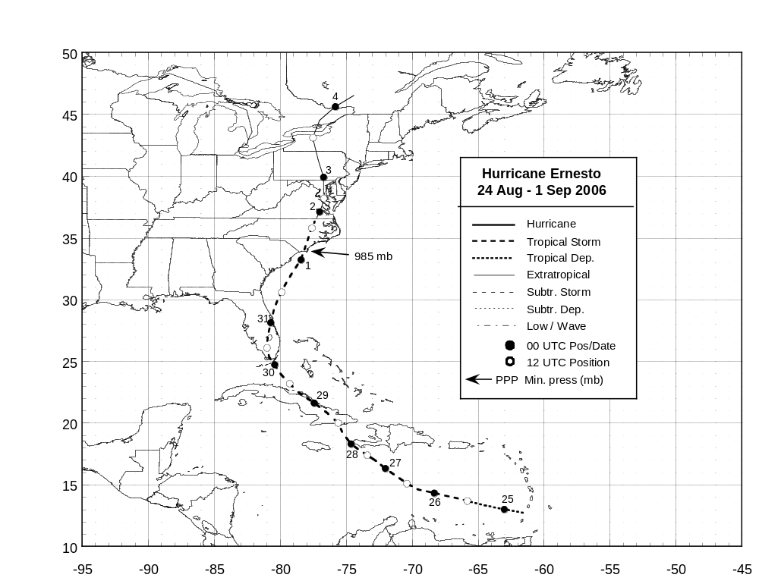

Figure 1. Best track positions for Hurricane Ernesto, 24 August – 1 September 2006. Track during the extratropical stage is based in part on analyses from the NOAA Ocean Prediction Center and the NOAA Hydrometeorological Prediction Center.
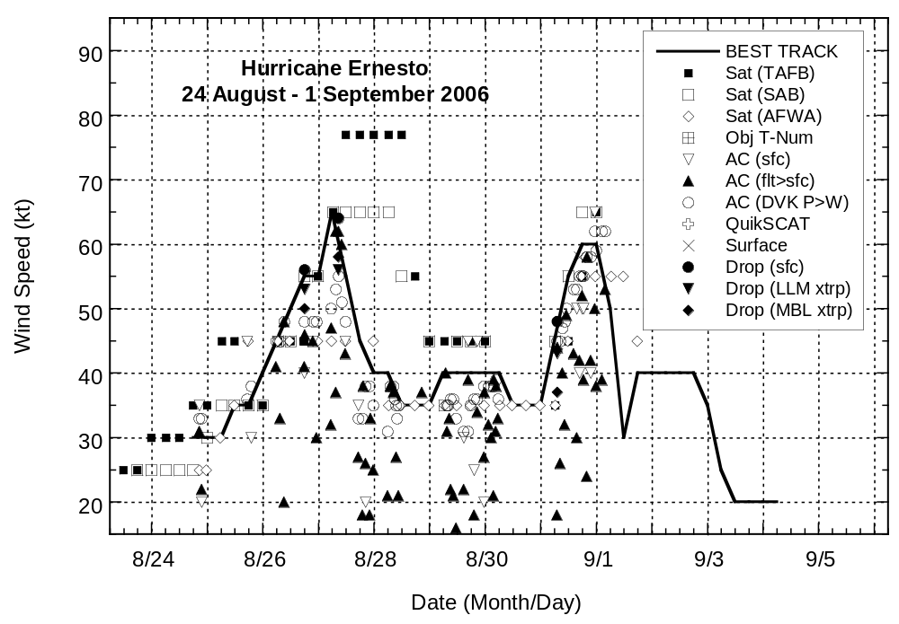
Figure 2. Selected wind observations and best track maximum sustained surface wind speed curve for Hurricane Ernesto, 24 August – 1 September 2006. Aircraft observations have been adjusted for elevation using 90%, 80%, and 80% reduction factors for observations from 700 mb, 850 mb, and 1500 ft, respectively. Dropwindsonde observations include actual 10 m winds (sfc), as well as surface estimates derived from the mean wind over the lowest 150 m of the wind sounding (LLM), and from the sounding boundary layer mean (MBL). Estimates during the extratropical stage are based on analyses from the NOAA Ocean Prediction Center and the NOAA Hydrometeorological Prediction Center.

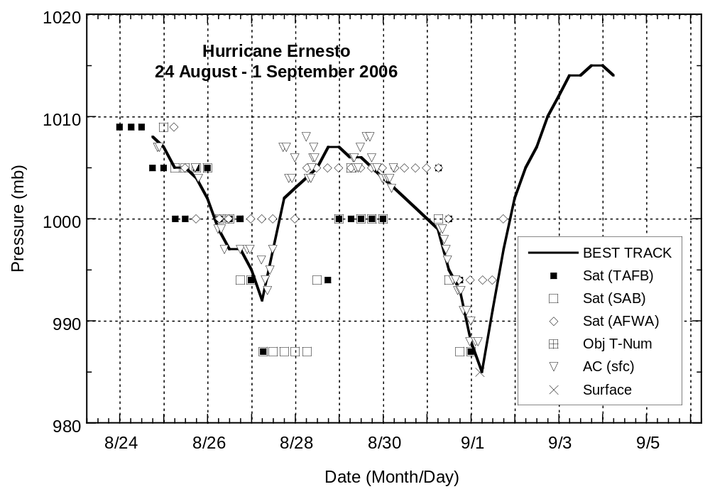

Figure 3. Selected pressure observations and best track minimum central pressure curve for Hurricane Ernesto, 24 August – 1 September 2006. Estimates during the extratropical stage are based in part on analyses from the NOAA Ocean Prediction Center and the NOAA Hydrometeorological Prediction Center.

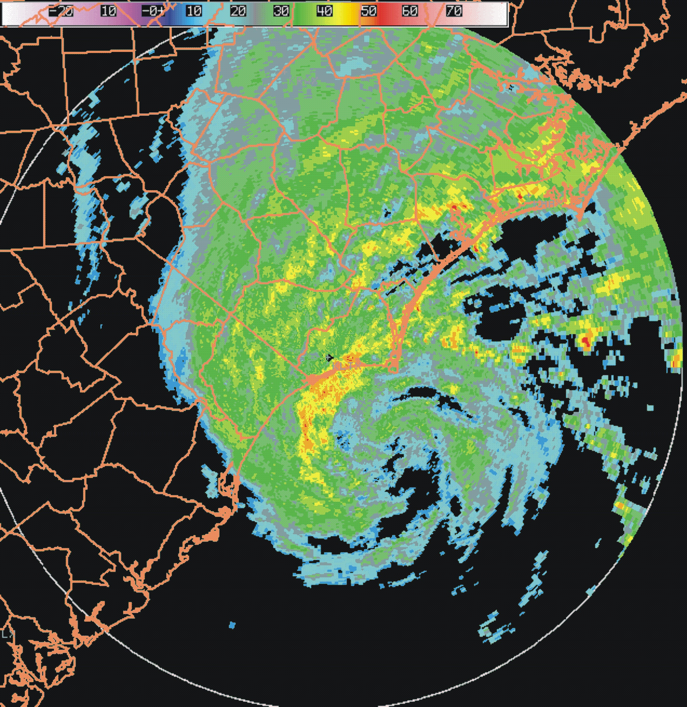
Figure 4. WSR-88D radar imagery from Wilmington, North Carolina of Ernesto at 0104 UTC 1 September 2006, about two and one half hours prior to landfall of the circulation center just west of Cape Fear, North Carolina.

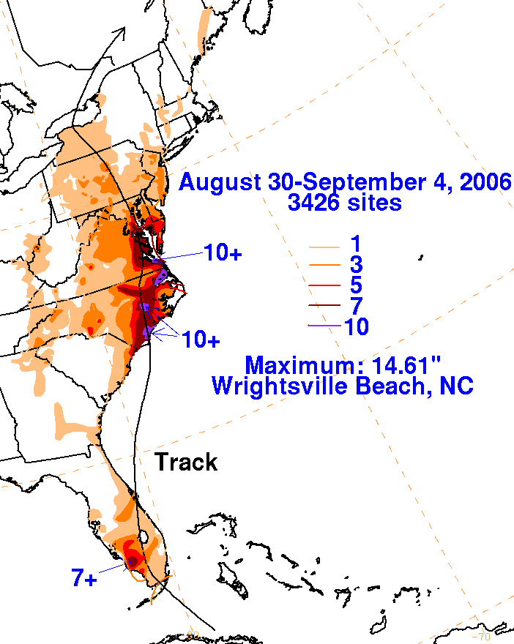

Figure 5. Rainfall totals produced over the eastern United States during the period 30 August – 4 September 2006 in association with Ernesto. Graphic provided by the NOAA Hydrometeorological Prediction Center.

