Tropical Cyclone Report
Tropical Depression One
(AL012009)
28 – 29 May 2009

Robbie Berg
National Hurricane Center
12 June 2009

Tropical Depression One originated from a decaying frontal boundary that had been stationary from north of the Greater Antilles to the Bahamas for nearly a week. By 25 May, a mid- to upper-level shortwave trough moved eastward across Florida and caused the western end of the front to move northward. An area of low pressure developed along the boundary on 26 May, about 250 n mi south-southeast of Wilmington, North Carolina, but by that time deep convection near the low was limited. The low moved northward and then northeastward ahead of the shortwave trough over the next day or so, coming within 75 n mi of the Outer Banks and producing scattered shower activity across parts of eastern North Carolina.

A cluster of deep convection developed near the low early on 28 May, and it is estimated that the system became a tropical depression at 0600 UTC 28 May while centered about 150 n mi east-northeast of Cape Hatteras. Over the next 24 h, the depression moved over the warm waters of the Gulf Stream and produced intermittent bursts of deep convection as it was steered northeastward and then east-northeastward between an Atlantic subtropical ridge and a deep mid- to upper-level trough over eastern North America. By 29 May, westerly vertical shear increased, and the depression was unable to generate persistent deep convection once its center moved over colder waters north of the Gulf Stream. As a result, the system degenerated into a remnant low around 0000 UTC 30 May, about 300 n mi south-southeast of Halifax, Nova Scotia. The remnant low dissipated shortly thereafter when it merged with a warm front that extended southeastward from a larger area of low pressure over eastern Canada. The “best track” chart of the tropical depression’s path is given in Fig. 1. The best track positions and intensities are listed in Table 1.

The development of Tropical Depression One was not expected. A Special Tropical Weather Outlook was first issued for the system around 1200 UTC 27 May, about 18 h before its designation as a tropical depression. The low was given a low chance (less than 30%) of developing into a tropical cyclone due to its close proximity to the cold ocean waters off the coast of New England. The low ultimately moved a little farther southeast than originally indicated by most of the models, keeping it over the warm Gulf Stream waters for a longer period of time and allowing it to maintain organized deep convection.

Of the 28 known tropical or subtropical cyclones to have formed in May, Tropical Depression One had the northernmost genesis point. It should be noted, however, that only cyclones that ultimately reached storm strength appear in the historical record prior to 1967.
Table 1. Best track for Tropical Depression One, 28 – 29 May 2009.

Date/Time  (UTC) | Latitude  (°N) | Longitude  (°W) | Pressure  (mb) | Wind Speed  (kt) | Stage
26 / 1800 | 30.6 | 75.4 | 1010 | 25 | low
27 / 0000 | 31.7 | 75.6 | 1010 | 25 | "
27 / 0600 | 32.7 | 75.5 | 1010 | 25 | "
27 / 1200 | 33.6 | 75.2 | 1009 | 25 | "
27 / 1800 | 34.5 | 74.6 | 1008 | 25 | "
28 / 0000 | 35.3 | 73.8 | 1007 | 25 | "
28 / 0600 | 36.1 | 72.9 | 1007 | 25 | tropical depression
28 / 1200 | 36.9 | 71.8 | 1007 | 25 | "
28 / 1800 | 37.5 | 70.3 | 1006 | 30 | "
29 / 0000 | 38.0 | 68.6 | 1006 | 30 | "
29 / 0600 | 38.6 | 66.8 | 1006 | 30 | "
29 / 1200 | 39.3 | 65.0 | 1006 | 30 | "
29 / 1800 | 40.0 | 63.1 | 1007 | 25 | "
30 / 0000 | 40.6 | 61.0 | 1007 | 25 | remnant low
30 / 0600 | 41.0 | 58.6 | 1007 | 25 | "
30 / 1200 |  |  |  |  | merged with a warm front
28 / 1800 | 37.5 | 70.3 | 1006 | 30 | maximum wind and minimum pressure

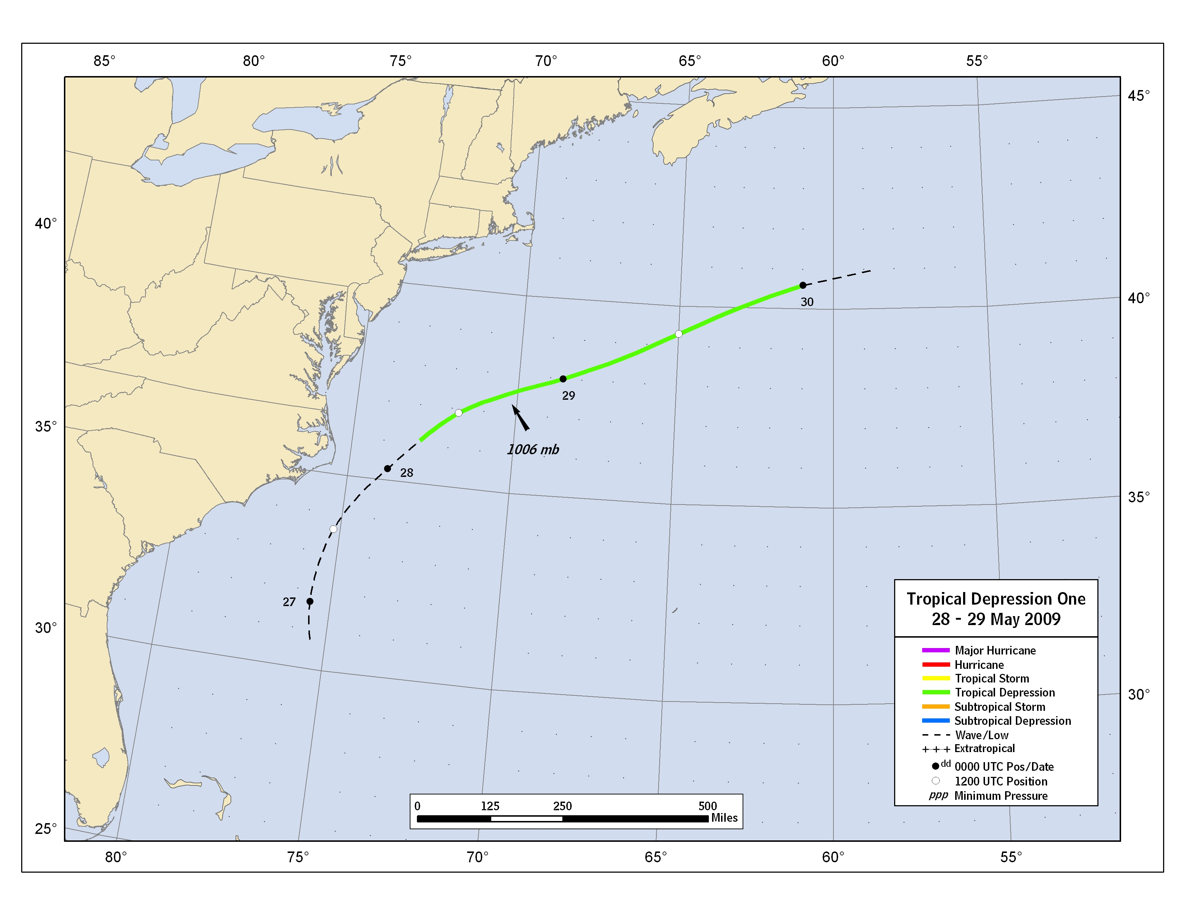
Figure 1. Best track positions for Tropical Depression One, 28 – 29 May 2009.

A digital record of the complete best track can be found on line at ftp://ftp.nhc.noaa.gov/atcf. Data for the current year’s storms are located in the btk directory, while previous years’ data are located in the archive directory.

